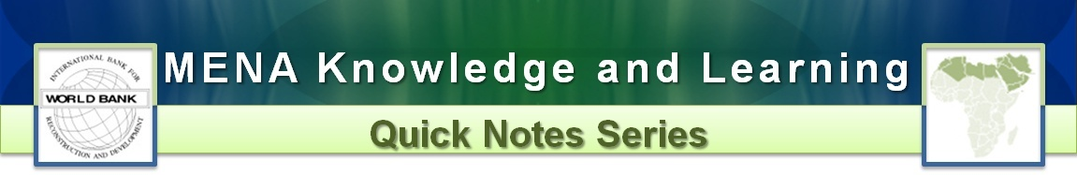
Z` ______________________________________________________________________________
March 2018 – Number 164
Climate Change in MENA:
Challenges and Opportunities for the World’s most water stressed region

Lia Carol Sieghart and Mahlette Betre
Introduction: The Middle East and North Africa (MENA) region is no stranger to extreme temperatures. It is predicted that these extremes will only worsen in the coming decades. Compounded by changing precipitation patterns, water insecurity and projected sea level rise, the region is set to experience significant challenges to its development, particularly in the areas of agriculture, livelihoods and food security. On the other hand, there are also significant opportunities to be realized and several countries in MENA are already taking steps towards advancing their global climate commitments and transitioning to a low-carbon, climate resilient economy.
Recognizing that climate change poses an acute threat to its mission, the World Bank Group has made strong commitments to tackle the climate challenge and to work with countries to meet their climate goals. With the adoption of a Climate Change Action Plan, the Bank has laid out concrete actions for how it intends to scale up climate action, integrate climate change across its operations, and work more closely with others, through collective action and partnerships, to implement new and innovative solutions.
In the MENA region, climate change is expected to result in sea level rise and an increase in heat extremes, which will put intense pressure on already scarce water resources. These in turn will have severe implications for regional food security, livelihoods, public health and large coastal cities (Figure 1).
Figure 1. Climate Change impacts in the MENA region. (Source: Infographic developed for the World Bank 2014, Turn Down the Heat: Confronting the New Climate Normal)
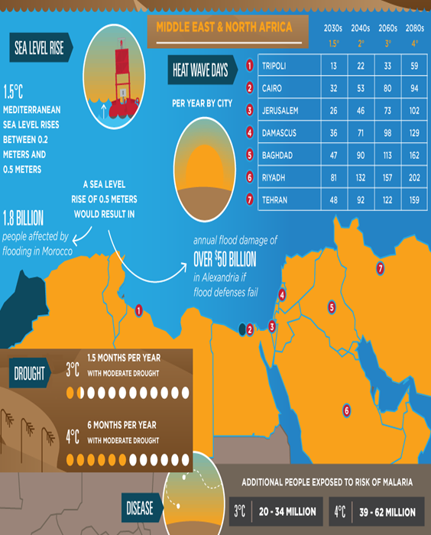
According to the WB report, Turn Down the Heat, crop yields could decrease by up to 30 percent at 1.5–2°C and by almost 60 percent at 3–4°C. At the same time, migration and climate-related pressure on resources might increase the risk of conflict.
MENA Countries Respond: Aware of their vulnerabilities to the impacts of climate change, MENA countries have begun to act. Almost every country in the region has submitted a plan for how they will contribute towards the global framework under the Paris Agreement that drives collective action toward a zero-carbon, climate-resilient future. To help countries implement these national plans, the MENA Climate Action Plan was launched and aims to increase the portion of financing dedicated to climate action with a focus on protecting the poorest that are most vulnerable to the impacts of climate change. The plan sets out five commitments:
- By 2020, 30% of WBG finance to MENA will go towards climate action (this is above the Bank’s institutional target of 28%)
- Significantly increase the share of adaptation financing (up to 50%)
- Support policy reforms that lay the foundations for a green future
- Crowd in private finance by leveraging the whole WBG, including IFC and MIGA
- Enable collective action to increase security in key cross-border challenges
In Iraq, the Bank is supporting a US$210 million project to improve the quality of drinking water supply and wastewater services in Baghdad. Leakage of untreated wastewater and the improper disposal of sewage contributes to outbreaks of waterborne diseases and aggravates health and environmental problems for residents. These issues are only compounded by climate change. The Baghdad Water Supply and Sewerage Improvement Project will tackle these issues through institutional strengthening for urban water and utility management and investments in drinking water supply and wastewater infrastructure, which will include the construction of a service reservoir with a total capacity of 135,000 cubic meters to ensure improved water supply quality and reliability for over 550,000 people.
Contact MNA K&L:
Samia Msadek, Director, Strategy and Operations. MENA Region, The World Bank

Regional Quick Notes Team: Omer Karasapan, & Mark Volk - Tel #: (202) 473 8177
The MNA Quick Notes are intended to summarize lessons learned from MNA and other Bank Knowledge and Learning activities. The Notes do not necessarily reflect the views of the World Bank, its board or its member countries.
In Tunisia, the Bank is supporting a US$ 100 million project to improve landscape management and access to economic opportunities for targeted rural communities in the North West and Center West regions of Tunisia. The project, which is targeting poorer rural communities, is aimed at promoting sustainable management of natural resources, which are currently being threatened by climate change, overgrazing and, deforestation. The integrated landscape development approach has the potential of raising the value of the regions output nearly five-fold from the current US$16 million to US$75 million, with the potential to create around 25,000 jobs
Next Steps: Looking forward, the Bank’s MENA region will focus on achieving all of their ambitious targets. The examples from Iraq and Tunisia both demonstrate how the Bank is actively working with countries to help them deliver on and exceed their Paris ambitions as well as highlight the tremendous potential in the region for increasing resilience to climate impacts and reducing emissions, while advancing development goals.

The authors are in the Environment and Natural Resources Global Practice
WBG Climate Action Plan, 2016
ibid
http://documents.worldbank.org/curated/en/317301468242098870/pdf/927040v20WP00O0ull0Report000English.pdf
http://unfccc.int/paris_agreement/items/9444.php

