

A Policy Agenda to Boost Human Capital in Bulgaria

Policy brief discussing the human capital index for Bulgaria
March 2019

Introduction

Human capital is a central driver of sustainable growth and poverty reduction. Yet despite substantial progress, significant gaps in human capital investment are leaving the world poorly prepared for what lies ahead. The World Bank Group has launched the Human Capital Project (HCP) to mobilize efforts to address these gaps. The goal of the HCP is a world in which all children arrive at school ready to learn, the time spent in school translates into better learning, and they can grow up to live and work as healthy, skilled, and productive adults. The Human Capital Project (HCP) is a global effort to accelerate more and better investments in people for greater equity and economic growth. The project aims at providing each country yearly high-quality information on the state of human capital by using relevant data from administrative records and national and international surveys on education and health outcomes of its child and adult population. The goal is to nurture a global and national conversation on why countries need to invest in all human capital dimensions. This is done by an in-depth analysis of the reasons why early health care and education prepare children to succeed as adults in a rapidly changing world, and more generally, prepare nations for reducing poverty and promoting shared prosperity in the years to come.

Even though economic research has shown the importance of human capital as a central driver of sustainable growth and poverty reduction, it is sometimes hard to make the case for human capital investments from a policy perspective as the benefits of investing in people can take a long time (sometimes decades) to materialize into positive results, which goes far beyond the horizon of short- and mid-term policies. Building roads and bridges can generate quick economic—as well as political—benefits. On the contrary, investing in the human capital of young children will not deliver economic returns until those children grow up and join the workforce. Beyond the macroeconomic benefits it entails, other gains that are usually overlooked when investing in human capital development (through better educated and healthier children and adults) are linked to individual benefits that arise throughout life in terms of better job market outcomes, socio-emotional development, or social and civic attitudes (Kautz et al. 2014).

The HCP is built on three pillars of action which can jointly promote awareness for policy action in national governments. First, the creation of a Human Capital Index (HCI) quantifies the contribution of health and education to the productivity of the next generation of workers. Second, the promotion of a research and measurement agenda for countries to become aware of the importance of investing in human capital. From a national perspective, this agenda goes beyond what is measured by the HCI, which in most cases can be equally important (i.e. tertiary education outcomes and on-the-job training). Third, the HCP is the kick-off of a new and more profound country engagement by using a multi-sectorial ‘whole a government’ approach.

For improved human capital outcomes Bulgaria needs to address quality of education and upgrade the health status of its population. This policy note aims at describing the current situation of Bulgaria in terms of the state of its human capital. In particular, it does so by going through the HCI to explore the differences and gaps with respect to other comparator countries in the region. These different dimensions provide a clearer picture of the policy areas that could enable human capital gains and productive life. Today, a child born in Bulgaria, will be 68 percent as productive when they grow up as they could be if they enjoyed complete education and full health. The HCI results are paired with recent country-level analyses to address existing challenges and identify opportunities for policy action. The note proposes a focused discussion on education policy outcomes identified as key area of policy investments that can significantly boost the productivity and human potential together with improvements in required health outcomes. Education policy actions are needed in several areas: expanding access and improving quality of preschool education, rethinking the student tracking functions of the education system to provide better opportunities for all, strengthening education financing, promoting school improvement policies to target learning, and investing in teacher policies.

List of Acronyms

ECD Early Childhood Development
EU European Union
GDP Gross Domestic Product
HCI Human Capital Index
HCP Human Capital Project
MOES Ministry of Education and Science
NCD Noncommunicable Diseases
PPP Purchasing Power Parity
PIRLS Progress in International Reading Literacy Study
PISA Programme for International Student Assessment
SABER Systems Approach for Better Education Results
TIMSS Third International Mathematics and Science Study

Human Capital Outcomes for Bulgaria

A child born in Bulgaria today will be 68 percent as productive when she grows up as she could be if she enjoyed complete education and full health. In practice, this means that Bulgaria’s HCI ranges between the third and the top quartile of countries. These numbers are far above the global average—the average child born today around the world will grow up to be, at best, half as productive as they could be (56 percent)—but yet far from the country with the highest human capital potential (Singapore, with children 88 percent as productive as they could be) and lag behind the European Union (EU) member states. The score (based on 2017 data) implies significant improvements with respect to 2012 data collection, where the indicator was at 65 percent. The first edition of the HCI, published in October 2018 (World Bank 2018b) revealed that countries with the highest levels of human capital are, in the following rank, Singapore, the Republic of Korea, Japan, Hong Kong, China, Finland, Ireland, Australia, Sweden, the Netherlands, and Canada. Country scores are displayed in Figure 3 and are compared with GDP per capita purchasing power parity (PPP) values.

Figure 1. Logic behind the World Bank’s HCI

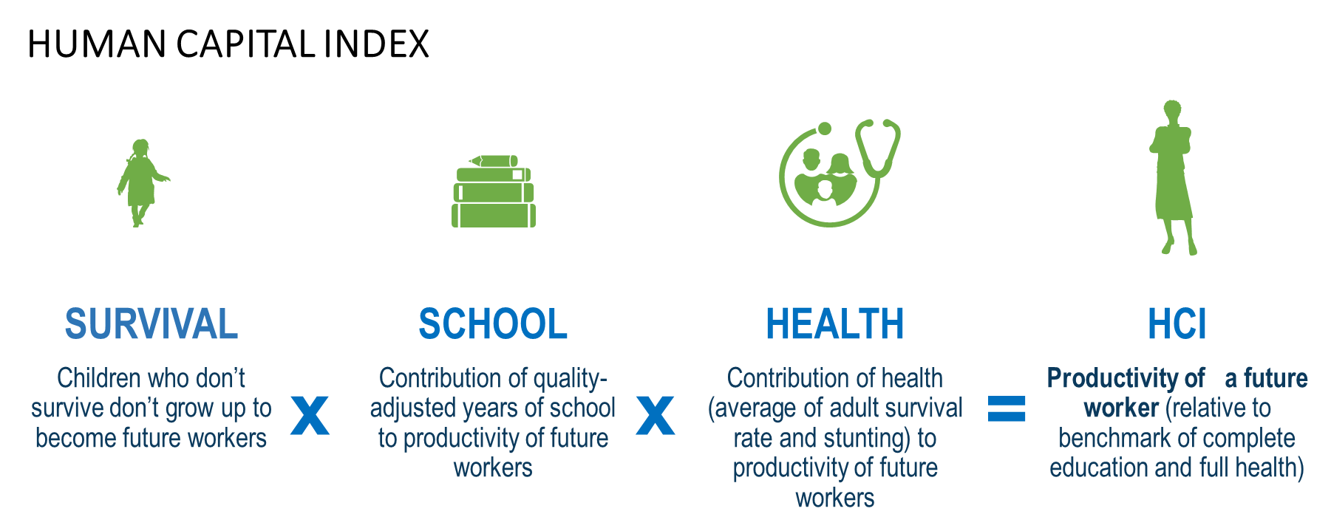
Source: World Bank 2018c.

The HCI is constructed through a comparative international benchmarking process of education and health outcomes. Education and health are the key pillars of human development since birth and these are precisely the two dimensions behind the HCI. On the one side, adults need to be equipped with adequate education qualifications and skills proficiency for the job market. In the HCI, education refers to a combination of education progress (the number of years at schooling attained) and learning outcomes achieved (the degree to which years of schooling attained translate to demonstrated proficiency in skills and abilities). On the other side, health is highly relevant for sustained and meaningful labor market participation throughout adult life. Regarding the HCI, health outcomes are divided in two components: child survival and health outcomes. Whereas survival refers to the probability of survival at age 5, health refers to a combination of the proportion of under 5 not stunted (stunting is the impaired growth and development experienced from poor nutrition, infection and stimulation) and the share of 15-year-olds who survive to age 60.

Figure 2. Components of HCI and GDP Per Capita
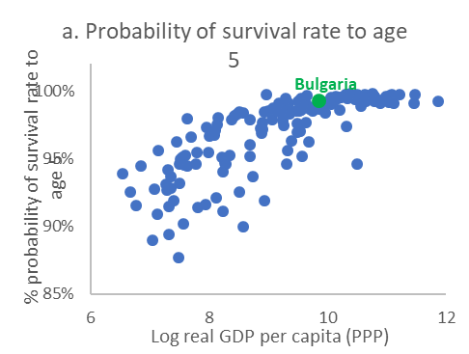 | 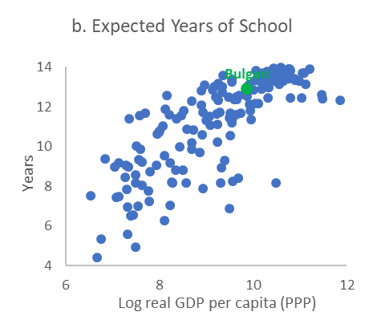
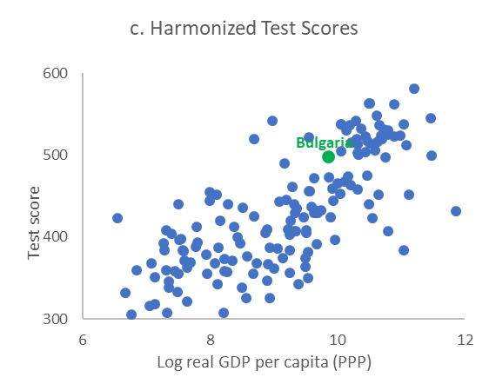 | 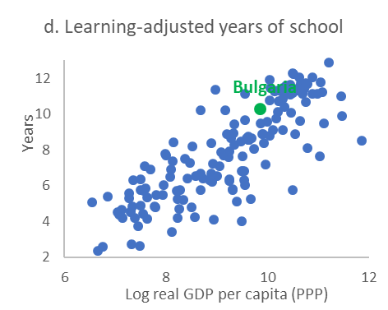
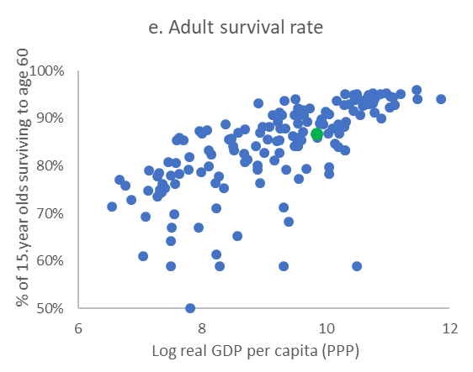  Bulgaria | 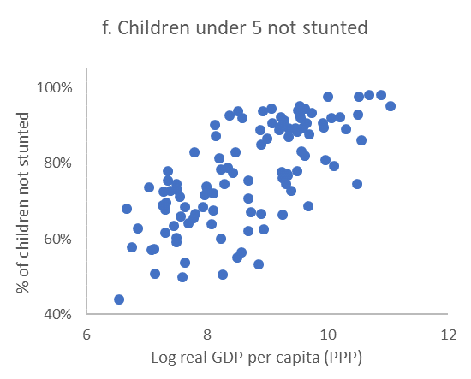
Source: World Bank 2018c.
Figure 3. HCI across Countries
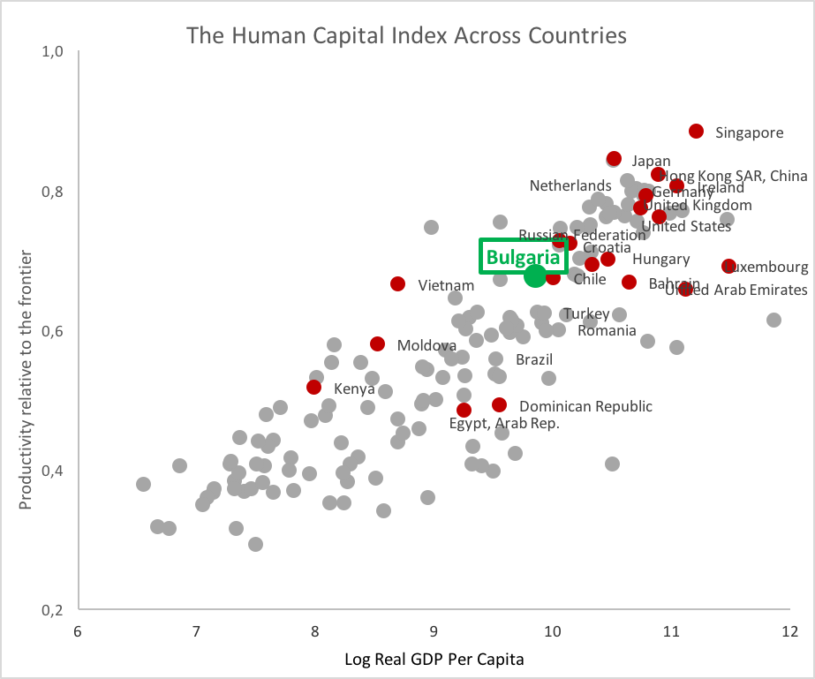
Source: World Bank 2018c.

The dimensions of human capital in Bulgaria range from ‘good’ outcomes in terms of probability of survival for children to better results regarding adult health outcomes or years of schooling and results in learning. Figure 2 shows the positive cross-country relation of each component (plus the learning-adjusted years of schooling—a combination of years of schooling and harmonized test scores) with the gross domestic product (GDP) per capita. The Probability of Survival to Age 5 for a newborn is 99 percent, similar to countries with the highest levels of human capital (Table 1). Regarding education outcomes, Expected Years of School in Bulgaria for a child who starts school at age 4 are 12.9 years of school by their 18th birthday, almost a year behind countries with the highest scores in terms of human capital. At the same time, Harmonized Test Scores of Bulgarian students are at 498 points, whereas countries with the largest HCI measures range at much higher levels at around 550 points. Regarding health outcomes, the Adult Survival Rate of 15-year-olds at age 60 is 87 percent in Bulgaria.

Recent data on stunting is not available for Bulgaria and hence the data were not used as part of the computation. Instead, the HCI is built assuming that the only health indicator is the adult survival rate: this implies that if Bulgaria has better outcomes in terms of non-stunting compared to adult survival rate, then the health component (which is built based on the two) will be underestimated. Conversely, if the non-stunting indicator is at lower levels relative to how Bulgaria ranks in terms of adult survival rate, then the health outcomes will be overestimated. Overall, absence of data does not allow to provide a reasonable picture of the reality and magnitude of stunting in Bulgaria.

Table 1. HCI and its Sub-components in Bulgaria (Total and by Gender)
 | Total | Boys | Girls
Probability of Survival to Age 5 | 0.99 | 0.99 | 0.99
Expected Years of School | 12.9 | 13 | 12.9
Harmonized Test Scores | 498 | 490 | 506
Survival Rate from Ages 15–60 | 0.867 | 0.82 | 0.92
Non-stunting rate of under 5 | No data | No data | No data
HCI | 0.68 | 0.65 | 0.71
Source: World Bank 2018b.

Gender differences in Bulgaria with respect to HCI are significant in favoring girls, especially in the dimensions of adult survival rate and harmonized test scores. Taking advantage of the richness of the datasets used, the HCI is also disaggregated by gender across countries. As can also be seen in Table 1, in Bulgaria, the difference in human capital between girls and boys is 6 percentage points, that is, the potential of a girl child born in Bulgaria today is 6 percentage points higher than that of a boy born today. That means that the gender gap in Bulgaria (where boys are lagging compared to girls) entails a potential source of human capital gains and requires policy attention.

Figure 4. Human Capital Index and Components across EU Countries 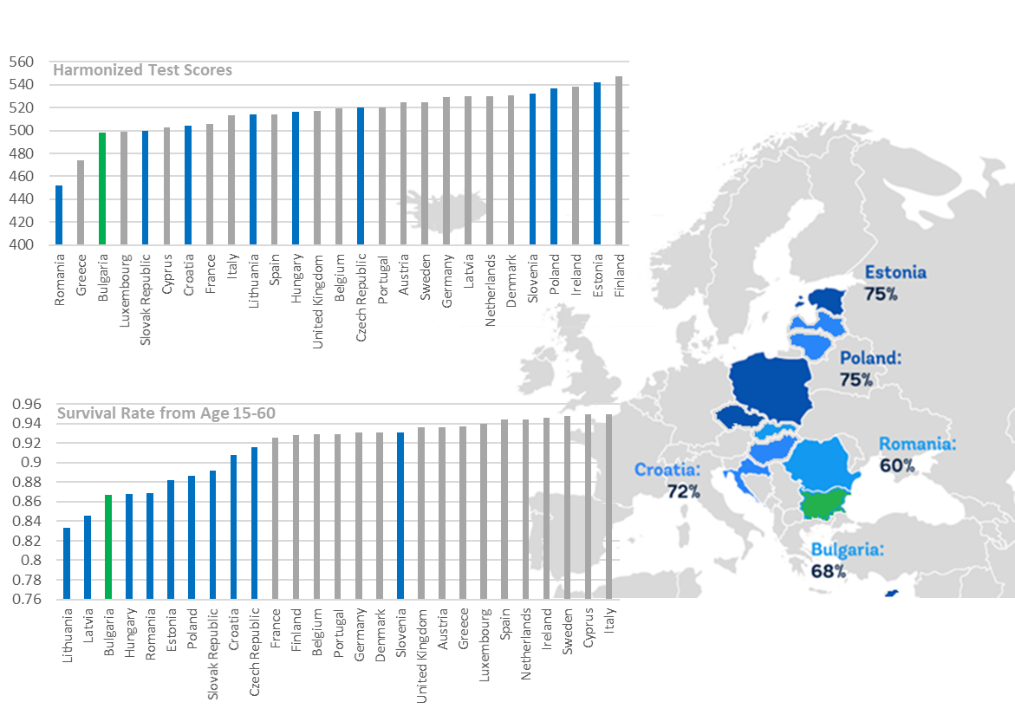
Comparing Bulgaria’s HCI score with other countries is a necessary step to identify potential human capital gains from a policy action perspective. Figure 5 depicts the overall differences in terms of human capital between Bulgaria and a subset of comparator countries, which has been organized by including a mixture of large developed EU countries (France and Germany), a Nordic country reference (Sweden), the two main Anglo-Saxon countries (the United Kingdom and the United States), and a sub-sample of neighboring countries with larger size (Romania and Turkey), similar size (Serbia), or smaller size (Croatia) relative to Bulgaria’s population. Bulgaria stands in average position compared to the subset of neighboring countries, with Romania and Turkey (which happen to be larger countries) having lower levels of HCI, whereas Croatia and Serbia display higher HCI scores. When expanding the comparison to larger economies, Bulgaria’s margin of growth is still large, especially when compared with the United Kingdom, Germany, or Sweden, and not as large as compared with the United States or France.
Figure 5. HCI for Bulgaria and Comparator Countries
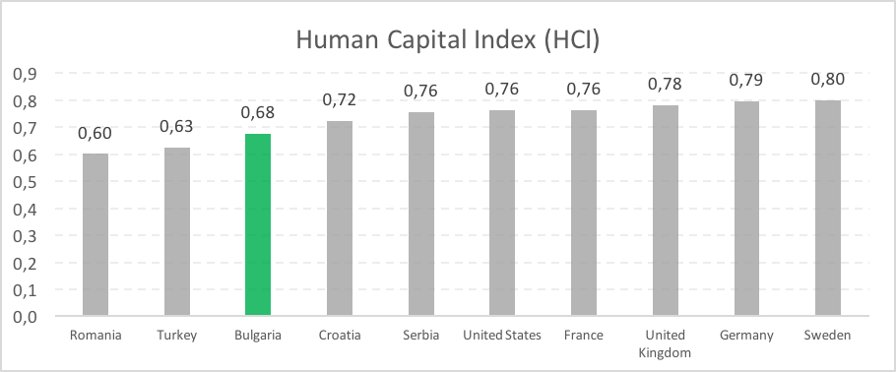
Source: World Bank.
Note: Except for Serbia and the United States, no country has available information on the stunting indicator.

Understanding the reason for these gaps by each of the dimensions of the index can help Bulgaria target current and future policy efforts to raise human capital. To dig deeper into the reasons why human capital in Bulgaria is still far behind the selected comparator countries, Figure 6 depicts where Bulgaria stands with respect to each of the four dimensions. As can be seen, whereas the differences in magnitude with respect to survival rate for children are low (less than 0.4 percent with respect to Sweden, the top performer), there are significant gaps in terms of expected years of schooling at age 4 (1 year difference with France, Sweden, Germany, or the United Kingdom), harmonized test scores (30 points difference with Germany, Sweden, or the United States) and survival rate for adult population (around 5 percent difference with Sweden, the United Kingdom, or Germany).

Figure 6. HCI Dimensions for Bulgaria and Comparator Countries
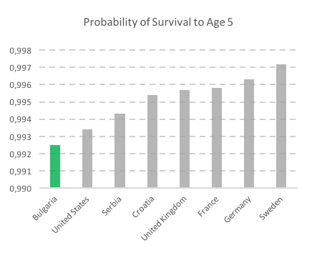 | 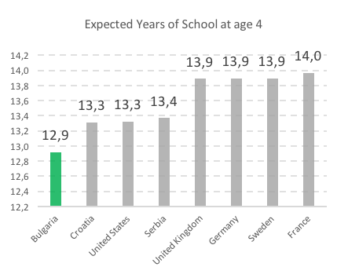
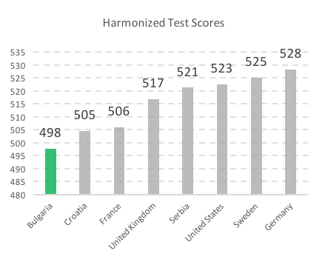 | 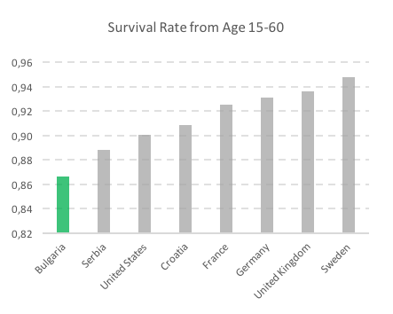
Source: World Bank HCI data.

To improve human capital outcomes in Bulgaria, key improvements are needed on two fronts: improving the quality of the education provided to children in Bulgaria and the health status of its adult population. Following the comparison presented in Figure 2, a simulation analysis is conducted by assuming an increase in different dimensions of the human capital policy outcomes in Bulgaria up to benchmark countries. By comparing the different values of the HCI dimensions to a benchmark value (from the best scoring country in each dimension) in Figure 6 from the above, potential gains of HCI are computed to indicate and discuss directions for policy developments. The benchmark values chosen are 0.997 probability of survival (Sweden), 14 years of schooling (France), 528 points in harmonized test scores (Germany), and 0.94 probability of adult survival rate (Sweden). Potential gains in human capital would be large if Bulgaria successfully combines policies for reducing dropout, promoting education attainment, improved learning outcomes and improved health outcomes: 5 percentage points if expected years of schooling increased from 12.9 to 14 (France), 4 percentage points if harmonized test scores increased from 498 to 528 (Germany), and 2 percentage points if the adult survival rate to age 60 increased from 0.87 to 0.93 (Sweden) and an increase in the probability of the survival age of newborns to the benchmark value from 0.993 to 0.997 (Sweden).

Table 2. Benchmarking Simulation of HCI in Bulgaria
 | Bulgaria | Benchmark Best Country | HCI (Benchmark) | HCI Gains
Probability of Survival to Age 5 (0–1) | 0.993 | 0.997 (Sw) | 0.68 | 0.00
Expected Years of School (0–14) | 12.9 | 14 (Fr) | 0.73 | 0.05
Harmonized Test Score (300–625) | 498 | 528 (Ger) | 0.71 | 0.03
Fraction of 15-Year-Olds Who Survive to Age 60 (0–1) | 0.87 | 0.93 (Sw) | 0.70 | 0.02
Source: World Bank HCI data (sample calculation).
Note: For each dimension, Bulgaria’s HCI sub-component value is benchmarked against the best country with respect to each dimension. HCI benchmark value and HCI gains are presented.

A Look into Health and Education Policy Outcomes in Bulgaria

Health outcomes

Significant improvements in the health sector outcomes, relevant to the HCI approach, are present in the last decade, although with some worrying recent trends. Maternal, infant, and under-5 mortality rates have decreased at a constant pace in the last 15 years, narrowing the gaps with EU countries. However, while life expectancy increased from 72 to 74 years between 2000 and 2013, it slightly decreased, since then, and stagnated in 2016, remaining far from the EU15 average at 82 years. Moreover, more specific health outcomes reveal problems regarding life expectancy at 65, premature mortality from noncommunicable diseases (NCDs), overweight or diabetes prevalence, alcohol consumption, and pollution.

Figure 7. Health Outcomes in Bulgaria and EU Countries
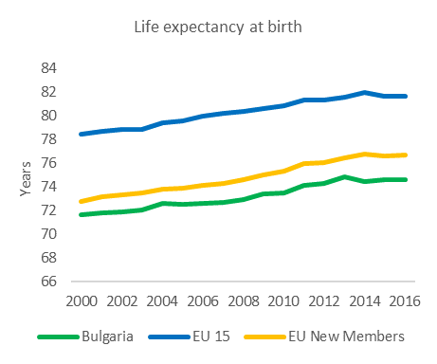 | 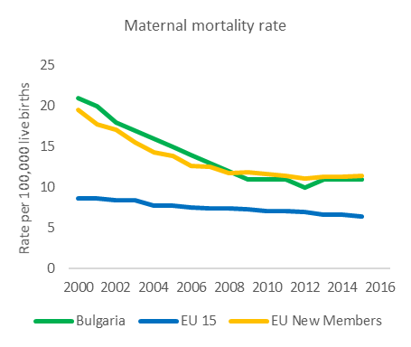
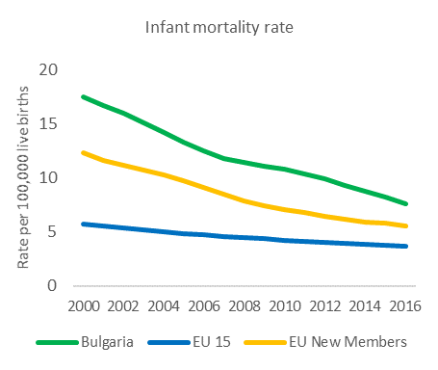 | 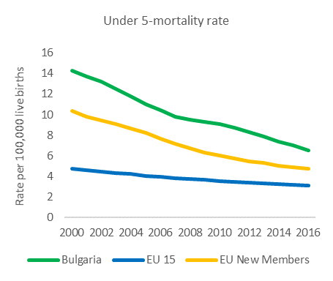
Source: World Development Indicators.

The lack of data on stunting, especially on children at physical and social risk, prevents adequate assessment of problems and hence policy responses through multisectoral nutrition, health, family, and child development support. The instruments of the policy for nutrition in Bulgaria are narrowed to (a) the mainstream consultation from generalists to parents and (b) the minimum functions under the provision of center-based services in early care and education (meals in nurseries and preschools that are universal and meals in schools that are demand based). The system is not investing in massive universal and targeted information instruments targeting different population groups and the preventive policy mix is underdeveloped. The country is not applying food fortification programs and systematic monitoring on nutrition outcomes as stunting and wasting is not present with some exceptions for overweight. In combination with the lack of systematized policies for parenting support that invest in empowerment of parents and building their skills and knowledge on quality nutrition and overall child development and with low combined efforts to comprehensively address early childhood development (ECD) outcomes, the policy implementation is fragmented and underperforming.

To improve health outcomes, progress is needed on improving coverage, management, and coordination of health services and on strengthening the preventive mix of policy and services across life cycles starting with focused ECD policy. In Bulgaria, public expenditures in health as a percentage of GDP or government expenditures are among the lowest of the EU (at around 4 percent) despite the annual growth of health funds. The expenditures for health should rise through the introduction of cost-effective interventions addressing the need to strengthen public health, health promotion, and prevention of smoking and alcohol consumption. In combination with the low attention to nutrition, Bulgaria has a very high rate of smoking (third among the EU) and alcohol consumption but the recent efforts in strengthening health promotion and prevention of smoking and tobacco consumption have not yet shown expected results. Improved coordination between primary care and hospital admissions is needed as the latter is exceptionally high—at least 20 percent of inpatient procedures performed in Bulgaria could have been conducted in outpatient settings (World Bank 2013). Accessibility to primary care is limited in many places—there are incentives for hospitals to treat more patients and primary care diagnostics tend to refer more patients to inpatient care because of ceilings. There is a need to introduce a new service delivery model that is suitable for the new burden of diseases that is heavily weighted toward NCDs as Bulgaria has the highest premature mortality from NCDs among EU countries. The Government of Bulgaria is introducing improvements to the existing health model for achieving better, sustainable and effective health care.

Education outcomes

Improving learning outcomes from education, combined with special efforts targeting the access and learning for vulnerable children, could guide the policy path for raising human capital in Bulgaria. Educational attainment (or, equivalently, the number of years at school) and learning outcomes can have a substantial impact in boosting human capital for Bulgaria’s population. More importantly, education indicators have persistently shown large inequities in access and learning opportunities. To use the potential of education, investments in quality and student level outcomes are needed.

Learning outcomes, revealed by different international assessments, show strong results at primary levels but problems at secondary level. Bulgaria has participated in international tests in the last two decades, such as PIRLS (reading for primary school), TIMSS (math and science both in primary and secondary), and PISA (reading, math, and science in secondary education). Results show that Bulgaria has been historically a better performer in primary school results compared to secondary school learning outcomes, although there have been recent improvements especially in PISA for 2009 and 2012 (see Figure 8). International testing results that measure learning outcomes are key as they provide relevant information connected to the HCI, which in turn has an impact on individual progress and economic growth (Figure 2).

Figure 8. PISA Scores by Subject in Bulgaria, 2006–2015
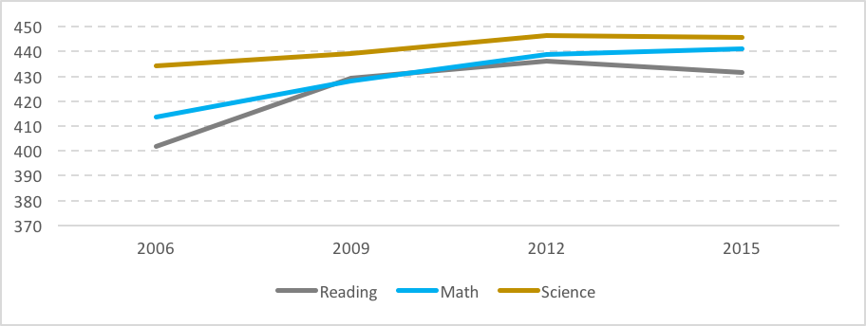
Source: World Bank (2018a).

International testing results reveal important gaps in performance according to gender, schools, regions, language at home, geographical location, or socioeconomic status. Previous analysis of international test results in secondary education show (Gortazar et al. 2014; World Bank 2018a) large differences by gender in reading skills, that are equivalent to more than one year of schooling at age 15. Moreover, linguistic minority students (Turkish or Roma) lag to the equivalent to three and a half years of schooling in reading, and two years of schooling in math and science. Moreover, there are large differences by geographical area, with rural students lagging far behind urban students. Finally, there are significant gaps by socioeconomic status: the average student is at least one year ahead of the student from the bottom 40 percent in terms of socioeconomic characteristics. These differences can be seen in Figure 9.

Figure 9. Learning Gaps in Bulgaria, by Gender, Home Language, and Geographical Area
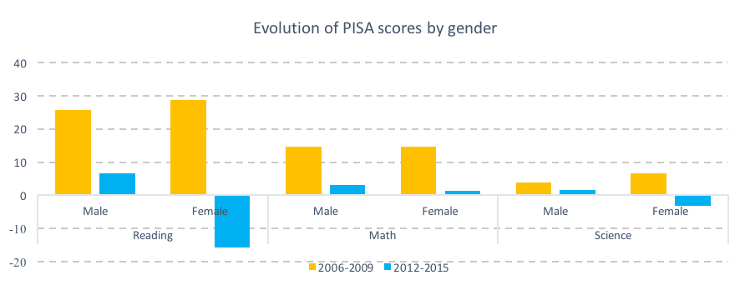
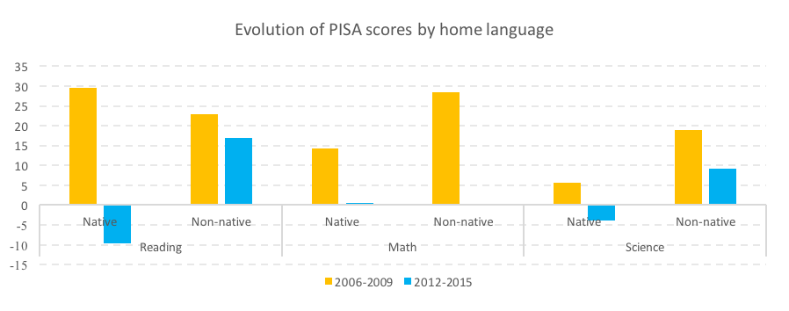
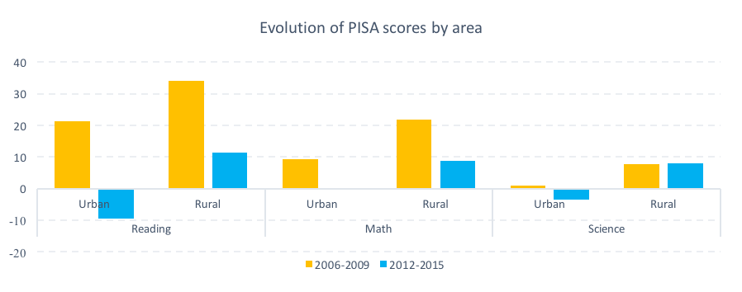
Source: World Bank (2018a).
Note: 30 points in PISA are considered equivalent to what students learn in one year of schooling.

Schools contribute to amplify student gaps, even after considering pre-existing educational and socioeconomic differences among students. As part of the engagement between the World Bank and the MES, school value-added measures were developed for schools based on national assessments in 2015, 2016, and 2017. In short, school value-added measures the contribution of schools to student learning based on the progress made by the student throughout the years and considering key student characteristics (such as gender, language at home, parental level of education or parental employment status, and others). Hence, these factors allow to isolate the net effect of school contribution to learning. Results are relevant in terms of policy implications, as they reveal that beyond the existing relevant background differences in student performance, schools amplify such differences in terms of value-added. School value-added measures are significantly higher for Bulgarian speaking students (compared to Romani or Turkish-speaking students), for students whose parents have higher levels of educational attainment (bachelor’s or post-graduate degrees) or students with parents who are employed (as opposed to parents who are unemployed or inactive). Moreover, there are large differences in terms of school value-added by school types (general vs. vocational) in the case of secondary schools and differences across regions. These findings help confirm that the education system, rather than contributing to reduce gaps among students, still contributes to widening pre-existing inequities present in the early years.

Although serious challenges with education outcomes are present, half of the secondary student population is targeted to vocational schools based on supply, designed to follow the system resources (teacher profiles) and not evidenced by system outcomes. This approach is replicating the challenges without targeted attempts to offer improved education to students and meet their needs with teachers or school profile ready to provide targeted education and skills needed for the future. Education is organized around 2 to 4 years of pre-primary education, 7 years of basic education, and 3 to 4 years of post-basic education, which starts after grade 7 and which basically offers three different school streams: non-profiled, profile-oriented, and technical (vocational) schools. Education is compulsory for students up to the age of 16. Overall, the age where compulsory education finishes determines the final number of years completed at school. This in turn is relevant for students, as it allows access to better opportunities in post-compulsory stages and finally labor market outcomes. Hence, individual consequences of educational attainment are as relevant as those for the country’s economic progress, as shown in Figure 2.

To improve education outcomes, action is needed in several areas to enable the Bulgarian education system to have a relevant incidence in increasing attainment and student outcomes: expanding access and improving quality of preschool education, rethinking the student tracking functions of the education system to provide better opportunities for all, strengthening education finance, promoting school improvement policies to target learning, and investing in teacher policies.

Quality and universal preschool provision
There have been considerable efforts in expanding access and supporting the quality of preschool education. Since 2010, the regulatory framework states that municipalities should assure 2 years of compulsory preschool education at ages 5 and 6. Nevertheless, implementation has experienced some challenges in terms of provision, targeting vulnerable populations, assuring quality to established standards, and financing of services. Evidence from previous analysis in Bulgaria suggests the importance on investing in early childhood education, as it has a positive and significant impact on student achievement, even more when considering low-achieving students (Gortazar, Kutner, and Herrera-Sosa 2014). Recent impact evaluation from a targeted ECD program for vulnerable students in Bulgaria (2017) which included cash transfers found a considerable increase in preschool participation of children from minority households, although limited results were seen in short-term child development. The government plans for introducing free access to preschool need to be accompanied with strengthening the capacity of the system to (a) work with vulnerable children and (b) monitor child outcomes to inform policy and classroom preschool practices. From a policy perspective, one of the key challenges of investing in quality and equitable ECD is that benefits tend to be observed years after the investment, hence making it difficult to generate government and societal consensus at the time of the investment. Nevertheless, national and international evidence on the benefits of ECD as the most efficient and equitable public investment recommends a sustained and consistent effort.

In addition, the government has taken serious actions to boost student attainment and combat dropping out from school. In 2016, the MES launched a special program to trace children and identify those who are out of education but in the compulsory education age. Reports reveal that the initiative was successful in boosting enrolment and addressing dropouts in early school years. Based on the lessons from the program, the government is now adjusting the approach and policy response to address vulnerabilities and secondary school age vulnerabilities to education where system tracking effects are producing serious segregation effects.

Early tracking and school segregation
Excessive school segregation through early tracking can hamper the opportunities of the most vulnerable students without bringing efficiency gains to the system. In Bulgaria, academic tracking takes place at the end of grade 7 based on the selection of students after a national high-stakes test, generating divergent educational paths from primary education that have a lifetime impact on students from a socioeconomic perspective. This results in Bulgaria being the country in the EU with one of the largest index of School Social Segregation (see Gortazar, Kutner, and Herrera-Sosa 2014; World Bank 2018a), meaning that students with similar backgrounds tend to go together to secondary education more than in other EU countries (see Figure 10). The consequences of segregation for students in learning opportunities, aspirations, attitudes toward school or role models are huge. At the societal level, by connecting different groups of students, school segregation is also related to other social outcomes, such as social cohesion, trust or empathy between groups (Rumberger and Palardy 2005; Palardy 2013). Nevertheless, delaying tracking remains a desirable policy option as international experience shows: in overall terms, the benefits of delaying tracking up to age 15 or 16 are large in terms of fostering learning opportunities for all without compromising the efficiency of the system.

The tracking system has been in place for many years and recent policy developments have shown no reform prospects in the short term with regard to delaying tracking. Evidence suggests that early tracking also has second-order effects, such as incentives for teachers to sort themselves into the most advantaged social environments to teach (Van Maele 2011) or parents who invest heavily and unequally in private tutoring. In the absence of policy targeting, the delay in school tracking other alternatives mostly focusing on mitigating the impact of tracking could help: one option is to work in no dead-end tracks, by building paths between general and vocational secondary education. Moreover, alternatives regarding consistency of curriculum between basic and secondary could narrow the gap between the vocational and academic tracks. But the social segregation effect could not be addressed by such measures.

Figure 10. School Social Segregation among 15-Year-Olds across EU Countries (PISA 2015)
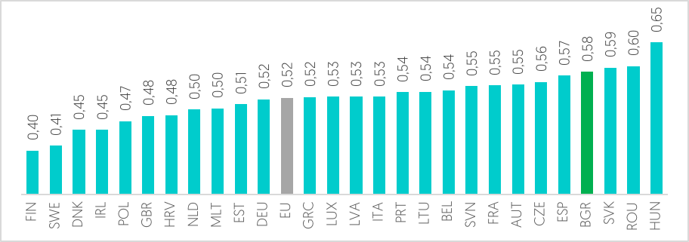
Source: World Bank 2018a.

Education finance
Education expenditures are lower compared to international and EU benchmarks. Although this investment path needs to be balanced with fiscal and economic policies, huge economic and social benefits could be derived from such an effort. Public investment can boost human capital by expanding the coverage in pre-primary and post-compulsory education (hence increasing the average expected years of schooling) combined with improvement policies regarding the quality of the system, by providing better and more targeted quality delivery that results in gains in student outcomes. Bulgaria is one of the EU countries which invests less in education. Latest data show that Bulgaria invests around 4 percent of its GDP in education, far from the 5.1 percent EU average. Moreover, these levels of investment are lower than those prior to the Great Recession in 2008 (which was around 4.2/4.3 percent), meaning that the GDP decline in 2009 and 2010 crisis had been accompanied by a structural decline of public investment in education. Recent policy actions targeting education (annual increase in education finance including raise of teacher salaries, infrastructure investments, budgets for national education programs) could induce investment increases but still investments are not reaching the EU levels neither those of the EU countries experiencing similar demographic challenges and decline in child population. By 2015, investment in education had not returned to the path pre-crisis. Evidence has shown that public investment in education is relevant and key up to a certain threshold, after which the benefits of public investment are less clear (OECD 2016; World Bank 2018a). Current data show that Bulgaria is still far from such threshold, at around USD 7,000 per student (in PPP).

Figure 111. Total General Government Expenditure on Education, 2017 (% of GDP)
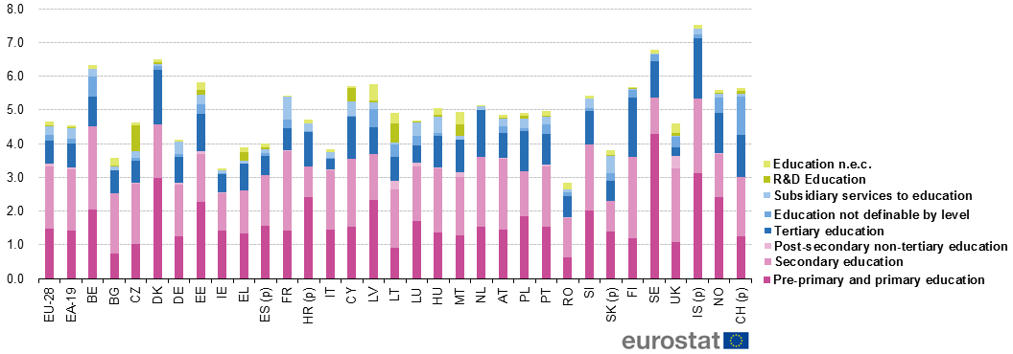

School accountability and school improvement policies
There have been substantial efforts to improve the capacity of schools to make autonomous decisions on management and resources, but the results of such reforms did not meet expectations in learning outcomes (Gortazar et al, 2014). Strengthening the autonomy and capacity of schools as well as working toward a more coherent accountability framework remains one of the key challenges in the system. Implementation of coherent accountability frameworks of school improvement and school progress is yet to be institutionalized in Bulgaria. The role of student assessments and the data these provide on school effectiveness (including school value-added measures) can be crucial in informing the MES, regions, schools, and inspectorate on the progress made and develop a sound program addressing support to poor performing schools. This would require consistent maintenance and use of a rich information base on school performance and outcomes to inform implementation. It will be beneficial for the system in providing support toward pedagogic improvement of schools oriented to student outcomes: such a role should strengthen the advisory and oversight capacity, as well as strengthen technical skills of the inspectorate and its general framework. Although supporting the teaching profession is clearly a necessary step, it is not enough without school level efforts and capacities toward improvement. As Hargreaves and Fullan (2012) argue, beyond teacher skills and training, the school dimension (through leadership, engagement, cooperation) of teacher professionalism is crucial for improvements.
Supporting the teaching profession
Teachers are the key element which can make the biggest difference for students across school systems. Supporting the teaching profession adequately requires correct institutional setting (through clear responsibilities of each governing body—Ministry of Education, regions, universities, teacher training institutions), a clear and attractive career path from the very beginning, and effective continuous training support which combines theory and practice. A recent report (Teach for Bulgaria 2018) states the importance of a coherent career path which includes attraction, selection, training, and retention of teachers: it emphasizes the importance of an effective selection model combined with an induction program that equips teacher candidates with skills and the sense of belonging to a community of practice of other teacher professionals. Overall there is a need to strengthen the teaching profession in a coherent and consistent manner. In fact, the challenges identified by SABER (Systems Approach for Better Education Results) teachers’ assessment (World Bank 2013) are still valid: the teaching profession is still not attractive enough for most talented and motivated young graduates; there is no clear policy in place to match teachers’ skills with students’ needs, or systems to monitor teaching and learning in the classroom as well as supporting teachers to effectively improve instruction. A rigorous evaluation of the national programme of teachers’ qualification is needed as a strong policy segment to provide teachers the support they need in the coming years. Although considerable progress has been made in the working conditions of the Bulgarian teaching workforce, little progress has been made in overall teacher policy including teacher education and training (World Bank 2013). Education systems with the highest learning outcomes are those which support and emphasize the importance of the teaching profession, from different perspectives such as resources, institutional design, or social recognition.

A development direction towards complete education and full health will require Bulgaria to continue with urgent investments and improvements of its education and health policies. In health, a combination of measures for strengthening access, management and coordination of health services, and improvement of outcomes through efficient preventive mix of policies and services across life cycles starting with focused ECD policy, is needed. Education could significantly boost the productivity and human potential together with gains in health care and healthy living through focused actions targeting improved education attainments. The key areas for policy improvements that could be a successful path for Bulgarian society are:

Health
- Expanding public health programs targeting all life cycle stages, ECD, health promotion, and prevention of smoking and alcohol consumption
- Improving access and efficiency by strengthening primary health care
- Strengthening finance for the health sector
- Supporting a new service delivery model suitable for the new burden of NCD

Education
- Expanding access and improving quality of preschool education
- Conceptualizing further the student tracking functions of the education system to provide better opportunities for all
- Strengthening education finance further
- Promoting school improvement policies to target learning
- Investing in teacher policies

The Human Capital Project will support policy makers in exchanging ideas and experience and will better focus developmental work towards investing in human capital. Bulgaria could profit from this exchange by crafting policy steps based on knowledge and experience across countries and by exchanging practices models, including local policy examples, with human capital policy peers and leaders. Information on the Human Capital initiative, the countries that joined the activities, and the index row data for all countries are available at the website of the Human Capital Project http://www.worldbank.org/en/publication/human-capital

References

Altinok, N., Angrist, N., & Patrinos, H. A. 2018. Global data set on education quality (1965–2015). The World Bank.

Barber, M., and Mourshed, M. 2007. How the World's Best-Performing School Systems Come out on Top. McKinsey & Company.

Hargreaves, A., and M. Fullan. 2012. Professional Capital: Transforming Teaching in Every School. Teachers College Press.

Gortazar, L., D. Kutner, and K. Herrera-Sosa. 2014 How can Bulgaria Improve its Education System? Washington, DC: World Bank.

Hanushek, E. A., and L. Woessmann. 2008. “The Role of Cognitive Skills in Economic Development.” Journal of Economic Literature 46 (3): 607–68.

Jackson, C. K. (2018). Does school spending matter? The new literature on an old question (No. w25368). National Bureau of Economic Research.

Kautz, T., J. J. Heckman, R. Diris, B. Ter Weel, and L. Borghans. 2014.” Fostering and measuring skills: Improving cognitive and non-cognitive skills to promote lifetime success.” No. w20749. National Bureau of Economic Research.

OECD. 2016. PISA 2015 Results (Volume I): Excellence and Equity in Education, PISA, OECD Publishing, Paris

Organisation for Economic Co-operation and Development (OECD). 2017. “State of Health in the EU.” Bulgaria Country Health Profile 2017.

Palardy, G. 2013. High School Socioeconomic segregation and student achievement. American Educational Research Journal. Vol 50, Issue 4, pp. 714 – 754.

Rumberger and Palardy. 2005. Does segregation still matter? The impact of student composition on academic achievement in high school. Teachers College Record, 107(9) pp. 1999-2045.

Teach for Bulgaria. 2018. How to find, train, and retain successful teachers.

Van Maele, D., and Van Houtte, M. 2011. Collegial Trust and the Organizational Context of the Teacher Workplace: The Role of a Homogeneous Teachability Culture. American Journal of Education, 117(4), 437-464.

Well, D. N. 2007. “Accounting for the Effect of Health on Economic Growth. The Quarterly Journal of Economics 122 (3): 1265–1306.

World Bank. 2013. Mitigating the Economic Impact of an Aging Population: Options for Bulgaria. Washington, DC: World Bank.

———. 2017. Supporting Disadvantaged Children Enter Kindergarten: Experimental Evidence from Bulgaria (English). Washington, DC: World Bank Group.

———. 2018a. “Improving the Quality of Bulgaria’s Education System: A Review of Bulgaria’s Performance on the 2015 Programme for International Student Assessment (PISA).” World Bank, Washington, D.C.

———. 2018b. Human Capital Index Policy Note for Bulgaria. Washington, DC: World Bank.

———. 2018c. “The Human Capital Project.” Washington, DC: World Bank.

Zuckerman, G. A., G. S. Kovaleva, and M. I. Kuznetsova. 2013. “Between PIRLS and PISA: The Advancement of Reading Literacy in a 10–15-year-old cohort.” Learning and Individual Differences 26: 64

This brief was produced by Lucas Gortazar and Dessislava Kuznetsova from the Europe and Central Asia unit in the Education Global Practice of the World Bank Group. The note was developed under the technical supervision of Harry A. Patrinos (Practice Manager) and reflects contributions from Lars Sondergaard, Jason Allen Weaver, Ha Thi Hong Nguyen, Alexandra Valerio, Adela Delcheva, Marta Helena Reis de Assis and Patrick Biribonwa.

For more information on the Human Capital Project and index rate for Bulgaria, please visit http://www.worldbank.org/en/publication/human-capital

World Bank. 2018. The Human Capital Project. World Bank, Washington, DC. © World Bank. https://openknowledge.worldbank.org/handle/10986/30498 License: CC BY 3.0 IGO.”
This is mostly due to improvements in harmonized test scores in education between 2012 and 2017.
(a) Probability of Survival to Age 5 reflects the fact that children born today need to survive until the process of human capital accumulation through formal education can begin. Survival is measured using the under-5 mortality rate; (b) Expected Years of School is a measure of the number of years of schooling obtained by students at age 18 when they start preschool at age 4; (c) Harmonized Test Scores measure how much children learn in school based on countries’ relative performance on international student achievement tests, based on a harmonized database using TIMSS (Trends in International Mathematics and Science Study), PISA (Programme for International Student Assessment), PIRLS (Progress in International Reading Literacy Study), and others (Altinok, Angrist, and Patrinos 2018); (d) The combination of (b) and (c) produces the Expected Years of Learning-Adjusted School. By adjusting for quality, this component reflects the reality that children in some countries learn far less than those in other countries, despite being in school for a similar amount of time; (e) Adult Survival Rate is defined as the proportion of 15-year-olds who will survive until age 60; (f) Children Under 5 Not Stunted measures an indicator during childhood which is a powerful predictor of adult health outcomes.
This statistic is a proxy for the range of fatal and non-fatal health outcomes that a child born today would experience as an adult under current conditions.
The index does not include data that are expanding over 10 years. Latest data on stunting for Bulgaria are for 2004.
Due to lack of data availability for Bulgaria, the indicator on stunting is not presented.
In terms of percentage points.
See World Health Outcomes.
For PIRLS in 2001 and 2006 and TIMSS in 2015.
As measured by PISA 2000, 2006, 2009, 2012, and 2015 and TIMSS 2003 and 2007.
In Bulgaria, socioeconomic background of the student determines more than in any other EU country the school the student attends, the number of years of schooling she gets, and the skills she acquires in the education lifetime (OECD 2017; Gortazar et al. 2014).
Bulgaria’s national assessments have been implemented for a long-standing period to track student learning trajectories and are a good tool for education planning and policy purposes. In Bulgaria, testing is at the national scale in primary (grade 4), lower secondary (grade 7 and with a high-stakes purpose), and the so-called Matura examination at the end of upper secondary (grade 12 and with a high-stakes purpose).
World Bank Impact evaluation of Springboard for School Readiness, Trust for Social Achievement
See World Bank 2018a.
А discussion on whether investment matters after such threshold has been recently challenged by robust evidence from the United States (an education system which invests far more than USD 7,000 per student). As stated by Jackson (2018), “the recent quasi-experimental literature that relates school spending to student outcomes overwhelmingly support a causal relationship between increased school spending and student outcomes.”
https://ec.europa.eu/eurostat/statistics-explained/index.php?title=Government_expenditure_on_education
Barber and Mourshed 2007.

