THE CENTRAL BANK OF YEMEN: PAYMENT SYSTEM CAPACITY BUILDING WORKSHOP

April 28-May 3, 2019 Abu Dhabi, UAE

Between April 28- May 3, 2019, a World Bank Group (WBG) mission consisting of Ahmed Faragallah, Senior Financial Sector Specialist (GFCFI) and Ghada Ismail, Financial Sector Specialist (GFCMW) visited Abu Dhabi, UAE to (i) deliver with the Arab Monetary Fund (AMF) a joint a capacity building workshop to the Central Bank of Yemen (CBY); (ii) discuss with CBY representatives potential areas of technical assistance to transform payment system development recommendations listed in the IMF CBY needs Diagnostic into technical assistance tasks to address the gaps in payments systems; and (iii) strengthen and steer coordination with AMF through exploring with the AMF representatives’ potential areas of joint support to implement the TA agenda for CBY Yemen.

- Summary:
- Potential WBG TA agreed on based on recommendations listed in IMF CBY needs Diagnostic and discussions with CBY representatives include: (i)TA to establish a Payment Systems Department (PSD) and a same-day settlement arrangement among commercial banks at CBY- as a temporary solution, to allow CBY to perform its settlement function till a full RTGS system is established; (iii)TA to develop the full operation of the card/m-money Switch which will facilitate the distribution of salaries, pensions, humanitarian aid; increase electronic transactions and hence resolve the extreme liquidity shortage in the market; and (iv) TA to develop a national payment systems strategy and design a model for Government payment through payment cards or mobile money.
- Next steps agreed on include: (i) Mission team to share a detailed action plan for payments systems with USAID and AMF to agree on joint deliverables/ division of cost; (ii) launch TA to CBY to establish the payment systems department and a same-day settlement arrangement among commercial banks at CBY; (iii) explore taping on the existing card switch managed under Mahfathati -Bank Tadhamon and IFC interest in financing the TA for the Switch, or the new systems required; (iv) CBY to advise on status of their funding request to AEFSD; and (v) agree on timing with CBY and AMF to conduct a AML/CFT training to CBY.

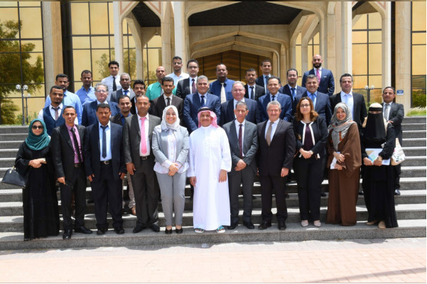
- Payment Systems Capacity Building Workshop. Ahmed Faragallah delivered Five-days capacity building workshop ─ one of the short term priorities in the IMF diagnostic ─on Payment System infrastructure to 20 participants from CBY.Most of the participants will join the planned payments system department (PSD) - Operations, Oversight, and Policy Sections that will be officially formed later this month through CBY Board decree.
- The training covered (i) National Payment System structure, the PSD Structure; and its Functions of Operations, Oversight, and Policy and catalyst roles; (ii) Real Time Gross Settlement (RTGS): Discussions tackled the importance of RTGS including its structure, role as the main settlement system in Yemen, how RTGS operates, legal aspects, Credit/ Liquidity risks and risk mitigation methods, Integration of RTGS with other payment and securities systems, types of connections to RTGS, and IT requirements for the RTGS project; (iii) Retail Payment Systems: Discussions covered; Interbank Cards Switch; types of cards, ATMs, and POSs; discussions centered on services that can be provided through the Card Switch and how to encourage cards acceptance; cycles of clearing and settlement of cards; and Central Bank role in retail payment systems; Government Payment Systems cycles, and architecture for payment of salaries, and social transfers and Collection of taxes, customs, and other fees; and e-money and mobile money operators; (iv) Payment Systems Oversight: the training highlighted the standards, principles, and instruments of Oversight; regulating systems and services; licensing of payment system operators and service providers PSPs; Principles of Financial Market Infrastructure; and finally types of risks and risk mitigation in payment systems.

- While the AMF delivered a two day training on Risk Management, Financial reporting, and cyber security.

- The team held discussions with Shadi Seif, Director of Development and International Affairs and CBY representatives, focusing on the need for a fast method to reach an interbank near real-time settlement system and next steps towards RTGS Project implementation. Potential WB TA and next steps agreed on to develop payments system financial infrastructure include:

- TA to establish a Payment Systems Department (PSD) that would operate important payment systems like RTGS and Cheques Clearing House, promote usage of electronic payments for governmental services and humanitarian purposes, and provide oversight for the payment systems, services, and instruments in the country.
- TA to develop a same-day settlement arrangement among commercial banks at CBY using SWIFT Closed User Group and existing core banking system. This solution is considered a temporary one, to allow CBY to perform its settlement function till a full RTGS system is established which usually takes 2 years’ time. CBY vetted this option as a fast track to have a controlled risk over inter-bank transactions in Yemeni Riyal, and to help Banks and CBY gradually get ready for the RTGS system. The World Bank team will also work in parallel on a different TA to Identify the operational environment and requirements of the RTGS system to be established in Yemen.
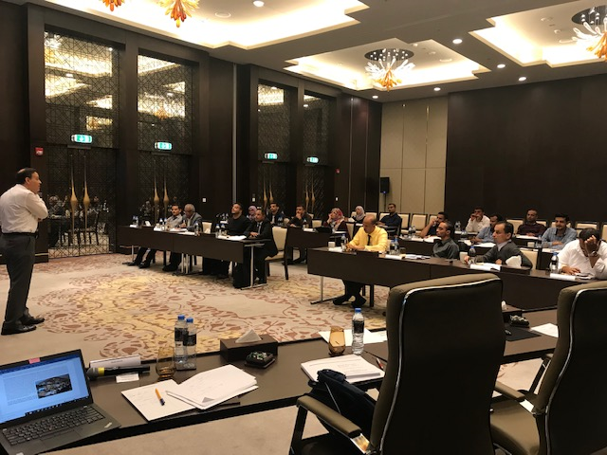
Note: CBY drafted a funding request to the Arab Fund for Economic and Social Development (AFESD) to set up an RTGS system. The team reviewed and provided comments to CBY draft funding request- including that this will be accompanied by TA from WB to set the RTGS (help identify the information technology, connectivity, security, backup and disaster recovery arrangements, accounts structure, liquidity management, and credit facility requirements of the CBY and develop a detailed requirements document, leading to procurement and operations of RTGS, and Automated Clearing House (ACH) systems).
- Developing the retail payment services in Yemen. A full operation of the card/m-money Switch will facilitate the distribution of salaries, pensions, humanitarian aid; and most important is a corner stone in increasing electronic transactions and hence resolving the extreme liquidity shortage in the market. TA will include arrangements of Governance structure for the switch, developing required policies to be applied by the CBY and products and services to be provided through the Switch, developing rules for the card scheme basic services, e-commerce, and for the mobile interoperability platform to be provided by the Switch.
  - It is recommended to tap on the existing Card Switch (connecting all banks) as the establishment of an alternate interbank switch may take several years and will cost millions of USD. The Card Switch is owned by commercial banks and other private sector investors, and it is a core infrastructure while there is no RTGS or any other retail payment system that is operational in Yemen. The role of the Switch can expand to cover the interoperability of mobile money services, and can even extend to bank accounts.
  - The challenge is that the card switch is located in Sanaa Yet, it is recommended that CBY make the best usage of the Switch, in the absence of any alternative solution, and to encourage the commercial banks to use it, while CBY can provide the settlement to the daily results of the Switch clearing and netting among the banks. The political issues including the loyalty of the Switch management may be resolved if the CBY selected one or two as board members, have the board meetings held in Aden, and signed with the Switch to settle the Switch transactions in CBY Books.
- TA to develop a national payment systems strategy. The strategy should identify the short-term and medium-term priorities and action plan for the CBY, covering dimensions like, large value payment systems, retail payment systems, government payment systems, and oversight. The strategy should consider priorities related to the conflict and the scope of implementation during and post conflict. The strategy will build on the earlier draft developed by the World Bank few years ago, but will require many changes to reflect the current status.
- TA to design a model for Government payment through payment cards or mobile money. This could for example be payments of teachers’ salaries or distribution of humanitarian financial aid. The aim of the TA should be to design a model for government payment through payment cards or mobile money, targeting the expansion of the reach of financial sector and ensuring its role in providing government services to the Yemeni citizen. The TA will require discussions with CBY and Ministry of Finance to reach an agreement on the optimal projects of largest impact.

- Coordination with the Arab Monetary Fund (AMF)
- H.E. Dr. Abdulrahman Al-Hamidy, Chairman and D.G. Arab Monetary Fund (AMF) delivered the closing remarks of the Payment Systems Workshop. He confirmed support to CBY and praised partnership with the World Bank Group. Dr. Al- Hamidy expressed willingness to join forces to implement the TA agenda for CBY moving forward. I thanked Dr. Al-Hamidy and Yisr for hosting the training and confirmed WBG engagement with the AMF, with priorities to TA to payment systems and AML/CFT to CBY.
- Meeting with Yisr Barnieh, Senior Financial sector Specialist, AMF. Yisr confirmed AMF interest in working with the WBG and co-funding TA activities. This includes: conducting trainings, hosting missions, hiring consultancy firms or individual consultants. We agreed on sharing a proposed action plan for TA with the AMF based on short term priorities identified by IMF diagnostic of CBY needs and discussions held with CBY representatives.

- Coordination with USAID
The team had a coordination call with Maria Davydenko, Yemen desk officer -US Department of state USAID along with Shadi Seif, Director of Development and International affairs, CBY. Main points raised include:
- USAID have an ongoing TA program to CBY and are in the process of developing a new action plan for coming period. Proposed support in the coming period include (i) preparing an Action Plan to implement the recommendations listed in IMF Diagnostic; (ii) establishment and operationalization of a sound analytical framework for assessing money demand and establishing sound estimates of basic cash currency circulation needs and velocity; thereby facilitating the determination of basic currency management parameters; and (iii) strengthening of the CBY’s policy/procedural framework for and capacity in foreign exchange management/operations and international payment system activities.
- World Bank team briefed Maria on progress to date in payments and next steps agreed on with CBY including developing an action plan for payments system development. Maria expressed USAAID interest to provide funding (from ongoing and proposed TA funding that they will provide to CBY) Including also covering the cost of engaging Pragma consultancy firm (their consultancy firm on the ground in Yemen). We agreed to share with her a concrete action plan for the establishment of an efficient and transparent retail payment system for Yemen with estimated cost by next week.

- Next Steps
- Mission team will share a detailed action plan for payments systems with USAID and AMF to agree on joint deliverables, division of cost.
- launch TA to CBY to establish the payment systems department. This includes advising on the department structure, roles and responsibilities, and required skills.
- TA to Develop a same-day settlement arrangement among commercial banks at CBY using SWIFT Closed User Group and existing core banking system, to allow CBY to perform its settlement function till a full RTGS system is established. This includes (i) assessing the IT systems capacity and Core Banking System capabilities tapping possibly on the consultancy services of the same vendor that is currently upgrading the core banking system (AEC consultancy); (ii) assessing the connectivity of commercial banks to CBY including SWIFT lines Status
- Follow up on possibility of taping on the existing card switch managed under Mahfathati -Bank Tadhamon. Explore IFC interest in financing the TA for the Switch, or the new systems required by the Switch.
- CBY to advise on status of their funding request to AEFSD. Once funding is secured, TA could be provided to identify the operational environment and requirements of the RTGS system in Yemen
- Agree on timing with CBY and AMF to conduct a AML/CFT training to CBY.

