SFG2852 V1

inyenyeri_logo v3 black kinya (print)

Environmental Management Plan

December 2016

Contents

[1. Introduction 3](#_Toc461681033)

[2. Project Objective 3](#_Toc461681034)

[3. Project Description 3](#_Toc461681035)

[4. Policy, Legal and Administrative Framework 4](#_Toc461681036)

[5. Relevant World Bank Policies 5](#_Toc461681037)

[6. Implementation Arrangements 6](#_Toc461681038)

[7. Potential Environmental Impacts and Environmental Management Approach 6](#_Toc461681039)

[8. Stakeholder Engagement and Public Consultations 9](#_Toc461681040)

Appendices

1. Health and safety protocol
2. Poster
3. Summary of stakeholder engagement and consultations
4. Due diligence for sourcing of wood

# Introduction

Inyenyeri, a Rwanda-based private company, have approached the World Bank, in response to a Call for Proposals, for funding from the Carbon Initiative for Development (Ci-Dev) Trust Fund, a carbon facility that supports innovative business models through purchase of certified emission reductions. The proposal was selected as one of the two the most promising and innovative of 25 cookstove projects submissions received by Ci-Dev internationally. The proposal is associated with sophisticated studies of the reduction of Household Air Pollution and the potential health benefits in beneficiary households.

The Inyenyeri is planning to expand the improved cookstove sector in Rwanda. The company’s business model appears complex, but has evolved through trial and error during a multi-year pilot phase in Rubavu. The program has been well received, and not that they are switching to a new stove model with even higher efficiency and lower emissions, they are confident of their ability to grow rapidly in further urban markets, particularly Kigali, given sufficient capital. Their model is dependent on the willingness of existing charcoal users to purchase BFPs, which appears to be the case as long as BFPs remain functionally cheaper, given the additional benefits of cleaner and faster cooking from adoption of their stoves. Peri-urban customers have also shown a high level of willingness to exchange biomass for BFPs, although the company may explore alternate sources of biomass (e.g. professionally managed plantations) as their operations expand. Inyenyeri have support from the Ministry of Infrastructure for their program.

# Project Objective

The overall objective of the World Bank supported Carbon Finance operation is to reduce the use of woody biomass for cooking through promotion of improved cookstoves, and to assess the effectiveness and health benefits of contrasting stove / business models (of the two selected companies Inyenyeri and DelAgua).

# Project Description

**Component 1: Results-Based Carbon Finance Payments**. Ci-Dev will purchase carbon credits -- up to 500,000 CER from Inyenyeri and would also offer an optional purchase of additional 500,000 CERs. The scale of the business needs to be evaluated carefully during appraisal stage. The exact commercial terms of the carbon transaction will be determined during project preparation, informed by financial and other analysis. Both projects rely on carbon finance to achieve the scale and demonstration effects that will establish viable businesses (see Project Appraisal Document for the summaries of the financial due diligence and the expected role of carbon finance for Inyenyeri project).

**Component 1a**: **Introduce Advanced Cook Stove Technology and standardized fuel to replace inefficient charcoal and wood stoves.** Under this subcomponent the Bank would support Inyenyeri, a local energy utility company in Rwanda, to scale up an innovative business model through purchase of emission reductions. The business model consists of the (effectively) free lease to customers of an advanced fan-driven forced-draft biomass gasifier stove (considered the cleanest & most efficient type of solid biomass stove), on the condition that they may only use it with Inyenyeri’s Biomass Fuel Pellets (BFPs: produced from compressed woody biomass). Urban (previously charcoal-using) customers purchase BFPs through Inyenyeri’s BFP delivery network. Rural (or peri-urban) customers receive BFPs in exchange for supplying raw biomass (mostly small eucalyptus branches, although reeds and sawdust are also accepted) through a network of collection points. The combination of standardized BFPs and the high efficiency fan-driven gasifier stoveallows Inyenyeri to serve 3 or more urban households (HHs) from every rural biomass-suppling customer, which still requiring those HHs to collect less biomass than they otherwise would have needed. The high efficiency of the system and the price of charcoal mean that Inyenyeri can charge a sufficiently high price to recover the cost of the leased stoves in a reasonable time period, whilst urban Households still pay less for BFPs than they otherwise would for the same amount of charcoal-based cooking (around $9 a month instead of $15). Overall, the amount of woody biomass required across customer households is expected to decrease by around 90% once they are using the stove and pellets.

Ci-Dev will support the scale up of the business by purchasing 0.5 million certified emission reductions (CERs) with option to buy additional 0.5 million if this subcomponent is able to scale up and deliver more CERs.

**Component 2:** **Evaluation of health outcomes and market viability:** Inyenyeri is already involved in sophisticated randomized clinical trials (RCTs) to determine the health outcomes of their intervention. The health outcome evaluation of the company’s program is being implemented by the University of North Carolina, with funding from a National Institute of Health (NIH) research grant and the Global Alliance for Clean Cookstoves ($2.9m). The study measures HAP levels, personal exposure to pollutants and disease incidence in program and control HHs. The study will also look at the economics and factors driving the success of the enterprise.

Under component 2, Bank-executed funds from the Ci-Dev readiness trust fund would be used to fill gaps in the studies mentioned above, and (i) leverage their findings to evaluate the health outcomes of the carbon finance operation, (ii) based on those outcomes, estimate the potential for averted Disability Adjusted Life Years (aDALYs) and explore the possibility of linking the program to any aDAILY-related results-based finance for cookstoves initiatives, as may be available in the market and (iii) assess the effectiveness of the business models of both companies by the end of the project, both with and without carbon and aDALY payments.

# Policy, Legal and Administrative Framework

This section of the ESMF outlines and reviews the existing legislations, policies and institutions and identifies requirements as well as gaps and conflicts of the relevant legal and institutional arrangements that would hinder or guide the development of the project in line with the national and international laws applicable to Rwanda Improved Cookstoves Project.

The main national legislations that provide for and guide Environmental Impact Assessment (ESIA) for road infrastructure, and the provisions, thereof, include the following: National Constitution of June 2015 obliges the Government of Rwanda - current and future – together with the population, to carefully harness environmental resources in order to ensure sustainability and inter-generational equity. The degree of relevance of these legislative instruments varies with the activity and area, because environmental consequences of development tend to be area and theme specific.

**Environment policy 2004:** seeks to integrate environmental sustainability principles into all development processes, programmes and projects.

**Constitution of 2015:** As the supreme law of the country, the constitution of the Republic of Rwanda stipulates that the state shall protect important natural resources including land, water, wetlands, mineral, oil, fauna and flora on behalf of the people of Rwanda. This constitution entrusts the Government with the duty of ensuring that Rwandese enjoy a clean and healthy environment. Article 49 states that every citizen is entitled to a healthy and satisfying environment. Every person has the duty to protect, safeguard and promote the environment. The state shall protect the environment. The law determines the modalities for protecting, safeguarding and promoting the environment.

**Law on Environment Protection and Management**

The most relevant legislation for this study is the Organic Law on Environmental Protection, Conservation and Management. The legislation sets out the general legal framework for Environment protection and management in Rwanda. The law centers on avoiding and reducing disastrous consequences on Environment.

The Ministry of Natural Resources, the ministry responsible for the Environment, puts in place the organic law regarding environment conservation.

Initially until very recently, REMA was responsible for the approval of ESIA reports; this responsibility has now been transferred to Rwanda Development Board (RDB) where there is a department for ESIA responsible for review and approval of all ESIA reports.

**Institutional Framework**

The institutional framework for environmental management is currently enshrined in the Organic Law determining the modalities of protection, conservation and promotion of the environment in Rwanda, published in the Official Gazette RWA Nº 9 of the 1st May 2005, particularly in its chapter III relating to the establishment of the institutions.

1. **Ministry of Natural Resources (MINIRENA)**

MINIRENA is a multispectral ministry covering five sectors: Lands, Water Resources, Forest, Mining and Environment. Environment is a cross cutting sector because it covers the four other sectors. MINIRENA is responsible for the development of policies, laws and regulations as well as coordination of all activities in the management of land, water resources, forest, mining activities and environment, as well as their follow up and evaluation.

1. **Rwanda Environment Management Authority (REMA)**

Rwanda Environment Management Authority (REMA) was established in 2004 to act as the implementation organ of environment-related policies and laws in Rwanda. REMA is also tasked to coordinate different environmental protection activities undertaken by environmental promotion agencies; to promote the integration of environmental issues in development policies, projects, plans and programmes; to coordinate implementation of Government policies and decisions taken by the Board of Directors and ensure the integration of environmental issues in national planning among concerned departments and institutions within the Government; to advise the Government with regard to the legislation and other measures relating to environmental management or implementation of conventions, treaties and international agreements relevant to the field of environment as and when necessary; to make proposals to the Government in the field of environmental policies and strategies; etc.

1. **Rwanda Development Board (RDB)**

RDB was created by Organic Law N° 53/2008 of 02/09/2008 with a mission of improving the well-being of all Rwandans by fast-tracking development, catalyzing sustainable economic growth, and creating prosperity for all. According to the recent restructuring of government institutions, RDB was assigned the responsibility of reviewing the ESIA report and authorising the project to proceed by issuing an ESIA certificate.

# Relevant World Bank Policies

The World Bank's has 10 environmental and social safeguard policies, which are a cornerstone of its support to sustainable poverty reduction. The objective of these policies is to prevent and mitigate undue harm to people and their environment in the development process. These policies provide guidelines for Bank and borrower in the identification, preparation, and implementation of programs and projects. During preparation of the project the World Bank identified that Operational Policy OP 4.01 is the only policy relevant to the Inyenyeri project, based on the environmental and social risk screening of the proposed activities (as listed under Project Description section above).

# Implementation Arrangements

Component 1(a) of the project will be implemented by Inyenyeri, a for-profit social enterprise registered in Rwanda in 2011. It has roughly 60 staff, all but one of which are locally based in Rwanda. The company has spent the last 3-4 years developing and refining their business model in their Rubavu pilot site.

All components of the Inyenyeri operation, except the Clean Development Mechanism (CDM) processing, will be directly implemented by Inyenyeri. These include: marketing and promotion, procurement and dissemination of stoves, production and sale of Biomass Fuel Pellets (BFPs), collection and pre-processing of biomass at biomass collection centers, repair and maintenance as well as replacement of stoves.

The carbon aspects including verification and issuance of carbon credits from the project will be managed by Atmosfair GmbH as the Coordinating and Managing Entity (C/ME) of their registered Program of Activity (PoA). Atmosfair GmbH has already demonstrated its capacity to manage the carbon process by successfully completing several verification and issuances for both Gold Standard and CDM.

All key contracts have been signed or are in the final stages of negotiation with key suppliers including Buskirk (for the pelletizing equipment) and Mini Moto for the provision of stoves. Full Financial closure is expected to occur concurrently with the signing of an ERPA with Ci-Dev. Inyenyeri is in advanced stage of discussions with financiers and claims to achieve full closure by December, 2016 (to be further evaluated).

# Potential Environmental Impacts and Environmental Management Approach

1. **Health and safety issues for cookstove users**

Inyenyeri applies an intensive approach of on-boarding new customers. We have a dedicated team of 15 trainers. These trainers have been trained for two full weeks by the Training Coordinator before they are allowed into the field to do the customer training.

Apart from explaining our customers the various elements of the contracts, our trainers spend time one-on-one with the new customers to train them on the safe and efficient use of the stove + fuel. This training takes place at the house of the customer, and lasts for around 2 hours.

After the training at the customer’s home, we leave an A0 size a large size poster with instructions in the local language on how to use of the stove, and with a description of what should NOT be done.

A copy of the poster (the English version) is attached as Annex 2.

**Fuel pellet manufacturing facilities**

The Pellet plant facilities of Inyenyeri are located in Gisenyi, District of Rubavu, Western Province

1. The grounds

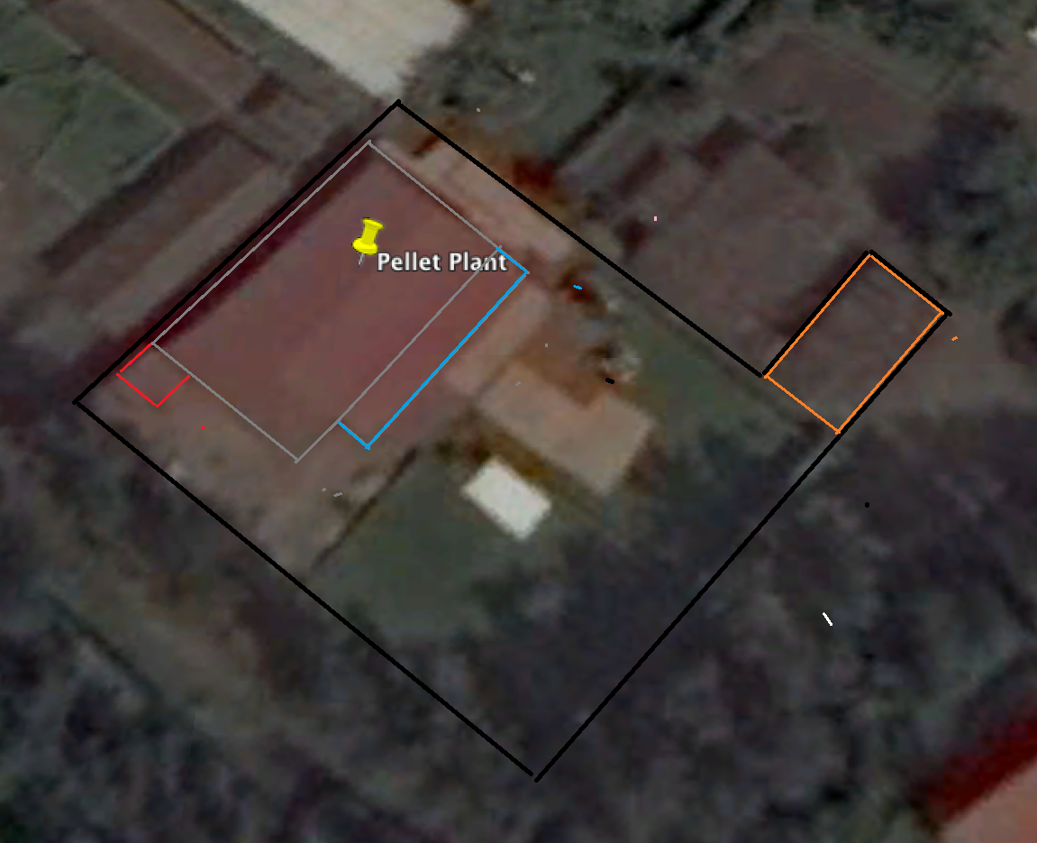

Inyenyeri has an indefinite year rental agreement with the owner of the land (black line), and has the right to extend the infrastructure of the facilities on the grounds. All facilities, except for the storage facilities of stoves, have been built by Inyenyeri over the past 5 years, including all concrete floors, the structure of the buildings, and equipment. A water tank was recently added in the context of our plan to implement a fire risk management system.

We use the grounds for the following purposes:

* Pellet production in the plant (with grey lines in picture)
* Biomass storage under a tin roof (blue lines)
* Cook stoves storage in a brick storage facility (orange lines)
* Metal works in metal shop (blue lines)

1. The plant

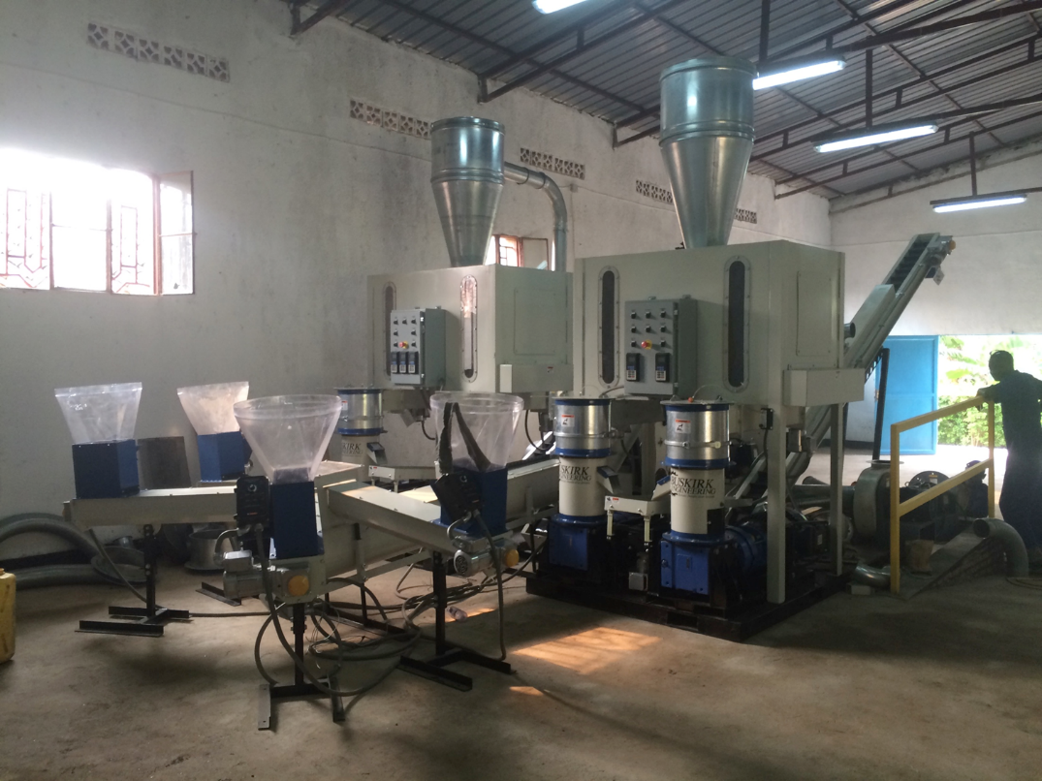

Equipment in the plant:

1. Conveyor for biomass to intermediate storage
2. Storage for biomass prior to milling in the hammermill
3. Conveyor from intermediate storage to 2 hammermills
4. Intermediate storage post-milling
5. Four pelletizers
6. Two drying lines (conveyors) to final packing area
7. A dust collection system
8. The safety procedures

See Annex 1: Occupational Health & Safety Protocol for Inyenyeri ltd.

1. **Disposal of quantities of damaged or obsolete cookstoves**

Disposal of damaged or obsolete cookstoves may also be required and will be conducted during project implementation by each company based on the requirements of Organic Law N° 04/2005 of 08/04/2005. Although the project does not anticipate disposal of massive quantities of cookstoves, the disposal is envisioned to be conducted in close coordination with the local District authorities. Only district-approved sold waste management facilities will be used to dispose of the obsolete stoves. At the same time the project will promote recycling practices to minimize waste, where applicable.

1. **Analysis of impacts of company business models on other market players including in stoves distribution and charcoal producers**

Inyenyeri, due to its mission to have an impact in the field of health, deforestation, and economics of our customers will have an impact at the level of the individual household, the community and on country-wide matters of environmental nature. Below are the highlights of the impact that scaling of our business in Rwanda is expected to have.

1. Traditional stove suppliers (tier 0-1) and improved cook stove suppliers (tier 1-3)

Our aim is to replace traditional stoves with the cleanest stoves available on the market, which is the Mimimoto stove that Inyenyeri distributes. As we have negotiated exclusivity of distribution of those particular stoves, any other distributor will be restricted to offering any other stove.

It will be up to the customers to decide which stove they wish to buy. Based on our pilot phase in Gisenyi we expect that many customers will want to sign a contract with Inyenyeri and get to use the Mimimoto stove. Customers tell us that they like the fact that the stove is easy to use, clean and time saving.

The impact will be that, while the workforce of Inyenyeri will grow, distributors of traditional stoves will find it more difficult to compete. In most cases, stove distributors have a wide product range, and facing severe competition in one of their products doesn’t mean that they will go out of business.

If they are specialized stove distributors, and if they have the right skills, work ethics and commercial network they have a chance of filling in one of the vacancies that our growing company will offer rather than competing with us.

1. Charcoal dealers

Our aim is to replace the use of charcoal by pellets made of biomass that can be burned in the cleanest gasifying stoves. Charcoal requires 10 times more wood then pellets to provide the same amount of cooking energy. On top of that, charcoal produces toxic smoke, and is more costly to use than our pellets.

It will be up to the customers to decide whether or not they wish to switch from traditional and harmful ways of cooking or whether they continue in the traditional way. As said, we expect many target customers will want to make the shift.

The impact will be that, while the workforce of Inyenyeri is expected to grow, traders of charcoal will see their market shrink. Many of these traders operate in an informal way. While Inyenyeri will be growing, it will need to fill the vacancies. The company will consider providing training to charcoal traders. If the charcoal traders have the right skills, work ethics and commercial network they have a chance of filling in one of the vacancies that company will offer.

# Stakeholder Engagement and Public Consultations

The program is expected to benefit the households that adopt improved cookstoves by offering reductions in environmental health risk factors and savings in productive time that is otherwise used for collecting fire wood for cooking. The program will also contribute to the enhancement of the cooking/fuel value chain and the creation of job opportunities in the areas of marketing, sales and after sales services for improved cookstoves and customized fuel.

Inyenyeri consults with its potential customers and stakeholders on a regular basis as part of market research for future customers and outreach to the current customers, which includes provision of reference materials on health and safety aspects of using the improved cookstoves. A summary of stakeholder engagement and public consultation is provided in appendix 3.