Competitiveness in Azerbaijan – A Call to Action

Introduction
On 6 March 2019, a high-level Forum on Economic Diversification convened more than 100 participants from the Government of Azerbaijan, representatives of the private sector and development partners. Recognizing the key role of the private sector in the growth and development of Azerbaijan over the long term, the Forum was organized by the World Bank Group (WBG) in partnership with the Office of the Deputy Prime Minister, Ministry of Economy, Ministry of Taxes, Central Bank of Azerbaijan Republic and Ministry of Labor and Social Protection of the Population. This call to action summarizes the key issues that were discussed at the Forum and puts forth recommendations that the Government of Azerbaijan may consider in its effort to enhance the role of private sector in the economic diversification of the country.

Rebalancing Azerbaijan’s economy
Learning from success stories around the world, the Forum highlighted that endowments and size are not necessarily a driver for economic development. According to the research of the Growth Commission, the most critical commonality among the world’s economic success stories is economic management, particularly (i) openness to trade; (ii) maintaining macroeconomic stability; (iii) mustering high rates of saving and investment; (iv) letting markets allocate resources; (v) having committed, credible, and capable governments. These ingredients of success apply to a wide spectrum of economic success stories, including Botswana China, Oman, Norway and South Korea.

The Forum emphasized the importance of economic diversification through enhanced private sector participation and non-oil sector development. Considering rapid technological advancements, such as the growth of renewables and increased efficiencies in transport, Azerbaijan would benefit from diversifying, e.g. into petrochemicals. Azerbaijan should embark on a new private sector-led model (including through a dynamic participation of MSMEs) with competition, innovation and productivity growth as its cornerstones while developing automatic, market-based transmission channels for growth, job creation, and equity. The Forum participants recognized that investment in education and human capital will be key to Azerbaijan’s ability to collaborate and compete internationally, therefore urging intensified investments in this area (see Call to Action of Human Capital Forum). The rapid rise of Asia’s middle class presents a large new market for Azerbaijan’s diversified goods and services as well as an opportunity for Azerbaijan to take advantage of its regional position as a bridge between Europe and Asia.

Rebalancing Azerbaijan’s economy has become more acute against the backdrop of the sharp decline in oil prices since the end of 2014 which has led to a double devaluation of the local currency, which in turn has created large pressures on the financial sector. While it imposes short-term stress on the financial sector, the devaluation can also help the economy to rebalance towards non-oil exports by a favorable shift in relative prices and a stronger role for the private sector (Figure 1). However, economic rebalancing would also entail more investment-friendly policies, improving physical infrastructure involving private sector participation and easier access to capital.

Figure 1: Rebalancing Azerbaijan’s economy
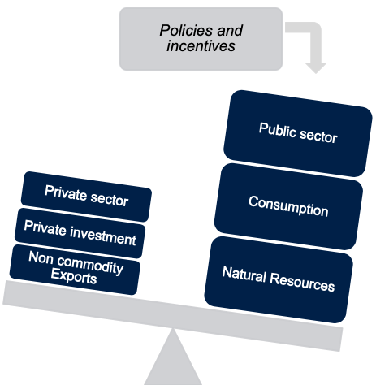 | 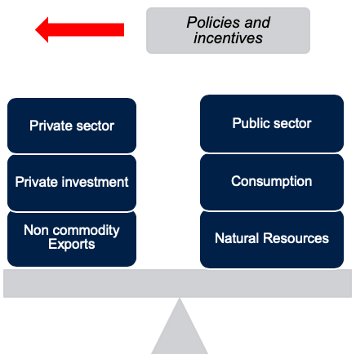

Building on Azerbaijan’s successes, including in the recent Doing Business ranking, reforms and effective public programs in the following areas are crucial for successfully rebalancing the economy and boosting competitiveness:
- Improving the allocation of resources (labor and capital) from less to more productive uses, increasing competition and improving investment and trade policies;
- Boosting the drivers of firm productivity: technology adoption, firm-level innovation, FDI attraction, and establishment of linkages between local and foreign firms;
- Establishing policies and programs for firms that attract human capital;
- Identifying sectors in which Azerbaijan has comparative (or competitive) advantages;
- Advancing governance reforms, tackling informality as well as increasing transparency and efficiency;
- Increasing the role and depth of private financial intermediation and enhancing banking sector resilience.

Within its program of support to Azerbaijan’s reform effort in the context of strengthening the country’s resilience to shocks and enhancing its competitiveness, the WBG has been cooperating with the government of Azerbaijan in many areas, including in strengthening the business environment, advancing tax reform, and stabilization and deepening the financial sector.

New opportunities
The Forum highlighted four major regional and global trends from which Azerbaijan can benefit:

- A post-oil economy. Diversifying into petrochemicals production and reducing the exposure to oil sales and fuels production is a major opportunity for Azerbaijan. Considering that the chemical sector is a $4 trillion industry (versus a $2 trillion global market for petroleum), the future of the oil industry is in chemicals. Advances in technologies are making the crude-to-chemicals directly process more efficient, further increasing the profitability of the chemicals industry.
- Asia’s growing middle class. Azerbaijan can leverage the large new market presented by the one additional billion people entering the global middle class by 2025, with 87% coming from Asia. With an improved economic environment, Azerbaijan’s diversified goods and services will soon have a large market to serve and better conditions in which to reach these markets in light of improved efficiencies in transport as well as the Belt and Road Initiative.
- A mobility revolution. Driverless transport will reshape transport corridors, improving connectivity for Azerbaijan. Electric autonomous cars and trucks will reduce transportation costs and efficiency as labor costs are minimized and advances in technologies will make renewable energy a cheaper alternative to fossil fuels. While a shift to electric and driverless mobility will reduce the demand for petroleum there will also be opportunities for Azerbaijan, especially Baku, position itself as an international logistics and trade hub, serving both the European and Asian markets.
- The digital economy. Modern technologies (including digital finance, Blockchain, and Big Data) provide new opportunities for reaching rural and underserved MSMEs in addition to enhanced exploration of the existing infrastructure (including Azerpost-wide network which can be instrumental in both facilitating access to financial services as well as promoting domestic and cross-border trade via e-commerce). Still, for consumer protection and the creation of a level playing field, the development of Fintech services needs to be regulated to further minimize micro and macro risks (e.g. cyber security).

A Call to Action
To ensure long-term economic growth and the sustainability of that growth, Azerbaijan needs to enhance the role of private sector in the economic diversification of the country. There were several recommendations that came out from the discussions at the Forum to support Azerbaijan in this endeavor. The most pertinent ones are listed here.

- Enhancing the business environment. The next level of through business environment reforms would put an emphasis on improving trade logistics, modernizing the building permitting system and improving the process for electricity connections. Such reforms will improve the efficiency of government to business services, improve the predictability of business operations, and reduce opportunities for corruption.
- Strengthening financial sector resilience. Continued robust reforms of financial sector legislation and regulation are needed to ensure compliance with international standards and practices that will help enhance public and investor confidence and create level playing field with internationally acceptable rules for domestic and international investors. Azerbaijan can strengthen the financial safety net and enhance crisis preparedness and resilience by enhancing macro-prudential supervision role and capacity of Financial Stability Council, conducting regular stress-testing of the financial sector and taking measures to address key vulnerabilities.
- Tackling informality. Azerbaijan can reform its tax system to reduce the size of the shadow economy in strengthening smart enforcement, providing incentives to consumers and businesses to report financial transactions correctly, and facilitating SMEs to formalize. Such measures will provide a level playing field for business, create conditions for greater productivity and growth, and bring higher tax revenues that can be deployed to reduce poverty and economic inequality.

Building on a strong 25-year partnership, the WBG is looking forward to remain a trusted partner for Azerbaijan to help transform its economy and create a better future for its people.

