ROAD DEPARTMENT OF GEORGIAN MINISTRY OFREGIONAL DEVELOPMENT AND INFRASTRUCTURE

Environmental and Social Management Plan
REHABILITATION OF SECONDARY
(S–25) Gupta–Oni Road section KM54–KM63

Tbilisi, Georgia
2019

PART I: General Project and Site Information

INSTITUTIONAL &ADMINISTRATIVE
Country | Georgia
Project title | Rehabilitation of secondary road (S–25) Gupta-Oni, Section KM54–KM63 L=10 Km
Scope of project and activity | Asphalt/concrete pavement of existing road is quite damaged, narrowed and entirely cracked., There are holes, edges are smashed, longitudinal profile is destructed (at places of slope falling), cross section retains its initial (designed) condition.  Carriageway width is variable and equals to 5-6.5 m.  There are 3 bridges at the proposed road section: (Length L=9 m, L=6 m and L =30 m). Bridge adjustments and spans are in a good condition. The sidewalks, decks and rail will be repaired during the rehabilitation works. The concrete wings of the L=30 bridge will be repaired during the rehabilitation works.  There are 3 box culverts at the proposed road section, two of them will be repaired during the rehabilitation works.  The arch stone culvert in a good condition, only wall wings will be repaired during the rehabilitation works.  There is stone culvert, covered with concrete cover, section 1,5m, which will be replaced during the rehabilitation works. Majority of culverts should be replaced by new ones. Additionally, at some places new culverts have to be installed.  Road practically lacks furniture and no elementary safety is provided, what causes re-installation of this section of road again.  3 new auto pavilions were constructed on design road section (New one on pk 0+00 and on pk 48+53; 60+92 existing ones were dismantled and new was constructed)  There are number of residential buildings and private/privately used land plots along the proposed road section. The pavement will be installed to insure entrances to existing gates. The culverts (Diam.=0.5 m) will be arranged at the proposed road section in order to pass through drainage water. The similar works will be done with road junctions and, if necessary, culverts will be arranged (Diam.=0.5 m)  Design Decision Table  No. Classification Design Result  1 Rehabilitation Length (km) 10 Km  2 Design Speed (km/hr) 60.0 Km/h  3 Carriageway Width (m) 6 m  4 Shoulder Width (m) 1.m  5 Cross-section (%) 2 %  6 Pavement Thickness (cm) Asphalt surface -4 Asphalt base course- 6  7 Bridges (Units) 3 units  8 Culverts (Unit) 15 units  9 Bus Stop (Unit) 3 unit  10 Junctions (Unit) 12 units  11 Yard Entrance (Unit) 12 units  12 Construction period (Month) 10 months
Supervision arrangements (Name and position) | WB  (Project Team Leader)  Aymen A. Osman Ali |  | Project Management  Giorgi Tsereteli | Local Counterpart and/or Recipient  Oni Municipality
Implementation arrangements (Name and position) | WB  Safeguard Supervision  Darejan Kapanadze  Environment  Sophia Georgieva  Social |  | Local Counterpart Supervision  LtD “Roads Rehabilitation and Modernization Supervision Direction” | Local Inspectorate Supervision  - | Contractor  LtD “New Road”

SITE DESCRIPTION
Name of site |  | (S–25) Gupta-Oni Secondary Road Section KM54–KM63
Describe site location |  | Basically, roadbed of Gupta-Oni secondary road section km 54-km 63 is sustainable and no landslide or other significant geodynamic processes are seen. Collapse of slope is obvious at some places. On these places, destruction of longitudinal profile is visible. Under visual survey, no any other geodynamic processes were found. The entire stretch of the track is located in the valley of river Jojora.
Who owns the land? |  | - The existing ROW is owned by Oni municipality;  - State Forest Fund under the LEPL National Forest Agency of the Ministry of Environment Protection and Agriculture of Georgia (17,055 m²). The territory had been de-listed from the State Forest Fund;  - The investment will not conduct any widening or realignment that may cause impact on private lands or assets.
Description of geographic, physical, biological, geological, hydrographic and socio-economic context |  | Location: The road is located in Ratcha-Lechkhumi Kvemo Svaneti region, in Oni Municipality, Georgia. Following road section has strategic importance as it is connected to one of the Georgia conflict regions. Road section is connected to one of the two municipal centers of Ratcha and it is only alternative for population to have access to social services including emergency and education,  Air - Air quality in the subproject area is good due to low traffic levels and the absence of industrial facilities.  Water and Soil - No pollution is reported.  Flora - On the above-mentioned territory following tree species are registered.  Species Number of Trees  English name Latin  willow Salix magnifica 20  Black pine Pinus nigra 33  Hornbeam Carpinus caucasica 65  Oak Quercus iberica 107  Hawthorn Crataegus microphylla 3  Elm Ulmus foliacea 3  Maple Acer campestre 4  Cherry Plum Prunus insititia 8  Hornbeam Carpinus orientalis 53  cedar Cedrus deodara 2  wild cherry Cerasus avium 10  wild apple Malus sylvestris 5  Alder Alnus barbata 17  Wild Pear Pyrus communis 8  Acacia Acacia dealbata 81  Lime Tilia caucasica 12  Ash Tree Fraxinus excelsior 2  Walnut Juglans regia 10  These species had been located on the territory managed by the LEPL National Forest Agency of the Ministry of Environment Protection and Agriculture of Georgia. The Red Listed species do not occur.  Fauna - The road section passes through the degraded territory and accordingly the fauna is not reach. Mostly fauna is presented by the species which does not need any special protecting measures. Due to the small area of the project the impact on the fauna will be minimal.  Noise - The current noise level is low due to low traffic levels and a lack of industrial facilities.  Construction activities will have modest impact on those people who reside in existing villages (immediately along the road) and this impact will be limited to the rehabilitation phase.  Social – Total number of subproject beneficiaries in a 2km buffer zone of the section is 5 villages with a total of 2992 population. Population density for the project is 365.
Locations and distance for material sourcing, especially inert aggregates, water, stones |  | Contractor may choose to operate quarry located in Oni municipality, village Shardometi  12 km away.

LEGISLATION
Identify national & local legislation &permits that apply to project activity |  | The project triggers World Bank OP/BP 4.01 - Environmental Assessment and, according to its principles, has been classified as environmental Category B. The present ESMP has been prepared to meet requirements of OP/BP 4.01.  Georgian legislation does not require any type of environmental review, approval, or permitting for the project. Though according to the national regulatory system,  - Contractor company must be licensed,  - Construction materials must be obtained from licensed providers,  - Once contractor wishes to open quarries, then the contractor must obtain respective license.  - If, in time of rehabilitation, contractor wishes to operate own asphalt or concrete (Or both) plants, he should have permission regarding specified limited level of pollutant substances in exhaust.  - Disposal of the construction waste and excess ground generated in the course of earth works shall be placed in selected locations agreed and approved by local governing bodies in written.  - Land plots along the road required for undertaking of planned works were subject to de-listing from the Territory of the State Forest Fund and transfer to the Road Department. The process is finished.
GRIEVANCE REDRESS MECHANISM
A grievance redress mechanism will be available to allow an AP appealing any decision on which they disagree; The APs should be informed about the available GRM. This could be achieved through distributing brochures and relevant information provided and announced.
APs will be fully informed of their rights and of the procedures for addressing complaints whether verbally or in writing during pre-contraction, construction and operation periods. Care will always be taken to prevent grievances rather than going through a redress process.
Oni Municipality have assigned a responsible person:
Meliton Metreveli T: 591010456 and Irakli BIchashvili T551724646;
onisgamgeoba@gmail.com
The Contact Person collects and records the grievances in special log.
If the grievance will not be unsolved at the local level, it will be lodged to the RDMRDI. For any information and advice, RD nominated following persons:
Road Department of RDMRDI: 12 Kazbegi str., Tbilisi, Georgia
2. Mariam Begiashvili - Social safeguards Consultant
Mobile Phone 577 74 40 88; 555 400 205; e-mail: mbegiashvili2@gmail.com
3. Maya Vashakidze – Environmental safeguards consultant;
Mobile Phone: 593 32 30 77 e-mail: maya_vashakidze@yahoo.co.uk
Grievance Redress Commission (GRCN) is formed by the order of the Head of RDMRDI as a permanently functional informal structure, engaging personnel of RDMRDI from all departments. This includes top management, Safeguards, Legal Departments, PR department and other relevant departments (depending on specific structure of the IA).
If the RDMRDI decision fails to satisfy the aggrieved APs, they can pursue further action by submitting their case to the appropriate court of law (Rayon Court) without any reprisal.

PUBLIC CONSULTATION
Identify when / where the public consultation process shall take place |  | Environmental Management Framework for the Secondary and Local Roads Project III was disclosed through the RDMRDI web page and a stakeholder consultation meeting was held on 11/04/2014.  http://www.georoad.ge/uploads/files/SLRP_III_ESMF_April%203_WBcomments47.pdf  Present draft ESMP was posted on the RDMRDI website and its printed versions was provided to Oni Municipality. Public consultation on the draft ESMP was held in Gupta municipality July 26, 2018.
ATTACHMENTS
Attachment 1: Site map;
Attachment 2: Minutes of public consultation on the draft ESMP;
Attachment 3: Waste disposal agreement;
Attachment 4: Borrowing license

PART II: safeguards SCREENING AND Triggers
ENVIRONMENTAL /SOCIAL SCREENING FOR SAFEGUARDS TRIGGERS
Will the site activity include/involve any of the following? | Activity/Issue | Status | Triggered Actions
 | - Roads rehabilitation | [x] Yes [ ] No | If “Yes”, see Section A
 | - New construction of small traffic infrastructure | [x] Yes [ ] No | If “Yes”, see Section A
 | - Impacts on surface drainage system | [x] Yes [ ] No | If “Yes”, see Section B
 | - Historic building(s) and districts | [ ] Yes [x] No | If “Yes”, see Section C
 | - Acquisition of land¹ | [] Yes [x] No | If “Yes”, see Section D
 | - Hazardous or toxic materials² | [ ] Yes [x] No | If “Yes”, see Section E
 | - Impacts on forests and/or protected areas | [x] Yes [] No | If “Yes”, see Section F
 | - Risk of unexploded ordinance (UXO) | [ ] Yes [x] No | If “Yes”, see Section G
 | - Traffic and Pedestrian Safety | [x] Yes [ ] No | If ‘Yes”, see Section H
 | - Impacts on land property and use | [] Yes [x] No | If ‘Yes”, see Section I
 | - Social risk | [x] Yes [ ] No | If ‘Yes”, see Section J

------------------------------------------------
¹ Land acquisition includes displacement of residents, change the way of life, this is concerning with land which was purchased/handed over and impact on persons living and/or unlawfully exist and or/performing business activities (Booths) on the land already purchased.
² Hazardous or toxic materials contain, but is not limited to: asbestos, toxic paints, hazardous dissolvent materials, removal of lead containing materials and etc.

PART III: Mitigation measures
ACTIVITY | PARAMETER | MITIGATION MEASURES CHECKLIST
- General Conditions | Notification and Worker Safety | - The local construction and environment inspectorates and communities have been notified of upcoming activities  - The public has been notified of the works through appropriate notification in the media and/or at publicly accessible sites (including the site of the works)  - All legally required permits have been acquired for construction and/or rehabilitation  - The Contractor formally agrees that all work will be carried out in a safe and disciplined manner designed to minimize impacts on neighboring residents and environment.  - Workers’ PPE will comply with international good practice (always hardhats, as needed masks and safety glasses, harnesses and safety boots)  - Appropriate signposting of the sites will inform workers of key rules and regulations to follow.
- General Rehabilitation and /or Construction Activities | Air Quality | - During excavation works dust control measures shall be employed, e.g. by spraying and moistening the ground  - Demolition debris, excavated soil and aggregates shall be kept in controlled area and sprayed with water mist to reduce debris dust  - During pneumatic drilling or breaking of pavement and foundations dust shall be suppressed by ongoing water spraying and/or installing dust screen enclosures at site  - The surrounding environment (sidewalks, roads) shall be kept free of soil and debris to minimize dust  - There will be no open burning of construction / waste material at the site  - All machinery will fit emission originating regulations, well maintained and serviced and there will be no excessive idling of construction vehicles at sites
 | Noise | - Construction noise will be limited to restricted times agreed to in the permit  - During operations the engine covers of generators, air compressors and other powered mechanical equipment shall be closed, and equipment placed as far away from residential areas as possible
 | Water Quality | - The site will establish appropriate erosion and sediment control measures such as e.g. hay bales and / or silt fences to prevent sediment from moving off site and causing excessive turbidity in canalization and nearby streams and rivers
 | Waste management | - Waste collection and disposal pathways and sites will be identified for all major waste types expected from excavation, demolition and construction activities.  - Mineral construction and demolition wastes will be separated from general refuse, organic, liquid and chemical wastes by on-site sorting and stored in appropriate containers.  - Construction waste will be collected and disposed by licensed company  - In order to control waste disposal accuracy and compliance, waste disposal reports shall be done  - Whenever feasible Contractor will reuse and recycle appropriate and viable materials (except when containing asbestos)
- Impacts on surface drainage system | Water Quality | - There will be no unregulated extraction of groundwater, nor uncontrolled discharge of process waters, cement slurries, or any other contaminated waters into the ground or adjacent streams or rivers; contractor should obtain all necessary licenses and permits for water extraction and for further pouring out of used water in state current water system  - There will be proper storm water drainage systems installed and care taken not to silt, pollute, block or otherwise negatively impact natural streams, rivers, ponds and lakes by construction activities.  - There will be procedures for prevention of and response to accidental spills of fuels, lubricants and other toxic or noxious substances.  - Construction vehicles and machinery will be washed only in designated areas where runoff will not pollute natural surface water bodies.
- Historic building (s) | Cultural Heritage | a) If construction works takes place to designated historic structures or are located in a designated historic district, notification shall be made and approval/permits be obtained from local authorities and all construction activities planned and carried out in line with local and national regulation  b) It shall be ensured, that provisions are put in place so that artifacts or other possible " chance finds" encountered in excavation or construction are noted and registered, responsible officials contacted, and work activities delayed or account for such finds
- Acquisition of land | Land Acquisition Plan/Framework | - If expropriation of land was not expected but is required, or if loss of access to income of legal or illegal users of land was not expected but may occur, that the Bank’s Task Team Leader shall be immediately consulted.  - The approved Land Acquisition Plan/Framework (if required by the project) will be implemented
E. Toxic materials | Asbestos management | a) If asbestos is located on the project site, it shall be marked clearly as hazardous material  b) When possible of asbestos will be appropriately contained and sealed to minimize exposure  c) Asbestos prior to removal (If necessary) will be treated with a wetting agent to minimize asbestos dust  d) Asbestos will be handed and disposed by skilled & experienced professionals  e) If asbestos material is stored temporarily, the waste should be securely enclosed inside closed container and marked appropriately. Security measures will be taken against unauthorized removal from the site.  f) Removal of asbestos will not be reused
 | Toxic / hazardous waste management | a) Temporarily storage on site of all hazardous or toxic substances will be in safe containers labeled with details of composition, properties and handling information  b) Containers of hazardous substances shall be placed in n leak-proof container to prevent spillage  c) Waste shall be transported by specially licensed carriers and disposed in licensed facility  d) Paints with toxic ingredients or solvents or lead-based paints will not be used
F. Affected forests, wetlands and/or protected areas | Ecosystem protection | a) Works within the territory of the State Forest Fund are disallowed prior to completion of de-listing and user right transfer to this territory from the National Forest Agency to the RD  b) Tree cutting must be held down to minimum by adjusting alignment of access roads, using small machinery or manual labor in individual locations, etc.  c) All trees that have to be extracted must be marked and their removal must be entered into tree-cutting ledger on daily basis
- Risk of unexploded ordinance (UXO) | Hazard to human health and safety | a) Before to start any excavation activities, Contractor shall verify that the construction area has been checked and cleared regarding UXO by appropriate authorities
H. Traffic and pedestrian safety | Direct or indirect hazards to public traffic and pedestrians by construction activities | - In compliance with national regulations, ensure that the construction site is properly secured, and construction related traffic regulated. This includes but is not limited to:  - Use signposting, warning signs, barriers and traffic diversions so that the work site is clearly visible, and the public warned of all potential hazards  - Apply traffic management system and train staff, especially for site access and near-site heavy traffic; provide safe passages and crossings for pedestrians where construction traffic interferes.  - Adjust working hours to local traffic patterns, e.g. avoid major transport activities during rush hours or times of livestock movement  - If required, undertake active traffic management by trained and visible staff at the site for safe passage for the public  - If school children are in the vicinity, include traffic safety personnel to direct traffic during school hours  - Ensure safe and continuous access to all adjacent office facilities, shops and residences during construction
I. Impacts on Land Property and Use | Limited/lost access to the land | - Ensure provision of undisturbed and safe access to homes, lands and other assets of the local population;  - Plan road works to maintain undisturbed access to land and assets of the local population by planning and implementing works and activities in coordination with residents and representatives of the local community.
 | Temporary impact on privately-owned assets | - Avoid trespassing or incidentally damaging of private property (using small-size machinery or manual labor near walls and fences, stockpiling of construction material and waste away from private property; etc.);  - In case of unintended damage to private property, quickly restore it to the original or better status;  - In case of expected temporary impact on privately-owned property, inform owners upfront and guarantee restoration, acquire written consent of owners for intervention, and promptly restore the damage to the original or better status;  - If an unexpected need for land take emerges in the couse of works, do not enter the affected site prior to development and full implementation of the Resettlemet Action Plan by RD
 | Loss of income or assets caused by unauthorized intervention, occupation of territory outside of ROW | - Avoid unauthorized intervention of territory outside of ROW;  - If such impact occurs by negligence of the construction company workers, record the case/claim; assess the loss and negotiate with an affected owner based on the adopted principles and valuation methodology described in the RAP and provide fair cash compensation at the Company’s own cost;  - Apply GRM procedures if the case is unresolved through negotiation.
J. Social Risk Management | Public relationship management | - Assign local liaison person within Contractor’s team to be in charge of communication with and receiving requests/ complaints from local population  - Consult local communities to identify and proactively manage potential conflicts between an external workforce and local people  - Raise local community awareness about sexually transmitted disease risks associated with the presence of an external workforce and include local communities in awareness activities.  - Inform the population about construction and work schedules, interruption of services, traffic detour routes and provisional bus routes, blasting and demolition, as appropriate.  - Limit construction activities at night. When necessary ensure that night work is carefully scheduled, and the community is properly informed so they can take necessary measures.  - At least five days in advance of any service interruption (including water, electricity, telephone, bus routes), advice community through postings at the work site, at bus stops, and in affected homes/businesses.  - Address concerns raised through Grievance Redress Mechanism established by the Employer within the designated timeline within the scope of Contractor’s liability  - To the extent possible, work camps should not be located in close proximity to local communities  - Siting and operation of worker camps should be undertaken in consultation with neighboring communities
 | Labor management | - The Contractor will recruit unskilled or semi-skilled workers from local communities to the extent possible. Where and when feasible, worker skills training, should be provided to enhance participation of local people.  - The Contractor will provide adequate lavatory facilities (toilets and washing areas) in the work site with adequate supplies of hot and cold running water, soap, and hand drying devices. A temporary septic tank system should be established for any residential labor camp and without causing pollution of nearby watercourses  - The Contractor will raise awareness of workers on overall relationship management with local population, establish the code of conduct in line with international practice and strictly enforce them, including the dismissal of workers and financial penalties of adequate scale

PART IV: Monitoring Plan
Construction Phase
Activity | What  (Is the parameter to be monitored?) | Where  (Is the parameter to be monitored?) | How  (Is the parameter to be monitored?) | When  (Define the frequency / or continuous?) | Why  (Is the parameter being monitored?) | Who  (Is responsible for monitoring?)
Supply of construction materials | Purchase of the construction materials from licensed providers | Offices and warehouses of material suppliers, and borrowing sites | Checking documents;  Inspection of material quality | In the process of signing the agreements for material provision | Ensure technical quality of construction;  Protect human health and environment | Roads Department (RD)
Works in the forested territory | No physical activity takes place in the territory of the State Forest Fund until de-listing and user right transfer procedures are complete.  Movement of construction vehicles and machinery, storage, or other activities do not damage and cause cutting of trees unless tree extraction is required for arranging road surface and shoulders.  Threes that must be extracted are labeled prior to removal and each extracted tree is entered into the tree cutting ledger (species and diameter identified) | Work site within forested territory  Construction contractor’s office | Checking documents  Visual observation | Prior and in the course of works within the forested territory | Ensure compliance with the national legislation;  Minimize impact on forested area;  Facilitate procedure of hand over of logs generated through tree cutting | RD  LEPL National Forest Agency of the Ministry of Environment Protection and Agriculture
Transportation of construction materials and waste  Movement of construction equipment | Technical condition of construction vehicles and machinery;  Adequacy of the loading trucks for transported types of cargo, and canopy coverage of cargo transported in open trucks;  Movement of construction vehicles and machinery along pre-defined routes. | Routes for transportation of construction materials and construction wastes | Inspection of roads adjacent to the construction site and included in the agreed-upon routes of transportation | Unannounced checks during the working hours | Avoid air and road pollution eith dust and solid matter;  Reduce traffic disruption | RD;  Traffic Police
Operation of Construction machinery on site | Proper technical condition of construction machinery:  - no excessive exhaust,  - no fuel leakage,  - respect of working hours  - no damage to trees and other vegetation what does not need to be creared for the purposes for road construction | Construction site | Inspection | Within and off working hours | Reduce air and soil pollution caused by equipment operation;  Reduce noise and dust nuisance to local population | RD
Contamination  of surface waterduring rehabilitation of the bridge | Suspended solids,organic  compounds, lubricants, fuel, solvents, heavy metals, pH value,mineral oils | Rehabilitation of the bridge | Inspection | During rehabilitation works near in the water .  Unannounced inspections during works nearwatercourses | Reduce water pollution caused by equipment operation; | RD
Servicing of construction machinery | Washing vehicles and machinery off-site of in the location sufficiently distant from water bodies;  Servicing vehicles and machinery with oils and lubricants off-site or in an especially arranged location on-site;  Technical adequacy of the servicing location:  - solid, insulating floor or adsorbent layer (sand, gravel, membrane),  - containment barriers allowing enough sapce for holding fuel over the maximum amount expected on the location at a time,  - emergency fire-fighting kit,  - sedimentation pool at car wash area. | Construction site and construction base (if applicable) | Inspection | Entire period of machinery operation | Avoid land and water pollution with oil products due to servicing of vehicles and machinery;  Be ready for fire emergency action to promptly localize fire source and minimize material damage | RD
Extraction of natural construction material | Purchase of natural construction material from the existing providers if possible;  Obtaining license for extraction of material by the Contractor and strict adherence to the terms of such license;  Terrace processing of the borrow pits, backfilling of excess material, and harmonization with landscape;  River bed gravel extraction away from water flow, arrangement of gravel barriers for isolating extraction area from water flow, prevention of water flow entry by vehicles and machinery;  Demarcation of borrow areas with warning signs | Borrow areas | Checking documents  Inspection of activities | The period of material extraction | Reduce slope erosion and damage to the ecosystem and landscape;  Reduce river bank erosion, water pollution with suspended particles, and impact on the aquatic life;  Protection of animals and people from accidents | RD  LEPL National Agency of Mines of the Ministry of Economy and Sustainable Development of Georgia
Generation of construction waste | Temporary storage of inert and hazardous wastes separately at the designated locations;  Timely disposal of waste to the formally designated landfills;  Hand-over of hazardous wastes to licensed deactivating and processing companies. | Construction site and base (if applicable);  Locations designated for waste disposal | Checking documents;  Visual observation | Entire period of construction | Avoid pollution of the environment | RD;  Oni Municipality
Accumulation of household waste | Provision of waste containers on-site;  Agreement with local municipality for regular out-transporting of waste | Construction site and base (if applicable) | Visual inspection | Entire period of construction | Avoid pollution of soil and water with household waste | RD;  Oni Municipality
Generation of liquid waste | Arrangement and operation of toilets compliant with sanitary norms on-site;  Arrangement of drainage system for storm water collection and its periodic cleaning from silt;  Arrangement of sedimentation pool for waste water collection on-site | Construction site and base (if applicable) | Visual inspection | Entire period of construction  Increased frequency of inspection in periods of high precipitation | Avoid flooding of construction site and base;  Reduce pollution of surface and ground water | RD
Operation of asphalt-concrete plant | Obtaining permit for impacting environment by Contractor and strict adherence to its terms;  Placement of plant in the location permissive for minimal disturbance of local population;  Arranging sedimentation pool for capturing of liquid discharges from plant | Construction site and base (if applicable) | Checking documents  Inspection | Before establishment of plant and during entire period of its operation | Reduce inconvenience for local population due to plant operation;  Reduce air and surface water pollution from emissions and discharges from plant | RD;  LEPL National Environment Agency of the Ministry of Environment Protection and Agriculture
Safety of labor | Obtaining permit for impacting environment by Contractor and strict adherence to its terms;  Provision of uniforms and personal protective gear to workers and enforcement of their use;  Consistency with the rules of exploitation of the construction equipment and machinery | Construction site | Inspection of the activities | Entire period of construction | Reduce the probability of accidents | RD
Works near privately-owned land, buildings and other assets | Avoid trespassing or incidentally damaging of private property (using small-size machinery or manual labor near walls and fences, stockpiling of construction material and waste away from private property; etc.);  In case of unintended damage to private property, quickly restore it to the original or better status;  In case of expected temporary impact on privately-owned property, inform owners upfront and guarantee restoration, acquire written consent of owners for intervention, and promptly restore the damage to the original or better status;  If an unexpected need for land take emerges in the course of works, do not enter the affected site prior to development and full implementation of the Resettlement Action Plan by RD. | Within the RoW | Permanent monitoring of impacts on the privately-owned land or other assets | Entire period of construction | To avoid any impact on private lands or assets | RD
Community liaison | Community liaison person assigned with clear set of responsibilities;  Affected communities informed on the ongoing works, their scope and timing;  Affected communities are given timely notice on any interruption in the provision of utility services due to construction;  Contact information of Contractor posted in well-observed points along the construction site and work base;  Grievance Redress Mechanism is set up, operates, and is supported by relevant record-keeping arrangements. | Contractor’s work base | Permanent monitoring and express checks in case of complaints from project-affected communities | Entire period of construction | Minimize nuisance of project-affected communities | RD

Operation Phase
Activity | What  (Is the parameter to be monitored?) | Where  (Is the parameter to be monitored?) | How  (Is the parameter to be monitored?) | When  (Define the frequency / or continuous?) | Why  (Is the parameter being monitored?) | Who  (Is responsible for monitoring?)
Cleaning road surface and shoulders from waste | Trash deposited from moving vehicles timely colleacted and removed;  Bodies of animals overrun by vehicles timely collected and removed | Carriageway and shoulders of the road section | Inspection | Quarterly | Prevent road littering;  Road safety | Oni Municipality
Keeping road drainage system operational | Periodic cleaning of drainageditches from silt and trash | Drainage system long the road section | Inspection | Quarterly | Maintaining drainage system capacity for preventing road flooding and water damage | Oni Municipality
Confinement of accidental spills and clean-up | Timely confinement, deactivation, and removal of liquid or powder spills of cargo in case of road accidents | On the road and its immediate surroundings | Inspection | Upon occurenace of accidents, as required | Prevent pollution of soil and water | Traffic Police;  Oni Municipality
Disposal of waste from regular road maintenance works | Collection and timely disposal of waste from maintenance works to the designated landfill | On the road and its immediate surroundings | Inspection | Towards completion of scheduled maintenance works | Prevent enviornment pollution | Oni Municipality

Attachment 1: Project Location Map
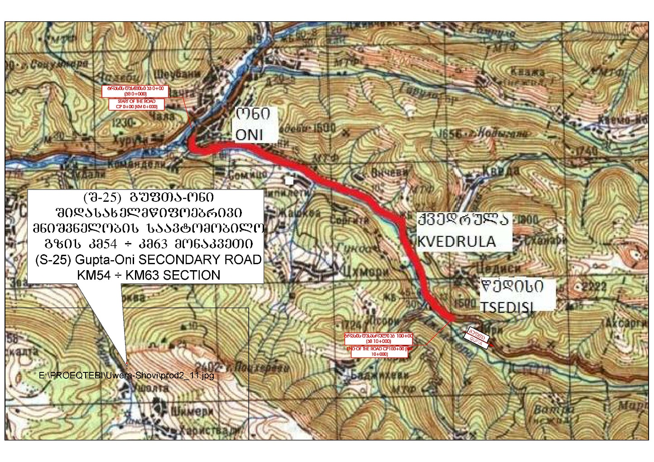
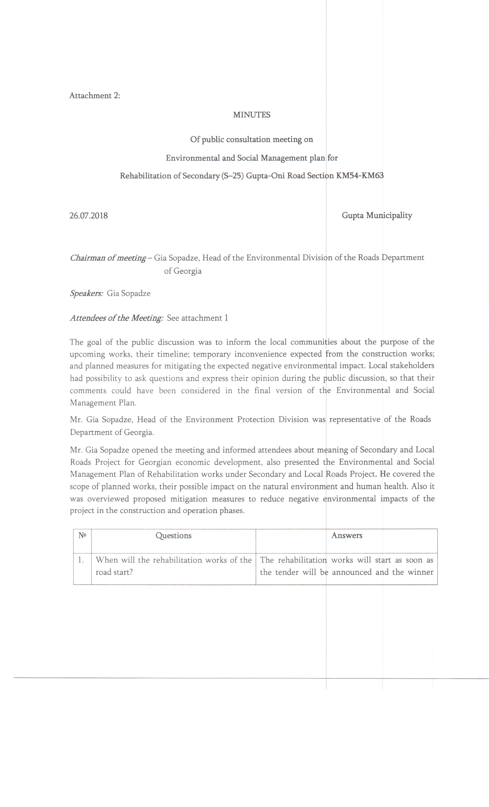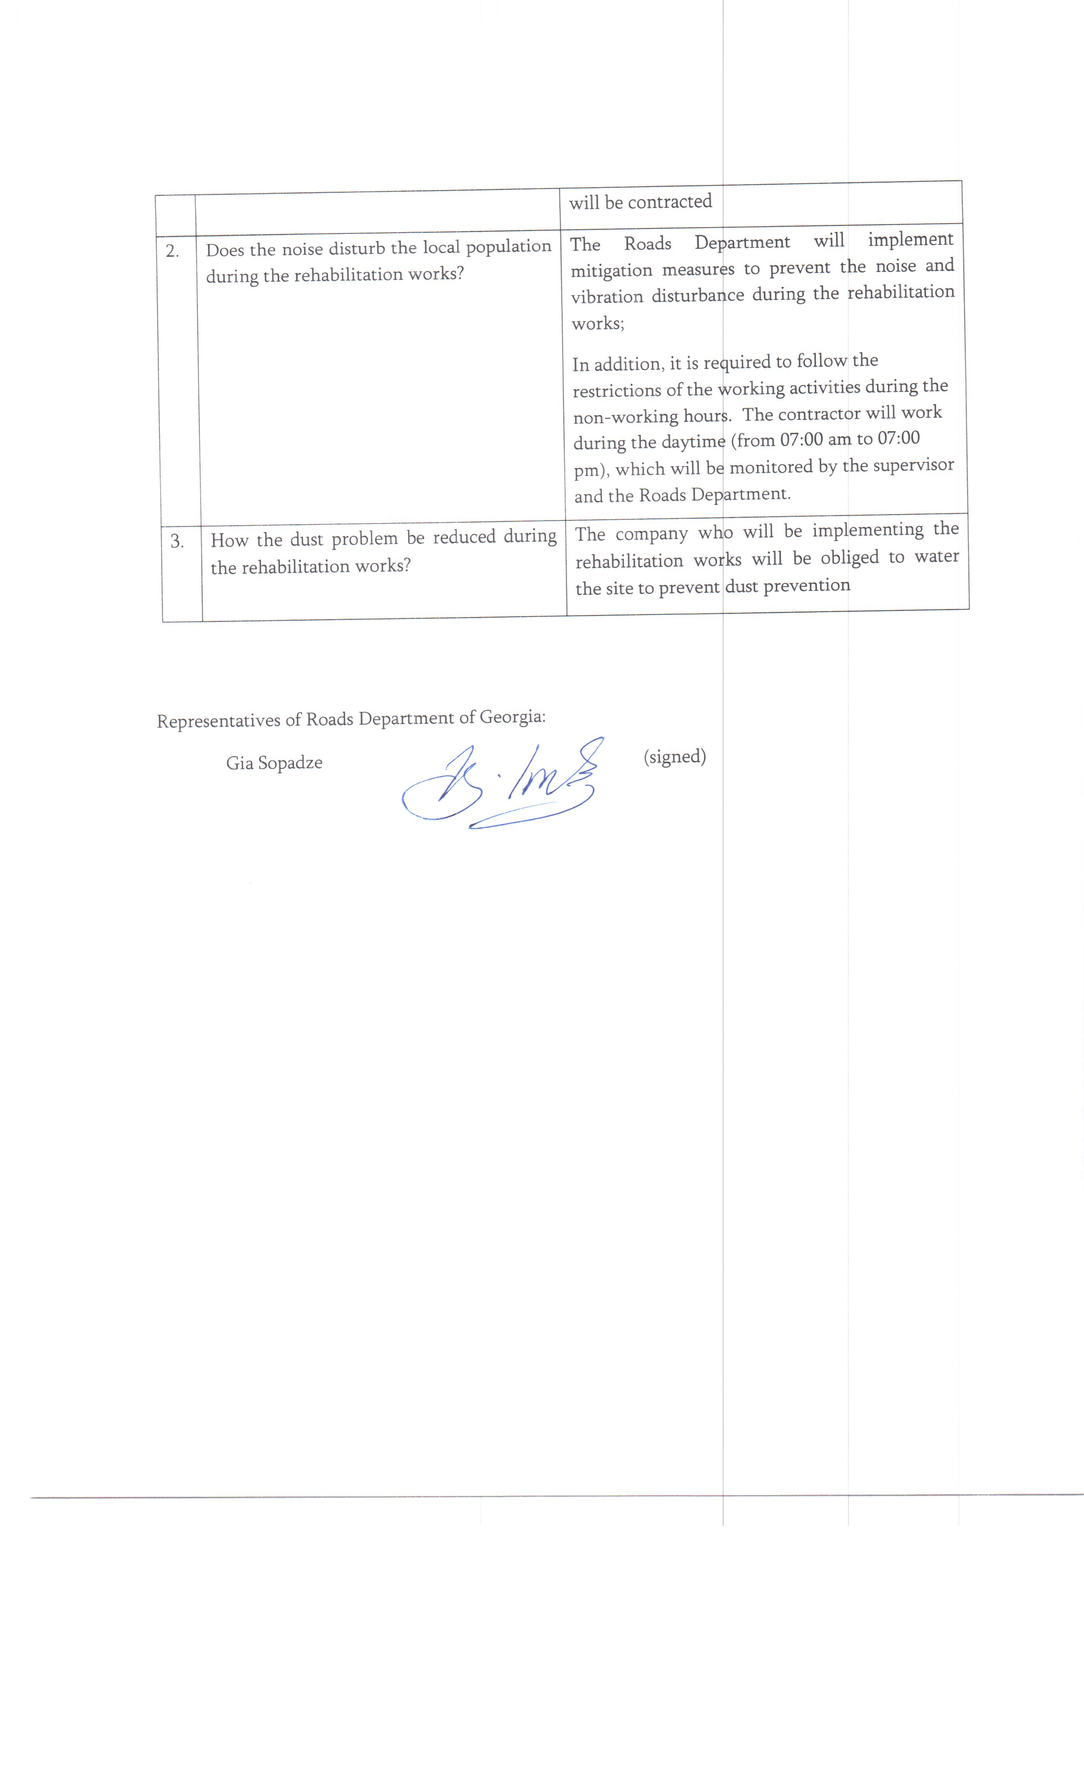
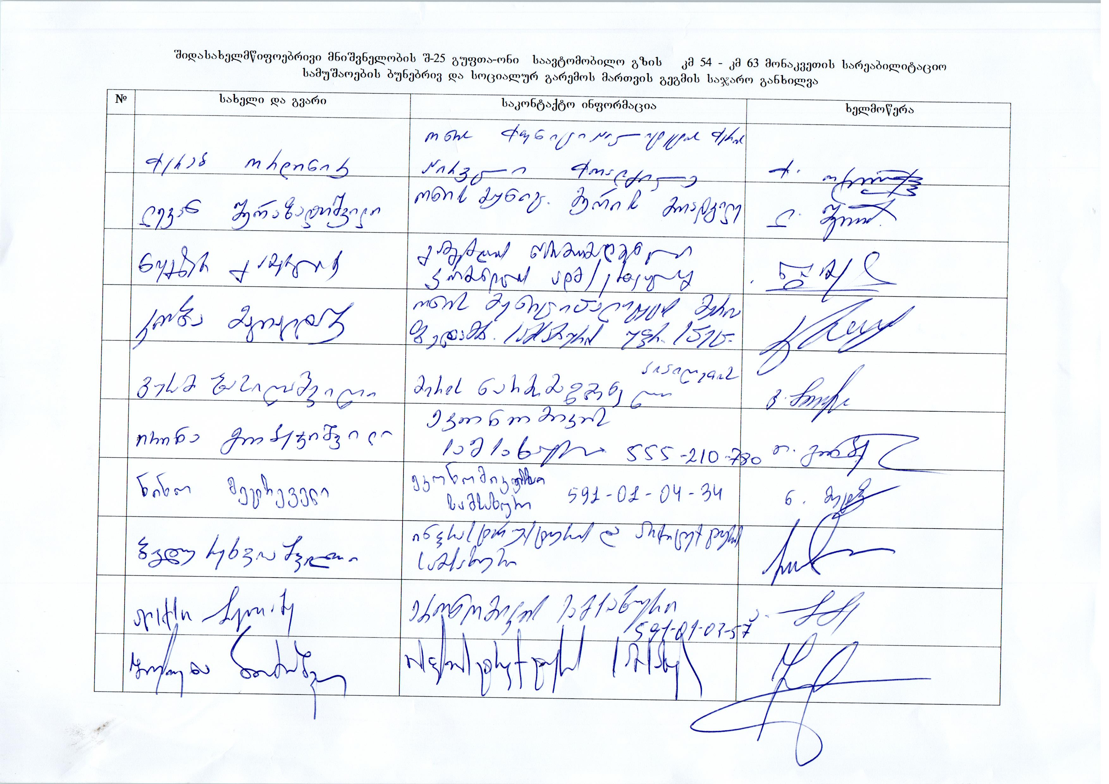
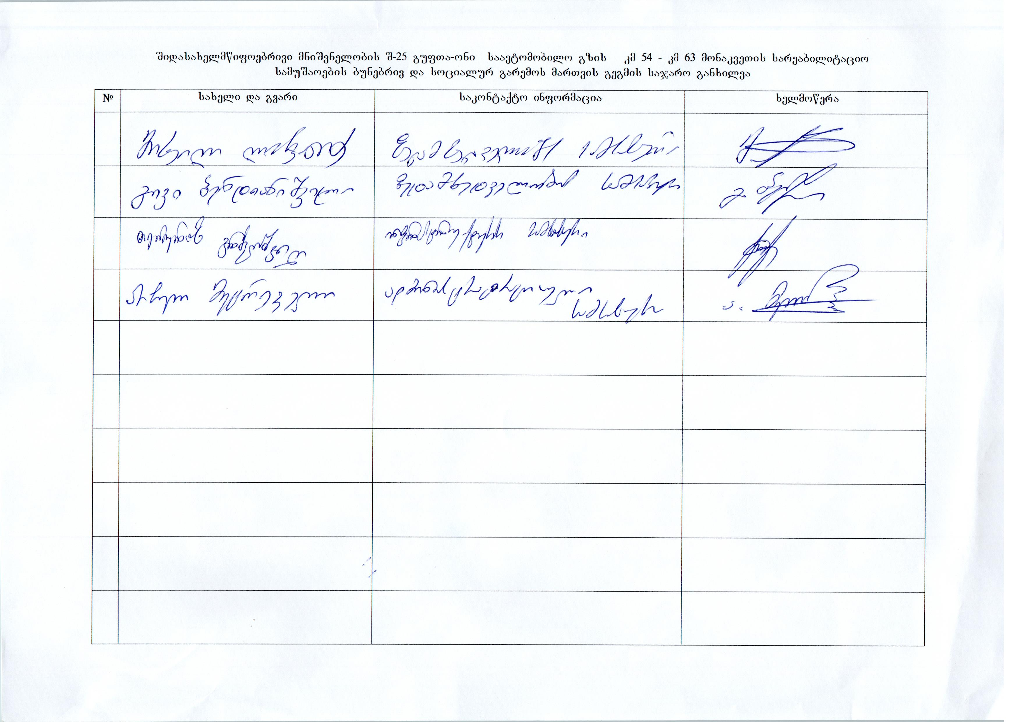
Attachment 3: Waste disposal agreement

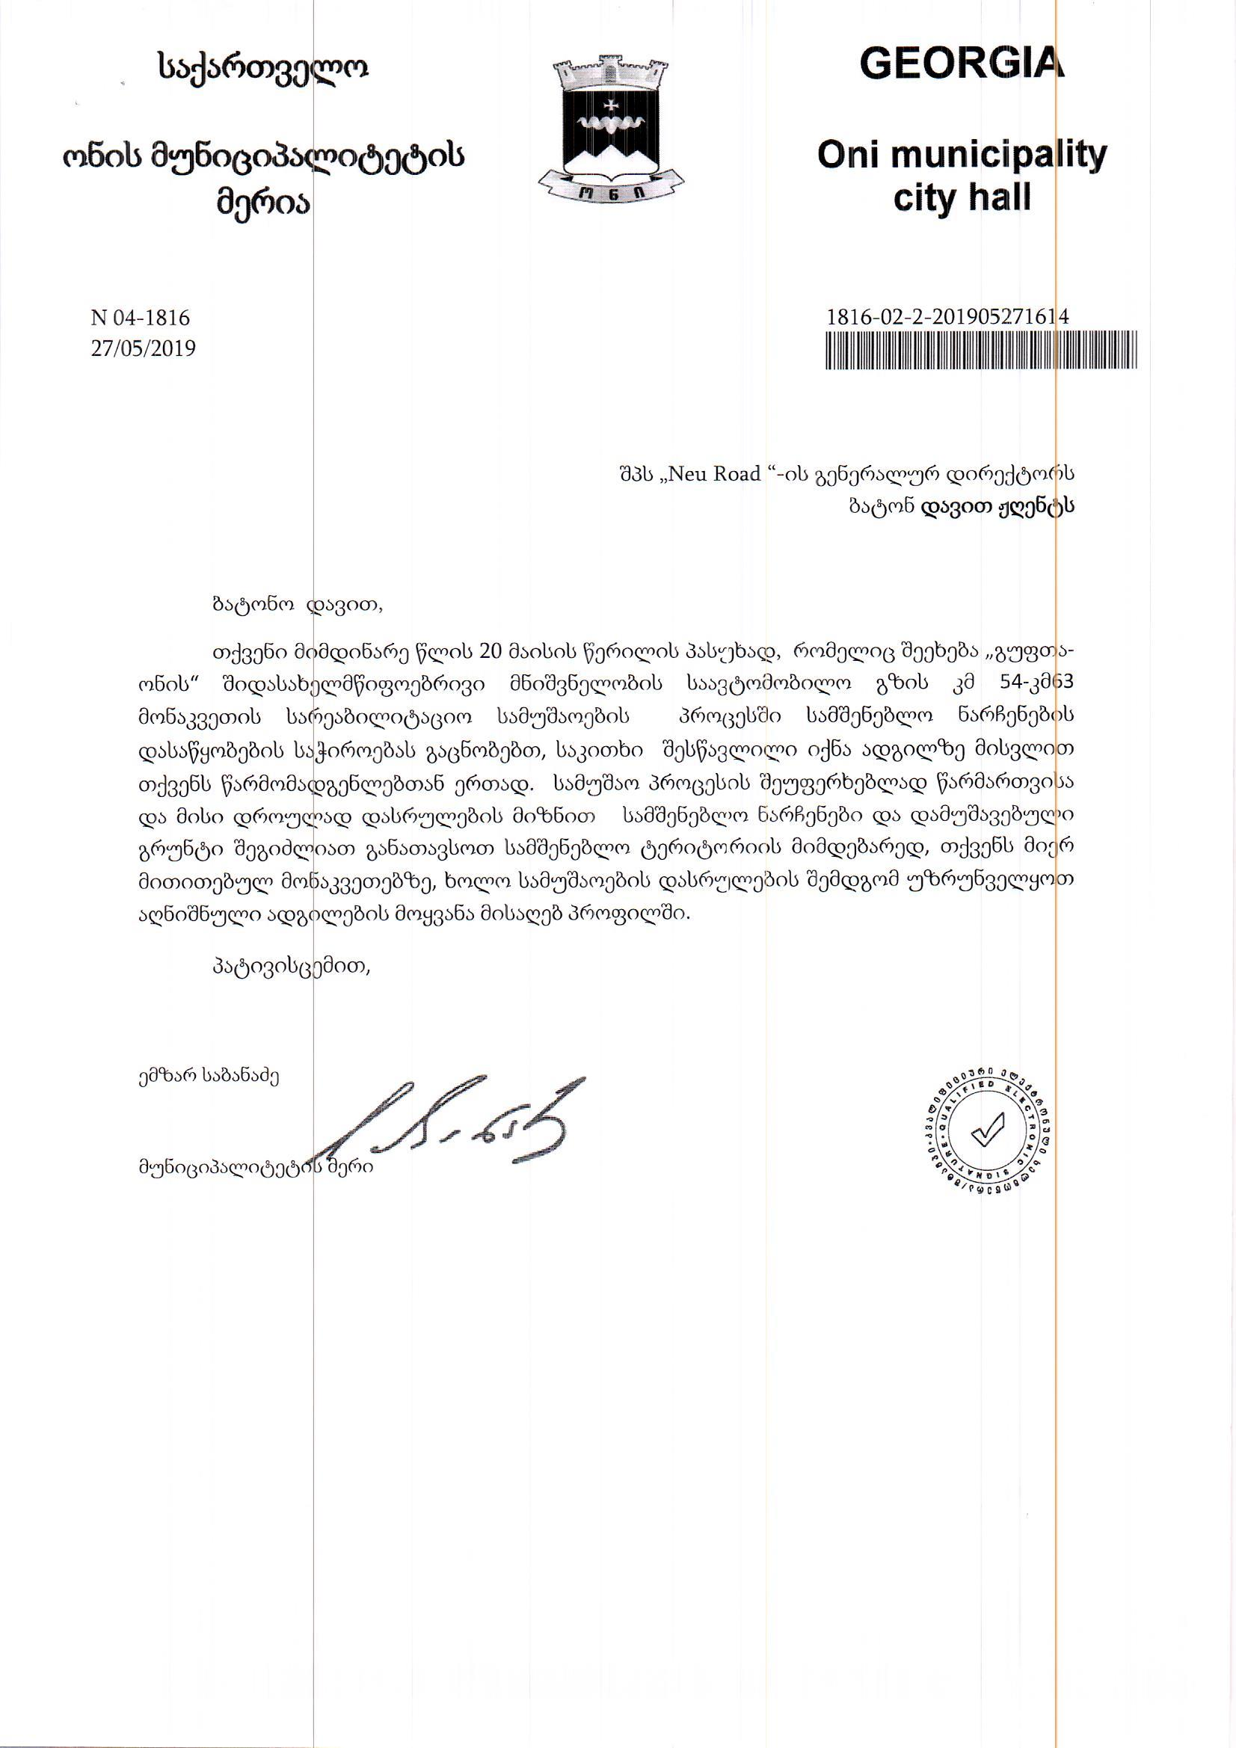

Attachment 4: Borrowing license 