June 2007
96576
Europe and Central Asia, Finance and Private Sector Development Department
In collaboration with the Information and Technology Policy Division
The World Bank


Implementing Electronic Business Registry (e-BR) Services

Recommendations for policy makers based on the experience of EU Accession Countries

Anat Lewin
Leora Klapper
Bruno Lanvin
David Satola
Sophie Sirtaine
Richard Symonds

Table of Contents

Executive Summary 5
Introduction 7
What Does e-BR Reform Entail? 7
E-BR Reform in the EU New Member States 8
Types of e-BRs 10
1. The Role of e-BRs in Private Sector Development 11
Electronic Business Registration around the World 11
2. Benefits of “Good Practice” e-BR Services 17
3. Good Practice e-BR Products and Services 20
4. Other Aspects of Good Practice e-BR Reform 24
5. Key Legal Aspects of Establishing, Maintaining and Using e-BRs 25
Overview of Legal Issues 25
Objectives of Legal e-BR Reforms 27
Key Legal e-BR Issues 28
6. Good Practice Public-Private Partnerships for e-BRs 29
Good Practice Examples of PPPs in e-BR Implementation 29
Legal Aspects of Public-Private Partnerships (PPPs) 30
Important Considerations for the PPP Contract 36
7. Monitoring and Evaluation of e-BRs 37
8. Integrating e-BRs into National e-government Frameworks 38
E-Government as a Tool for Public Sector Reform 38
Benefits of e-BRs as a Component of e-government Strategies 39
Good Practices 40
Important Institutional Considerations for e-BRs and e-government Dynamics 41
The e-Enabling Environment 42
Conclusion: Recommendations 43
Annex 1: Legal Aspects of Establishing, Implementing and Using e-BRs 44
The Legal Authorization Framework for Business Registries in the EU 44
The Legal Enabling Environment 47
Annex 2 - Legal Checklist 51
Annex 3 – Survey summary 52
Acronyms 56
References 57

List of Figures

Figure 1: Phases of Business Registry Automation 7
Figure 2: Electronic Business Registration, by Region, 2007 10
Figure 3: E-registration Requirements, 2007 10
Figure 4: E-Registration and the Investment Climate, 2007 10
Figure 5: E-Registration and Entry Rates, 2007 10
Figure 6: Number of New Businesses Incorporated 10
Figure 7: Use of Web-based and Paper-based Registries in Denmark and in Italy 10
Figure 8: e-BR Legal Issues Map 10
Figure 9: The Legal Framework Design is Dynamic 10
Figure 10: Distinguishing Characteristics of Common PPP Models 10
Figure 11: Framework for ICT in Government 10
Figure 12: Interoperability of e-government Services 10

List of Boxes

Box 1: The BRITE Project 10
Box 2: The Case of Guatemala 10

List of Tables
Table 1: Potential Users of an E-BR 10
Table 2: Availability of Good Practice e-BR Products and Services 10
Table 3: Sample e-BR Monitoring and Evaluation Indicators 10

Acknowledgements

This report was prepared by a multi-disciplinary team from the World Bank’s Eastern Europe and Central Asia, Global Information and Communication Technologies, Development Economics Research, and Legal departments. It was led by Sophie Sirtaine (ECSPF, Senior Financial Sector Specialist) and its main authors are Anat Lewin (CITPO, Operations Analyst), Sophie Sirtaine (ECSPF, Senior Financial Sector Specialist), David Satola (LEGPS, Senior Counsel), Richard Symonds (LEGPS, Senior Counsel), Leora Klapper (DECRG, Senior Economist), and Bruno Lanvin (CITPO, Advisor).

The authors would like to thank Cara Zappala (ECSPF, Operations Analyst), Serah Kimane (LEGPS, Intern) and Laci Barrow (CITPO, Program Assistant) for their research and written contributions. The comments provided by the following peer reviewers were particularly helpful and highly appreciated: Randeep Sudan (CITPO, Senior ICT Policy Specialist), Jacqueline Coolidge (CICFI, Lead Investment Policy Officer), and Anjali Kumar (FPDFA, Advisor).

Executive Summary

This paper shares experiences and good practices of early business registry reformers who transformed a formerly paper-based business registry into a nationally centralized, one-stop, automated, web-enabled electronic business registry (e-BR) that delivers products and services via online transactions and authentication of users and documents.

On the basis of country data, the paper discusses the role of e-BRs in Private Sector Development and concludes that countries with e-registries tend to have a shorter incorporation timeframes, fewer bureaucratic procedures, and a markedly lower cost of entry. The data also reveal a significant role of modernized business registries in facilitating business creation.

The paper then turns to the benefits of good practice e-BRs (i.e. a one-stop shop for services of interest to business registry users, enabling them to submit requests for services online, perform transactions online, and receive delivery of services online). Country experience illustrates that a good practice e-BR offers users improved efficiencies, by (i) reducing transaction time, (ii) providing transparency of information, (iii) providing “real time” access to information updates, (iv) streamlining transaction processes, (v) improving service availability, (vi) removing hurdles associated with in-person visits, (vii) providing a user-friendly interface, (viii) improving data accuracy, (ix) improving transaction security, (x) reducing costs and improving efficiencies for private businesses through the online submission of data, (xi) decreasing the public-sector cost of maintaining registries, and (xii) providing a better tool for market surveillance and business monitoring. Good practice e-BRs also provide the private sector with competitive data services, which are of particular interest to users such as credit rating agents, loan officers and business partners.

The paper then underlines the need to ensure a proper legal enabling environment, a necessary ingredient to produce legal and transactional certainty and transparency to encourage use of the e-BR. The paper proposes a holistic framework to constructing the legal enabling environment for the maintenance, operation and use of e-BRs, in which legal functionalities are defined along with technical and business process issues. The paper suggests that many legal issues need to be addressed to ensure a successful e-BR, including, inter alia, assigning adequate powers to the e-BR, choosing the nature and scope -- transparency -- of information to be provided by the registry, defining the degree of privacy and treatment of non-public information retained by the registry, determining how to avoid multiple filings by firms, ensuring the legal validity of electronic documents and electronic signatures, defining the rules of dispatch and receipt of data through the e-BR, ensuring data integrity and protect the data base, including from cyber-crime

The paper further suggests that contracting the private sector to create or operate some or all e-BR services through Public Private Partnerships (PPPs) leads to several benefits, including (i) reduced costs, (ii) improved efficiency, (iii) improved quality of public services, and (iv) transferring risks away from the public sector. It suggests that several key issues are particularly sensitive to the project’s success and need to be addressed in the PPP design, including: fees for transactions, profit sharing agreement with the private partner, ownership of the data, intellectual property rights, security and privacy issues, public sector oversight, competition of PPP arrangements, and consultation with stakeholders.

Finally, the paper recommends that business registry reform, both procedural and technical, should be an integral part of the national e-government strategy. E-government is about bringing better and cheaper government services to citizens, businesses and other government agencies. Available evidence shows that the countries most successful at implementing e-government services are those that focused on reforming their public sector rather than on automating existing procedures. Business registries are considered a priority area for governments in the process of designing and implementing an e-government vision, policy and strategy, as they are cross-cutting in scope and support a broad array of applications relevant to a range of stakeholders. In particular, the interoperability of business registries with the pledge and land registries can offer a one-stop-shop for loan applications by businesses, while their interoperability with other registries many facilitate other services useful to businesses (e.g. fiscal exemptions, staff search, etc).

Introduction

The objective of this paper is to share the experiences and good practices of early business registry reformers who implemented web-enabled and automated electronic business registries (e-BRs). These lessons are hoped to be of help to EU New Member countries as they embark on delivering EU-conformant e-BRs. At the same time, policymakers in other developing countries may also find these lessons of use.

This paper cites examples of “good practices” rather than “best” practices. As elsewhere in the development agenda, solutions that have worked well in some countries may not work in other local circumstances. In the case of e-BRs, success depends on a broader set of reforms; as will be discussed in a subsequent chapter, e-BRs require a supportive legal and regulatory infrastructure, such as electronic signature laws and document authentication. A needs assessment and analysis of the options in the local country context need to be conducted in order to find the most relevant best practice options for a specific country. Nevertheless, a number of practical good practices can be identified and are presented in this paper for consideration.

What Does e-BR Reform Entail?

This paper refers to ‘e-BR reform’ as the process by which a formerly paper-based business registry evolves to a nationally centralized one-stop, automated, web-enabled platform delivering products and services via online transactions and authentication of users and documents. Phases 1 – 3 of an e-BR reform process are illustrated in Figure 1 below – centralization, automation and authentication. Ideally, but in practice less prevalent, e-BR reform extends also to the integration of the e-BR platform with those of other governmental services, such as e-government services of the taxation authority, citizen registry, land and pledge registries, and trade databases. Integration and interoperability in this sense means the ability of a user to transact (e.g. view, download, upload information) concurrently with multiple registries from a “one stop shop” and single window. Such integration of related e-government services, the benefits of which are discussed later in this paper, refers to Stage 4 of Figure 1 below.

Figure 1: Phases of Business Registry Automation
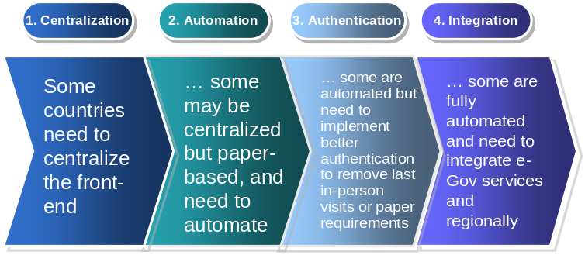
Having outlined what e-BR reform entails, it is important to point out also what it does not include. The e-BR reform discussed in this paper does not refer to the automation or web-enabling of ineffective or inefficient processes. Such reforms are important and discussed at length in the literature, but are beyond the scope of this paper.

E-BR reform involves addressing any existing hostile legal, institutional or regulatory environment to business registry success. In Chapter 5 of this paper, the legal, institutional and regulatory environment conducive to e-BR success will be analyzed.

This paper presents its discussion on good practice implementation of e-BRs by discussing (1) the role of e-BRs in Private Sector Development; (2) the benefits of good practice e-BRs; (3) good practice online applications and services; (3) creating a well-functioning legal and regulatory framework for electronic documents and signatures; (4) creating Public-Private Partnership (PPPs) for implementation; (5) integrating government databases and service provision for interoperability; and (6) anchoring electronic registries in national e-government frameworks.

E-BR Reform in the EU New Member States

The First Council Directive published by the EU on March 9, 1968 mandated in its Article 3 the requirements for companies to file specific corporate and financial information, by electronic means, to a central commercial or company register. When the new member countries joined the EU, they were given a deadline of January 1, 2007 to meet the requirements set in the First Council Directive.

Despite this deadline, progress in meeting the requirements set in the First Council Directive has been unequal among the EU8 countries. While some, such as Latvia and Estonia, have among the most advanced and best performing business registries in Europe, others, such as Poland, are still working to a large extent with paper-based decentralized registries in municipal courts, and working towards meeting the EU requirements past deadline.

So as to best capture the current status of electronic business registries in Europe, a short survey was distributed to agencies responsible for registry management. Responses were received from 10 countries, namely Estonia, Hungary, Ireland, Latvia, Lithuania, Norway, Romania, Slovakia, Slovenia, and the United Kingdom (see detailed in Annex 3). It is clear from the responses that there are varying levels of sophistication among these countries in terms of the on-line services offered.

In terms of basic capabilities, the survey asked whether it was possible for new firms to register entirely on-line. Five countries responded that they presently have this capacity: Estonia, Hungary, Norway, Romania, and the United Kingdom. Slovakia is expected to offer this service beginning on August 1, 2007, while Slovenia will begin on November 11, 2007. The remaining countries (Ireland, Latvia, and Lithuania) do not currently offer such service. Several other countries which did not answer the survey do not offer on-line company registration either. (See Table 2).

Within those countries offering electronic registration, firms can now enjoy shorter registration processing times as part of the regular service standard and even shorter times with expedited service. For instance, in the case of Estonia, prior to implementation of the electronic service, the standard processing time was five days. Since implementation of the on-line registry, the service standard for completing a registration was reduced to 2-3 days; and with expedited service it takes just 2 hours. Norway can claim even greater efficiency gains. Prior to implementation of the on-line registry, it would take 5 days to complete the process. Presently the service standard is 1 day, with expedited service completed in 1 hour.

It is interesting to note that with regard to cost, most countries responded that there are either little or no transaction fees to use the on-line registry.

Beyond the basic electronic business registry capabilities of the countries surveyed, a few countries’ systems offer several advanced features. For instance, in Estonia and Norway, systems are interoperable and interlinked with six other agency systems, namely e-procurement system for government agencies, and the land, labor, tax, pledges and citizen’s registries. Slovenia’s system is also interoperable with six systems: land, labor, tax, pledges and citizen’s registries and the trade database. Among those which responded to the survey, countries showing the lowest degree of interoperability with other registries and databases include the Slovak Republic (with only two partial links) and The United Kingdom, Ireland, Romania (with no link capabilities). Several of the countries which did not respond to the survey do not offer much interoperability either. This having been said, all 10 respondents confirmed that their electronic business registries are part of the countries’ official e-government vision and framework.

Thus, while lessons can be learned from the experience of some EU new member states with advanced e-BR processes and services, others would benefit from further reforms of their business registries. It is likely that reforms accelerate in Europe, in part under the impetus of the EU requirement mentioned above, and of further work by the EU, such as the BRITE project to connect EU-wide e-BRs online, through a common platform that enables information searches on firms across countries (see below). The paper now looks at how best to implement such business registry reforms.

Box 1: The BRITE Project
With the goal of establishing a dynamic business ecosystem, the European Union, in conjunction with the European Business Registry, has launched the “Business Register Interoperability throughout Europe” (BRITE) project in 2006.

BRITE aims to address the cross-border registration problem within the EU and facilitate greater private and public sector access to data by creating a common and unified European Business Registry that harmonizes the collection and distribution of business registry data.

Its main challenge is the interoperability among national-level EU registries. A common ontology for each of the EU business registries, as well as linkage existing and equivalent data fields, are part of the solution. An additional goal is to promote registry data as part of greater e-government initiatives.

Source: http://www.briteproject.net

Types of e-BRs

Business registry officials moving from a paper-based business registry towards a full-fledged e-BR need to think about the type of e-BR or reform process best suited to their context. This involves finding answers to the following questions:

- Should reforms be phased into steps (see Figure 1) or should the implementation leapfrog from Phase 1 to Phase 3 or 4? An example of a country that successfully sustained the IT skills challenges of leapfrogging is India.
- Should a multiple utility registry be set up? For smaller countries such as Rwanda, a one-stop-shop and single window registry for various e-government services makes good sense, and it is in the process of designing
- If the Business Registry is currently run out of the courts system, should a centralized e-BR be moved to a central agency? The answer depends on the overall, larger administrative reform that accompanies the introduction of the e-BR. Germany, for example, has retained business registry operations in local courts, therefore its business registry IT solutions have found ways to collect data from disparate geographical locations. Other countries, such as Serbia, unified the registry under a new independent administrative agency. Three Serbian organizations with different mandates – 13 commercial courts, 131 municipalities and the statistical office administered business registries before. It now, similar to Bulgaria, has avoided delays by creating a new administrative registry.

The Role of e-BRs in Private Sector Development

Entrepreneurship is essential for the continued dynamism of the modern market economy; a greater entry rate of new businesses can foster competition and economic growth. Many governments have taken action to make it easier for entrepreneurs to start a new firm, such as deregulating the registration process and automating the business registry, which can reduce time and cost for entrepreneurs. These steps have been shown in countries around the world to increase entry and small business employment. In this chapter we focus on electronic business registration as a mechanism to promote private sector development and growth.

The introduction of electronic registration systems is a high priority and a challenge to many of the new and accession EU countries. In these countries, the small and medium sized enterprise (SME) sector comprises relatively young, highly leveraged, profitable and fast growing firms. This suggests that a new type of firm is emerging in transition economies, a firm that is more market- and profit-oriented. One way the governments of Central and Eastern Europe can encourage the growth of SMEs is to facilitate and reduce the time and cost of registration process by allowing on-line registration. In addition, a larger number of formally registered firms is associated with a smaller informal sector, which are associated with slower growth and employment and lower tax revenue. Furthermore, formal sector registration provides firms access to a VAT sales ID, which offer greater domestic and international sales opportunities. Automating the registration process also helps provide lenders, suppliers, and customers greater access to information on the financial health, management, and ownership of registered firms, which encourages greater access to financing and growth.

Electronic Business Registration around the World
This first section provides a review of the different typologies of business registries around the world as shown in the World Bank Group Entrepreneurship database. Seventy-five countries participated in the survey populating this database, providing valuable information about their registration processes, information requirements, and the availability of e-registries and e-distribution, among other issues. While these survey results are global in nature, greater detail on business registries in the new and accession EU countries in particular is provided in Chapter 3.

a) Business Registry Typology
In order to asses the different degrees of modernization of business registries, the survey collected information on the availability of electronic registration, which broadly includes the automation and computerization of local registrars, the ability to register over the Internet, and electronic distribution of data via the Internet. However, this does not necessarily include on-line authentication or integration of e-government services. Figure 2 shows the deep disparity found between industrialized and developing countries. While on average only 40% of developing countries have implemented an electronic registry, more than 80% of the industrialized countries have already achieved complete automation. With the exception of emerging economies in Eastern Europe – which are working to meet EU requirements for electronic and harmonized business registries – only 35% of developing countries have electronic registries. However, in most regions over 60% of countries make registrar information available over the internet. This discrepancy might be explained by the fact that electronic distribution is less expensive and difficult to implement, not requiring the implantation of electronic signatures or complex e-government platforms.

Figure 2: Electronic Business Registration, by Region, 2007
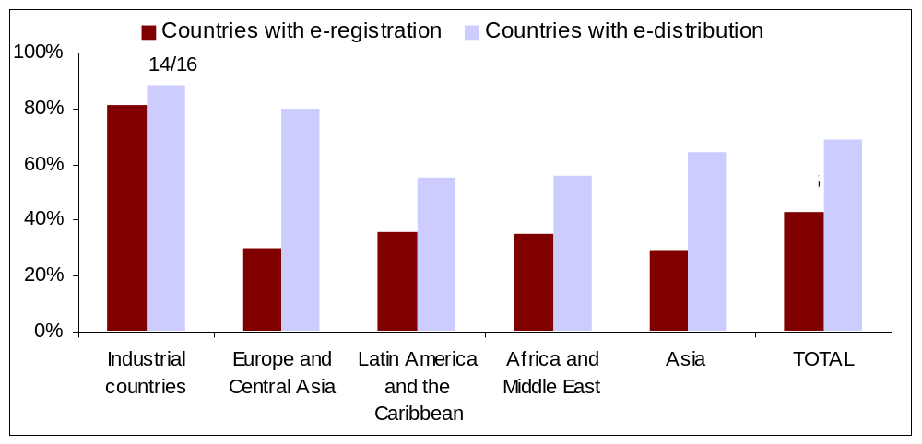
Source: World Bank Group Entrepreneurship Database

The registries were also questioned on the information businesses were required to file, as well as whether they registered information other than business incorporations. Deep disparities among regions were found (Figure 3). When it comes to the information the companies are required to register, the majority of regions oblige businesses to report closures and annual financial statements (with the exception of Asia). Nevertheless, while many countries have this requirement, not all of them have any enforcement mechanisms. In addition, while business registries in industrialized countries tend to stand alone, and only in some cases they register internet domains, developing countries tend to have registries where businesses, real state, Internet domains and patent registrations coexist. These results suggest that countries introducing platforms for electronic business registration should also consider the demands for and potential to provide other electronic services, and the possibility to employ interoperable, one-window platforms.

Figure 3: E-registration Requirements, 2007
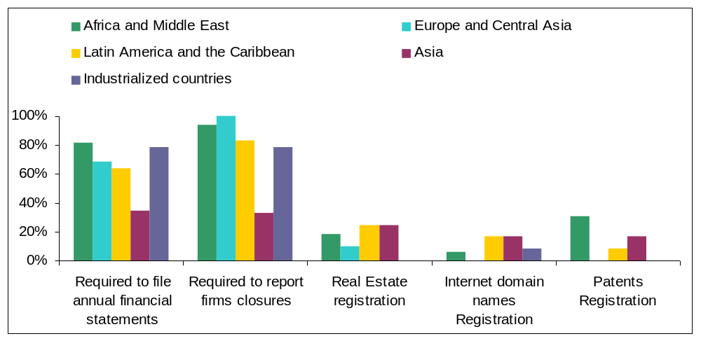
Source: World Bank Group Entrepreneurship Database

b) Impact of Electronic Registry in the Ease of Doing Business
Ultimately, we are interested in how business registry reform impacts entrepreneurship and the ease of doing business. We find that countries with e-registries tend to have a shorter incorporation timeframe, fewer bureaucratic procedures, and a significantly lower cost of entry. For instance, the average cost of entry is on average less than half in countries with electronic registries than in countries without electronic registration, as shown in Figure 4.

Figure 4: E-Registration and the Investment Climate, 2007
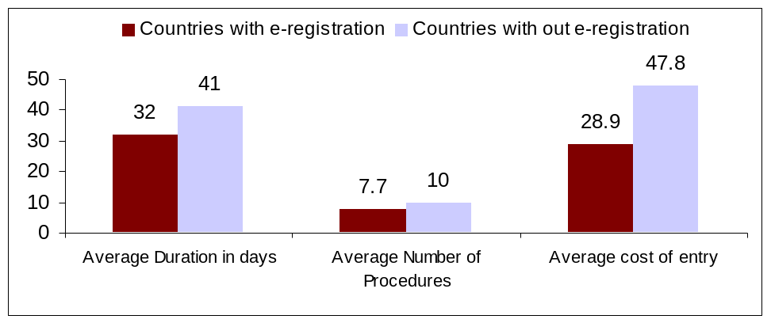
Source: World Bank Group Entrepreneurship Database and Doing Business (2006 data)

c) Impact of Electronic Registration on Entry Rates

The data also reveal a significant role of modernized business registries in facilitating business creation. Figure 5 shows higher entry rates – defined as the number of new registrations divided by the stock of existing registrations – in those countries with electronic registries compared to the ones without them. Although we have no evidence that these firms that register following business modernization reform are more or less likely to survive and contribute to job creation and growth, we do know that greater private sector entry provides competition to existing firms, which encourages innovation, greater added value, etc. This relation is strongest in developed and ECA countries. However, we cannot dismiss reverse causality; that registry modernization is demand-driven by a more robust private sector. Furthermore, the increase in new business registrations may be a short-lived phenomenon, i.e. the largest increase in new firms might occur in period immediately following reforms.

Figure 5: E-Registration and Entry Rates, 2007
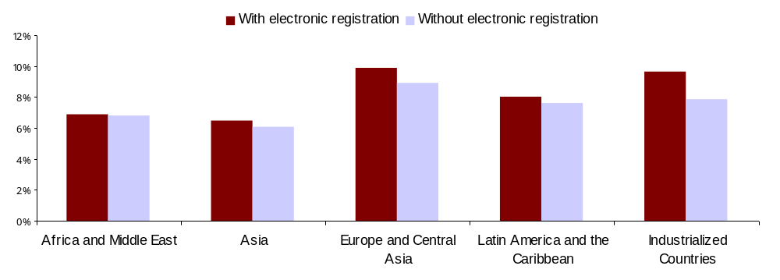Source: World Bank Group Entrepreneurship Database. Entry rates are for 2005.
Note: the above numbers may be inflated by closed firms.

d) Impact of Private Sector Modernization and Electronic Registration: Guatemala, Sri Lanka and Jordan

The modernization of business registries is an important step in a successful private sector development strategy. If appropriate political and economic reforms take place, the country will require an efficient registry that can satisfy new businesses demands. Otherwise, the registry will become a bottleneck for entrepreneurs, not only encumbering the business creation process, but also discouraging the transition between the informal and formal sectors.

The modernization process of business registries is usually a long process framed inside a larger national private sector development strategy. On average, countries draft five-year plans and the goal is to implement electronic registration and distribution. Data from the World Bank Group Entrepreneurship database suggest a strong relationship between the implementation of a modern business registries and a significant increase in the number of new business registered. Figure 6 shows the timeline of new business registrations for three countries – Guatemala, Sri Lanka, and Jordan – that have successfully implemented a business registry modernization strategy.

Figure 6: Number of New Businesses Incorporated
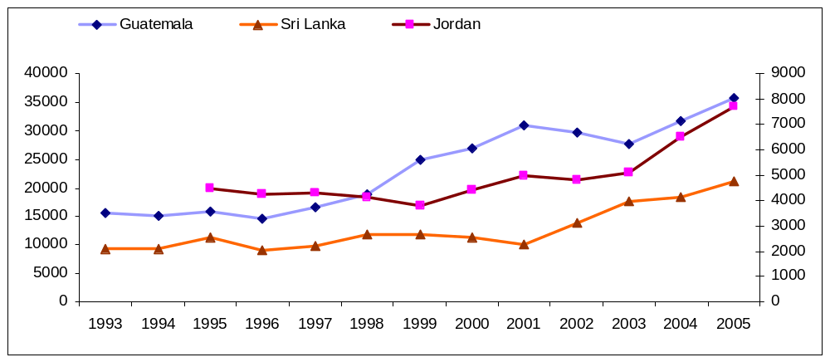
Year of implementation of e-BR
All three countries witnessed an increase larger than 20% in the number of new business registration after the full implementation of their modernization plans. It is also noteworthy that in Jordan and Guatemala, the growth of new firms begins before the implementation of the reform, usually about 4 years earlier when the modernization plan was announced and initiated.

For example, Guatemala began its modernization plan in 1996, achieving e-registration and e-distribution in 1999. Jordan, following a 1997 law, created a new entity in charge of business registration and entrepreneurship promotion that fully implemented the electronic registration in 2002. Sri Lanka, on the other hand, partially implemented its electronic business registration in 2001, in order to prepare for the new Companies Act of 2007.

Box 2: The Case of Guatemala
Since the creation of the business registry of Guatemala in 1971, its structure remained almost unchanged for two decades. An average of seven employees and a couple of mechanical typewriters composed its organizational structure until 1995. In 1996, under a new administration, the Business Registry undertook an ambitious modernization plan. The initial program, divided into four phases, would be accomplished with the implementation of e-registry and e-distribution in 1999.

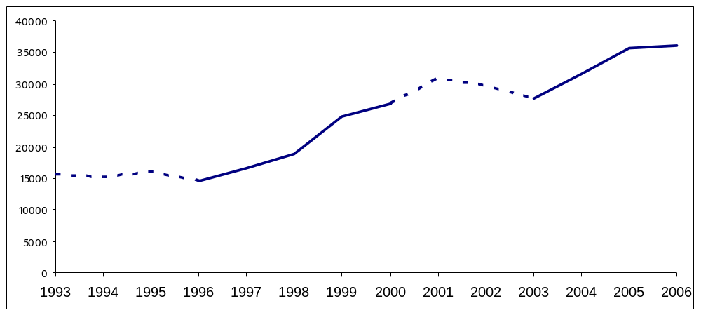
EBR implementation
Active Modernization plan
Inactive Modernization plan plan

The plan included not only the modernization of the business registry, but also the entrustment of the registry as the central actor for the new private sector development strategy. The registry would gain an active role in the promotion of entrepreneurship through activities such as training of entrepreneurs, investment promotion, dissemination, etc. As shown in the Figure above, the modernization of the business registry and the new economic policies had a direct impact in the number of new business registered, with an increase of 40% on new registrations. In comparison, the three years period (2000-2003) during which the modernization strategy was paralyzed due to a change in the administration, resulted in a sharp 11% decline in the number of new business registered.

In 2003, the new administration reactivated the second modernization plan for the business registry. A number of new and ambitious goals were defined, such as increasing the number of registration locations, reducing the necessary steps for business incorporation, and promoting foreign investment. This second stage had a remarkable impact in the number of new business incorporated, and increased the number of new business registered per year by almost 25%. Moreover, the number of monthly electronic transactions – including incorporations, closures, re-registrations and consultations - has climbed over 3400, representing more than 50% of the total number of monthly transactions.

Benefits of “Good Practice” e-BR Services

A ‘Good Practice’ e-BR provides a one-stop shop for services of interest to business registry users, enabling them to submit requests for information or services online, perform transactions such as updating information or paying fees for information delivery online, and receive delivery of services online.

Potential users of e-BRs and examples of the services they would pay for are summarized in the table below:

Table 1: Potential Users of an E-BR
Potential Users of an e-BR | Potential use of e-BR services:
A business owner … | … registers a new business or lists the board of directors of a firm.
A loan approval officer at a financial institution … | … confirms the financial health and history of a potential borrowing firm and owners.
A potential business partner … | … confirms the details of a potential business partner, such as who in the company is legally entrusted with signing agreements.
A potential customer … | ... confirms historical information on the operations and management of the firms.
A potential supplier … | … confirms the financial health of a potential buyer in making trade credit decisions.
A lawyer or notary … | … validates information.
A government official (e.g. a tax, customs, pension, VAT or social security authority official)) | … verifies a company’s active business status.

The benefits of using an e-BR versus an in-office or paper-based service are those relevant also to e-government services in general. A properly functioning, good practice e-BR offers service providers and users improved efficiencies, by:

- Reducing transaction time, often from several days or weeks with an in-paper format, to just a few hours in the online version for such transactions as registering or de-registering a company or changing the board of directors of a firm.
- Providing equal transparency of information to all who care to obtain a login and password, and pay for the service if needed. To be noted here is that e-BRs require web skills, Internet literacy, general language literacy, a PC and a reasonable Internet connection. While most of these constraints are not problematic in EU Accession Countries, an e-BR reform should be accompanied with a push for rural access to the e-services, perhaps through local governments, family- or student-focused PC campaigns, or rural telecenters, as well as Internet literacy.
- Providing immediate and simultaneous “real time” access to information updates at the time of uploading, in contrast with waiting for a new paper-based registry entry to be released.
- Streamlining transaction processes such that services previously needing several steps (perhaps at different physical locations) can be conducted in one step online.
- Improving service availability (24 hours a day, 7 days a week online, versus 9 to 5, on 5 days a week for most registries requiring in-person visits).
- Removing hurdles associated with in-person visits, such as long lines, and traffic jams.
- Providing a consistently user-friendly interface online versus possibly inconsistent quality of service during an in-person visit.
- Improving data accuracy, by minimizing paper-based manual data entries, and allowing the validation of data. For example, in South Africa, a recent introduction of a new online annual reporting and submission requirement at the Company Registry has led to a dramatic increase in the number of company de-registrations and therefore improved the accuracy of overall corporate sector data. In addition, the time needed to correct potential errors is reduced substantially.
- Improving transaction security, if the system enables, as in Italy, the automatic verification of identities and roles, and of signatures.
- Reducing costs and improving efficiencies for private businesses through the possibility for online submission of data, especially in the case of submission of annual accounts data. For instance, InfoCamere, the Italian e-BR, estimated that the filing of 850,000 annual accounts electronically saved Euro360 millions to Italian SMEs in 2005. In Romania, in consideration of the expected reduced costs of providing services, the business registry fees were cut by 50%.
- Decreasing the public-sector cost of maintaining registries, mainly by decreasing the need and thus the cost of paper support and archiving, as well as the amount and cost of administrative tasks (which enables a reduction in registry staff).
- Providing a better tool for market surveillance and business monitoring by making the easy aggregation of business registry data along sector, industry, or geographic lines possible. Aggregated data in areas such as business entry, exit, profits (where annual account data are provided) facilitate the analytical work, investment decisions and policies of third parties as, for example, domestic credit bureaus, rating agencies, foreign investors, economists and academics. One example of this is Sweden’s UC, a computerized business and credit information agency owned by banks. UC regularly collects data from over 20 sources, including the Swedish Companies Registration Office, into a large, web-enabled database that offers credit monitoring and qualified financial analysis on all enterprises registered in Sweden and all individuals over 16 years of age living in Sweden.
- Providing the private sector with competitive data services. E-BRs can become competitive to private sector data and analysis firms where they provide value-added calculations and analysis of the e-BR data, such as in Latvia.

Good Practice e-BR Products and Services

Examples of good practices in e-BRs registries that illustrate the benefits identified in the section above abound.

In Portugal, for example, the e-BR called “FastTrack” allows users to select a pre-approved name from the registry’s website, and proceed to the one-stop website to register one’s company (the time for registering a new name out of the pre-approved list being also quite short). The registry then automatically processes the taxation, social security and labor registration, and publishes the incorporation notice. The articles of association are standardized and there is no need for a notary. Within a year of providing the FastTrack service, the number of companies registering using FastTrack rose from 12 to 75 a day.

In Denmark and in Italy, the benefits of the business registry reforms implemented from 1993 to 2005 rapidly led to web-based overtaking paper-based transactions.

Figure 7: Use of Web-based and Paper-based Registries in Denmark and in Italy
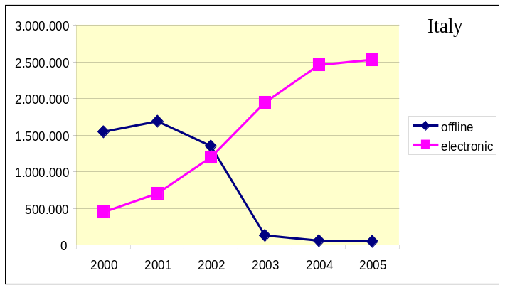
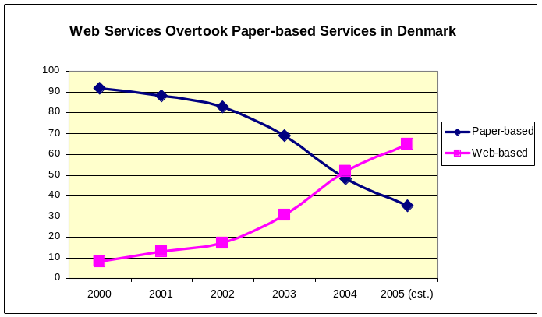

Good practice e-BR offer products and services of particular interest to users such as credit rating agents, loan officers and business partners fall into two categories – basic e-BR functionality, which mirror online processes of registry functions available also in the paper-based format, and advanced e-BR functionality, which leverage off the online nature of the e-BR to provide value-added services. Both are listed in Table 2 below, in addition to the results of a recent questionnaire to business registry officials in Europe illustrating who have already adopted the good practices.

Table 2: Availability of Good Practice e-BR Products and Services
Basic e-BR Functionality | Countries That Answered Yes
Do you have an online, central Internet platform for your business registry, accessible via one Internet site? | Estonia, Ireland, Latvia, Norway, Romania, Slovakia, Slovenia, United Kingdom
Do local business registries (such as regional business registries or local courts) feed data electronically to the centralized online platform? | Estonia, Latvia, Lithuania, Norway, Romania, Slovakia
Can an entrepreneur register a new company entirely online? | Estonia, Hungary, Norway, Romania, Slovakia*, Slovenia, United Kingdom
Can one enter/change the firm’s name or address entirely online? | Estonia, Hungary, Ireland, Norway, Romania, Slovakia*, Slovenia**, United Kingdom
Can one enter/change the names of the firm’s management or board entirely online? | Estonia, Hungary, Ireland, Norway, Romania, Slovakia*, United Kingdom
Can one pledge property and capital entirely online? | Hungary, Romania, Slovakia*, Slovenia**
Are samples of the firm’s authorized signatures available online? | Norway, Slovakia*,United Kingdom
Does your online platform authenticate users? | Estonia, Ireland, Latvia, Norway, Romania, Slovakia*, Slovenia, United Kingdom
Is national legislation in force for user authentication? | Estonia, Ireland, Latvia, Lithuania, Norway, Romania, Slovakia*, Slovenia, United Kingdom
Is the e-BR authentication in compliance with relevant national legislation? | Estonia, Ireland, Latvia, Norway, Romania, Slovakia, Slovenia, United Kingdom
Is this authentication method used also on other Internet sites, for example on e-government services sites or commercial banking sites? | Estonia, Latvia, Lithuania, Norway, Slovakia*, Slovenia
Does your online platform have a legally valid electronic signature capability? | Estonia, Ireland, Latvia, Norway, Romania, Slovakia*, Slovenia
Are extractions from your online platform accepted as true and correct copies under the law? | Estonia, Norway, Slovakia*, Slovenia, United Kingdom
Other than transaction fees, are there any access restrictions placed on potential registry users such as credit information/rating agencies, commercial banks? | Slovenia
Can registry data be purchased or downloaded in bulk? | Estonia, Hungary, Ireland, Lithuania, Norway, Romania, Slovakia, Slovenia, United Kingdom
If the services of a notary are needed, can a notary log in to sign a document associated with a firm, or perform a notarizing transaction without needing in-person or in-paper steps? | Estonia
If the services of an accountant are needed, can an accountant log in to sign a document associated with a firm, or perform an accounting-related transaction without needing in-person or in-paper steps? | Norway, Slovenia
Is a firm’s annual account data viewable online? | Estonia, Ireland, Lithuania, Norway, Romania, Slovenia, United Kingdom
Is all historical data available online? | Estonia, Hungary, Latvia, Lithuania, Slovakia
Was the majority or all historical data scanned in? | Hungary, Norway, Slovakia, Slovenia
Was the majority or all historical data entered manually? | Estonia, Hungary, Latvia, Lithuania, Romania
Did one or more private firms under a public-private partnership (PPP) agreement implement the electronic business registry? | Latvia, Slovakia
Did one or more private firm(s) develop the online platform? | Hungary, Ireland, Latvia, Norway, Romania, Slovakia, Slovenia
Does/do one or more private firm(s) manage/operate the online registry today? | Hungary, Latvia, Norway
Advanced e-BR functionality
Is information on a firm’s legal court-sanctioned bankruptcy available online through the e-BR (for example through automatic links with a relevant database)? | Estonia, Hungary, Latvia, Norway, Romania
Is information on independent or registrar-issued credit ratings available online through the e-BR (for example through automatic links with a relevant database)? | --
Is the e-BR part of the country’s official e-government vision and framework, such as being included in the government’s e-government Strategy or Policy? | Estonia, Hungary, Ireland, Latvia, Lithuania, Norway, Romania, Slovakia, Slovenia, United Kingdom
Is the e-BR interoperable and interlinked with a credit-rating system? | Lithuania, Norway, Slovenia
Is the e-BR interoperable and interlinked with an e-procurement system for government agencies? | Estonia, Norway
Is the e-BR interoperable and interlinked with a land registry? | Estonia, Latvia, Lithuania, Norway, Slovenia
Is the e-BR interoperable and interlinked with a Pledges registry? | Estonia, Latvia, Norway, Slovenia
Is the e-BR interoperable and interlinked with a Trade database? | Lithuania, Slovakia, Slovenia
Is the e-BR interoperable and interlinked with a social security or labor registry? | Estonia, Lithuania, Norway, Slovenia
Is the e-BR interoperable and interlinked with a Tax registry or database? | Estonia, Latvia, Lithuania, Norway, Slovakia, Slovenia
Is the e-BR interoperable and interlinked with a citizens’ registry? | Estonia, Latvia, Lithuania, Norway, Slovenia
Does the e-BR offer automatic tracking of firms of interest (Favorites) to users? | Ireland, Latvia, Norway
Does the e-BR offer automatic news feeds about the firm being viewed? | Hungary, Ireland, Latvia, Norway, United Kingdom
Can firms enter or upload their annual accounts information online directly into a field-by-field database? | Hungary, Lithuania, Norway, United Kingdom
Are analysis and aggregation of annual accounts data (by industry, region, sector, profitability or for the entire country) available through the e-BR site? | --

Other Aspects of Good Practice e-BR Reform

When implementing online applications and services, the following considerations are important.

The accuracy of data can be improved through:
- Manual entry or checking of scanned data when entering historical information;
- Verification by notaries or lawyers remains a necessity, but could be simplified in workflows as much as possible;
- Automatic population of online forms with existing data.

The timeliness of services can be improved through:
- Provision of Help Desk Services during extended hours. The Danish customer information center, for example, is staffed by 100 people.
- Removal of any in-person steps for transactions;
- Removal of in-paper steps for transactions.

The institutional environment can be improved through:
- Securing sufficient government budget for the reform during the planning stage.

The BR workflows and processes need to be evaluated and if needed, reformed through:
- Gaining time efficiencies by reducing workflows to intermediaries where needed. For example, some countries have found that business start-up takes 20 days more on average where judges approve business registration applications. In response, Bosnia and Herzegovina, Romania and Slovakia left registration in the courts but shifted responsibility from judges to legal clerks. Italy and Honduras transferred registration from judges to private chambers of commerce. Bulgaria and Serbia avoided delays by creating a new administrative registry.

Key Legal Aspects of Establishing, Maintaining and Using e-BRs

This chapter summarizes the key legal issues that need to be addressed when establishing, maintaining and using an electronic business registry. Further details on each of the key legal questions addressed in this chapter can be found in Appendix I.

Overview of Legal Issues

The establishment, operation and use of e-BRs raise a number of legal issues. Certain aspects about e-BRs make them qualitatively different than their paper-based business registry predecessors. The move from paper-based, analogue systems to on-line, electronic systems is more than a migration from one medium to another. The electronic format raises new and unique legal issues regarding e-BRs and how to use them.

In the establishment of the registry, the Member State will decide whether to operate the e-BR itself or outsource some or all of its operation through a contractual or other legal arrangement sometimes involving the private sector, or Public-Private Partnerships (PPPs). These arrangements in turn involve public procurement issues. Once established, each time a business makes a filing with the e-BR, legal issues are raised, such as how to “authenticate” the supplier of the information as the party it purports to be; how to ensure the integrity of information supplied to the e-BR; how the e-BR stores and manipulates that data; how third parties access the data in the e-BR; the manner in which the registry is protected as “critical infrastructure”; and how fraud, interference with data transmission entries and hardware and software systems, and misuse of the E-BR are punished. Some registries are cross-linked, cover more than one subject matter area, or are linked (or should be linked) with other governmental automated systems. In that sense, issues of interoperability – at the logical, technical, legal and content levels – are important. Similarly, since the national e-BRs are part of a pan-European system, how the EU Member States’ e-BRs interact with one another across borders also must be taken into consideration.

Figure 8: e-BR Legal Issues Map
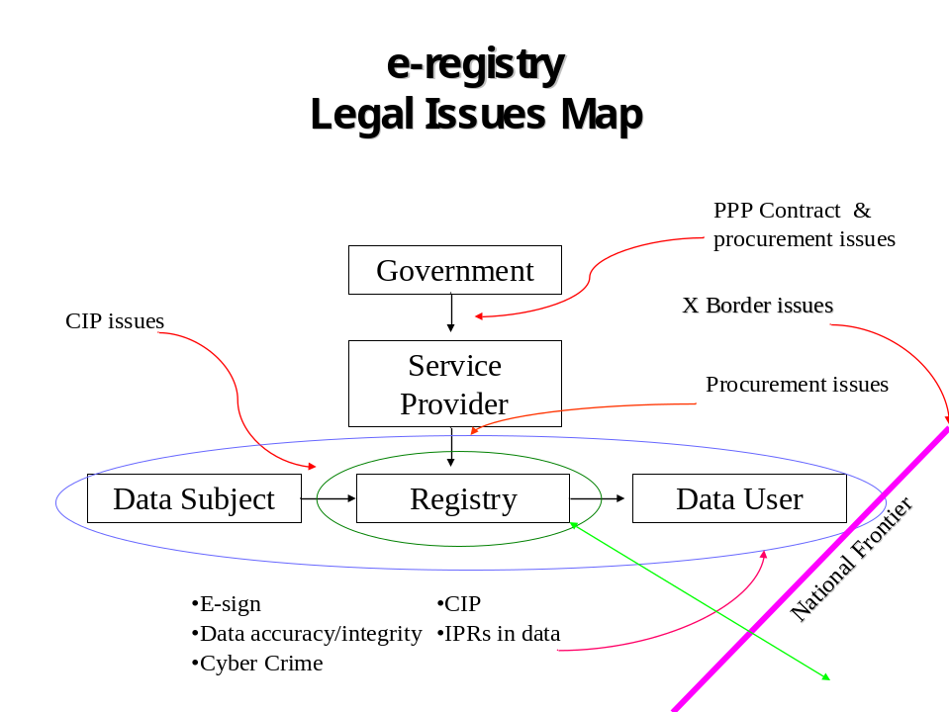

This chapter looks at the substantive legal requirements for business registries, including e-BRs, (purpose, and institutional, content and form requirements, etc). The detailed “electronic” legal issues affecting e-BRs (authentication of users, legal validity of electronic documents and signatures, ensuring data privacy and integrity, intellectual property rights, critical infrastructure protection, and cybercrime) are discussed in Appendix 1.The legal issues – such as liability - affecting the use of PPPs in connection with e-BRs are discussed separately in the next chapter on PPPs. It should be emphasized that this overview is not prescriptive and is not intended to be a substitute for legal advice by competent, qualified counsel on any legal matter affecting e-BRs. Moreover, the issues described here (and possibly others) would need to be appropriately adapted to local circumstances within the framework of applicable Directives – what works in one Member State may not be appropriate for another. In that sense, the issues discussed in this chapter are intended to provide a framework for assessing next steps in the design and implementation of e-BRs at the national level.

While the applicable Directives play an obvious role in determining the legal enabling environment for the effective operation of e-BRs in the EU, this chapter goes beyond a mere recitation of applicable Directives and looks behind them at the key legal elements that need to be taken into account in the establishment, operation and use of e-BRs. An indicative “checklist” of legal issues regarding the electronic aspects of e-BRs can be found at Annex I.

Objectives of Legal e-BR Reforms

As with all matters of legal reform, the underlying purpose of ensuring a proper legal enabling environment for the function of e-BRs is to produce legal and transactional certainty and transparency to encourage use of the e-BR.

This chapter proposes a holistic, methodological framework to constructing the legal enabling environment for the maintenance, operation and use of e-BRs. A starting point is an understanding that the establishment of an e-BR is more than merely a conversion of an existing paper-based, analog registry. The electronic aspects of the registry trigger a number of issues that should be analyzed. Electronic registries raise issues of access to computing infrastructure, storage of data, authentication of users, how to treat “form requirements” (e.g., functional legal equivalents of notarized paper copies and other evidentiary requirements, and whether there is a “priority’ of one type of filing or record over another (paper vs. electronic).

In analyzing these questions, it is recommended that, when designing the registry and its process, legal functionalities should be included in a dynamic design paradigm along with technical and business process issues. Decisions about registry design should include inputs from the “business process” decision makers, the technical design team and the legal team in a dynamic fashion that cut across functional boundaries (see Figure 9Error: Reference source not found).

Figure 9: The Legal Framework Design is Dynamic
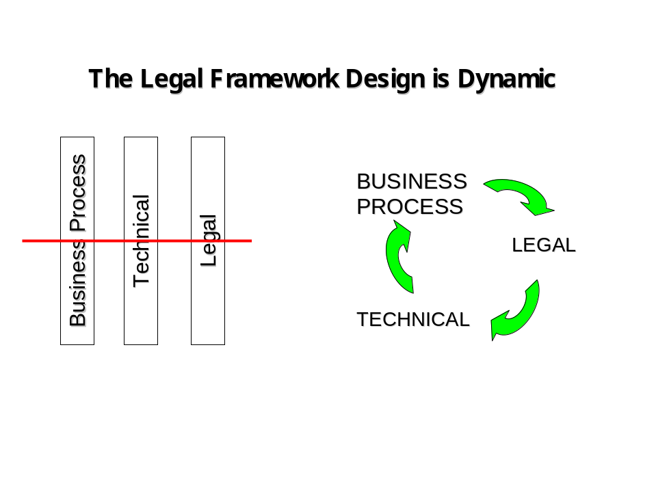

Key Legal e-BR Issues

Detailed legal issues need to be addressed to ensure an appropriate legal authorization process and an adequate legal enabling environment for a successful e-BR. These key legal issues consist of the following (discussed in detail in Annex 1):

- Assigning adequate powers to the business registry;
- Choosing the nature and scope -- transparency -- of information to be provided by the registries to the public;
- Defining the degree of privacy and treatment of non-public information retained by the registry;
- What types of companies to include in the registry (i.e. listed Vs non listed);
- How to avoid multiple filings, domestically and internationally;
- Ensuring the legal validity of electronic documents and electronic signatures;
- Defining the rules of dispatch and receipt the transfer of data through the e-BR;
- Ensuring the e-BR’s data integrity and protect its data base;
- Considering the e-BR as ‘Critical Infrastructure’ and subjecting to the Critical Infrastructure Protection (CIP) rules;
- Protect the e-BR from cyber-crime; and
- Ensuring the legal interoperability of the e-BR with other government data bases.

Good Practice Public-Private Partnerships for e-BRs

Contracting with private sector actors to create and provide some or all e-BR services would be useful in EU New Member Countries. Such arrangements are called public-private partnerships (PPPs). Among the many public policy objectives that could be served by using PPPs are (a) reduced costs, (c) improved efficiency, (d) improved quality of service in delivery of public services, and (e) the potential to transfer certain risks away from the public sector in the provision of these services.

PPPs can lead to increased efficiencies in the design, building, financing, operating and delivery of public services. Introducing a well-designed PPP is useful when some or all of the following characteristics are in place:

- The public budget for the implementation of the e-BR is insufficient or scarce;
- The private sector is interested in investing, even when up-fronting the needed investment cost for e-BR implementation may be difficult;
- Levels of technical skills/capacity in the IT cadre of the public sector are insufficient to implement an e-BR, or fall short of the skills available in the private sector;
- Levels of skills/capacity to manage a sophisticated e-BR system do not exist in the public sector; and
- An incentive structure for rewarding timely and qualitative performance is absent in the public sector.

Under such conditions, opportunities and motivations for a private involvement in the delivery of public services are increased.

Good Practice Examples of PPPs in e-BR Implementation

Countries should define PPP frameworks in accordance with their local needs and context; as in other areas of development economics, no one template fits all. But implementing an e-BR with a private partner, and later managing and operating it with possibly the same or other private partners, is an important and long undertaking that needs to be carefully designed. Several good practices can be distilled from existing e-BR PPP frameworks around the world:

- In Austria, the Ministry of Justice owns e-BR data, while eight private clearing houses are on PPP contracts to provide services (some for niche clients) and share profits with the public sector.
e-BR PPPs

Ireland
The Irish companies’ registry, “Companies Online Registration Environment” (CORE) is an electronic registry operated by a private party under a PPP arrangement.
www.cro.ie

Latvia
The Latvian business registry is also operated through a PPP agreement with a private operator..
www.lursoft.lv
- In Latvia, a private firm provided the initial investment for the creation of the e-BR, but keeps all transaction profits. It is on a term contract to provide software and services.
- In Denmark, the Danish e-BR has pre-qualified a group of 7 firms for contracts in e-BR implementation and service delivery. Of the seven firms, four resell data from business register and two handle only annual accounts. The seven private partners pay royalties to the government. Profits are reinvested in the e-BR.

One of the challenges of implementing or managing an e-BR through a PPP may be the retention of competitiveness among private sector firms. Denmark and Austria have solved this predicament by dividing the e-BR work program among several firms, some of which cater to different business needs or clients. For example, in Austria, one of the PPP firms caters only to lawyers and notaries by providing e-BR data and services of interest to that clientele.

In countries where one firm only is partnered to work on the e-BR, or one firm wins the largest contract and share of the work, a lack of competitiveness may take root over time. One consequence may be that the private partner provides de facto monopoly e-government services to the e-BR and to other agencies that sign on, which does not facilitate interoperability with systems created by other private firms for other agencies.

Legal Aspects of Public-Private Partnerships (PPPs)

The business registry’s competence is a function of the national law that gives rise to it. The office of the “registrar” is a public office. Generally, the registrar has the duty to maintain the registry, issue certificates and other public documents. The registrar will also be charged with overseeing the filing of documents and ensuring the reliability (and certifying as to the authenticity) of that information. With the shifting of these functions from a paper-based to an e-registry and the provision of registry services through PPP arrangements, questions arise about responsibilities for maintaining the registry and providing registry services, such as issuing certificates which can be relied on as authentic legal documents. Moreover, even though outsourced to a private party via a PPP, the registry is still a “public good”, raising issues regarding the integrity and availability of the database notwithstanding a private operator's legitimate grievances (e.g. nonpayment, etc.). This highlights the necessity to address in the PPP contract remedies and recourse of the operator that do not impair the public good.

The agreement creating the PPP would need to explicitly define the responsibilities of both the government and the private provider, including their respective roles in issuing of certificates. It may be that, under national law, only a governmental agency can issue an official certificate and this function cannot be “outsourced” to a third party. Clearly identifying responsibilities for operation of the registry and provision of registry services is closely related to liability issues for operating the e-BR (discussed below), as well as the authenticity and legality of certificates or documents issued by the e-BR. This allocation of responsibility would normally be coupled with appropriate indemnities. In this sense, the government party may need to waive any sovereign immunity to give effect to the indemnity.

If registry functions are outsourced through a PPP, the transparency of the e-BR’s operations and service provision should also be addressed in the PPP contract. It may be that, under national law, the operation of the e-BR by the public authority requires certain transparent processes. The public party will need to ensure that these obligations are “passed through” to the private party.

By its nature, the e-BR contains valuable, and possibly even sensitive, information about business entities. To the extent that the public party is obligated to ensure the integrity of the data in the registry, the PPP contract should “pass-through” this obligation to the private party. Use of the data in the database beyond the purposes for which it is intended should also be dealt with in the PPP contract. Likewise, there may be requirements that the public party disclose certain information about the private party, or about the PPP arrangement.

a) Legal Enabling Framework for PPPs

The legal framework or enabling environment for PPPs will vary from country to country. In some countries, there will be specific laws regarding the establishment of PPPs. Sometimes these can be found in concession or similar laws, which can fix the scope of application of PPPs, possibly the rights and obligations of the parties, selection and approval of projects, public roles and responsibilities and possibly even dispute resolution.

b) Forms of PPP Arrangements

The nature of such an arrangement could range between a service contract (where the government would contract the service provider to operate, maintain and manage the e-registry); a franchise (where the government would grant a concession to a service provider to operate the e-registry, regulate the fees and set the standards of the registrar services, for which the service provider takes payments directly from the users); and a hybrid model. Depending on the nature of the PPP, the service provider could also be a mere agent of the government in the issuance of these documents. One of the distinguishing features of the different kinds of contractual arrangements that embody PPP relationships is the allocation of risk between the parties. (See, Figure 10, which shows the different types of contracts).

Figure 10: Distinguishing Characteristics of Common PPP Models
Type of Contract | What the Private Contractor Receives | Nature of Private Contractor Performance
Service Contract (outsourcing) | Fee from government for performing a non-core service | Definitive, often technical type of service
Management Contract | Fee from government for the service and a performance-based incentive | Manage the operation of a government service
Lease | All revenues, fees or charges from consumers for the provision of the service; the service provider rents the facility from government | Manage, operate, repair, and maintain (and maybe invest in) a service to specified standards and outputs
BOO & BOOT (Build-Own-Operate and Build-Own-Operate-Transfer) | The government mostly pays the service provider on a unit basis | Construct and operate, to specified standards, the facilities necessary for service provision
Concession | All revenues from consumers service provision; the service provider pays a concession fee to the government and may assume existing debt | Manage, operate, repair, maintain and invest in public service infrastructure to specified standards

Following are brief descriptions of each type of PPP contractual arrangement and their distinguishing features.

  - Service Contracts (or outsourcing) - Service contracts are agreements between a government authority and a private partner to perform specific, usually non-core tasks. These, usually short-term contracts provide the government with private sector expertise, and save time and money spent on non-core services.

  - Management Contracts - Management contracts transfer responsibility for the operation and maintenance of government-owned entities to the private sector. Asset ownership and commercial risk remains with the government, while management control and authority are transferred to a private partner, which applies its expertise to improve management systems and practices. Compensation may be in the form of a fixed fee, as in the case of a fixed fee management contract, or it may be linked to performance indicators.

  - Leases - There are two primary ways in which lease agreements function. One, the private sector builds an asset and leases it to the State for operation. Alternatively, the private sector operates an asset owned by the State and pays the State rent, while collecting fees from end users.

  - BOT and variants – Build-operate-transfer (BOT), build-own-operate (BOO), build-own-operate-transfer (BOOT), design-building-finance-operate (DBFO) and similar arrangements are contracts specifically designed for new projects or investments in facilities that require extensive rehabilitation. Under such arrangements, the private partner typically designs, constructs and operates facilities for a limited period of time; after which time all rights or title to the assets are relinquished to the government. Under a build-operate-own (BOO) contract, the assets remain indefinitely with the private partner. The government will typically pay the BOT partner a price calculated over the life of the contract to cover its construction and operating costs and provide a reasonable return.

  - Concessions – Under a concession, the private partner ("Concessionaire") bears overall responsibility for the services, including operation, maintenance, and management, as well as capital investments. The fixed assets either remain the property of the public authority or revert to public ownership at the end of the concession period. One of the main features of a concession is that it passes full responsibility for operations, maintenance, rehabilitation, renewal, and service expansion to the private partner and so creates incentives for efficiency in all activities.

c) Allocation of Risk

There are many areas of potential liability and risk in PPP arrangements. A major part of any PPP contract will be about allocating this risk and assigning liability. For example, liability may arise where the integrity of data in the registry is compromised, data are misused or the privacy of individuals’ data is violated. The PPP contract should address liability for data protection and data base management.

Second, there may be cases where the data provided by users to the service provider is misused or becomes vulnerable to abuse by third parties. This would happen in cases in which third parties intercept, tamper or even manipulate data being sent to the service provider or already existing in the service provider’ systems. The PPP contract should deal with liability issues arising from third party actions resulting in damage to users.

Third, the PPP contract will have to deal with liability for system failures hampering the daily operations of businesses, or worse still, compromise of critical infrastructure resulting in unintended harm to data. It has been suggested that the public partner should assume contractual responsibility for security systems notwithstanding that the service provider would have the contractual responsibility to provide fully functional, secure systems.

Fourth, the PPP contract should deal with preparedness in the event of an emergency affecting the e-BR. The PPP contract should define the appropriate level of necessary security to protect critical infrastructure and information, and also state clearly the desired and market achievable security and avoidance of risks that the provider should have in place. Private sector actors may not have incentives to invest heavily in emergency preparedness for its systems (especially where the systems are not owned by the private sector party), and the public partner may have to assume the responsibility for addressing any emergency preparedness.

The fifth area of concern relates to delays in the case of time-sensitive transactions in the e-BR. The PPP contract should determine which party has the responsibility for preventative and remedial matters regarding interruptions to the operations of the registry. Again, the fact that private actors may lack incentives to invest in security and risk preparedness should inform the allocation of responsibilities in the contract.

d) Recourse against service provider

The PPP contract will need to address responsibility in the case of negligence and provide appropriate indemnification for gross negligence or intentional acts on the part of the service provider. In the same spirit, the PPP contract should list any applicable service provision standards or standards of conduct.

e) Intellectual Property Rights

One of the main intellectual property rights issues raised by electronic data bases is the copyright treatment of the collected data of various persons as a “compilation.” While, in general, the party whose data is in the database has the rights over its own data, compilations of such data are generally not the copyright of any individual, and the database operator may be able to claim copyright in the compilation. This raises thorny questions about who has the copyright over data in a database such as an e-BR, and what the rights of the e-BR operator (government or perhaps outsourced private sector party under a PPP) in the database are vis-à-vis the data subjects’ rights.

Some of these questions are addressed in the EU’s Directive on the legal protection of databases, which provide a definition of a “database” – "a collection of independent works, data or other materials arranged in a systematic or methodical way and individually accessible by electronic or other means" – and defers the copyright question to the national law of the Member State on matters such as reproduction of information, distribution, etc.

Note that good practices registries, such as in Latvia, allow the use of a large part of the registry’s data by the operator to produce and sell statistical and research resulting from the analysis of the registry’s data.

f) Cost Recovery

Since PPP are complex to design, implement and operate, it will be important for the contract establishing the e-BR partnership to include clear provisions ensuring that the service provider realizes financial returns for its investments and services to the public. The financial consideration for the services provided can take the form of shared revenues between the partners based on a percentage. The sharing formula can depend on the volume of e-transactions. In such a case, the government would have to guarantee sufficient opportunity for the service provider to generate revenues. This guarantee would have to be matched with the government’s concern that the service provider does not provide below average services. The contract must therefore be specific on expected standards.

The service provider may also receive compensation for services provided to the public in the form of a fixed fee. In such a case, the PPP contract would need to be clear as to the duration of the contract and how much such a fee would be. Again, the fee would be based on the availability and performance of the e-BR and associated services. The government can reserve the right to make deductions for non-availability or poor performance of the e-BR.

All in all, the cost recovery strategy should be based on the quality of service, the investment cost of the e-BR, and the tariffs that users are willing and able to pay. The parties to the e-BR would have to agree on how to supplement shortfall of revenues, if that ever was to happen.

g) Dispute Resolution

Potential problems resulting from the operation and use of e-BRs raise a number of special legal and technical issues (such as disputes about dispatch and receipt, integrity/alteration of data, authentication of persons and electronic documents, to name a few) that would seem to lend themselves well to alternative dispute resolution (ADR) mechanisms established to deal with those specialized problems. ADR has a number of attributes suitable for application to the specialized problems and disputes raised by e-BRs. Special rules can be established to address the peculiar problems raised by e-BRs (industry orientation), and ADR can be quicker and more flexible than ordinary adjudicatory settings. Because it can be less formal than the courts, ADR can allow the use of industry best practice and related relevant experience from other jurisdictions, permitting the ADR process to address situations that may not be explicitly dealt with by existing law. Accordingly, in designing the enabling legal framework for e-BRs, consideration could be given to including ADR mechanisms.

Important Considerations for the PPP Contract

When designing a PPP with the chosen private partner, the following areas are particularly sensitive to the project’s success, and should be carefully addressed:

- Fees for transactions
- Profit sharing agreement
- Ownership of the data
- Intellectual Property rights
- Security and Privacy issues
- Public sector oversight
- Openness to competition of PPP arrangements
- Consultation with stakeholders

Monitoring and Evaluation of e-BRs

Reforming, automating and web-enabling a business registry is costly. To measure the results of such a reform, it is useful to create baselines for collectable, calculable, and sustainable monitoring and evaluation (M&E) indicators and track them at regular intervals after implementation. Sample indicators could be:

Table 3: Sample e-BR Monitoring and Evaluation Indicators
M&E of Implementing an online e-BR platform
 | Indicators
Inputs | Annual costs to public sector of running the business registry (before and after implementing the online e-BR platform)
 | Annual costs to the private sector partner (if any) of running the business registry (before and after implementing the online e-BR platform)
 | Total Investment costs of implementing the online e-BR platform (public plus private investment)
 | Private investment in e-BR reform (% of total investment)
 | Projected number of years until investment costs will be recouped
 | Actual number of years until investment costs were recouped
Outputs | Number of registered users of the business registry (# of login accounts) per year
 | Number of information downloads per year
 | Number of information uploads per year
 | Annual revenues of the e-BR operations
 | Annual profits of the e-BR operations (government plus private partner profits)
Outcomes | Cost of a basket of typical annual transactions with the business registry before and after the reform
 | Average processing time for (a) business registration, (b) business de-activation before and after implementing the online platform
 | Waiting time to process a transaction before and after the reform (includes average time needed to reach business registry office, queues, follow-up visits to same or other governmental offices, etc)
 | Processing time for a rush-order transaction before (if it was possible then) and after implementation of the online platform
 | Number of interlinked e-government services (of different agencies) before and after reform
Impact | Annual savings for the registry of moving the business registry transactions online
 | Annual savings for firms for moving the business registry transactions online
 | Private sector’s satisfaction with the business registry before and after automation (survey)
 | Annual number of new business registrations (before and after implementing the online e-BR platform)

Integrating e-BRs into National e-government Frameworks

E-Government as a Tool for Public Sector Reform

E-government is about bringing better and cheaper government services to citizens, businesses and other government agencies. It is often defined as the provision of services and information by electronic means between different sections of government (G2G), between government and business (G2B), and between government and citizens (G2C). Available evidence shows that the countries most successful at implementing e-government services are those that focused on reforming their public sector rather than on automating existing procedures. Business registry reform, both administrative as well as technical, should therefore be an integral part and a core instrument of the national e-government strategy.

Successful e-government services, including e-BRs, need to focus not only on the “vertical” specialized applications provided by individual government entities, but also on the “horizontals” that relate to the cross-cutting aspects of e-government. The “horizontals” include, for example, interoperability frameworks and standards, enterprise architecture, security standards/processes and shared infrastructure and services. Below is a graph that illustrates the horizontals and verticals of e-government services.

Figure 11: Framework for ICT in Government
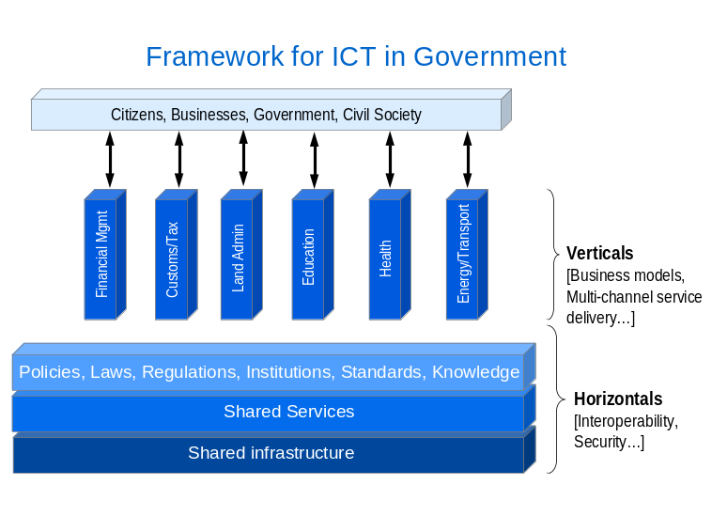
It is not uncommon that governments looking for ‘quick wins’ in the area of e-government will concentrate their efforts and resources on the verticals. Such efforts, when successful, generate support from civil society for e-government reform, and their value should not be underestimated. However, experience shows that the development of ‘verticals’ without due consideration to ‘horizontals’ tends to generate significant negative effects, which more than offset previously registered benefits. For one, the isolated development of verticals tends to perpetuate, or even feed, ‘silo cultures’ across ministries, making it much more difficult and costly to allow separate applications to communicate with one another, and significantly diminishing opportunities for economies of scale and scope. Additionally, focusing exclusively on verticals tends to strip an e-government reform from its most important long-term benefits, since it is the horizontals that yield the most significant potential as tools for reform of the public sector.

Electronic registries of various types should hence constitute a priority area for governments in the process of designing and implementing an e-government vision, policy and strategy, as they are cross-cutting in scope and support a broad array of applications relevant to a range of stakeholders.

Benefits of Governmental Registries’ Interoperability

The benefits of e-BRs as part of an interoperable set of governmental e-Services are numerous. Among them:

  - The digitalization of multiple, connected registries offers immediate and visible benefits to firms. The interoperability with registries such as pledge and land registries can offer a one-stop-shop for loan applications by businesses, while their interoperability with other registries many facilitate other services useful to businesses (e.g. fiscal exemptions, staff search, etc), eliminating the way for multiple entry of basic data and information.

  - Interoperability (a central part of the ‘horizontals’ of successful e-government strategies) yields other obvious benefits in the case of business registries. For example, when business registries can be shared between various administrations such as tax services, customs, and public procurement entities, new services can be offered to registered businesses such as pre-payment of taxes, pre-payment of customs duties, and automatic warnings about public tenders in which a particular company might be interested. Such interoperability comes as a ‘natural feature’ of e-business registries.

  - Once such an effort of informatization has been implemented for business registries, it is easily transposable to other registries (for example taxes, statistical offices – e.g. for trade or labor statistics -, land registries), increasing opportunities for economies of scale, better public services, and more savings for businesses. Statistics become more reliable and comparable, more timely, and less expensive to collect, compute and publish.

Figure 12: Interoperability of e-government Services

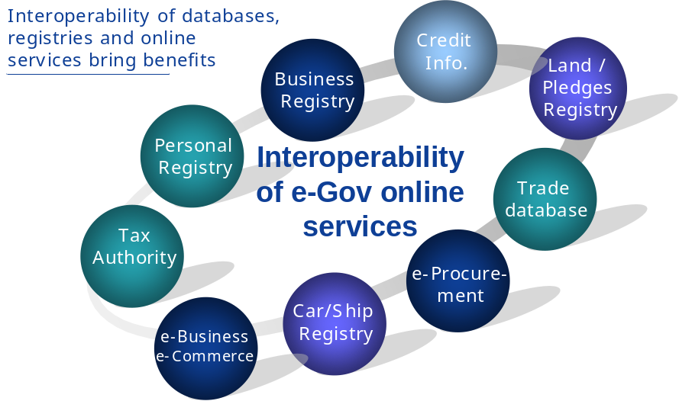

For all those reasons, it is considered ‘e-government best practice’ that e-BRs be a component of the ‘Enterprise Architecture Framework’ of any e-government strategy. As such, e-business registries also have to comply with shared implementation principles adopted by such strategies.

Several countries provide good practice examples of integrating registry services. Latvia interlinked several of its registries (see Table 2). The land registry is external but largely interlinked. Latvia uses online banking authentication methods while electronic authentication authority is being accredited.

It is not always easy to make various registries interoperable. Indeed, while some agencies cooperate, others are concerned with protecting their turf. In addition, country-specific solution are needed on whether to have one centralized IT agency, or decentralized IT departments in each agency, or a strong coordinating IT agency. In all case, it is necessary to ensure nation-wide interoperability and coverage for universal access. But, help desks and municipal offices can facilitate the initial transfer to the online platform.

Important Institutional Considerations for e-BRs and e-Government Dynamics

The following aspects are lessons learned in e-BR and e-government dynamics. Good practice implementation includes that the government:

- Outline larger policy objectives first and embed them in registry design; such an approach can for instance be centered on domestic SMEs (as job creators, innovation flag-bearers, for example), or on international companies (e.g. foreign investors for whom e-registration means less red tape, and is generally a visible marker of a good investment climate);
- Earmark a reasonable public budget for e-BR design and implementation, while keeping the door to private-public partnerships and encouraging the involvement of external players such as chambers of commerce; in addition to earmarking a budget, central governments need to take the lead in e-BR reforms and e-government strategies by providing guidance and leadership, at least in the initial stages of e-BR design and implementation;
- Foster a strong e-government champion and e-government agency; this is a prerequisite for the successful implementation of an e-government strategy, and it will be of direct benefit to the rapid and sustainable implementation of e-BRs. Many countries report problems in having Ministries agree to make their systems interoperable with a one-stop-shop. In Denmark, for example, arguably the more “open” Ministries are included in “VIRK” (English: work), the online system that links the e-BR and several other e-services, including e-taxation;
- Coordinate actions and initiatives in areas relevant to e-BRs (such as the legal and regulatory environment, the technical implementation of measures linked to a better business environment and investment climate, etc.) with a view to align them as much as possible with the development and availability of adequate IT systems. Nothing can be more detrimental to the cause of e-BRs than a premature launch, leading to failure (and backlash) because one link is missing in the chain, may it be legal, regulatory or technical;
- Avoid turf battles. Some agencies will cooperate; others will be protective of their mandate, their data and their services. Change management will hence have to be a key component of both e-BR and e-government strategies;
- Consider carefully which country-specific solutions are the most relevant sources of ‘best practices’ on whether to have one centralized IT agency, or decentralized IT departments in each agency, or a strong coordinating IT agency;
- Ensure nation-wide interoperability; this is a key ‘horizontal dimension’ of e-government, which needs to be imbedded in the earliest stages of e-BR (and other registries’) design;
- Accelerate the provision of universal Internet access; this is a far reaching national objective that goes beyond both e-government and e-BRs; various approaches should be considered (and possibly combined) to reach this objective, including PPPs, outsourcing and local solutions such as shared public access points (e.g. through local chambers of commerce or SME incubators), or WiFi / WiMAX broadband access;
- Offer help desks and local support (e.g. through municipal offices) to facilitate first transfer to online presence;
- Provide incentives to firms (especially SMEs) to become paper-less.
- Train civil servants whose job descriptions will be modified; such training (or re-training) should be considered as a tool for career upward mobility in the public sector; it should grant a significant role to life-long learning and e-learning;
- Encourage civil servants to upgrade their performance and adapt it to an e-government environment; part of the savings generated by the migration away from paper should be used to that effect;
- Communication and sensitization campaigns will need to be carried out for policy makers, civil servants, business leaders and citizens, to inform them of the plans being considered or implemented, and raise awareness of the benefits they can expect to receive from a nationwide implementation of an interoperable system;

The e-Enabling Environment

To deliver on e-BR’s promises of efficiencies and savings, it is critical that countries adopt policies for a positive, enabling e-environment for e-government in general. This encompasses policy, legal, market, and social considerations that interact at domestic and global levels to create fertile conditions for successful e-government services. They can be illustrated by three layers:

- The trust layer involves creating the enabling environment for improved citizen and private sector confidence and trust, especially in a pro-competitive legal and regulatory environment. Areas in which regulatory reform will be most important are the independent regulation of communications services and infrastructure, data privacy protection, security, intellectual property rights, Internet governance (including domain name registration), protection of critical infrastructure, and conforming to general principles of competition. In return, e-government can also contribute to creating an attractive investment climate, and building investor confidence.
- The access layer involves creating the enabling environment for access to e-government services. This includes facilitating the proper choices in public infrastructure, its technologies (e.g. broadband deployment), easy access to hardware and software needed by e-government users, and its universal accessibility by rural and marginalized populations such as the disabled or the poor. Moreover, this layer should address the social implications for access, such as maximizing the country’s potential in literacy rates, promoting capacity in computer and IT skills among the general population (e.g. through ICT education in primary, secondary, vocational and tertiary schools) and improving school enrollment.
- The applications layer involves creating the enabling environment for improved, innovative, interoperable e-government applications. Policies that need to be considered have in part been discussed earlier, and in short, are (a) implementing interoperability among government systems, operating norms and shared infrastructure (some of the vertical pillars of e-government Architecture discussed earlier), (b) implementing electronic signature laws and online user authentication that have full standing under the law, (c) promoting innovation and creativity for content solutions, and (d) contracting with the private sector as a partner in building applications and delivering services.

These layers are important elements to be considered when embarking on an e-BR reform.

Conclusion: Recommendations

Annex 1: Legal Aspects of Establishing, Implementing and Using e-BRs

The Legal Authorization Framework for Business Registries in the EU

This section describes the key legal decisions that policy makers will need to make in the design phase of implementing an e-BR. Note that the first three questions pertain more generally to business registries than to online business registries per se.

    - Judicial v. Administrative Regimes for the Registries

The members of the European Union use two separate regimes for the registration of business enterprises. Many countries such as Slovenia, Germany, and the Czech Republic use a court-based system in which business enterprises are registered with a designated commercial court and all initial and subsequent filings regarding corporate events are made with the court. The relevant commercial court oversees the operation of this activity which is handled by an administrative unit of the court. Other countries such as the UK, Spain and Sweden use a separate administrative agency to handle the enterprise filings.

Both of these systems work well and there is no intrinsic superiority of one over the other. The important issue is the internal organization and efficiency of the unit responsible for the activity.

    - The Location of Administrative Registries within the Governmental Structure

In establishing an administrative agency, a decision must be made as to where to establish the registry: in a new administrative agency under the supervision of a ministry, as part of an existing ministry or outsourced to a private company as a contractor. For example, in Latvia, The Register of Enterprises is a separate legal person that acts under the supervision of the Ministry of Justice. In the UK, the Companies House is an Executive Agency of the Department of Trade and Industry (DTI) which is somewhat administratively separate from the DTI but does not have a separate legal status. In Sweden, the Companies Registration Office is a separate government agency under the Ministry of Industry and its Director General is appointed by the government; however, it is not funded from the state budget and relies on fees for its services to finance its activities. Some countries such as Austria and Belgium have outsourced the registries to private contractors through “public-private partnership” (PPP) arrangements (discussed below), under supervision by the government.

The trend for administrative registries is towards financially self-supporting institutions which benefit the budget; however supervision is needed by the government to ensure that fee schedules are reasonable.

    - The Powers of the Registries

Registries throughout the EU have the authority to collect basic information on business enterprises in line with the requirements of the First Directive. However, this authority does not extend to verification of the data, such as the financial statements of the company. Some registry offices in Asia have the responsibility to go further than accept the filing, but this has not been the case in the EU. Compliance with the filing requirements is enforced by the establishment of penalties for the failure to file data as well as the filing of false, incomplete or inaccurate data.

Registries have the power to make information filed with them available to the public. As a result, the data is not only useful to the government in its monitoring of economic activity in the country, but is also available to citizens as a means of identifying or monitoring commercial counterparties.

Registries established under the supervision of the courts also have a role in the resolution of shareholder and corporate disputes. The information in the registry is indeed readily available to the Court in evaluating the arguments of the parties to the dispute.

    - Transparency: Nature and Scope of Information to be Provided by the Registries to the Public

Article 2 of the First Directive sets forth a minimum set of information that an enterprise should provide to the registry and the circumstances and time period in which the information must be updated. The laws and regulations in the member countries implementing this article require at least the minimum amount of information required in the Directive. Nonetheless, a country could require more if it felt it were useful.

    - Privacy: Non-public Information Retained by the Registries - EU Directive would relate to IDs of individuals that could be used for identity theft

Privacy laws related to personal data are generally not applicable to entities registering with a business enterprise registry. However, Article 2.1(d) of the First Directive requires information regarding the managers and directors of the enterprise to be made available to the public. Each country will require a different set of data to meet this general requirement in the First Directive. This information must be coordinated with the relevant privacy legislation to ensure that no protected information regarding these individuals is made public and vice versa that information that needs to be made public by the registry can legally be made public.

    - Centralized vs. Decentralized Registries
Italy – infoCamere
Italy’s infoCamere is a private provider of database services connecting 103 chambers of commerce to a single database operating under the auspices of the Ministry of Industry. It was created under a 1993 law that anticipated a distributed, national business register. In 2003, electronic filings were mandated. InfoCamere uses “advanced electronic signatures” for its electronic transactions, and processes 2.5 million transactions per year.
www.infocamere.it

Austria
Business registration in Austria is conducted at the local commercial courts which are connected via a network to the Austrian Commercial Register. Electronic filing is mandatory in Austria but Austria does not issue “certificates” or require the use of “e-signatures.
www.bmj.gv/at
Even though Article 3.1. of the First Directive requires that a Member State establish a “central register, commercial register or companies register,” it is not clear if each Member State is obligated to establish a single, centralized register. Many Member States keep their registries on a regional basis so that a company is registered in the locality where it is situated.

In the era of e-registries, this is not as significant as in the days of paper filings. A central, digital registry can be maintained which is accessible by a data terminal in the various localities of the country. This is feasible even if the initial filings are made at the regional level in paper format. Some countries, such as Germany and Spain, have already established central registries based on the regional data, which would appear to be suitable in Europe as business is increasingly cross-border and the need for easy-to-access, centralized data on businesses will increase.

    - Registries for Listed vs. Non-listed Companies

Companies listed on a stock exchange and other publicly offered companies will have more extensive disclosure requirements than the companies register. For the most part this data is made available by the exchange or by the securities regulatory authority. These registries should always be considered as a separate source of information, in addition to, but not in lieu of, the data in the enterprise registry. However, facilitating one-stop-shop access to these other sources through the business registry might be contemplated to offer greater efficiency to users of corporate data.

    - Subsidiarity (national vs. community (or cross-border) issues)

One continuing concern is the problem of multiple filings, both domestically in different regions of a country and internationally as enterprises do more and more business in non-domestic jurisdictions. Legal requirements will need to be in place to assure the harmonization of the information that is supplied to the different registries, such as mandatory periodic verification. This will be increasingly efficient with e-registries where digitalized information can be quickly and cheaply compared.

    - Other matters raised by the directive not addressed in the best practice overview

One issue that must be resolved in the national law of member states is whether the requirement in Article 3.3 of the First Directive that requests for information are to be made “in writing” would be met by an e-request with a recognized e-signature. This is best practice and should be put into effect in all member states.

The Legal Enabling Environment

This section describes legal issues that are related to the transmission of information through the registry.

  - E-registry activities are C2G/G2C electronic “transactions”

In the electronic sense, the entry of data into the e-BR is an electronic transaction, specifically a business-to-government (B2G) electronic transaction. As such, that activity should be subject to the same treatment under national e-commerce and e-signature laws as any other electronic transaction.

  - Legal validity of electronic documents and electronic signatures

The laws in member states regarding the legal validity of electronic documents and electronic signatures are governed by some well-known directives. While much has been written about those directives, we focus here on specific requirements with respect to e-BRs. The first requirement is the authentication of parties supplying information. Being able to reasonably rely on the fact that “X” is who X says it is, rests for a large part on granting the same legal validity to the electronic signature that X uses in its filings with the e-BR, as well as granting legal validity to the “electronic communication” (in this case the e-BR filing). Authentication of the party submitting an electronic document is usually governed by rules about electronic signatures.

Much has been written elsewhere about the legal validity of electronic signatures and documents, and this chapter will not repeat the existing literature. However, it is important to point out that the operation and use of an e-BR should take account of local law in respect of what constitutes a legally valid electronic document as well as a legally valid electronic signature. Electronic documents can be authenticated in a number of different ways involving encryption, date- or time-stamping or the use of public/private key infrastructure (PKI).

The authentication of the party submitting the document, as well as the authentication of its content, are key elements in ensuring trust in, and corresponding use of, the e-BR system. In this context, consideration could be given to whether “weak” or “strong” e-signature requirements are appropriate for making filings into the e-BR. Both “weak” and “strong” signatures provide a minimum level of “authentication”, while “strong” signatures also guarantee the integrity of the content of the electronic document to which the signature is attached.

Cross-border recognition of digital certificates /signatures will be essential for the realization of a pan-European system of inter-linked e-BRs.

  - Rules on dispatch and receipt

Of particular relevance to e-BRs because of the time-sensitivity of certain filings are rules of “dispatch” and “receipt.” In the context of the e-BR, dispatch is the time when an electronic communications leaves the “system” of the sender (i.e., when a filing is made) and “receipt” is the time at which that communications is received into the “system” of the e-BR. If rules on dispatch/receipt are not defined in the Member State’s national laws on e-commerce, or if they are not defined with the specificity required for purposes of any time-sensitive filings in the e-BR, special legislation addressing questions of dispatch/receipt may be required. The UNCITRAL Model Law on e-Commerce has extensive provisions regarding rules for determining dispatch and receipt of electronic messages.

  - Data Integrity and Protection / Data base management

The two principal Directives regarding protection of data privacy apply generally to natural persons. Policy-makers when designing e-BRs will need to take account of these directives to the extent that data regarding individuals are included in filings made in e-BRs (e.g., information regarding officers or directors), information about individuals filing corporate organizational documents prior to incorporation, or information about individuals in partnerships. Related to data privacy protection are issues concerning data storage, protection and use.

In cases where the data privacy directives do not apply (i.e., to legal persons, such as companies, etc., as opposed to natural persons), e-BRs will still need to ensure the integrity of the data of the legal person.

To a large degree, since an e-BR is a database, the applicable rules of the Database Directive would apply to its operation.

  - Critical Infrastructure Protection (CIP)

It is helpful to look at e-BRs as “critical infrastructure” that would be afforded the same protection as other elements of critical infrastructure. Maintaining and operating an e-BR creates certain expectations on the part of users of the registry (both data contributors and third parties seeking access to and relying on that data), as well as certain responsibilities (and perhaps liabilities) on the “owner”/operator of the registry. While the relationship between government and service provider is discussed in more detail above in the discussion of PPPs, in this section the concern is about protecting the physical aspects of the registry affecting the processing, collection, transfer and protection of the integrity of the data housed in the e-BR. Those responsible for operating e-BRs will want to ensure that any interruptions to the operation of the registry are brief, infrequent, isolated and minimally detrimental to the Member States affected.

  - Cybe-rcrime issues

Providing effective enforcement remedies and penalties are an important part of the legal enabling environment for e-transaction activities, including e-BR activities. These measures are sometime referred to as “cyber-crime” issues and address issues in the digital, on-line world that similar criminal issues deal with in the physical world. The typical issues dealt with under the rubric of cyber-crime include unauthorized access to or interference with systems; unauthorized interception of or interference with data; misuse of devices; and fraud and forgery. The principal legal source for cyber-crime in Europe is the Council of Europe Convention on Cyber-crime.

  - Interoperability

Interoperability has two components. At the national level, interoperability refers to the ability of the e-BR to interact with other databases, i.e. the ability of the e-BR database to be somehow linked to other governmental databases. Internationally, interoperability refers (i) to the ability of persons outside the Member State to be able to access and rely on data in the e-BR, and (ii) for e-BRs to be able to be used in a pan-European sense. In both cases, interoperability is the key to ensure that (1) the e-BR system “talks” to other systems in government (see also in the next chapter); and (2) recognizes the digital certificates of a foreign country.

One of the main features of the pan-European e-BR network anticipated by the BRITE (Business Register Interoperability throughout Europe) project sponsored by the EU since 2006 is that it would provide pan-European access to business data of registered firms. One of the principal legal drivers of this BRITE’s pan-European objectives is the interoperability of the different national e-BRs. Cross-recognition of digital (electronic) signatures is one important step in the direction of achieving cross-border interoperability.

Finally, in the international context, interoperability also impacts on cross-border jurisdictional issues involving the enforcement of rights and duties of data suppliers, data users relying on data contained in an e-BR, and the obligations and liabilities of the operators of e-BRs. In this sense, there is some overlap with the dispute resolution matters that may be applicable to disputes arising under the maintenance and use of e-BRs (discussed above).

Annex 2 - Legal Checklist

The Legal Enabling Environment Regarding Electronic Aspects of Business Registries

  - Legal validity of electronic documents and electronic signatures
    - Authentication and non-repudiation
    - Weak vs. strong e-signatures
    - Certification of authority
    - Cross-border recognition

  - Rules on dispatch and receipt

  - Data Integrity and Protection / Data base management
    - Data Collection, Storage, protection & use.
    - Data retention
    - Coordination with privacy rules

  - Critical Infrastructure Protection

  - Interoperability
    - With other governmental registries
    - Cross-border with other Member State e-business registries

  - Cyber-crime issues
    - Access to/interference with systems
    - Interception of/interference with data
    - Misuse of devices, data
    - Fraud, forgery

  - Other PPP Issues
    - Allocation of risk/liability
    - Recourse against provider

  - Intellectual Property Rights
    - Ownership of data

  - Cross –border/ jurisdictional issues

  - Dispute Resolution

Annex 3 – Survey summary

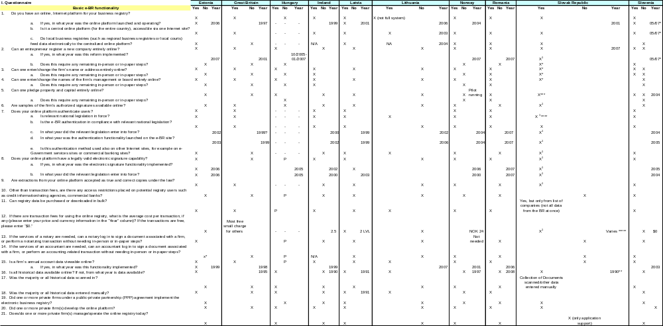

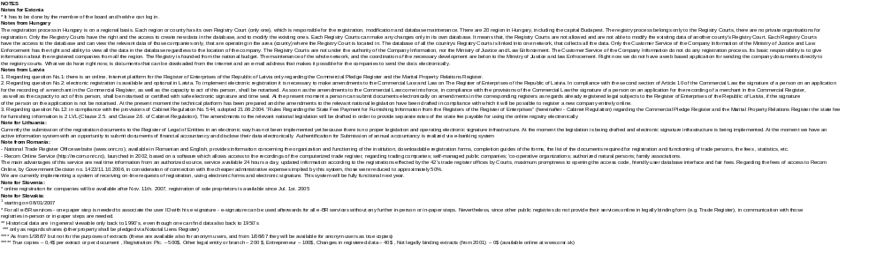

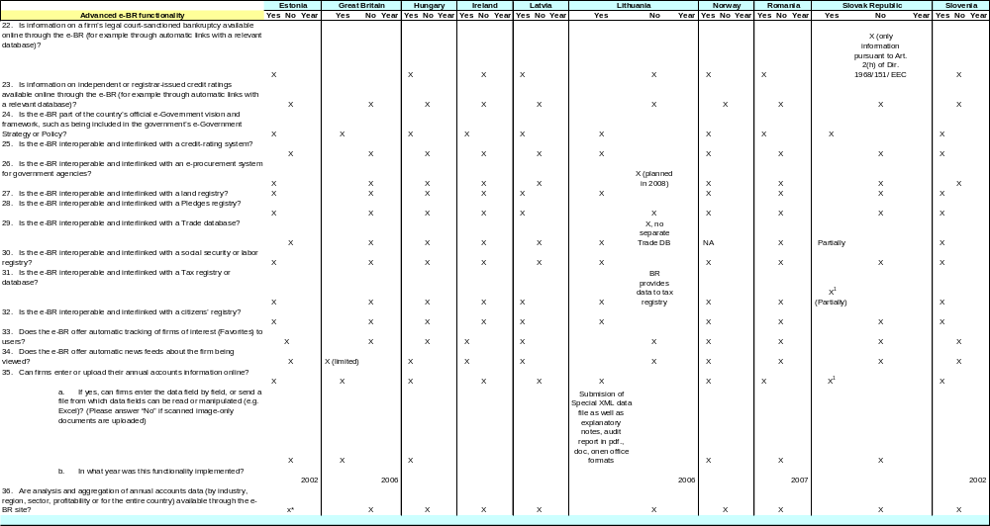

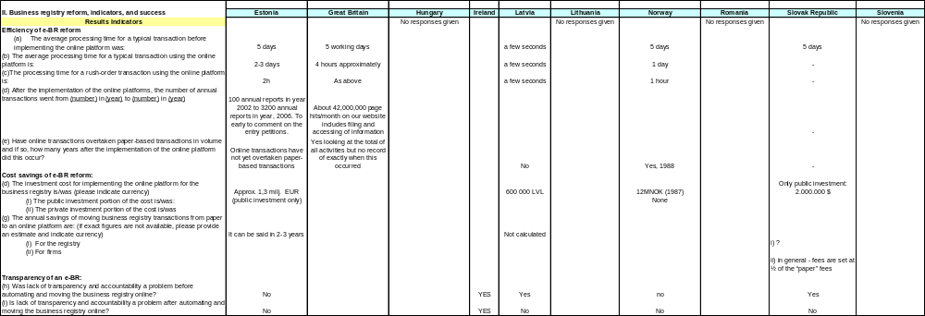

Acronyms

ADR | Alternative Dispute Resolution
B2G | Business-to-Government
BOO | Build-Own-Operate
BOOT | Build-Own-Operate-Transfer
BOT | Build-Operate-Transfer
BRITE | Business Register Interoperability Throughout Europe
C2G | Citizen-to-Government
CIP | Critical Infrastructure Protection
DBFO | Design-Building-Finance-Operate
DCA21 | e-Governance program under the Indian Ministry of Company Affairs
e-BR | Electronic Business Registry
ECA | Europe and Central Asia
EU  G2B | European Union  Government-to-Business
G2C  G2G | Government-to-Citizen  Government-to-Government
IT | Information Technology
M&E | Monitoring and Evaluation
OECD | Organization for Economic Co-operation and Development
PKI | Public/private Key Infrastructure
PPP | Public Private Partnership
SME | Small and Medium Sized Enterprises
TA | Technical Assistance
UNCITRAL | United Nations Commission on International Trade Law
VAT | Value Added Tax

References

Black, S. E. and P. E. Strahan. 2002. Entrepreneurship and bank credit availability. Journal of Finance 57, 2807-2833.
Department of the Parliamentary Library. 2002. Research Paper No. 1 2002–03, “Public Private Partnerships: An Introduction,” Australia.
Djankov, S., R. La Porta, F. Lopez-de-Silanes, and A. Shleifer. 2002. The regulation of entry. Quarterly Journal of Economics 117, 1-35.
European Commission, “Initiative on Public Private Partnerships and Community Law on Public Procurement and Concessions."
European Commission. 2003. Guidelines for Successful Public – Private Partnerships.
European Commission, Public Private Partnerships (PPP) website - includes Guidelines for Successful Public-Private Partnerships and Resource Book on PPP case studies.
Hause, J. C. and G. du Rietz. 1984. Entry, industry growth, and the microdynamics of industry supply. Journal of Political Economy 92, 733-757.
IFC. 2006. Reforming Business Registration Regulatory Procedures at the National Level: A Reform Toolkit for Project Teams.
IFC, Country Summary, Serbia Case Study. SME Toolkit Best Practice Case Studies, Nathan Associates.
IFC, Country Summary, Turkey Case Study. SME Toolkit Best Practice Case Studies, Nathan Associates.
Infodev. 2007. Public-Private Partnerships in e-government: Knowledge Map, Toolkit and Training Material (forthcoming).
InfoDev. 2007. e-government toolkit.
International Monetary Fund (IMF). 2004. “Public-Private Partnerships”.
Jacobs and Associates, Reforming Business Registration in Serbia, August 2002
Klapper, L., V. Sarria-Allende and V. Sulla. 2002. Small and medium sized enterprise financing in Eastern Europe, World Bank Working Paper No. 2933.
Klapper, L., L. Laeven and R. Rajan. 2006. Entry regulation as a barrier to entrepreneurship. Journal of Financial Economics, 82, 591-629.
Klapper, L., R. Amit, M. Guillén, and J. Quesada. 2007. Entrepreneurship and firm formation across countries, World Bank Working Paper (forthcoming).
McKinsey & Company. 2005. “Building Effective Public Private Partnerships: Lessons Learnt from the Jordan Education Initiative”.
Seira, E., D. Kaplan and E. Piedra. 2007. Entry Regulation and Business Start-Ups: Evidence from Mexico. Working Paper.
Subhash Bhatnagar, “PPP in Delivery of e-government Services to Urban and Rural Citizens: Key Lessons in Implementation.”
The Australian Government Information Management Office (AGIMO). 2002. “Public Private Partnership Opportunities in e-government”.
The National Council for Public-Private Partnerships (US), “Keys to Successful Public Private Partnership.”
UNESCO. 2005. e-government Toolkit for Developing Countries, Chapter 6, Partnerships.
Williams Trefor. 2003. “Moving to Public-Private Partnerships: Learning from Experience around the World”.
World Bank 2007. Doing Business Report. Washington, DC.
Yakovlev, E. and E. Zhuravskaya. 2007. Deregulation of Business. Working Paper.

A comprehensive publication on reforming business registries is IFC, Reforming Business Registration Regulatory Procedures at the National Level: A Reform Toolkit for Project Teams, February 2006
Note that the “EU New Member States” referred to in this paper are the Eastern European countries that joined the EU since 2000 (i.e. Bulgaria, the Czech Republic, Estonia, Hungary, Latvia, Lithuania, Poland, Romania, Slovakia and Slovenia). It does not refer to countries that joined the EU after 2000 from other regions of Europe, such as Malta and Cyprus.
First Council Directive - 68/151/EEC of 9 March 1968, as amended.
Jacobs and Associates, Reforming Business Registration in Serbia, August 2002
The Doing Business Report 2007 states that business registration takes 20 days more on average where judges are involved.
For example, Klapper, Laeven, and Rajan, 2007; Hause and Du Rietz, 1984; Black and Strahan, 2002.
For cross-country data on the cost, time, and number of procedures required to register a business, see Djankov, La Porta , Lopez de Silanes and Shleifer, 2002 or www.doingbusiness.org.
See Seira, Kaplan, and Piedra, 2007 and Yakovlev, E, E. Zhuravskaya, 2007, for studies on the effect of registration reform on entrepreneurship in Mexico and Russia, respectively.
See Klapper, Sarria-Allende, and Sulla, 2002 for a complete review of the SME sector in ECA countries.
For example, see Djankov, La Porta , Lopez de Silanes and Shleifer, 2002.
The complete database is available at: www. ifc.org/ifcext/sme.nsf/Content/Resources.
For a complete description of the survey and entrepreneurship rates, see Klapper, Amit, Guillén, and Manuel Quesada (2007).
Although most registrars remove firms that have not submitted annual filings for four years, some countries are becoming more proactive to ensure that only active firms are included. For instance, Denmark is the first registrar that confirms annually that registered firms are also filing with the tax authority.
See Seira, Kaplan, and Piedra, 2007 for evidence that the impact of registration reform in Mexico was concentrated in the first 10 months after implementation.
Access to registrar information is even more important in countries where non-banks are denied access to credit information bureaus. For instance, historical information on the firm and owners is important for leasing, factoring, and other financial decisions.
For instance, the Chamber of Commerce of Bologna, Italy (which operates a local business registry with about 80,000 registrations in 2005) estimates that the average time needed to correct entry errors was reduced from 10 days to half a day after the registry was put online.
World Bank e-BR Questionnaire, Romania response, June 2007.
For instance, the Chamber of Commerce of Bologna estimates that the implementation of its online business registry platform led to an annual cost savings of Euro343,000, resulting chiefly from staff cost and space cost savings.
For more information, please see http://www.uc.se.
In Latvia, the firm operating the e-BR, Lursoft, sells to private users data compilations and analysis prepared on the basis of the registry data. See: www.lursoft.lv
Doing Business Report, World Bank 2007
Danish Business Registry, Visit in September 2006; Italy business registry presentation by David Mitzman, September 2006.
The countries that answered the questionnaire are: Estonia, Hungary, Ireland, Latvia, Lithuania, Norway, Romania, Slovakia, Slovenia, and the United Kingdom.
*This will be possible in Slovakia beginning on August 1, 2007.
**Registration for sole proprietors has been available since July 2005. Online registration for companies will be available after November 11, 2007.
Interview with Danish registry officials, September 2006
World Bank, Doing Business Report 2007
See, Chapter 6, Public-Private Partnerships in e-government : Knowledge Map and Toolkit, infoDev and IP3 (Institute for Public Private Partnerships) (forthcoming) (“infoDev/IP3 Toolkit”)
infodev 2007, Public-Private Partnerships in e-government: Knowledge Map, Toolkit and Training Material (forthcoming)
Ibid. See chapter 7.
Ibid, Chapter 4.
Taken from Chapter 4, infoDev/IP3 Toolkit.
Ibid.
These issues are covered by the Directive on the Legal Protection of Databases, adopted by the EU Parliament and Council on March 11, 1996.
The EC recognizes the importance of having an Agency charged with Network and Information Security. This regulation places a heavy duty on EU Member countries to ensure that systems are secure and best practices are put in place to ensure protection of data, and to safeguard the security of services conducted electronic networks.
See, e.g., CIIP Handbook, Vol II, Analyzing Issues, Challenges and Prospects, explaining that private actors lack motivation to provide public goods. The overall security of an e-registry is a public good.
Ibid.
See Commission of the European Communities (2005), Green Paper on a European Programme for Critical Infrastructure Protection.
Database Directive see articles 1(2), 3, 5 and 6.
At the time of writing, a Draft Directive on certain aspects of mediation in civil and commercial matters was being considered in the EU, which can be found at: http://www.richardbutler.net/Euromed/DraftDirective0905.pdf .
For situations in which a public-private partnership did not exist prior to the reform, the pre-reform data point for this indicator would be equal to zero.
A typical basket of services would need to be defined by the local country context, which would not make this data point comparable across countries.
E-government is defined by the OECD as “the use of ICTs, and particularly the Internet, as a tool to achieve better government.” For the OECD, this means that “the impact of e-government at the broadest level is simply better government – e-government is more about government than about “e”. It enables better policy outcomes, higher quality services and greater engagement with citizens. Governments and public administrations will, and should, continue to be judged against these established criteria for success.” (OECD, The e-government Imperative, 2003).
Sometimes ‘interim solutions’ can be used, whereby an ‘emerging process’ and a pre-existing one can overlap for a certain period of transition: this is frequently the case while implementing ‘multi-channel e-government services’ (on-line and manual systems being allowed to co-exist for a while). It may also happen that a country will choose to launch a particular service even though the relevant regulatory / supervising authority has not yet been fully established: for example, Latvia started to use online banking authentication methods while its electronic authentication authority was still being accredited.
First Council Directive - 68/151/EEC of 9 March 1968, as amended.
See discussion in §3.d, below.
First among these Directives are E-commerce Directive - 2000/31/EC of 8 June 2000 (E-commerce Directive); the Electronic Signature Directive - 1999/93/EC of 13 December 1999 (e-Signature Directive); and Distance Contracts Directive - 1997/7/EC of 20 May 1997. Other sources are described in supra notes 5 & 6.
Possible future work on electronic commerce Comprehensive reference document on elements required to establish a favorable legal framework for electronic commerce: sample chapter on international use of electronic authentication and signature methods, UNICTRAL, ACN.9/630/Add.3, available at: http://daccessdds.un.org/doc/UNDOC/GEN/V07/822/59/PDF/V0782259.pdf?OpenElement (UNCITRAL Future Work). It is worth noting that while not an explicit requirement, the e-Commerce and e-signature Directives essentially adopt a PKI-based approach which involves the issuing of so-called digital certificates as well as the establishment of processes and organizations responsible for issuing such certificates.
See, e.g., e-Commerce Directive – “electronic signatures” or so-called weak signatures are described in articles 2(1); and “advanced electronic signatures” based on a qualified certificate (so-called “strong e-signatures”) are described in articles 2(2) and 5.
Cross-border recognition is required by article 7(1) of the e-signature Directive.
See, article 15, and the accompanying text in the explanatory notes to article 15 in Paragraphs 100-107 of the “Guide to Enactment” of the UNCITRAL Model Law on Electronic Commerce 1996 with Guide to Enactment, with additional article 5 bis as adopted in 1998, (Uncitral e-Commerce Model Law).
Data Privacy Directive – 95/46/EC; Privacy and Electronic Communications - 2002/58/EC; Directive on Data Retention – COM (2005) 438 (amends 2002/58/EC).
Directive 96/9/EC of the European Parliament and of the Council of 11 March 1996 on the legal protection of databases (Database Directive). The application of the Database Directive to intellectual property matters raised by databases can be found in the text accompanying infra note 15.
For general principles applicable to critical infrastructure protection in the EU, see, Green Paper on EPCIP - COM (2005) 576; and European Council Framework Decision on Attacks Against Information Systems – 2005/222/JHA.
Op cit. An excellent survey of national and international CIP measures – including the national legal frameworks – can be found in the Critical Information Infrastructure Handbook (2006) (“CIIP Handbook which can be found at: http://www.crn.ethz.ch/publications/crn_team/detail.cfm?lng=en&id=16156
Council of Europe Convention on Cybercrime, http://conventions.coe.int/Treaty/en/Treaties/Html/185.htm
See http://www.imu.iccs.gr/sweg/papers/SS0606vanElstL.pdf

