GENDER IN WATER
SNAPSHOTS
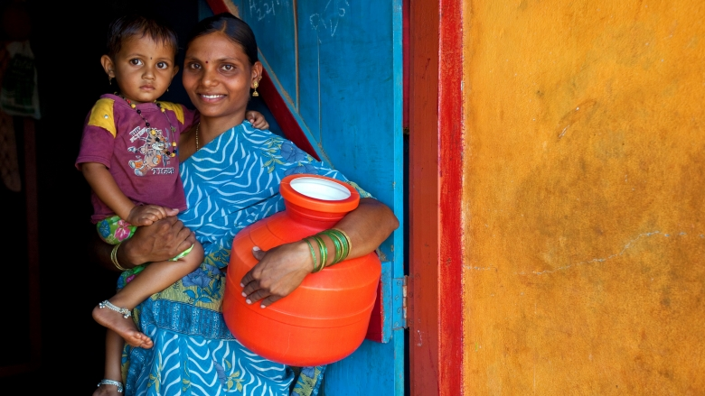

  - INDIA | Swachh Bharat Mission - Gramin

Photo credit: World Bank, Achieving a Clean and Healthy Rural India Video

Context
In many parts of the world, a combination of social norms and lack of adequate sanitation facilities leaves people with little choice but to defecate in the open. In India, back in 2015, open defecation was practiced by about 56 percent of the population. These high numbers correlated to the shortages of adequate sanitation, with well over 70 percent of rural households lacking access to safe sanitation facilities at that time. Poor sanitation and hygiene have detrimental effects on the health and well-being of millions, but particularly hurt by it are women and girls, who are forced to walk long distances to relieve themselves, exposed to risks of sexual violence or harassment. Moreover, the absence of safe sanitation facilities is often the principal factor deterring girls from attending school and women from accessing paid employment.
To address these gaps, in 2014, the Government of India launched a flagship sanitation program, Swachh Bharat Mission - Gramin (“Clean India Mission - Rural”, or, SGM-G), that seeks to eliminate open defecation in rural India by 2019. The World Bank provides support to this program through technical advice and a USD 1.5 billion loan. The program aims to provide sanitation facilities, such as toilets, to households, schools, and public institutions in the villages, and to ensure effective solid and liquid waste management systems. Since implementation, the program has reported increased rural sanitation coverage to about 82 percent of households, and about 58 percent of villages have been declared as open defecation free (ODF).
Unlike previous sanitation programs, SBM-G stands out with its shift in emphasis on changing behavior at the collective level, aiming to create lasting demand for toilet use among the population, and thereby ensuring and sustaining ODF status in the villages. It provides flexibility to the states in implementation, while following the broad guidelines set under SBM-G. Understanding gender differences in behavior, needs, and social norms related to sanitation, is a key component in the program design. To advance gender inclusion, the program includes a range of activities and far-reaching guidelines.
The role of women in community mobilization and local leadership
With the overall aim of triggering people themselves to demand that their villages become ODF, the
SBM-G program empowers community leaders and networks of change agents to become frontrunners in the behavior change campaigns. Paramount to this approach is the role given to women in leading their communities towards sustained sanitation. Women have distinctive roles in sanitation and unique understandings of the health benefits of clean and safe sanitation, and it is believed that sanitation programs spread more rapidly where women have a greater say. Multiple channels have enabled the emergence of women leaders throughout the country. The program promotes allocation of half of the seats in village water and sanitation committees to women. Additionally, the program mobilizes women as ‘foot soldiers’ (called Swachagrahis), who are responsible for motivating, assisting, constructing, and ensuring sustained latrine use by every person in the village. Out of the total 440,000 Swachagrahis mobilized across the country, about 40 percent are women. Women are also involved in village-level surveillance committees run exclusively by women, in charge of checking the sanitation behavior of villagers. Women have also mobilized localized collective action by forming self-help groups, or by acquiring leadership roles in formal local institutions and in informal community groups.
Menstrual Hygiene Management (MHM)
SBM-G pays particular attention to menstruating women and adolescent girls, recognizing that to safeguard their safety, privacy, and dignity, adequate menstrual hygiene management (MHM) must be ensured. For this, the program earmarks specific funds for awareness-raising activities aimed at breaking the stigmas and taboos around menstruation, specifying that these funds must be targeted to the entire community, including to girls, boys, women, and men to be effective. Separate MHM guidelines provide instructions on the design of public segregated facilities, recommending that they include safety and comfort considerations in toilet design, such as ample lighting, private entrances, sufficient water and space, disposal bins with lids, and incinerators.
Gender Guidelines
The importance given to women is reflected in the SBM-G guidelines. By taking a comprehensive approach to sanitation, recognizing that in different stages of a human life cycle sanitation requirements vary, the guidelines aim to ensure that benefits of the program reach all community members, particularly women and vulnerable groups. As such, the activities in the guidelines span from birth to old age, focusing on the diverse sanitation needs of the caregivers of infants and children, adolescent girls experiencing puberty, menstruating and pregnant women, the chronically ill, persons with disabilities, and the elderly.
Three years into implementation of SBM-G, the Government of India has further elaborated its guidelines to be more forward-looking on gender inclusivity. Among other, the new guidelines aim to overturn gender stereotypes, such as by giving recognition to the roles and sanitary needs of ‘third-sex’ persons.
All this shows that deeply embedded in the SBM-G is not only a gender-sensitive approach, but, moreover, an aspiration to empower all gender identities.
Sources and additional information:
JMP 2017 Update: Progress on Drinking Water, Sanitation and Hygiene
2 Chambers, R. 2009, Going to Scale with Community-Led Total Sanitation: Reflections on Experience, Issues and Ways Forward, IDS PRACTICE PAPER 1
- http://projects.worldbank.org/P153251?lang=en
- http://swachhbharatmission.gov.in/sbmcms/writereaddata/images/pdf/Guidelines/Complete-set-guidelines.pdf
- https://mdws.gov.in/sites/default/files/Guidelines%20on%20Gender%20issues%20in%20Sanitation.pdf
Note prepared based on inputs from Michael Haney, Raghava Neti, Xavier Chauvot De Beauchene, Soma Ghosh, and Mariappa Kullappa

Gender Snapshot #1. June 2018
Water Global Practice http://www.worldbank.org/water

For more information about this series, contact: Toyoko Kodama tkodama@worldbank.org

JMP 2017 update: Progress on Drinking Water, Sanitation and Hygiene
Chambers, Robert, 2009, Going to Scale with Community-Led Total Sanitation: Reflections on Experience, Issues and Ways Forward, IDS PRACTICE PAPER 1

