Chongqing New Urbanization Pilot & Demonstration Project
Nan’an Subproject

Social Assessment Report
(2nd Version)

Chongqing Nan’an Development and Reform Commission
Chongqing Inturer Technology Development Co., Ltd.
March 2018

Contents
Table 3
Figure 3
1. Introduction 6
1.1 Background of the Subproject 6
1.2 Overview of SA 7
1.2.1 Purpose and main tasks 7
1.2.2 Subjects and scope 8
1.2.4 Methods 9
1.2.5 Key concerns 10
2. Socioeconomic Profile of the Subproject Area 12
2.1 Demographics 12
2.2Economic and social development 13
3. Sampling Survey on Local Households 15
3.1 Sampling method 15
3.1.1 Screening of target communities 15
3.1.2 Determination of sample size 17
3.2Socioeconomic profile 19
3.2.1 Age and gender 19
3.2.2 Educational level 19
3.2.3 Employment 20
3.2.4 Income 20
4. Stakeholder Analysis 22
4.1 Stakeholder identification 22
4.2.1 Current situation of old communities and residents’ needs 23
4.2.2 Current situation of public spaces and residents’ needs 28
4.2.3 Current situation of areas of Urban Slow Traffic System Renewal and residents' needs 29
5. Local Poor Population 31
5.1 MLS population 31
5.2 Extremely poor population 33
5.3 Floating population 33
5.4 Disabled population 34
5.5 Main needs of special groups 35
5.5.1 Poor population 35
5.5.2 Floating population 35
5.5.3 Disabled population 35
6. Social Impact Analysis 37
6.1 Old Community Renewal 37
6.1.1 Positive impacts 37
6.1.2 Negative impacts 37
6.2 Public Space Renewal 38
6.2.1 Positive impacts 38
6.2.2 Negative impacts 39
6.3 Urban Slow Traffic System Renewal 39
6.3.1 Positive impacts 39
6.3.2 Negative impacts 40
6.4 Measures to mitigate negative impacts 40
6.4.1 LA and HD impacts 40
6.4.2 Measures to reduce traffic and safety impacts 40
6.4.3 Negative environmental impacts 41
6.4.4 Negative impacts on special groups 41
7. Social Gender Analysis 42
7.1 Local women’s perceptions of, needs for and suggestions on the Subproject 42
7.1.1 Situation of local women 42
7.1.2 Statistics of female samples in the questionnaire survey 42
7.1.3 Women’s main needs for the Subproject 43
7.1.4 Suggestions on the Subproject 44
7.2 Positive impacts of the Subproject on women 45
7.3 Negative impacts of the Subproject on women and mitigation measures/plan 46
7.4Gender Action Plan 46
8. Public Participation 48
8.1 Forms and process of public participation at the preparation stage 48
8.1.1 Site visit 48
8.1.2 Questionnaire survey 48
8.1.3 Key informant interview 48
8.1.4 FGD 48
8.2 Public participation plan for the implementation stage 51
9.3Grievance redress mechanism 51
9. Social Risks and Social Action Plan 53
9.1 Social risks in project design 53
9.2 Social risks in project implementation 53
9.3 Management and maintenance risks 54
9.4 Social Action Plan 55
Appendix 1 FGD Minutes 59
Appendix 2 In-depth Interview Minutes 62
Appendix 3 Key Informant Interview Minutes 63
Appendix 4 Fieldwork Photos 67

Abbreviations

AP | - | Affected People
FGD |  | Focus Group Discussion
HD | - | House Demolition
LA | - | Land Acquisition
MLS | - | Minimum Living Security
PMO | - | Project Management Office
RAP | - | Resettlement Action Plan
SA | - | Social Assessment

Units

Currency unit = Yuan (RMB)
US$1.00 = RMB6.33
1 hectare = 15 mu

1. Introduction

1.1 Background of the Subproject
Chongqing Municipality is located in southwestern China, bordered by Hubei and Hunan Provinces on the east, Guizhou Province on the south, Sichuan Province on the west and Shaanxi Province on the north, with a land area of 82,400 km², governing 38 districts / counties, with a resident population of 30.4843 million, an urbanization rate of 62.6% and a GDP of 1.755876 trillion yuan in 2016. As China’s 4th municipality directly under the central government, Chongqing is an economic, financial, scientific, shipping and trading logistics center on the upper Yangtze River, and an important node on the Belt and Road, and in the Yangtze River Economic Belt.
Nan’an District is an urban district of Chongqing Municipality, surrounded by the Yangtze River on the west and north, opposite to Jiulongpo, Yuzhong and Jiangbei Districts across the river, bordered by Banan District on the east and south, with a land area of 262.43 km², governing 8 sub-districts and 7 towns, with a registered population of 699,500, a resident population of 873,900 (including an urban population of 829,900), and an urbanization rate of 94.97% in 2016.
As one of the urban districts of Chongqing undergoing rapid urbanization, Nan’an District has many old communities, mostly built before China’s housing system reform. These communities are faced with serious problems, such as insufficient supporting facilities, illegal construction, insufficient parking spaces, and poor sanitation, affecting residents’ living quality and urban image directly.
The Nan’an District Regeneration Subproject (hereinafter, the “Subproject”) aims to improve road accessibility, and the availability and quality of public spaces through the improvement of public spaces and urban slow traffic systems, as well as urban planning and management capacity. The subproject area is about 60 km².
The gross investment in the Subproject is 1.94246 billion yuan, including a Bank loan of 438.2837 million yuan. The Subproject consists of Old Community Renewal, Public Space Renewal, Urban Slow Traffic System Renewal, and Urban Planning and Management Research, and Capacity Building. See Table 1-1.

Table 1-1 Components
Component |  | Description
Old Community Renewal | Nanping Sub-district | 83 buildings with 4,678 houses in 11 blocks in 4 communities (Dongxing Road, Jinzi Street, Yangguang, Xiangshui Road), mainly including public facility renewal, street facility improvement and addition (benches, stairways, urban furniture, etc.), water supply and drainage pipelines, etc.
 | Huayuanlu Sub-district | 158 buildings with 9,715 houses in 8 blocks in 4 communities (Jinshan Road, Jinyan, Gulouwan and Nanhu), mainly including public facility renewal, street facility improvement and addition (benches, stairways, urban furniture, etc.), water supply and drainage pipelines, etc.
 | Nanshan Sub-district | 27 buildings with 1,740 houses in 10 blocks in 2 communities (Huangjueya and Wuzhenshan), mainly including public facility renewal, street facility improvement and addition (benches, stairways, urban furniture, etc.), water supply and drainage pipelines, etc.
Public Space Renewal | Optimization of existing parks | Improvement of public spaces of Nanhu, Guohuishan and Houbao Communities, including addition of recreational facilities, pavement improvement, landscaping, green space improvement, etc.
 | Optimization of existing squares | Improvement of public spaces of Nanping and Huigong Square, including pavement improvement, addition of recreational and living facilities, and urban furniture, etc.
 | Utilization of open spaces | Utilization of old spaces under Dafosi Bridge, and construction of waterfront spaces, including footpath, pavement, landscaping and supporting facilities
Urban Slow Traffic System Renewal | Slow traffic footpaths | Improvement of 29 slow traffic footpaths, including sign renewal, addition of resting facilities, trash bins and urban furniture, landscaping, etc.
 | Mountain climbing footpaths | Improvement of 16 mountain climbing footpaths, including blind road opening, pavement renewal, addition of resting facilities, power distribution facilities and pipelines, etc.
 | Supporting roads | 3 urban connecting roads (769m Longhuang Highway broadening, 1,403m Hugui Road and 647m Tushan Branch Road), including sidewalks, pavements, street-crossing facilities, supporting pipelines, etc.
Urban Planning and Management Research, and Capacity Building |  | Urban renewal planning and research of Nan’an District; management innovation and capacity building; development of a slow traffic system app for Nan’an District; project management, etc.

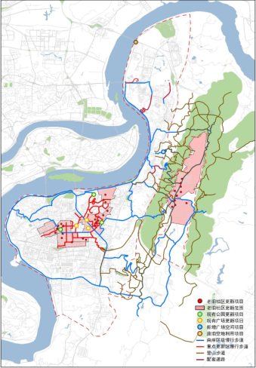
Figure 1-1 Location map of the Subproject

1.2 Overview of SA

1.2.1 Purpose and main tasks
This SA aims to learn stakeholders’ expectations and needs, identify the Subproject’s positive and negative impacts, and design a series of measures to ensure that stakeholders participate extensively and benefit from the Subproject, and the benefits of the Subproject are maximized. Therefore, the main tasks of this SA are:
1) Identifying the Subproject’s primary stakeholders, learning their perceptions of and needs for the Subproject, and collecting their comments on the Subproject;
2) Identifying the Subproject’s impacts on and potential risks to stakeholders, especially women, the poor, the disabled and other vulnerable groups;
3) Promoting extensive public participation, especially women, the poor and other vulnerable groups, and proposing a project management pattern and a public participation strategy accordingly;
4) Learning the current situation of local old communities, public spaces and slow traffic footpaths, and the Subproject’s positive and negative impacts on the subproject area and local residents;
5) Developing a social action plan to optimize the subproject design, evade risks and promote the realization of the subproject objectives.
In 2017, Nan’an District’s minority population accounted for 1.05% of gross population; in the subproject area, Nanping Sub-district’s minority population accounted for 0.65%; Huayuanlu Sub-district’s minority population for 0.35%; and Nanshan Sub-district’s minority population for 0.59%. Local minority population has moved in by employment, migration and marriage mainly, and there is no hereditary or centrally-living minority population here. Thus, the Subproject does not trigger OP4.10, and it is not necessary to prepare an ethnic minority development plan.
Urban Slow Traffic System Renewal involves the permanent acquisition of 14.2 mu of collective land, and the demolition of rural residential houses of 1,450 m², urban residential houses of 539 m² and houses with limited property rights of 4,636.8 m², affecting 31 households with 90 persons. According to OP4.12 and BP4.12, a resettlement action plan (RAP) should be prepared for the Subproject.

1.2.2 Subjects and scope
This SA involves the 3 components of Old Community Renewal, Public Space Renewal and Urban Slow Traffic System Renewal mainly, and aims to evaluate their impacts, local adaptability and acceptance. This SA covers 7 sub-districts and 3 towns in Nan’an District, which are densely populated, and has 82% of the district’s population and many old communities. Among the 3 sub-districts involved in Old Community Renewal, Nanshan Sub-district has rich natural and cultural resources, a relatively large population converted from rural status into urban status, and a low income level, and many houses here were built before 2000; Nanping and Huayuanlu Sub-districts are located in central Nan’an District, and there are many old communities with no maintenance and property management here, and many houses here were built in 1980s or 1990s.

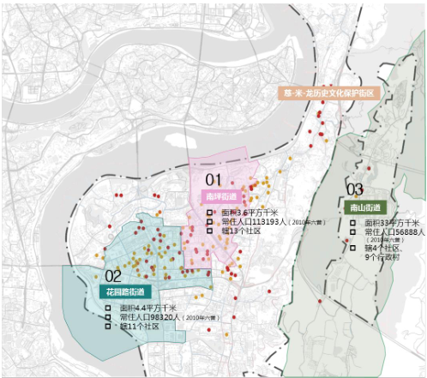
Figure 1-2 3 Sub-districts involved in Old Community Renewal
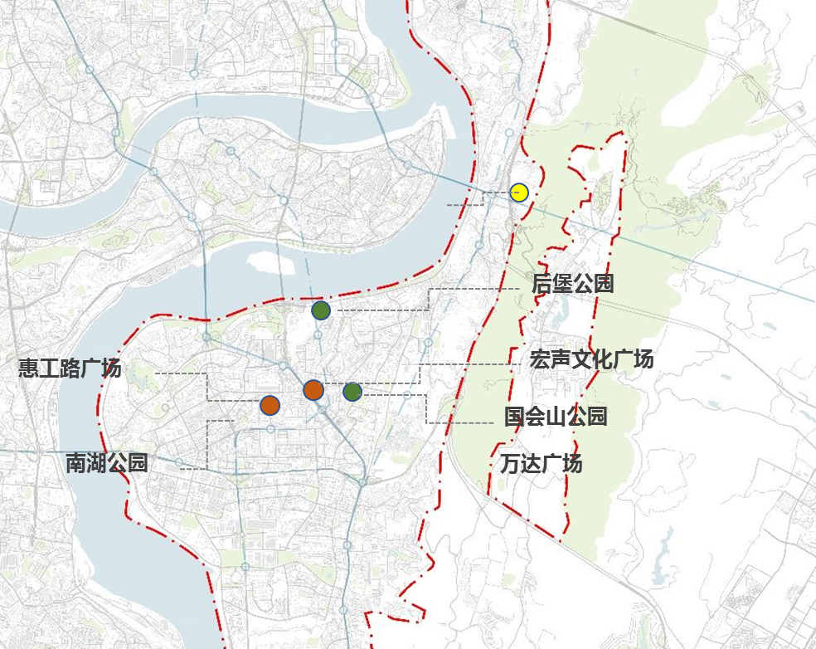
Figure 1-3 Location map of Public Space Renewal
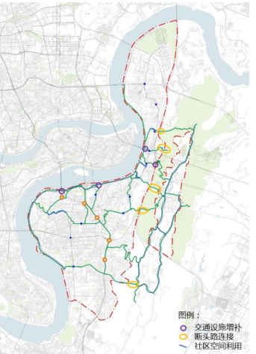
Figure 1-4 Location map of Urban Slow Traffic System Renewal

1.2.4 Methods
1) FGD
54 FGDs were held in 28 communities in Nanping, Nanshan and Huayuanlu Sub-districts in the beneficiary area of Old Community Renewal, including 27 FGDs with women, to learn residents’ needs for the Subproject, the Subproject’s impacts, and relevant comments and suggestions through brainstorming. 32 FGDs were held in 17 communities in the beneficiary area of Public Space Renewal, including 16 FGDs with women, with 436 participants in total, including 207 women, accounting for 47.8%; 167 residents aged 60 years or above, accounting for 38.3%; and 48 poor and disabled residents, accounting for 11%.
2) Key informant interview
Key informant interviews were conducted with 30 men-times of key informants from the district labor and social security bureau, employment bureau, civil affairs bureau, ethnic and religious affairs bureau, fire control detachment, public security bureau, land reservation center, women’s federation, disabled people’s federation, sub-district offices and town governments, Chongqing Jiangnan Urban Construction & Asset Management Co., Ltd., Nanshan Ecological Belt Management Committee, and community committees to learn the Subproject’s impacts and potential risks, relevant needs and suggestions, etc.
3) In-depth interview
20 in-depth interviews were conducted with residents’ representatives in the area of Old Community Renewal to learn their attitudes to and needs for the Subproject, and the Subproject’s potential impacts on and risks to them. 66 in-depth interviews were conducted in the area of Public Space Renewal to learn residents’ satisfaction with and needs for public spaces. 32 in-depth interviews were conducted in the area of Urban Slow Traffic System Renewal to learn residents’ satisfaction with and needs for road conditions, sanitation, urban furniture, supporting facilities, etc.
4) Participatory observation
Participatory observation was conducted on local community roads, infrastructure, landscaping, exterior walls, parks, squares, footpaths, etc. to gain a more intuitive understanding of the current situation of the subproject area.
5) Questionnaire survey
Through two rounds of screening, 28 communities affected by Old Community Renewal and 17 affected by Public Space Renewal were selected for the questionnaire survey at sampling rates of 3% for communities with 500 or less households, 2% for those with 500-1,000 households and 1% for those with over 1,000 households, with 450 copies in total, covering community parking management, sanitation, landscaping, roads, facade, drainage and infrastructure for Old Community Renewal, and overall environment of public spaces, protective facilities, lighting, convenience, comfort, road occupation for parking, resting facilities, management, maintenance, accessibility, etc. for Public Space Renewal. Among the samples, males account for 40.4% and females for 59.6%.For the slow traffic system, 256questionnaires were finished within the scope of the 28communities affected by Old Community Renewal, and the survey focused on the degree of satisfaction and demand of residents on the roads, sanitation, urban furniture, and supporting facilities.
6) Literature review
Local statistical yearbooks, bulletins, development plans, information on local socioeconomic profile, special plans, policies, regulations, summaries of past relevant activities were collected from the district development and reform commission, labor and social security bureau, employment bureau, civil affairs bureau, ethnic and religious affairs bureau, fire control detachment, public security bureau, land reservation center, women’s federation, disabled people’s federation, sub-district offices and town governments, Chongqing Jiangnan Urban Construction & Asset Management Co., Ltd., Nanshan Ecological Belt Management Committee, and community committees.

Table 1-2 Survey methods and statistics
Component |  | FGDs | Key informant interviews |  | HHs surveyed | In-depth interviews
 |  |  | District agencies, owner | Sub-districts, communities
Old Community Renewal |  | 54 | 18 | 12 | 256 | 20
Public Space Renewal | Huigong Road, Hongsheng Square and Wanda Square | - |  |  | - | 56
 | 4 parks | 32 |  |  | 194 | 10
Urban Slow Traffic System Renewal |  | - |  |  | 256 | 32

1.2.5 Key concerns
This report describes the local socioeconomic profile, and issues in old communities, public spaces and slow traffic footpaths, identifies primary stakeholders,analyzes their needs and impacts, identifies the Subproject’s potential positive and negative impacts, and social risks, analyzes local women’s development, the Subproject’s impacts on women and their needs for the Subproject, studies how to incorporate stakeholders into the Subproject and propose a public participation plan, and proposes measures to avoid or mitigate negative impacts.
The key concerns of this SA are:
1) Old communities, public spaces and slow traffic footpaths: current situation of the subproject area, residents’ needs, the Subproject’s positive and negative impacts, and measures to mitigate negative impacts;
2) Public participation: how to involve local residents in the Subproject, potential issues, and relevant mechanism and strategy, especially the participation of old people, women and the poor;
3) Social gender: participation of women in the Subproject’s design, construction and implementation, and how to ensure that women play an effective role in improving the sustainability of the Subproject; and
4) The poor: participation of the poor in the Subproject, the Subproject’s impacts on them, and how to ensure that they benefit from the Subproject

2. Socioeconomic Profile of the Subproject Area
Chongqing Municipality is located in southwestern China, bordered by Hubei and Hunan Provinces on the east, Guizhou Province on the south, Sichuan Province on the west and Shaanxi Province on the north, with a land area of 82,400 km², governing 38 districts / counties, with a resident population of 30.4843 million, an urbanization rate of 62.6% and a GDP of 1.755876 trillion yuan in 2016. As China’s 4th municipality directly under the central government, Chongqing is an economic, financial, scientific, shipping and trading logistics center on the upper Yangtze River, and an important node on the Belt and Road, and in the Yangtze River Economic Belt.
Nan’an District is an urban district of Chongqing Municipality, surrounded by the Yangtze River on the west and north, opposite to Jiulongpo, Yuzhong and Jiangbei Districts across the river, bordered by Banan District on the east and south, being an urban industrial and business center.

2.1 Demographics
At the end of 2016, Chongqing had a registered population of 33.9211 million, up 202,700 or 0.61% from 2015, including 16.4687 million females, accounting for 48.55%; an urban population of 19.0845 million, and a population aged above 65 years of 3.8197 million, accounting for 12.53%.
In 2016, Nan’an District had a registered population of 700,100, up 19,000; a resident population of 873,900, up 15,800, a female population of 356,200, accounting for 50.88%; an urban population of 640,400, accounting for 91.47; a newborn population of 6,174 (birth rate 9.35‰); a dead population of 3,183 (death rate 4.82‰);and a natural population growth rate of 4.53‰. Urban resident population was 830,000, accounting for (urbanization rate)94.97% of gross population, up 0.4 percentage point.
Nan’an District governs 8 sub-districts and 7 towns, in which Longmenhao, Tongyuanju, Haitangxi, Danzishi, Nanping, Nanshan and Huayuanlu Sub-districts, and Nanping, Tushan and Jiguanshi Towns are covered by the Subproject.

Table 2-1 Administrative divisions of the subproject area
Division | Communities / villages | Communities | Villages
Nan’an District | 150 | 92 | 58
Tongyuanju Sub-district | 9 | 9 | 0
Huayuanlu Sub-district | 11 | 11 | 0
Nanping Sub-district | 13 | 13 | 0
Meitangxi Sub-district | 10 | 10 | 0
Longmenhao Sub-district | 5 | 5 | 0
Danzishi Sub-district | 9 | 9 | 0
Nanshan Sub-district | 13 | 4 | 9
Nanping Town | 11 | 9 | 2
Tushan Town | 10 | 8 | 2
Jiguanshi Town | 8 | 3 | 5

The 7 sub-districts and 3 towns had a registered population of 574,100, accounting for 82% of Nan’an District’s registered population; a female population of 292,400, accounting for 82.09% of Nan’an District’s female population; and an urban population of 568,800, accounting for 88.82% of Nan’an District’s urban population.

Table 2-2 Registered population of the subproject area (0,000)
Division | Component (Old Community Renewal: A; Public Space Renewal: B; Urban Slow Traffic System Renewal: C) | HHs | Population | Gender |  | Total population
 |  |  |  | Male | Female | Urban | Rural
Chongqing Municipality |  | 1260.88 | 3392.11 | 1745.24 | 1646.87 | 1776.60 | 1615.51
Nan’an District |  | 27.71 | 70.01 | 34.39 | 35.62 | 64.04 | 5.97
Longmenhao Sub-district | C | 1.00 | 2.46 | 1.21 | 1.24 | 2.46 | 0
Tongyuanju Sub-district | C | 2.17 | 5.40 | 2.63 | 2.77 | 5.40 | 0
Meitangxi Sub-district | C | 2.47 | 6.73 | 3.38 | 3.35 | 6.73 | 0
Danzishi Sub-district | B, C | 1.59 | 3.94 | 1.94 | 2.00 | 3.94 | 0
Nanping Sub-district | A, B, C | 3.54 | 9.57 | 4.67 | 4.90 | 9.57 | 0
Nanshan Sub-district | A, C | 1.72 | 4.23 | 2.10 | 2.13 | 3.70 | 0.53
Huayuanlu Sub-district | A, B, C | 3.08 | 8.64 | 4.30 | 4.34 | 8.64 | 0
Nanping Town | B, C | 3.80 | 9.26 | 4.47 | 4.79 | 9.26 | 0
Tushan Town | C | 2.46 | 5.74 | 2.78 | 2.96 | 5.74 | 0
Jiguanshi Town | C | 0.63 | 1.44 | 0.68 | 0.76 | 1.44 | 0
Source: Statistical Yearbook 2017 of Chongqing Municipality, Statistical Yearbook 2017 of Nan’an District

2.2Economic and social development
1) GDP and composition
In 2016, Chongqing’s GDP was 1.755925 trillion yuan, up 184.198 billion yuan or 11.2% from 2015, in which the added value of primary industries was 15.309 billion yuan, up 13.3%; that of secondary industries 68.628 billion yuan, up 9.7%; and that of tertiary industries 100.261 billion yuan, up 13.3%. In 2016, Chongqing’s general public budgetary revenue was 222.79117 billion yuan, up 7%; and general public budgetary expenditure 400.181 billion yuan, up 4.9%.
In 2016, Nan’an District’s GDP was 74.55 billion yuan, up 10.8%. in which the added value of primary industries was 430 million yuan, down 6.8%; that of secondary industries 43.38 billion yuan, up 11.3%; and that of tertiary industries 30.74 billion yuan, up 10.3%.
The ratio of primary, secondary and tertiary industries of Nan’an District changed from 0.7:59.2:40.1 in 2015 to 0.6:58.2:41.2 in 2016.
2) Fiscal revenue

Table 2-3 Fiscal revenues of Chongqing Municipality and Nan’an District (2016)
Division | General public budgetary revenue (0,000 yuan) |  |  |  |  | General public budgetary expenditure (0,000 yuan)
 | Total | VAT | Business tax | Corporate income tax | Personal income tax
Chongqing Municipality | 13,914,170 | 1,714,723 | 1,018,999 | 920,987 | 282,082 | 28,771,265
Nan’an District | 705,079 | 71,914 | 43,623 | 26,058 | 12,413 | 1,146,476
Source: Statistical Yearbook 2017 of Chongqing Municipality

In 2016,Nan’an District’s local fiscal revenue was 7.55 billion yuan, down 2.3% from 2015, including public fiscal revenue was 7.05 billion yuan, down 8.8%, and tax revenue 5.01 billion yuan, down 6.1%. Fiscal expenditure was 14 billion yuan, up 2.0%.
3) Income and expenditure
In 2016, the per capita disposable income of residents of Nan’an District was 32,160 yuan, up 8.5%, in which the per capita disposable income of urban residents was 32,983 yuan, up8.3%, and the per capita disposable income of rural residents 17839 yuan, up9.0%.

Table 2- 4 Income indicators of Nan’an District and Chongqing Municipality (2016)
 | Nan’an District | Chongqing Municipality
Average pay of in-service employees of urban non-private organizations (yuan) | 67,978 | 67,386
Per capita disposable income of urban residents (yuan) | 32,983 | 29,610
Per capita disposable income of rural residents (yuan) | 17,839 | 11,549
Source: Statistical Yearbook 2017 of Chongqing Municipality, Statistical Yearbook 2017 of Nan’an District

In 2016, the per capita nonproductive expenditure of urban residents of Nan’an District was 22,420 yuan, up 10.2%; the per capita nonproductive expenditure rural residents 11,317 yuan, up 2.1%; and the per capita savings balance of urban and rural residents 60.16 billion yuan, up 7.8%.

3. Sampling Survey on Local Households

3.1 Sampling method

3.1.1 Screening of target communities
A sampling survey was conducted in communities covered by Old Community Renewal and Public Space Renewal. The sample communities were selected based on certain factors. First, the task force visited all communities affected by the Subproject, and learned their conditions, issues and needs through random interviews with community officials and residents; second, the task force selected sample communities based on each component’s features and coverage; finally, all the 28 communities covered by Old Community Renewal and the 17 communities covered by Public Space Renewal were selected as the sample communities. Totally 42 sample communities covered, because 3 are affected by both Old Community Renewal and Public Space Renewal.
For Public Space Renewal, 3 rounds of screening were conducted as follows:
First, screening was conducted based on the positioning of public spaces. For open public spaces whose main users are not nearby community residents, research was conducted by interview other than door-to-door questionnaire survey. Therefore, communities near Huigong Road, Hongsheng Square and the Nanping Subway Station were not covered by the door-to-door questionnaire survey.
Second, communities within “areas directly affected” by public spaces were selected. A directly affected area is defined as follows:
- within the same block as the public space;
- within 5 minutes’ walk from the public space; and
- with good accessibility to the public space
Third, screening based on community type was conducted. For similar communities near the same park, only one was selected for the questionnaire survey. Similar communities should meet all the following conditions:
- having the same form of business (old multi-storied, modern multi-storied, single commercial building);
- having the same path to the public space; and
- having a similar number of households
For a large community, some buildings are far away from and have poor accessibility to the public space. Such communities are corrected for the number of households based on the area actually affected by the public space for questionnaire distribution.
17 out of 21 communities affected by Public Space Renewal were selected as above. See Table 3-1 and Figure 3-1.

Table 3- 1 Screening of target communities in the sampling survey for Public Space Renewal
Township | Community | No. | Community | # of buildings | HHs | Corrected HHs | Old / new | Surrounding public space | Walking timeto public space (minute) | Covered by questionnaire survey? | Remarks
Nanping Sub-district | Houbao | 1 | Houbao Community | 36 | 1,680 | 1,680 | Old | Houbao Park | 1 | Yes
 |  | 2 | Coral Waterfront (Phase 2) | 3 | 762 | 300 | New | Houbao Park | 3 | Yes | Only one building has access to Houbao Park.
 |  | 3 | Agate Garden | 14 | 1,508 | 750 | Old | Houbao Park | 3 | Yes | Only 4 buildings have access to Houbao Park.
 | Dongxing Road | 4 | Ningjing Community | 8 | 1,009 | 1,009 | Old | Guohuishan Park | 1 | Yes
 |  | 5 | Changhang Community |  | 1,200 | 1,200 | Old | Guohuishan Park | 1 | Yes
 |  | 6 | Xiangshui Jingyuan | 1 | 306 | 306 | Old | Guohuishan Park | 5 | Yes
Nanping Town | Furen | 7 | Chengnan Shijia | 4 | 1,508 | 1,508 | New | Guohuishan Park | 4 | Yes
 |  | 8 | Jingyuan | 1 | 300 | 300 | New | Guohuishan Park | 5 | - | Similar to Chengnan Shijia
 |  | 9 | Kangde Guohuishan | 25 | 6,649 | 2,000 | New | Guohuishan Park | 4 | Yes | Only 1/3 of the buildings have access to Guohuishan Park.
 |  | 10 | Mingfa Shangdu International | 4 | 940 | 940 | New | Guohuishan Park | 6 | - | Similar to Kangde Guohuishan
Huayuanlu Sub-district | Nanhu | 11 | Huayuancun 1 | 9 | 660 | 660 | Old | Nanhu Park | 4 | Yes
 |  | 12 | Huayuancun 2 | 12 | 572 | 572 | Old | Nanhu Park | 2 | Yes
 |  | 13 | Huayuancun 3 | 9 | 252 | 252 | Old | Nanhu Park | 2 | Yes
 |  | 14 | Huayuancun 4 | 5 | 480 | 480 | Old | Nanhu Park | 3 | Yes
 |  | 15 | Huayuancun 5 | 6 | 664 | 664 | Old | Nanhu Park | 2 | Yes
 |  | 16 | Huayuancun 6 | 7 | 588 | 588 | Old | Nanhu Park | 2 | Yes
 |  | 17 | Huayuancun 7 | 21 | 1,248 | 1,248 | Old | Nanhu Park | 4 | Yes
 |  | 18 | Huazhu Garden | 2 | 579 | 579 | New | Nanhu Park | 2 | Yes
 |  | 19 | Nanguo Garden | 1 | 290 | 290 | New | Nanhu Park | 7 | - | Similar to Huazhu Garden
 |  | 20 | Diamond Age | 2 | 548 | 548 | New | Nanhu Park | 7 | - | Similar to Huazhu Garden
Danzishi Sub-district | Dafosi | 21 | Longhu Lijiang | 26 | 2,582 | 2,582 | New | Riverfront space under the Dafosi Bridge | 3 | Yes

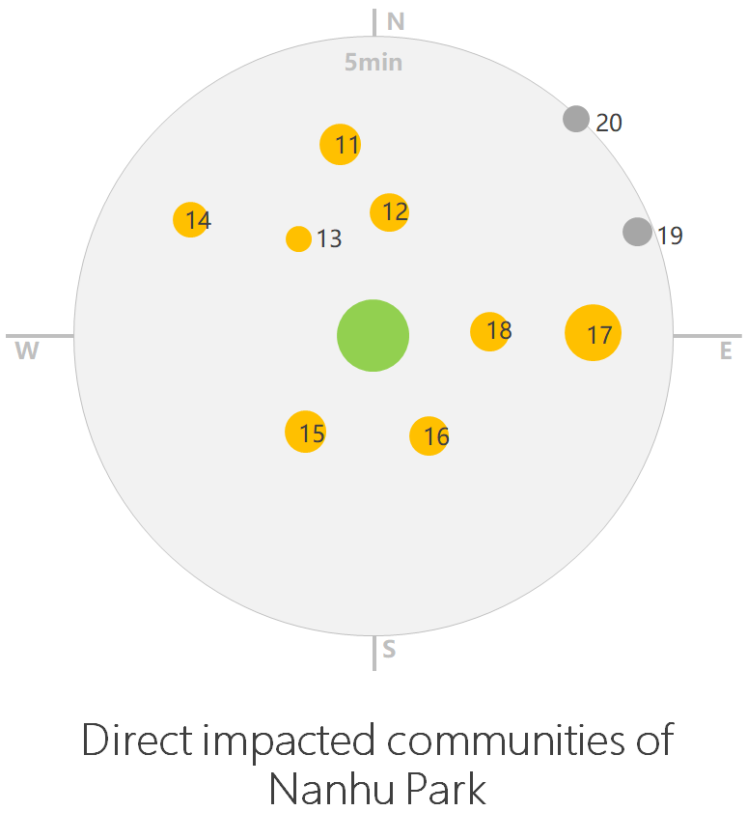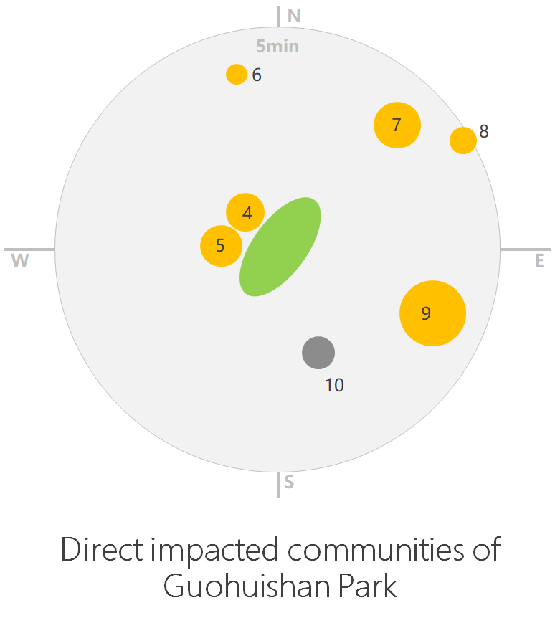
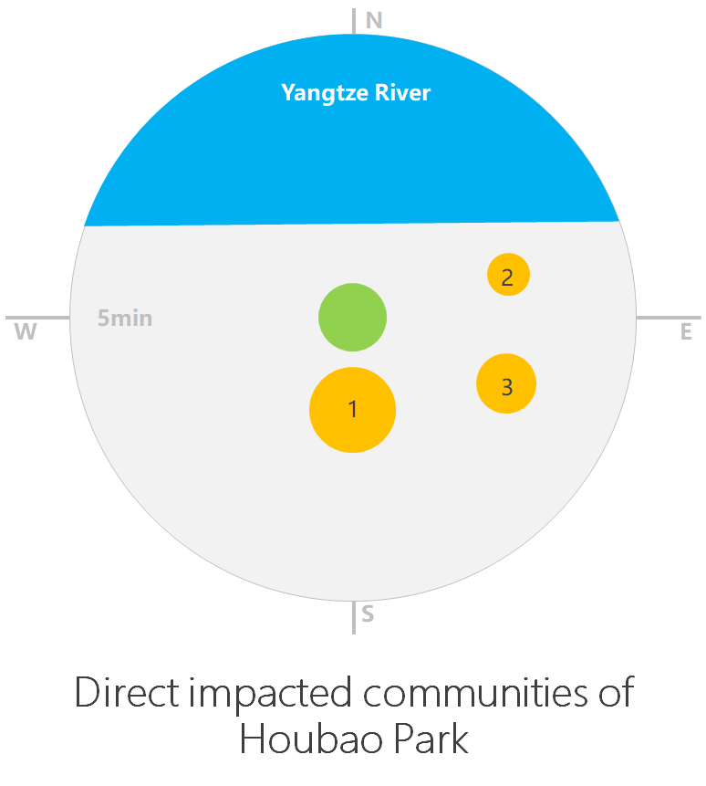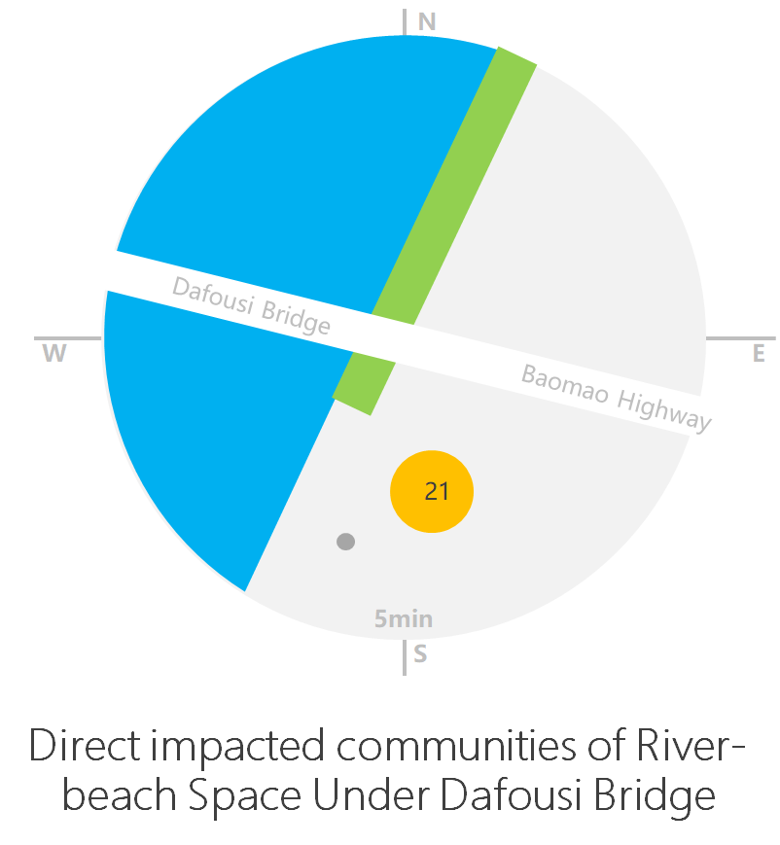
Note: The size of a circle is proportional to the number of households of the corresponding community. Yellow circle refers to community surveyed, while grey one refers to community not surveyed.
Figure 3-1 Locations and sizes of communities around public spaces

3.1.2 Determination of sample size
For the 42 sample communities (3 are affected by both Old Community Renewal and Public Space Renewal), the questionnaire survey was conducted at sampling rates of 3% for communities with 500 or less households, 2% for those with 500-1,000 households and 1% for those with over 1,000 households, with 272copies planned for the communities affected by Old Community Renewal and 238copies planned for those affected by Public Space Renewal. Residents in the communities affected by Old Community Renewal supported the survey well, but residents in some high-class communities affected by Public Space Renewal (e.g., Longhu Lijiang, Chengnan Shijia and Kangde Guohuishan) did not, so some copies under Public Space Renewal were invalidated. After screening, there were 450 valid copies in total, including 256 under Old Community Renewal and 194 under Public Space Renewal. For Public Space Renewal, the task force conducted some random interviews as a supplement.

Table 3-2 Statistics of questionnaire survey
Sub-district / township | Community | Area | # of buildings | Planned copies |  | Actual copies
 |  |  |  | Old Community Renewal | Public Space Renewal | Old Community Renewal | Public Space Renewal
Huayuanlu Sub-district | Gulouwan | Gulou 1 | 3 | 11 | 0 | 11 | 0
 | Jinshan Road | Chongqing Electric Power Construction Company Family Housing | 35 | 16 | 0 | 16 | 0
 | Jinyan | Nancheng Road No 245,247 | 2 | 8 | 0 | 8 | 0
 |  | Tuanyuanbao Area | 20 | 17 | 0 | 17 | 0
 | Nanhu | Huayuancun 1 | 9 | 12 | 12 | 12 | 11
 |  | Huayuancun 2 | 12 | 15 | 15 | 15 | 10
 |  | Huayuancun3 | 9 | 0 | 8 | 0 | 8
 |  | Huayuancun4 | 5 | 12 | 12 | 12 | 12
 |  | Huayuancun 5 | 6 | 0 | 13 | 0 | 11
 |  | Huayuancun6 | 7 | 0 | 12 | 0 | 12
 |  | Huayuancun 7 | 21 | 0 | 12 | 0 | 12
 |  | Huazhu Garden | 2 | 0 | 12 | 0 | 12
Nanping Sub-district | Dongxing Road | No.34-37 Xiangshui Road | 4 | 12 | 0 | 12 | 0
 |  | Xinhua Community | 7 | 9 | 0 | 9 | 0
 |  | Alley 3, Nanping East Road | 12 | 12 | 0 | 12 | 0
 |  | Ningjing Community | 8 | 0 | 10 | 0 | 10
 |  | Changhang Community |  | 0 | 12 | 0 | 11
 |  | Xiangshui Jingyuan | 5 | 0 | 9 | 0 | 9
 | Houbao | Houbao Community | 36 | 0 | 26 | 0 | 10
 |  | Coral Waterfront (Phase 2) | 3 | 0 | 9 | 0 | 9
 |  | Agate Garden | 14 | 0 | 15 | 0 | 12
 | Zijin Street | Hexie Community (No.204, 206, 208 and 210) | 4 | 3 | 0 | 3 | 0
 |  | No.196 Jinzi Street | 3 | 2 | 0 | 2 | 0
 | Xiangshui Road | No.15-25 Xiangshui Road | 6 | 6 | 0 | 6 | 0
 |  | Xingyu Garden | 4 | 12 | 0 | 12 | 0
 |  | No.27 Xiangshui Road | 10 | 15 | 0 | 15 | 0
 | Yangguang | No.10-12 Fuhong Road | 8 | 10 | 0 | 10 | 0
 |  | No.26 Fuhong Road | 11 | 11 | 0 | 11 | 0
 |  | No.4 and No.36-40 Fuhong Road | 14 | 12 | 0 | 12 | 0
Nanping Town | Furen | Chengnan Shijia | 4 | 0 | 15 | 0 | 13
 | Kangde | Kangde Guohuishan | 25 | 0 | 20 | 0 | 12
Nanshan Sub-district | Huangjueya | Huangjue Community | 6 | 18 | 0 | 15 | 0
 |  | No.1, 3, 5, 7 and 9 Xinjian Street Community | 5 | 13 | 0 | 13 | 0
 |  | Nanshan Shopping Center | 1 | 3 | 0 | 3 | 0
 |  | No.10, 12, 92 and 93 Chongwen Road | 4 | 1 | 0 | 2 | 0
 | Wuzhenshan | Cairui Garden | 3 | 3 | 0 | 3 | 0
 |  | Erwailao Dormitory Building | 2 | 1 | 0 | 5 | 0
 |  | Jinwo Community | 1 | 1 | 0 | 5 | 0
 |  | Lijing Garden | 2 | 6 | 0 | 5 | 0
 |  | No.135 Chongwen Road | 1 | 1 | 0 | 5 | 0
 |  | Huangxiao Dormitory Building | 2 | 0 | 0 | 5 | 0
Danzishi Sub-district | Dafosi | Longhu Lijiang | 26 | 0 | 26 | 0 | 20
Total |  |  | 358 | 242 | 229 | 256 | 194
Source: SA survey(January 2018)

3.2Socioeconomic profile

3.2.1 Age and gender
For Old Community Renewal, there were 256 valid copies, in which males and females accounted for 38.7% and61.3% respectively, minors and old people aged 60 years or above for 48.1%, and those aged 18-60 years for 51.9%. For Public Space Renewal, there were 194 valid copies, in which males and females accounted for 43.3% and 56.7% respectively, minors and old people aged 60 years or above for 40.7%, and those aged 18-60 years for 59.3%. In general, the age and gender distribution of the samples is quite uniform. See Table 3-3.

Table 3-3 Distribution of ages
Age | Old Community Renewal |  | Public Space Renewal
 | N | Percent (%) | N | Percent (%)
Less than 18 years | 1 | 0.4 | 3 | 1.5
18-30 years | 14 | 5.5 | 25 | 12.9
31-40 years | 15 | 5.9 | 23 | 11.9
41-50 years | 41 | 16 | 37 | 19.1
51-60 years | 63 | 24.6 | 30 | 15.5
60 years or above | 122 | 47.7 | 76 | 39.2
Total | 256 | 100 | 194 | 100
Source: SA survey (January 2018)

3.2.2 Educational level
Among the respondents of Old Community Renewal, those having received senior high school / secondary technical school or below education account for 88.7%, and those having received junior college or above education for 11.3% only. It can be inferred that the overall educational level of residents living in these old communities is below average. Among the respondents of Public Space Renewal, those having received senior high school / secondary technical school or below education account for 76.2%, and their overall educational level is slightly higher than that of those living in old communities, but is also below average, because the proportions of old people, rural residents converted into urban status and tenants are high in old communities.

Table 3-4 Distribution of educational levels
Educational level | Old Community Renewal |  | Public Space Renewal
 | N | Valid percent (%) | N | Valid percent (%)
Junior high school or below | 173 | 67.6 | 95 | 49.3
Senior high school / secondary technical school | 54 | 21.1 | 52 | 26.9
Junior college | 19 | 7.4 | 24 | 12.5
Undergraduate | 9 | 3.5 | 21 | 10.8
Graduate or above | 1 | 0.4 | 1 | 0.5
Total | 256 | 100 | 194 | 100
Source: SA survey (January 2018)

3.2.3 Employment
For Old Community Renewal, 9.6% of the respondents work at enterprises or public institutions, and 40.4% choose “other”, including rural residents converted into urban status and self-employers.
For Public Space Renewal, of the respondents work at enterprises or public institutions 63.7%; and 36.3% choose “other”, mainly including laid-off workers and rural residents converted into urban status.

Table 3-5 Distribution of occupations
Occupation | Old Community Renewal |  | Public Space Renewal
 | N | Valid percent (%) | N | Valid percent (%)
Administrative organ or public institution | 16 | 6.3 | 20 | 10.3
State-owned enterprise | 68 | 26.7 | 53 | 27.4
Private enterprise | 67 | 26.3 | 50 | 25.9
Foreign enterprise or joint venture | 1 | 0.4 | 0 | 0
Other | 103 | 40.4 | 70 | 36.3
Total | 256 | 100 | 194 | 100
Source: SA survey(January 2018)

3.2.4 Income
For Old Community Renewal, 65.5% of the respondents have annual household income of 50,000 yuan or less, and 2.8% over 300,000 yuan; for Public Space Renewal, 46% of the respondents have annual household income of 50,000 yuan or less, and 35.3%50,000-100,000 yuan. According to the Statistical Yearbook 2017 of Nan’an District, the average pay of in-service employees of urban non-private organizations was 67,978 yuan in 2016, and the household income of nearly half of the respondents was 50,000 yuan or less. Therefore, their overall income level was low.

Table 3-6 Distribution of annual household income
Annual household income | Old Community Renewal |  | Public Space Renewal
 | N | Valid percent (%) | N | Valid percent (%)
50,000 yuan or less | 164 | 65.6 | 86 | 46
50,000-100,000 yuan | 54 | 21.6 | 66 | 35.3
100,000-200,000 yuan | 19 | 7.6 | 23 | 12.3
200,000-300,000 yuan | 6 | 2.4 | 6 | 3.2
300,000-500,000 yuan | 4 | 1.6 | 4 | 2.2
Over 600,000 yuan | 3 | 1.2 | 2 | 1.1
Total | 250 | 100 | 187 | 100
Source: SA survey(January 2018)

In conclusion, those communities covered by Old Community Renewal and Public Space Renewal were aged and constructed in the nineties of the last century. After thirty or forty years, all kinds of facilities gradually aged and architectural appearance became dilapidated old. The proportion of the aged and tenants in these communities is high, and the household income is below the average level of the Nan’an district.

4. Stakeholder Analysis

4.1 Stakeholder identification
Stakeholders refer to individuals or groups affecting or affected by the realization of the objectives of the Subproject. According to the survey, the Subproject’s primary stakeholders include: 1) local residents, especially women, children, old people, the disabled, the poor, floating population and other vulnerable groups; and 2) local enterprises and stores. Secondary stakeholders include: 1) the PMO, owner, design agency, etc.; and 2) government agencies concerned.
1) Local residents
Local residents are a primary stakeholder, including community residents affected by Old Community Renewal, residents using or expected to use public spaces under Public Space Renewal, residents to be resettled under Urban Slow Traffic System Renewal, and residents using slow traffic footpaths and mountain climbing footpaths. The beneficiary population is about 574,100, and covers about 80% of the land area of Nan’an District.
Old Community Renewal will help improve overall community environment and security, and residents’ living quality through integrated environment and facility improvement. Public Space Renewal will increase the utilization of public spaces, and provide better leisure and recreational spaces to residents. Urban Slow Traffic System Renewal will improve urban accessibility and safety, and relieve urban traffic pressure. In addition, the improvement of community infrastructure, public spaces and slow traffic systems will also benefit old people, the disabled and women.
LA and HD in Urban Slow Traffic System Renewal will have some negative impacts on local residents. In addition, machinery operation and material transport during construction will occupy roads, and generate noise and waste to affect residents’ health and living environment. However, the Subproject’s advantages will outweigh its disadvantages, and its negative impacts will be temporary.
2) Local enterprises and stores
4 roads under Urban Slow Traffic System Renewal will involve the relocation of Chongqing Southwest No.2 Pharmaceutical Factory and nearly 30 stores See the Resettlement Due Diligence Report and the RAP for details.
Numerous stores near old communities, public spaces and slow traffic footpaths will benefit from the Subproject, and offer more job and income-generating opportunities to more residents. The increased pedestrian volume of public spaces and slow traffic footpaths will bring more revenue to stores, and promote local economic growth.
During construction, roads will be occupied, and noise and dust will affect nearby stores’ operations, thereby reducing their income. However, these stores will benefit in the long run.
3) Local schools
Local schools include kindergartens, primary schools, high schools, colleges and universities in the subproject area.
①Kindergartens: Kindergartens near some old communities are affected by wastewater and short of fire fighting facilities, posing certain safety risks to children. The renewal of communities, public spaces and supporting facilities will be crucial for children.
②Primary and high schools: Old Community Renewal involves Huangjueya Primary School, Chongqing No.2 Foreign Language School, Guangyi High School, etc. in Nanshan Sub-district, and Urban Slow Traffic System Renewal involves some primary and high schools. Road and infrastructure improvement will provide better living and traffic conditions to teachers and students. In addition, Yemaoxi Primary School involved in Urban Slow Traffic System Renewal has been no longer enrolling new students since September 2017. Its students and teachers have been transferred to other primary schools by the district education commission. HD compensation is being negotiated. This will be discussed in further detail in the RAP.
③Colleges and universities: The affected colleges and universities in the subproject area are Chongqing University of Posts and Telecommunications, Chongqing Technology and Business University, and Chongqing Medical and Pharmaceutical College. The former two universities will benefit from Old Community Renewal and Urban Slow Traffic System Renewal, while the latter will be relocated.
4) PMO, owner, government agencies concerned, etc.
The Subproject Leading Group has been established, and its members are leaders of the district development and reform commission, finance bureau, land and resources bureau, construction commission, etc. The Nan’an PMO under the Subproject Leading Group is responsible for coordinating and managing the preparation and implementation of the Subproject. The owner of the Subproject is Chongqing Jiangnan Urban Construction & Asset Management Co., Ltd., and Chongqing Huangshan Industry Co., Ltd. Other supporting agencies include the district development and reform commission, land and resources bureau, LA management office, and construction commission, sub-district offices, etc.

4.2 Stakeholder demand analysis
The main needs of stakeholders have been collected by means of FGD, sampling survey, interview, etc. See Table 4-1.

Table 4-1 Main needs of stakeholders
No. | Stakeholder | Main needs
1 | Local residents | 1) Need for sufficient compensation and proper resettlement; 2) need for improved community environment and public spaces infrastructure; 3) need for traffic safety and convenience; and 4) need for improved road infrastructure and convenience of slow traffic systems (see Sections 4.2.1, 4.2.2 and 4.2.3)
2 | Local enterprises and stores | 1) Need for proper resettlement and compensation; 2) improved roadside environment and public spaces; and 3) need for increased pedestrian volume
3 | Local schools | 1)Need for reasonable compensation and proper resettlement; 2) need for improved roads, pavements and supporting facilities; and 3) need to evade negative impacts, especially safety issues
4 | PMO, owner, government agencies concerned, etc. | Completing the Subproject successfully, promoting the renewal of community environment, public spaces and slow traffic systems in Nan’an District, and improving residents’ production level and living standard through the cooperation of all agencies concerned

The task force learned needs of local residents – the most important stakeholder – in depth by means of sampling survey, FGD and interview.

4.2.1 Current situation of old communities and residents’ needs
4.2.1.1 Current situation
The respondents’ overall satisfaction with their communities is low, especially due to poor sanitation, unsound facilities, poor exteriors and aged pipelines. The respondents in Nanshan Sub-district has the lowest overall satisfaction, especially in respect of septic tanks and sewer lines, fire fighting facilities, and roof water proofing; those in Nanping Sub-district are dissatisfied with public facilities, fire fighting facilities and fitness facilities mainly; those in Huayuanlu Sub-district are dissatisfied with parking management, fitness facilities, septic tanks and sewer lines mainly.

Table 4-2 Satisfaction with the current situation of communities
Satisfaction | Sub-district | Parking management | Sanitation | Septic tanks and sewer lines | Landscaping | Roads | Rain drainage | Fire fighting facilities | Facades | Roof water proofing | Wires, optical fibers, etc. | Fitness facilities | Public facilities
Very satisfied | Nanping | 6.54% | 6.54% | 5.61% | 7.48% | 6.54% | 5.61% | 2.80% | 7.48% | 6.54% | 4.67% | 4.67% | 1.87%
 | Huayuanlu | 1.14% | 2.27% | 0 | 0 | 0 | 1.14% | 0 | 0 | 3.41% | 1.14% | 2.27% | 0
 | Nanshan | 0 | 1.85% | 0 | 1.85% | 0 | 0 | 0 | 0 | 0 | 0 | 0 | 0
Satisfied | Nanping | 22.43% | 33.64% | 35.51% | 26.17% | 39.25% | 54.21% | 17.76% | 24.30% | 42.99% | 26.17% | 19.63% | 14.02%
 | Huayuanlu | 11.36% | 17.05% | 18.18% | 22.73% | 18.18% | 28.41% | 19.32% | 14.77% | 23.86% | 25.00% | 18.18% | 21.59%
 | Nanshan | 14.81% | 14.81% | 5.56% | 12.96% | 16.67% | 14.81% | 3.70% | 3.70% | 3.70% | 9.26% | 11.11% | 3.70%
Neither, nor | Nanping | 27.10% | 21.50% | 31.78% | 33.64% | 26.17% | 19.63% | 24.30% | 33.64% | 20.56% | 25.23% | 21.50% | 29.91%
 | Huayuanlu | 21.59% | 37.50% | 40.91% | 43.18% | 39.77% | 38.64% | 32.95% | 51.14% | 31.82% | 38.64% | 26.14% | 37.50%
 | Nanshan | 20.37% | 16.67% | 5.56% | 33.33% | 22.22% | 12.96% | 9.26% | 25.93% | 12.96% | 35.19% | 24.07% | 12.96%
Dissatisfied | Nanping | 26.17% | 20.56% | 23.36% | 26.17% | 21.50% | 14.02% | 24.30% | 26.17% | 22.43% | 33.64% | 31.78% | 40.19%
 | Huayuanlu | 37.50% | 31.82% | 22.73% | 25.00% | 31.82% | 21.59% | 38.64% | 26.14% | 28.41% | 23.86% | 38.64% | 32.95%
 | Nanshan | 38.89% | 37.04% | 29.63% | 38.89% | 37.04% | 46.30% | 22.22% | 51.85% | 53.70% | 44.44% | 25.93% | 42.59%
Very dissatisfied | Nanping | 17.76% | 17.76% | 3.74% | 6.54% | 6.54% | 6.54% | 30.84% | 8.41% | 7.48% | 10.28% | 22.43% | 14.02%
 | Huayuanlu | 28.41% | 11.36% | 18.18% | 9.09% | 10.23% | 10.23% | 9.09% | 7.95% | 12.50% | 11.36% | 14.77% | 7.95%
 | Nanshan | 25.93% | 29.63% | 59.26% | 12.96% | 24.07% | 25.93% | 64.81% | 18.52% | 29.63% | 11.11% | 38.89% | 40.74%
Source: SA survey(January 2018)

Table 4-3 Satisfaction of residents with communities (%)
 | Very satisfied | Satisfied | Neither, nor | Dissatisfied | Very dissatisfied
Parking management | 3.1 | 16.8 | 24.6 | 32.8 | 22.7
Sanitation | 3.9 | 23.0 | 25.8 | 29.7 | 17.6
Septic tanks and sewer lines | 2.3 | 22.3 | 29.3 | 25.8 | 20.3
Landscaping | 3.5 | 21.5 | 37.9 | 28.5 | 8.6
Roads | 2.7 | 26.2 | 30.9 | 28.9 | 11.3
Rain drainage | 2.7 | 36.3 | 25.8 | 23.0 | 12.1
Fire fighting facilities | 1.2 | 14.8 | 23.4 | 30.5 | 30.1
Facades | 3.1 | 16.4 | 37.1 | 32.8 | 10.5
Roof water proofing | 4.3 | 27.0 | 23.0 | 32.0 | 13.7
Wires, optical fibers, etc. | 2.7 | 21.5 | 32.0 | 33.2 | 10.5
Fitness facilities | 3.1 | 16.8 | 24.6 | 32.8 | 22.7
Public facilities | 0.8 | 14.1 | 30.9 | 37.1 | 17.2
Source: SA survey (January 2018)

The main issues facing these old communities are:
1) Irregular parking and serious road occupation
55.5% of the respondents are dissatisfied with parking in communities, because parking spaces in old communities are far from enough to meet parking demand. In addition, irregular parking is prevalent, affecting and vehicle and pedestrian traffic, and endangering property and personal safety.
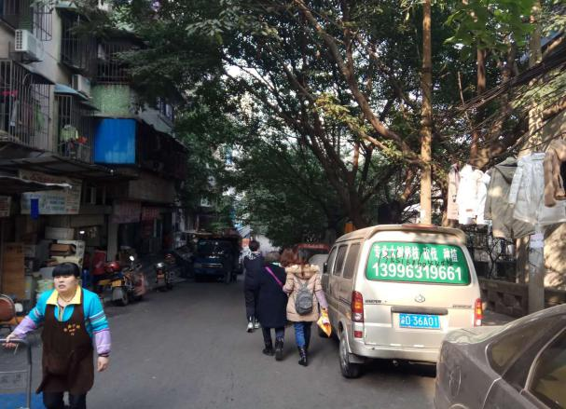
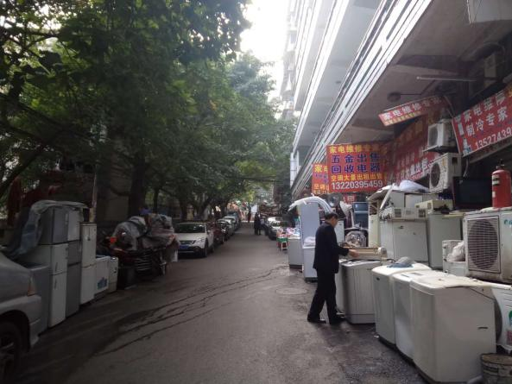

Figure 4-1 Road occupation in Dongxing Road Community, Nanping Sub-district

2) Untimely waste cleanup, and aged septic tanks and sewer lines
47.3% of the respondents are dissatisfied with community sanitation. In these old communities, old furniture, domestic waste and other sundries are dumped anywhere, not only causing inconveniences to residents, but also increasing the probability of bacterial spreading and disease infection.
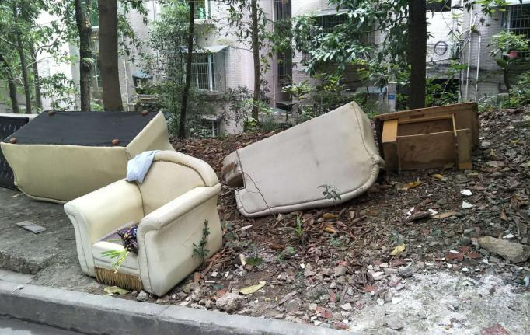
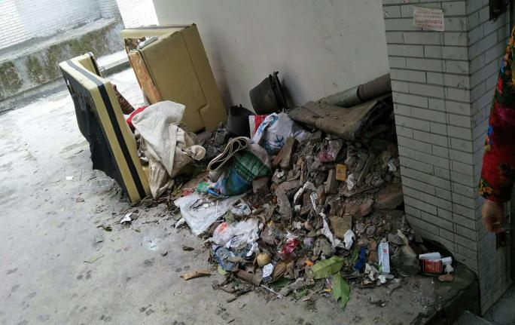

Figure 4-2 Randomly discarded waste in Nanshan Sub-district

46.1% of the respondents are dissatisfied with septic tanks and sewer lines in communities, which are likely to be blocked or leak, affecting community sanitation and comfort greatly. In addition, the accumulation of biogas is likely to cause safety risks.

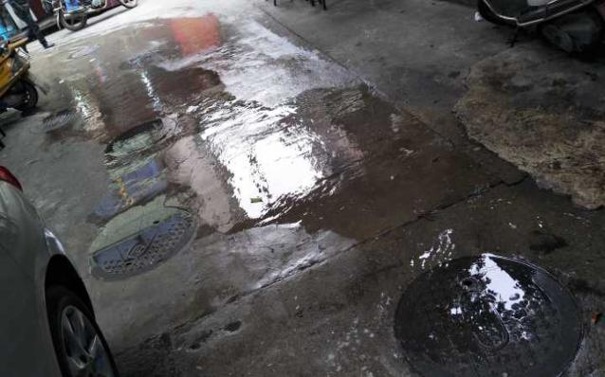
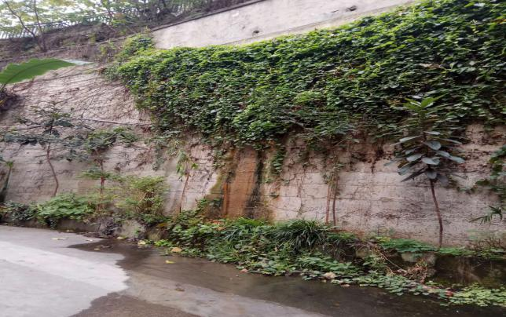

Figure 4-3 Overflowing wastewater in Huangjueya Community, Nanshan Sub-district and Xinhua Community, Nanping Sub-district
Uncle Li (over 60), a dormitory building in Wuzhenshan Community, Nanshan Sub-district
This is a dormitory building for teachers built decades ago, and most occupants are old people. No one is responsible for cleaning, and there is no septic tank or sewer line. The open ditch in the courtyard is used for drainage. We don’t know when it will be demolished and rebuilt. (Aunt Huang beside: The state should pay more attention to retired teachers, and provide a clean and orderly living environment for them.)

3) Shortage of infrastructure and amenities
40.2% of the respondents are dissatisfied with roads in communities because they are seriously damaged and uneven.
60.5% of the respondents are dissatisfied with inadequate fire fighting facilities, such as firewater pipelines, signs, hydrants and extinguishers.
55.5% and 54.3% of the respondents are dissatisfied with fitness facilities and other public facilities (e.g., resting benches) in communities due to high building density and the lack of public spaces. Most old communities are open communities without access control, leading to a low sense of security. In addition, the shortage of lighting facilities makes night traffic unsafe.
Random interview in Jinyan Community, Huayuanlu Sub-district
Residents would gather in this self-built shed to play or sit around, and heat by coal burning. Aunt Li said, “We have no place to play, and would sit around here. Most residents have been converted from rural status into urban status, and are poor. I’m ill, and my daughter is studying at a senior high school. I don’t know what to do in the future.” Uncle Li beside her said,“I expect an old people activity center to be built here. Past reconstruction efforts were futile, and irregular parking is still happening.”

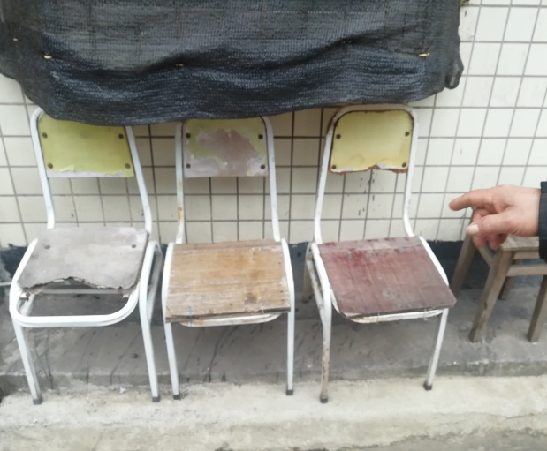
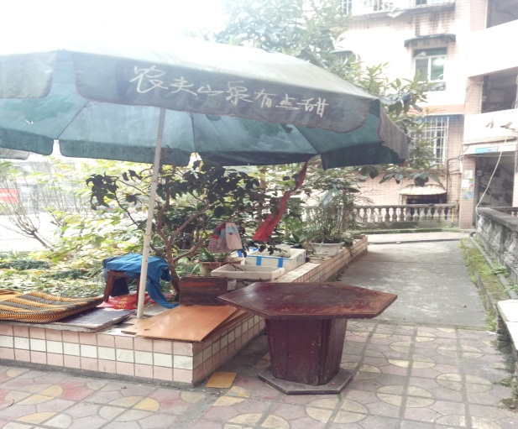

Figure 4-4 Shortage of resting benches in Xinjian Street Community, Nanshan Sub-district

Old communities are short of elevators, causing great inconvenience to old and disabled people. Some of them even do not leave home for this reason, resulting in health deterioration in the long run.
4) Seriously aging of buildings and disorderly wiring
Paint or decoration detachment, roof leakage and disorderly wiring exist in many buildings in old communities.
45.7% of the respondents are dissatisfied with roof water proofing. Roof leakage would result in furniture erosion and wall molding. 43.3% of the respondents are dissatisfied with facades. Facade tile or paint detachment, or handrail rusting would pose great risks to pedestrians and vehicles.
43.7% of the respondents are dissatisfied with wires, optical fibers, etc. Disorderly wiring is likely to lead to fires due to overload or bad connection, and personal injuries and property damages, and also affects community appearance.
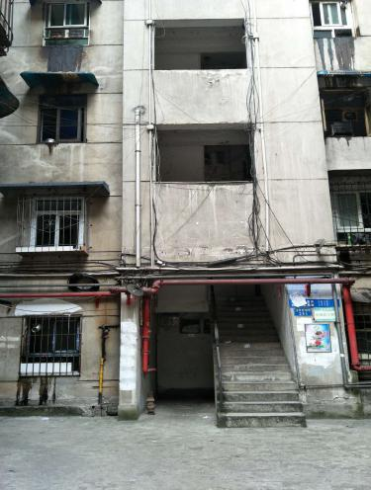
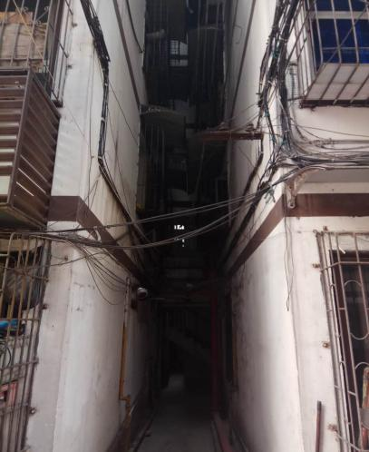
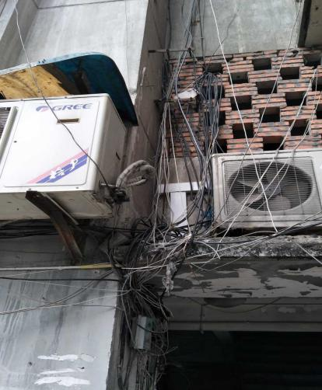

Figure 4-5 Disorderly wiring

5) Insufficient and poorly maintained landscaping
37.1% of the respondents are dissatisfied with community landscaping. In most old communities, landscaping is either insufficient or poorly maintained.
4.2.1.2 Demand analysis
It can be seen from Table 4-4 that Nanping Sub-district has the highest level of demand for sanitation, followed by parking management and fire fighting facilities; Huayuanlu Sub-district’s top 3 needs are sanitation, parking management and public spaces; Nanshan Sub-district has the highest level of demand for septic tanks and sewer lines, followed by public spaces and sanitation.

Table 4-4 Percentages of top needs for Old Community Renewal
Item | Nanping Sub-district | Huayuanlu Sub-district | Nanshan Sub-district
Parking management | 22.3% | 16.5% | 7.5%
Sanitation | 23.3% | 17.6% | 9.4%
Septic tanks and sewer lines | 5.8% | 10.6% | 45.3%
Landscaping | 4.9% | 2.4% | 3.8%
Roads | 5.8% | 10.6% | 3.8%
Rain drainage | 1.9% | 3.5% | 0
Fire fighting facilities | 18.4% | 3.5% | 7.5%
Facades | 1.0% | 2.4% | 1.9%
Roof water proofing | 0 | 1.2% | 1.9%
Wires, optical fibers, etc. | 1.9% | 2.4% | 0
Fitness facilities | 2.9% | 10.6% | 3.8%
Public spaces | 6.8% | 16.5% | 13.2%
Other | 4.9% | 2.4% | 1.9%
Source: SA survey(January 2018)

4.2.2 Current situation of public spaces and residents’ needs
The task force conducted a sampling survey on satisfaction and demand among households in communities around public spaces.
4.2.2.1 Current situation of public spaces
1) Irregular parking
46.4% of the respondents are dissatisfied with road occupation for parking near public spaces, resulting in the functional weakening of public spaces.
2) Poor sanitation
17.5% of the respondents are dissatisfied with the overall environment of parks, where waste and pet feces can be seen everywhere, resulting in bacterial proliferation.

Interview with a resident in Nanhu Park near Nanhu Community, Huayuanlu Sub-district (male, 46 years)
Everyone would sit for a while in Nanhu Park in leisure time, but there are too many dogs here. Sometime ago, a dog bit 4 persons and was then killed. Dog feces make the park very dirt.” A nearby aunt said, “There is only one pavilion in the park, and there is no other shelter. Roadside benches have no backrest, and are uncomfortable.”

3) Disturbance from square dancing music
Residents would dance on several big squares, such as Hongsheng Square. However, nearby residents hate square dancing because music is not controlled, but their complaints have not been handled properly.
4) Shortage of facilities
28.8% and 32% of the respondents are dissatisfied with public spaces resting facilities and functional facilities respectively. There is no fitness facility or recreational facility for children in 3 parks, making them less attractive to old people, women and children.
All the 4 parks are short of public toilets, trash bins and other sanitation facilities, resulting in poor sanitation and inconvenience.
Random interview in Houbao Park beside Houbao Community, Nanping Sub-district (female, 36 years)
We often come to the park to enjoy open river views, but the parking spaces here are insufficient, and road occupation is serious; there are many dog feces; the streetlamps are not bright enough, making us feel unsafe at night; the public toilets are also insufficient.

16.5% of the respondents are dissatisfied with public spaces protective facilities. For example, Guohuishan Park is close to old communities on Xiangshui Road, but is almost abandoned due to the lack of facilities.
5) Insufficient accessibility of some public spaces
Although Guohuishan Park is close to old communities on Xiangshui Road, its accessibility is low due to limited connecting footpaths.
4.2.2.2 Residents’ needs
Residents’ main needs for public spaces are as follows: 1) the management and maintenance of public spaces and surrounding environments, accounting for 28% and 19% respectively; 2) improved infrastructure of public spaces, especially protective and lighting facilities, both accounting for 11.6%, and resting and functional facilities, accounting for 6.3%; and 3) the accessibility and comfort of public spaces.

Table 4-5 Needs for public spaces
 | N | Valid percent
Overall environment | 36 | 19.0
Protective facilities | 22 | 11.6
Lighting facilities | 22 | 11.6
Space size | 13 | 6.9
Space convenience and comfort | 3 | 1.6
Functional facilities | 12 | 6.3
Road occupation for parking | 53 | 28.0
Resting facilities | 12 | 6.3
Distance | 2 | 1.1
Management and maintenance | 2 | 1.1
Accessibility | 1 | 0.5
Other | 11 | 5.8
Total | 189 | 100.0
Source: SA survey(January 2018)

4.2.3 Current situation of areas of Urban Slow Traffic System Renewal and residents' needs
256 questionnaires within the communities covered by the Old Community Renewal and 32 men-times of random interviews were conducted on slow traffic systems.
1) Current situation of the area of Urban Slow Traffic System Renewal
a) Poor walking environment on both sides of urban trunk roads
Some sidewalks are too narrow or occupied by vehicles. Most secondary trunk roads lack road-crossing facilities, traffic signals, sidewalks for the blind, etc.
b) Poor road connection
First, the connection between the built-up area of Nan’an District and the waterfront area west of Nanbin Road is poor, so that residents in the built-up area cannot utilize the waterfront area effectively, and enjoy river views closely.
Random interview in Houbao Park beside Houbao Community, Nanping Sub-district (male, 60 years or above, retiree)
The Houbao area is quiet and comfortable, ideal for old people. I bought a secondhand house (on the 2nd floor of an old building) here 10 years ago. There was a road between the park and Nanbin Road, and I could walk to the park in about 10 minutes. However, this road was broken due to house construction, extending the walking time to over half an hour.

Second, the connection between the built-up area of Nan’an District and the Nanshan Mountain is poor. No sufficient slow traffic space is reserved, resulting in mixed vehicle and pedestrian traffic, and serious traffic congestion, posing greater risks to pedestrians.
c) Insufficient urban furniture
The Nanshan Mountain climbing footpath lacks protective measures, signs, benches, toilets, trash bins, etc., and its both sides are disorderly.
2) Residents’ needs
Residents’ needs for slow traffic systems are focused on walking environment improvement.40.7% of the respondents are dissatisfied with road conditions, 62.5% are dissatisfied with urban furniture (e.g., beaches, trash bins).

Table 4-6 Satisfaction with slow traffic systems (%)
 | Road conditions | Sanitation | Infrastructure | Urban furniture
Very satisfied | 0 | 3.1 | 6.2 | 3.1
Satisfied | 31.3 | 34.8 | 25.0 | 25.0
Neither, nor | 28.1 | 31.3 | 9.4 | 9.4
Dissatisfied | 21.9 | 18.8 | 46.9 | 40.6
Very dissatisfied | 18.8 | 12.5 | 12.5 | 21.9
Total | 100.0 | 100.0 | 100.0 | 100.0
Source: SA survey (January 2018)

5. Local Poor Population
Nan’an District is one of the urban districts of Chongqing. Although it is relatively more developed, its development is unbalanced, and it has a large floating population (174,400 in 2016, accounting for 20% of its resident population). With the development of Jiangnan New Town of Nan’an District in recent years, its population is moving to Jiangnan New Town gradually. The Nanping old town has a large elderly population, a large floating population and a large low-income population, which will benefit from the Subproject.

5.1 MLS population
In 2017, the number of MLS population in Nan’an District is 10,630, ranking the fifth in Chongqing's main urban area; the proportion of the MLS population in the area is 1.52% of the total, ranking the third in Chongqing main urban area, which indicates the area is relatively poor.

Table 5- 1 MLS Population in Chongqing (2016-2017)
Area | MLS Population  (2016) | MLS Population  (2017) | Change | MLS proportion  (2016) | MLS proportion  (2017) | Change
Total | 940,368 | 941,819 | 0.15% | 2.79% | 2.78% | -0.44%
Yuzhong District | 11,875 | 11,442 | -3.65% | 2.24% | 2.18% | -2.62%
Dadukou District | 2,612 | 2,664 | 1.99% | 1.02% | 1.02% | 0.27%
Jiangbei District | 6,846 | 6,211 | -9.28% | 1.14% | 1.02% | -10.57%
Shapingba District | 8,207 | 7,989 | -2.66% | 1.02% | 0.98% | -4.30%
Jiulongpo District | 10,399 | 12,427 | 19.50% | 1.16% | 1.35% | 17.26%
Nan’an District | 10,581 | 10,630 | 0.46% | 1.55% | 1.52% | -2.14%
Beipei District | 9,586 | 9,652 | 0.69% | 1.52% | 1.52% | 0.26%
Yubei District | 14,629 | 14,536 | -0.64% | 1.50% | 1.45% | -3.51%
Banan District | 14,334 | 13,994 | -2.37% | 1.58% | 1.53% | -3.29%
Liangjiang New District | 452 | 437 | -3.32% | 0.19% | 0.17% | -8.15%
Source: Chonqging Civil Affairs Bureau

As of December2017, the number of MLS population in the sub-districts of the project area is as shown in Table 5-2, and the distribution of them is shown in Figure 5-1. From April 1, 2017, Chongqing’s urban MLS subsidy was 500 yuan per capita per month, and rural MLS subsidy 350 yuan per capita per month. These subsidies apply to Nan’an District.

Table 5- 2 MLS population of Sub-district or Town in Nan’an District (2017)
Sub-district / township | HHs |  | Females |  | Disabled |  | Underage |  | Severely disabled |  | Severely ill |  | Percent of MLS population (%)
 | Urban | Rural | Urban | Rural | Urban | Rural | Urban | Rural | Urban | Rural | Urban | Rural
Danzishi Sub-district | 994 | 0 | 336 | 0 | 186 | 0 | 122 | 0 | 56 | 0 | 50 | 0 | 2.59
Meitangxi Sub-district | 853 | 0 | 379 | 0 | 175 | 0 | 112 | 0 | 53 | 0 | 62 | 0 | 1.62
Huayuanlu Sub-district | 721 | 0 | 305 | 0 | 218 | 0 | 114 | 0 | 65 | 0 | 57 | 0 | 0.88
Jiguanshi Town | 228 | 48 | 105 | 24 | 54 | 7 | 36 | 10 | 20 | 1 | 36 | 21 | 1.98
Longmenhao Sub-district | 975 | 0 | 376 | 0 | 199 | 0 | 122 | 0 | 50 | 0 | 34 | 0 | 4.08
Nanping Sub-district | 1957 | 0 | 827 | 0 | 324 | 0 | 315 | 0 | 90 | 0 | 96 | 0 | 2.07
Nanping Town | 1308 | 18 | 657 | 8 | 243 | 3 | 193 | 3 | 70 | 0 | 72 | 0 | 1.53
Nanshan Sub-district | 410 | 350 | 176 | 214 | 139 | 102 | 48 | 20 | 50 | 28 | 41 | 74 | 1.83
Tongyuanju Sub-district | 588 | 0 | 207 | 0 | 99 | 0 | 64 | 0 | 27 | 0 | 27 | 0 | 1.12
Tushan Town | 769 | 18 | 296 | 7 | 206 | 8 | 73 | 0 | 69 | 4 | 70 | 4 | 1.40
Nan’an District | 9515 | 1118 | 3991 | 548 | 2091 | 303 | 1294 | 98 | 652 | 95 | 703 | 216 | 1.57
Source:Nan’an District Civil Affairs Bureau

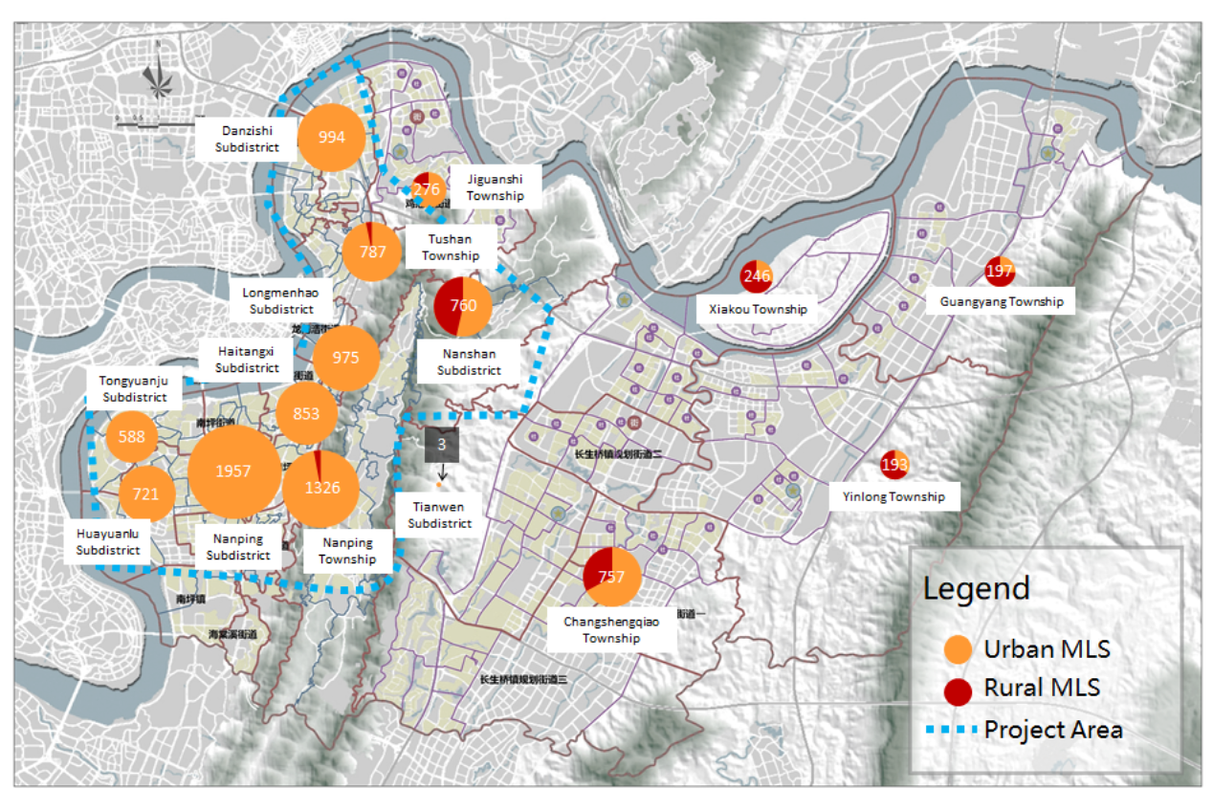
Figure 5-1 Map of MLS Population of the Project Area

Nan’an District’s MLS population is located mainly in old communities in Nanping Longmenhao, Danzishi Sub-districts and Nanping Town, where the aged and the poverty people live. Young and richer residents have moved to new areas or newly built communities.

Table 5- 3 MLS population affected by Old Community Renewal(2017)
Sub-district | Community | Registered population (0,000) | Male (0,000) | Female (0,000) | Low-income population |  | Proportion of MLS population (%)
 |  |  |  |  | Urban 3-noes population | Urban MLS population
Nanping | Dongxing Road | 1.2 | 0.6 | 0.9 | 1 | 171 | 1.4
 | Jinzi Street | 1.0563 | 0.3699 | 0.6279 | 3 | 82 | 0.78
 | Xiangshui Road | 1.202 | 0.6296 | 0.7333 | 1 | 49 | 0.41
 | Yangguang | 1.061 | 0.5137 | 0.6518 | 1 | 265 | 2.5
Nanshan | Wuzhenshan | 0.3251 | 0.1526 | 3589 | 3 | 53 | 1.63
 | Huangjueya | 0.9 | 0.4 | 1 | 6 | 156 | 1.73
Huayuanlu | Nanhu | 1.35 | 0.725 | 1.1386 | 1 | 95 | 0.73
 | Jinshan | 1.1978 | 0.6588 | 0.8552 | 1 | 91 | 0.76
 | Gulouwan | 0.8377 | 0.42 | 0.5 |  | 34 | 0.41
 | Jinyan | 0.9453 | 0.4523 | 0.8065 | 1 | 223 | 2.36
Source:local sub-district offices

In Old Community Renewal, the communities with more MLS population are Huangjueya and Wuzhenshan Communities, Nanshan Sub-district; Dongxing Road and Yangguang Communities, Nanping Sub-district; and Jinyan Community, Huayuanlu Sub-district, as shown in Table 5-3.

5.2 Extremely poor population
Currently, urban 3-noes residents, members of 5-guarantee households, orphans and distressed children are defined as extremely poor population, including urban and rural old people, disabled people, people under 16 years, and people with no ability to work, no income source and no statutory supporter. From April 1, 2017, the basic living subsidy for extremely poor population of Chongqing Municipality is 650 yuan per capita per month; from July 1, 2016, a caring subsidy of 200 yuan per capita per month is granted to extremely poor population that is disabled or under 16 years. Extremely poor population is subject to centralized or scattered support, where scattered support is recommended for those able to take care of themselves, and centralized support recommended for those unable to able to take care of themselves wholly or partly. See Table 5-4.

Table 5- 4 Extremely poor population of the subproject area (2017)
Sub-district / township | 3-noes population |  |  | 5-guarantee population
 | Total | Centralized support | Scattered support | Total | Centralized support | Scattered support | Orphans | Distressed children
Tongyuanju Sub-district | 11 | 2 | 9 | / | / | / | 1 | 1
Huayuanlu Sub-district | 6 | 4 | 2 | / | / | / |  | 2
Nanping Sub-district | 15 | 7 | 8 | / | / | / | 1 | 3
Haitangxi Sub-district | 12 | 7 | 5 | / | / | / | / | 2
Longmenhao Sub-district | 26 | 16 | 10 | / | / | / | 1 | 2
Danzishi Sub-district | 11 | 2 | 9 | / | / | / | 2 | 2
Nanshan Sub-district | 5 | 0 | 5 | 15 | 7 | 8 | / | 5
Nanping Town | 9 | 5 | 4 | / | / | / | / | 6
Tushan Town | 3 | 1 | 2 | 2 | 1 | 1 | / | 1
Jiguanshi Town | 7 | 5 | 2 | 1 | 1 | 0 | / | 4
Source: Nan’an District Civil Affairs Bureau

5.3 Floating population
In June 2017, Nan’an District had a floating population of 639,200, broken down as follows:

Table 5- 5 Floating population of the subproject area (2017)
Sub-district | Longmenhao | Tongyuanju | Nanping Sub-district | Danzishi | Huayuanlu | Nanping Town | Tushan Town | Nanshan | Jiguanshi | Haitangxi
Population | 10,643 | 44,154 | 70,352 | 3,701 | 50,125 | 91,865 | 75,459 | 45,612 | 12,276 | 94,314
Working | 10,247 | 35,492 | 66,410 | 2,416 | 48,765 | 89,826 | 346 | 11,452 | 11,122 | 58,315
Recruited | 114 | 121 | 164 | 35 | 22 | 64 | 1,337 | 56 | 12 | 336
Investment / doing business | 24 | 395 | 153 | 39 | 160 | 167 | 253 | 132 | 46 | 221
Farming | 3 | 12 | 87 |  | 4 | 25 | 1 | 5 | 4 | 12
Service | 15 | 158 | 127 | 289 | 21 | 14 | 198 | 20,008 | 6 | 119
Studying | 5 | 92 | 3 | 198 | 2 | 6 | 8 | 11,960 | 582 | 28,303
Preschool children | 78 | 1 | 54 | 4 | 7 | 293 | 3 | 11 | 66 | 17
Medical care |  | 8 | 1 | 555 |  |  | 1,188 | 197 |  | 2
Seeking refuge with relatives | 51 | 1,704 | 143 | 151 | 797 | 1,431 | 568 | 399 | 68 | 302
Visiting friends and relatives | 1 | 167 | 8 |  | 1 | 4 | 30 | 2 | 5 | 1,775
Source: Nan’an District Public Security Bureau

The floating population of the subproject area exists mainly in Tongyuanju Sub-district, Nanping Sub-district, Nanping Town, Huayuanlu Sub-district, Tushan Town, Nanshan Sub-district and Haitangxi Sub-district. In the floating population of Nanshan Sub-district of 46,000, 20,000 deal with services, over 12,000 are at school, and the others are mostly employed; in the floating population of Meitangxi Sub-districtof 94,000, 28,000 are at school, and the others are mostly employed; in the floating population of the other sub-districts and towns, over 90% are employed, and 58.6% are rural status, indicating that the main purpose of floating population is to increase income by working in town.
40.7% of floating population lives in leased houses, 20.5% in homes of urban friends, 16.5% in houses offered by employers, and 11.8% in self-purchased houses.
Among the old communities involved in Old Community Renewal, those Nanping and Huayuanlu Sub-districts have higher lease rates of 40%-60%, and those in Nanshan Sub-district have lower lease rates of 10%-25%.

Table 5- 6 Percentages of house lease under Old Community Renewal
Sub-district | Community | # of tenant households | Percent | # of tenants | Percent | Average per capita monthly income(yuan) | Year built
Nanping | Dongxing Road | 390 | 30% | 1,200 | 30% | 2,000-4,000 | 1980-1990
 | Jinzi Street | 1,920 | 47% | 5,768 | 57% | 2,000-4,000 | 1980-1990
 | Xiangshui Road | 2,600 | 50% | 5,400 | 45% | 2,000-4,000 | 1980s-1990
 | Yangguang | / | / | / | / | / | /
Nanshan | Wuzhenshan | 976 | 26% | 1,919 | 25% | / | /
 | Huangjueya | 800 | 11% | 3,000 | 13.5% | / | 1990s
Huayuanlu | Nanhu | / | 40% | / | / | 2,500 | /
 | Jinshan | / | 40% | / | / | 2,500 | /
 | Gulouwan | / | / | / | / | 1,750 | /
 | Jinyan | / | / | / | / | 1,670 | /
Source: Feasibility Study Report;“/” refers to “not available”.

5.4 Disabled population
In Nan’an District, disabled population accounts for 2.27% of gross population. In the subproject area, Jiguanshi Town, Longmenhao Sub-district, Danzishi Sub-district and Nanshan Sub-district have higher proportions of disabled population.

Table 5- 7 Disabled population of the subproject area (2017)
Sub-district / township | Gross population | Percent of disabled population (%) | Grade 1 disability population | Grade 2 disability population | Grade 3 disability population | Grade 4 disability population
Nanping Sub-district | 1,965 | 2.06 | 154 | 197 | 381 | 1,233
Huayuanlu Sub-district | 1,261 | 1.46 | 63 | 127 | 311 | 760
Meitangxi Sub-district | 1,228 | 1.82 | 101 | 134 | 221 | 772
Tongyuanju Sub-district | 1,002 | 1.86 | 81 | 101 | 207 | 613
Longmenhao Sub-district | 1,173 | 4.77 | 61 | 134 | 202 | 776
Danzishi Sub-district | 1,761 | 4.47 | 68 | 163 | 328 | 1,202
Nanshan Sub-district | 1,408 | 3.33 | 45 | 150 | 214 | 999
Nanping Town | 1,246 | 1.35 | 68 | 130 | 228 | 820
Tushan Town | 1,387 | 2.42 | 75 | 173 | 267 | 872
Jiguanshi Town | 720 | 5.00 | 20 | 54 | 129 | 517
Nan’an District | 15,914 | 2.27 | 896 | 1,711 | 3,120 | 10,187
Source: Nan’an District Disabled People’s Federation

5.5 Main needs of special groups

5.5.1 Poor population
Poor population mostly lives in old communities, dealing mainly with trading, catering, logistics, housekeeping, etc., or being retired or disabled. They prefer free fitness and recreational activities, and their social intercourse occurs in communities mainly, so they have a stronger demand for fitness and recreational facilities. Their main needs for the Subproject are: 1) improved community environment and public spaces infrastructure, richer community life, and more frequent social intercourse; 2) increased income and job opportunities; and 3) no or minimal rise in expenditure after project completion.

5.5.2 Floating population
Floating population includes two types mainly. One type consists of migrant workers, mostly from rural areas, dealing mainly with peddling, housekeeping, handling and skilled jobs, mostly earning less than 2,000 yuan per month and with poor living conditions, mostly in leased houses in old communities or worksite dormitories; the other type consists of residents having newly bought houses, mostly office workers, and with better living conditions. This SA focuses on the first type.
The main needs of those of the first type for the Subproject are: 1) improved community environment and public spaces infrastructure; 2) increased income and job opportunities; and3) acceptable rise in house rental after project completion.

5.5.3 Disabled population
Currently, barrier-free facilities is not constructed systematically; in some public spaces, there is no barrier-free toilet, and sidewalks for the blind are mostly occupied.

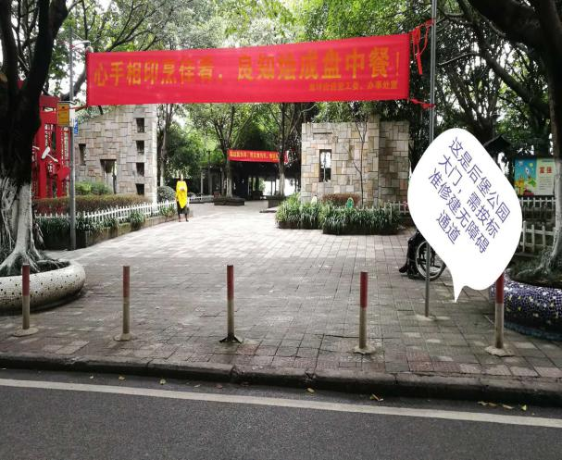
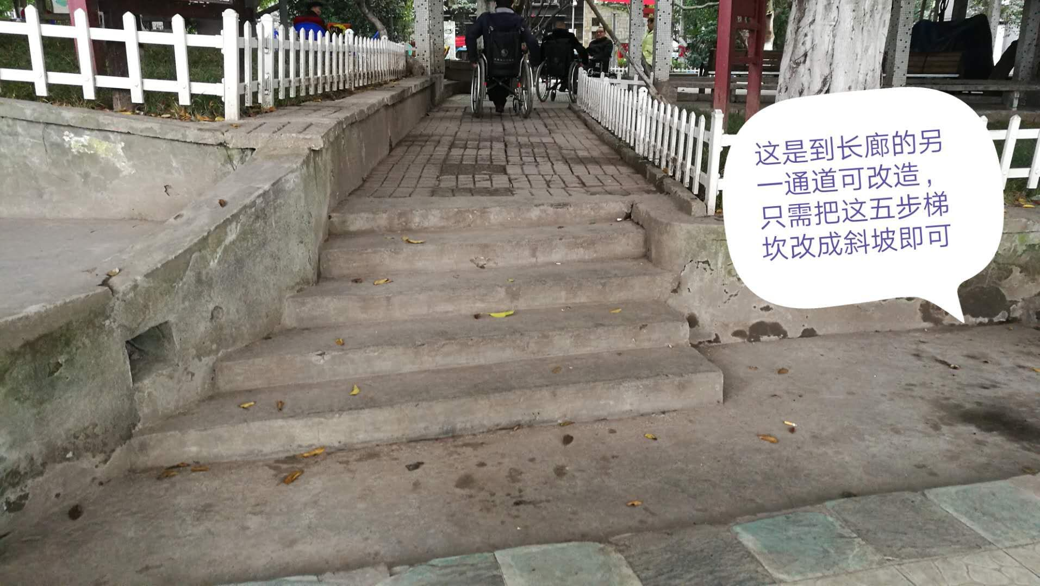
Figure 5-2 Shortage of barrier-free facilities in Houbao Park

The main needs of disabled population for barrier-free facilities are: 1) consistency of barrier-free facilities of roads; 2) construction of barrier-free facilities for overpasses and underpasses; and 3) construction of barrier-free facilities for public toilets.
Mr. Lu, Archives Section, Nan’an District Disabled People’s Federation
I am a disabled person, and have personal experiences of barrier-free facilities. On squares and streets, there is no ramp at entrances and exits, and sidewalks for the blind are not constructed systematically. There are elevators at light rail stations, but there is no ramp at entrances and exits, making the disabled difficult to reach elevators. There are sidewalks for the blind and signs on roads around parks, but are partly occupied by vehicles and peddlers. Some public toilets have no ramp.

6. Social Impact Analysis

6.1 Old Community Renewal

6.1.1 Positive impacts
1) Improving community security
Since fire fighting facilities in old communities are seriously damaged, they can hardly function when a fire occurs; fire passages are often blocked by vehicles; due to the lack of lighting and monitoring facilities, thefts and robberies occur often at night. Therefore, residents, especially old people and other vulnerable groups, have a low sense of security. Such measures as regulating parking management, increasing fire fighting facilities and improving pavements under the Subproject will strengthen residents’ sense of security significantly.
Interview with a resident in the railway community, Nanping Sub-district (female, 45 years)
The biggest problem of the community is being unsafe. In the last fire accident, fire wagon could not come in, and it was useless to call the traffic police. As a result, 3 persons of a family were killed. In addition, the streetlamps are insufficient and dark, so that we dare not go out at night.

2) Improving community infrastructure and residential comfort
Old communities mostly have no maintenance and property management, resulting in facility aging, water leakage, pipeline blocking, etc. In addition, old communities are short of fitness and recreational facilities. The Subproject will improve community infrastructure and residential comfort greatly.
3) Improving community sanitation and living quality
In old communities, due to the lack of property management, a household usually pays 3-10 yuan per month to hire a cleaner. In the questionnaire survey, 47.3% of the respondents are dissatisfied with community sanitation. In these old communities, old furniture, domestic waste and other sundries are dumped anywhere, causing inconveniences to residents. Old Community Renewal will improve community sanitation and living quality.
4) Promoting property appreciation
Through Old Community Renewal, house prices and rentals of old communities will rise, so that residents can earn more by selling or leasing houses.
5) Promoting social intercourse and integration
With the increase of fitness and recreational facilities and spaces, residents will participate more in community activities, thereby promoting social intercourse and integration, and improving their community identity and sense of belonging.

6.1.2 Negative impacts
1) Environmental impacts of construction
Construction machinery and vehicle operations will produce noise and dust, thereby affecting residents’ rest and life to some extent. Possible closed construction of community road pavement and facade reconstruction may cause traffic inconvenience. However, such impacts are temporary, and can be accepted by most residents.
Interview with a resident in a dormitory community in Nanshan Sub-district (male, 34 years)
Construction will certainly affect our lives, such as noise, air pollution and traffic inconvenience, but such negative impacts are temporary and can be overcome. The contractor is expected to take measures to reduce such measures, such as sprinkling and avoiding overnight construction.

2) Temporary impacts on stores
Old communities are mainly located in the urban center of Nanan district heartland, surrounding with some convenience stores, hair salons, fruit shops and restaurants. Construction machinery, construction work and construction noise will, to a certain extent, affect the normal business activities; The delivery vehicles of the stores will not be able to pass smoothly due to the construction, and the exotic vehicles will not be able to get in smoothly, which will have a negative impact on the external transportation and sales of the products. The income of the store may be affected.
3) Increased management and maintenance costs after renewal
After renewal, community management and maintenance costs may increase, such as landscaping, cleaning and facility maintenance, therefore, the residents of the community will be charged with certain property management fees, but residents can only accept a slight rise.

Interview in Dongxing Road Community, Nanping Sub-district (female, 46 years)
After renewal, the community will have a better environment, and better roads, fitness facilities and activity spaces. We are willing to pay for this, but many residents here are retirees with limited financial strength, so their affordability must be considered.

6.2 Public Space Renewal

6.2.1 Positive impacts
1) Increasing the utilization of public spaces, and providing better recreational experiences to residents
Existing public spaces are of low utilization rates due to limited size, inadequate management, occupation for business purposes, etc., such as Nanhu Park, Guohuishan Park, Houbao Park and Hongsheng Square.
In Public Space Renewal, parks will be re-planned, and provided with recreational facilities and infrastructure, such as beaches, trash bins, public toilets, streetlamps and guardrails, to improve their convenience and safety; vehicle and pedestrian systems of squares and pedestrian streets will be re-planned for orderly and convenient traffic. After renewal, residents using public spaces will have better recreational experiences.
2) Improving urban image, and making public spaces more active
Existing parks and squares lack cultural implications. In Public Space Renewal, local landscape factors will be incorporated into Hongsheng Square, and a tea culture street built for Nanhu Park, turning them into windows of urban image and local culture, and making them more active.
3) Improving the commercial environment, and promoting economic development and employment
The Subproject will provide better public spaces to residents, and increase pedestrian volume and consumption, thereby promoting the development of nearby commerce and services, economic growth, and employment, and increasing the income of local residents, especially the subproject area women, the poor, floating population and other vulnerable groups.
4) Improving the accessibility and safety of public spaces
The accessibility and safety of public spaces is an important factor that prevents residents from going to public spaces. For example, Guohuishan Park lacks connecting roads and guardrails; Houbao Park lacks slow traffic footpaths, and is inconvenient for disabled people and children.
The Subproject will improve the accessibility and safety of public spaces, and make public spaces more attractive to residents by regulating parking, re-planning vehicle and pedestrian systems, and providing protective facilities.
5) Economic benefits generated by urban green spaces
Public Space Renewal will increase housing prices of old communities by 20% as estimated in the Feasibility Study Report, and generate ecological benefits, such as carbon fixation, oxygen release and dust retention, thereby bringing economic benefits, totaling 1.0501 million yuan per annum.

6.2.2 Negative impacts
1) Construction impacts on environment
During construction, waste cleanup and transport will produce dust, noise and waste, thereby affecting nearby residents adversely, and threatening the personal safety of local residents, especially old people, children and pregnant women. The owner will pay more attention to such impacts during construction, give publicity and education on construction safety, and take measures to reduce such impacts.
2) Impact on the traffic efficiency and safety of nearby residents and vehicles
Some parks, squares and roads may be closed during construction, thereby affecting traffic, and nearby residents’ recreational activities.
3) Impact on nearby stores
Construction will affect nearby stores, such as making it inconvenient for customers to enter stores and delivery trucks to pass, so their income may be affected to some extent.

6.3 Urban Slow Traffic System Renewal

6.3.1 Positive impacts
1) Providing better walking experiences
In Urban Slow Traffic System Renewal, slow traffic systems and street appearance will be renewed, landscaping improved, and urban furniture added to create more attractive public spaces, and provide better walking experiences to pedestrians.
2) Strengthening road connection, and making urban traffic smoother
In Urban Slow Traffic System Renewal, some blind roads will be reopened, Longhuang Highway, Hugui Road, Tushan Branch Road and some slow traffic footpaths constructed to further optimize the urban road network, and strengthen the connection between the built-up area of Nan’an District, and the waterfront area west of Nanbin Road and the Nanshan Mountain.
3) Optimizing the walking environment
For urban trunk roads in Nan’an District, some sidewalks are too narrow or occupied by vehicles. Most secondary trunk roads lack road-crossing facilities, traffic signals, sidewalks for the blind, etc.
Existing footpaths will be broadened or reconstructed, road-crossing and supporting facilities (e.g., barrier-free facilities and sidewalks for the blind) added, and landscaping optimized to create a better walking environment for residents, especially old people, disabled and other special groups.
4) Providing better mountain climbing experiences
The Nanshan Mountain climbing footpath lacks protective measures, signs, benches, toilets, trash bins, etc., and its both sides are disorderly.
Mountain climbing footpaths will be constructed or renewed, and landscaping optimized to provide better mountain climbing experiences.
5) Advocating a low-carbon green lifestyle, and mitigating the urban heat island effect
The renewal of mountain climbing footpaths, and the optimization of slow traffic landscape in the Nanshan Mountain will increase the traffic flow of such footpaths, advocate a low-carbon green lifestyle, and reduce urban motor vehicle traffic and greenhouse gas emissions, thereby mitigating the urban heat island effect.

6.3.2 Negative impacts
1) Resettlement
The 4 roads will affect Nan’an District Tushan Town and Longmenhao Sub-district. 14.2 mu of collective land (6.5 mu of cultivated land, 2.5 mu of other farmland, 3.9 mu of housing land and 1.3 mu of unused land) will be acquired permanently, affecting 14 households with 36 persons; 112.85 mu of state-owned land will be allocated; rural residential houses of 1,450 m², urban residential houses of 539 m², non-residential properties on state-owned land of 4,464.32m², and houses with limited property rights of 4,636.8 m² will be demolished, affecting 33 households with 90 persons.
These affected households’ income and livelihoods will be affected to varying degrees. The owner should conduct land acquisition and livelihood restoration properly, and make sure that compensation is paid timely and fully in coordination with the agencies concerned.
2) Impacts of construction on traffic efficiency and safety
Safe impacts of construction are reflected mainly in impacts on nearby residents, students and vehicles. Some slow traffic systems are already narrow or have mixed traffic. Construction vehicles may threaten the personal safety of local residents, especially old people, children and women, and noise and dust produced by construction may affect pedestrian and vehicle traffic.
3) Environmental impacts of construction
Urban Slow Traffic System Renewal involves many roads and large construction quantities, and wastewater, solid waste, dust and waste gases produced by construction may have adverse environmental impacts. The construction of mountain climbing footpaths may affect the ecological environment of Nanshan Forest Park.

6.4 Measures to mitigate negative impacts

6.4.1 LA and HD impacts
1) First, take LA and HD impacts as an important factor of option selection for minimization.
2) Plan and implement LA carefully, and hold a public hearing when the LA compensation program is developed to collect comments and suggestions.
3) Conduct a social survey properly and extensive publicity on the benefits of the Subproject to win the support of local residents.
4) Improve the resettlement and compensation policies for LA and HD to protect the immediate interests of affected residents, and enforce the resettlement and compensation policies and rates strictly on an open, fair and just basis. Ensure that compensation is paid timely and fully.
5) Establish a risk early warning system, screen uncertainties in LA and HD daily, and strengthen field security to handle any emergency timely and effectively.

6.4.2 Measures to reduce traffic and safety impacts
Optimize the construction plan for key roads, accelerate construction, and disclose construction progress to residents by all means timely;
Regulate construction behavior, and ensure that construction vehicles and equipment operate within specified areas in order not to affect public traffic;
Strengthen safety protection by setting up fixed warning signs to remind vehicles to drive slowly;
Strengthen emergency management by providing rescue equipment and vehicles for quick and efficient emergency response.

6.4.3 Negative environmental impacts
1) All functional departments should cooperate closely to supervise construction strictly, and minimize construction impacts, such as noise, vibration, dust, wastewater and solid waste.
2) Construction staff is prohibited from discharging domestic water to natural receiving waters. Take measures to dispose of wastewater, solid waste and waste gases produced by construction timely and properly.
3) Extend wet operation during construction, and provide sprinkling equipment on the construction site to control dust, especially for affected communities and streets; arrange vehicle entries and exits rationally on the construction site, and provide tire flushing facilities there.
4) Schedule construction rationally, and prohibit high-noise construction machinery from operating near residential areas at night (22:00-6:00); prohibit high-noise construction near noise-sensitive buildings at night, and noise-generating construction within 100m around examination sites during the periods of the college and senior high school entrance examinations.
5) Locate construction passages and camps away from lush vegetation where possible, and take appropriate measures to conserve and restore the vegetation if this is impossible.
6) Ensure that construction vehicles do not drive during the peak traffic hours.
7) Control pollution and emissions in strict conformity with the applicable national standards at the operation stage.

6.4.4 Negative impacts on special groups
1) Comments of special groups, especially old people, the poor, the disabled and floating population, will be collected extensively to protect their interests.
2) After the completion of the Subproject, property management fees will be appraised strictly to ensure that such fees do not overly rise. Relevant policies will be enacted to ensure that poor population will receive subsidies for property management fees, and their expenditure will not rise.
3) Management and maintenance jobs during and after project implementation will be first made available to floating population, poor population and other vulnerable groups.

7. Social Gender Analysis

7.1 Local women’s perceptions of, needs for and suggestions on the Subproject

7.1.1 Situation of local women
At the end of 2016, Chongqing had a registered population of 33.9211 million, including 16.4687 million females, accounting for 48.6%, and Nan’an District had a registered population of 700,100, including 356,200 females, accounting for 50.9%. As shown in Table 7-1, the subproject area had more females than males.

Table 7-1 Female population of the subproject area (2016)
Division | Gross population(0,000) | Female population(0,000) | Gender ratio
Chongqing Municipality | 3392.11 | 1646.87 | 106
Nan’an District | 70.01 | 35.62 | 97
Longmenhao Sub-district | 2.46 | 1.24 | 98
Tongyuanju Sub-district | 5.40 | 2.77 | 95
Meitangxi Sub-district | 6.73 | 3.35 | 101
Danzishi Sub-district | 3.94 | 2.00 | 97
Nanping Sub-district | 9.57 | 4.90 | 95
Nanshan Sub-district | 4.23 | 2.13 | 99
Huayuanlu Sub-district | 8.64 | 4.34 | 99
Nanping Town | 9.26 | 4.79 | 93
Tushan Town | 5.74 | 2.96 | 94
Jiguanshi Town | 1.44 | 0.76 | 89
Source: Statistical Yearbook of Nan’an District

7.1.2 Statistics of female samples in the questionnaire survey
1) Age
Among the samples, 59.6% are females. Among the female samples, 46.8% are aged 60 years or above, and 46.4% aged 31-59 years. Among the male samples, 46.4% are aged 31-59 years, and 40.3% aged 60 years or above.

Table 7-2 Age and gender distribution of samples
 |  | Gender |  | Total
 |  | Male | Female
Age | Less than 18 years | 0.6% | 0.7% | 0.7%
 | 18-30 years | 12.7% | 6.0% | 8.7%
 | 31-40 years | 6.1% | 10.1% | 8.5%
 | 41-50 years | 19.3% | 16.1% | 17.4%
 | 51-60 years | 21.0% | 20.2% | 20.5%
 | 60 years or above | 40.3% | 46.8% | 44.2%
Total |  | 100.0% | 100.0% | 100.0%
Source: SA survey(January 2018)

2) Educational level
68% of the female samples and 47.5% of the male samples have received junior high school or below, indicating that the overall educational level of the samples is low. Based on a Chi-square test, the overall educational level of the females is much lower than that of the males.

Table 7-3Educational levels of samples by gender
 |  | Gender |  | Total
 |  | Male | Female
Educational level | Junior high school or below | 47.5% | 68.0% | 59.7%
 | Senior high school / secondary technical school | 31.5% | 18.0% | 23.5%
 | Junior college | 13.3% | 7.1% | 9.6%
 | Undergraduate | 7.7% | 6.0% | 6.7%
 | Graduate or above |  | 0.8% | 0.4%
Total |  | 100.0% | 100.0% | 100.0%

Table 7-4 Chi-square test
 | Value | df | Progressive Sig. (both sides)
Pearson chi-square | 21.917ª | 4 | 0.000
Likelihood ratio | 22.552 | 4 | 0.000
Linearity and linear combination | 9.489 | 1 | 0.002
N in valid cases | 447
Source: SA survey(January 2018)

3) Occupation
Those being employed mostly work at state-owned and private enterprises, with no significant difference between the two genders.

Table 7-5 Occupations by gender
Occupation | Gender |  | Total
 | Male | Female
Administrative organ or public institution | 8.9% | 7.5% | 8.1%
State-owned enterprise | 29.4% | 24.8% | 26.7%
Private enterprise | 26.7% | 25.9% | 26.2%
Foreign enterprise or joint venture | 0.6% | 0% | 0.2%
Other | 34.4% | 41.7% | 38.8%
Total | 100.0% | 100.0% | 100.0%
Source: SA survey(January 2018)

Table 7- 6 Chi-square test
 | Value | df | Progressive Sig. (both sides)
Pearson chi-square | 4.081ª | 4 | 0.395
Likelihood ratio | 4.428 | 4 | 0.351
Linearity and linear combination | 2.424 | 1 | 0.119
N in valid cases | 446
Source: SA survey(January 2018)

7.1.3 Women’s main needs for the Subproject
There is no gender difference in the most needed facility, both being parking management. In addition, women pay more attention to septic tanks and sewer lines, fitness facilities, sanitation, and recreational facilities, while men pay more attention to public spaces.

Table 7-7 Needs for Old Community Renewal by gender
 |  | Gender |  | Total
 |  | Male | Female
Most needed community facility | Parking management | 19.4% | 19.9% | 19.7%
 | Sanitation | 19.4% | 17.2% | 18.0%
 | Septic tanks and sewer lines | 9.7% | 19.9% | 16.0%
 | Landscaping | 6.5% | 2.0% | 3.7%
 | Roads | 7.5% | 6.6% | 7.0%
 | Rain drainage | 2.2% | 2.0% | 2.0%
 | Fire fighting facilities | 11.8% | 9.9% | 10.7%
 | Facades | 1.1% | 2.0% | 1.6%
 | Wires, optical fibers, etc. | 2.2% | 1.3% | 1.6%
 | Fitness facilities | 3.2% | 7.3% | 5.7%
 | Public spaces | 15.1% | 7.9% | 10.7%
 | Other | 2.2% | 4.0% | 3.3%
Total |  | 100.0% | 100.0% | 100.0%
Source: SA survey(January 2018)

Both genders show concern about overall environment, road occupation for parking, protective facilities, lighting facilities and functional facilities, but men pay more attention to road occupation for parking and overall environment, while women pay more attention to protective facilities, lighting facilities and functional facilities.

Table 7- 8 Needs for Public Space Renewal by gender
 |  | Gender |  | Total
 |  | Male | Female
Most urgent need for public space improvement | Overall environment | 22.9% | 16.0% | 19.0%
 | Protective facilities | 8.4% | 14.2% | 11.6%
 | Lighting facilities | 9.6% | 13.2% | 11.6%
 | Space size | 7.2% | 6.6% | 6.9%
 | Space convenience and comfort | 1.2% | 1.9% | 1.6%
 | Functional facilities | 3.6% | 8.5% | 6.3%
 | Road occupation for parking | 33.7% | 23.6% | 28.0%
 | Resting facilities | 7.2% | 5.7% | 6.3%
 | Distance | 1.2% | 0.9% | 1.1%
 | Management and maintenance | 2.4% | 0% | 1.1%
 | Accessibility | 0% | 0.9% | 0.5%
 | Other | 2.4% | 8.5% | 5.8%
Total |  | 100.0% | 100.0% | 100.0%
Source: SA survey(January 2018)

In general, men and women have roughly consistent needs for the Subproject, but their concerns are different, where men pay more attention to the overall environment, such as road occupation for parking, public spaces and sanitation, while women pay more attention to details, safety and comfort, such as septic tanks and sewer lines, protective facilities, fitness facilities and lighting facilities.

7.1.4 Suggestions on the Subproject
Women’s main suggestions for the Subproject are:
1) Establishing effective public participation and feedback mechanisms
Women are more concerned about communities than men, and have higher requirements for the comfort of communities and public spaces, so they are more likely to identify and raise issues. At FGDs, some women proposed that more attention should be paid to women’s needs, such as ensuring that a certain proportion of participants should be women, and establishing special public participation and feedback mechanisms for women.
Women’s FGD in Dongxing Road and Changhang Communities, Nanping Sub-district
The owner should listen more to us, but such opportunities are just too few. The community committee should also visit us more often, and establish a feedback mechanism, so that we know how our opinions have been collected and acted on.

2) Opening up more dancing spaces for women
Women like square dancing very much, and most dancers are women, usually with several teams dancing on the same square. Women expect more dancing spaces to meet their needs. However, since nearby residents often complain about square dancing music, dancing spaces should be far away from residential areas.
3) Enhancing training for women, and offering job opportunities
Since women’s overall educational and income levels are lower than those of men, they have needs for higher income and richer knowledge. In the Subproject, training and drilling on fire fighting can be offered to women, health workshops held for old women, and suitable jobs generated at the construction and operation stages offered to women to increase their income.
Women’s FGD in Nanhu Park, Huayuanlu Sub-district
We women are poorly educated and earn less. Of course, we want to earn more money through, for example, skills training on housekeeping, babysitting, etc., as well as employment, even if temporary.

4) Considering women’s needs in infrastructure improvement
Compared to men, women have a stronger demand for public toilets, slow traffic footpaths and landscaping. Such facilities should be designed in consideration of women’s needs.

Women’s FGD at No.10-12 Fuhong Road, Nanping Sub-district
1) There is no resting facility for residents, and the existing old people activity center is for profit; 2) Alley trees are too lush, and should be trimmed so as not to block sunlight and streetlamps. The benches in the community are insufficient, especially for old women. A public toilet should be built in the community for the convenience of women.

7.2 Positive impacts of the Subproject on women
1) Creating a comfortable living environment for the benefit of women’s physical and mental health
Old communities and public spaces have crude infrastructure and poor sanitation. After the completion of the Subproject, the community environment will be improved, public spaces will be utilized more efficiently, and more convenient slow traffic will be available, thereby improving the comfort of recreational activities for women, which is beneficial to women’s physical and mental health.
2) Improving communities and public spaces to ensure women’s safety
Compared to men, more women live alone or are elderly, and use public spaces for longer times. A good environment of communities and public spaces will improve women’s safety and living quality. Measures such as installing or improving cameras, fire fighting facilities, handrails, guardrails, lighting facilities, and access control systems will be taken to protect women’s personal and property safety.
3) Increasing women’s job opportunities and income
Some unskilled jobs will be generated at the construction and operation stages, and construction will also generate nearby commercial and service jobs, such as waiter, salesperson and cleaner. Women can get employed or earn more money by doing these jobs.
4) Enhancing women’s political participation
Women can express opinions and suggestions on the Subproject through the public participation mechanism. After the completion of the Subproject, women will participate in community maintenance and management.

7.3 Negative impacts of the Subproject on women and mitigation measures/plan
1) HD may affect women’s living standard directly. If affected women do not receive proper house replacement or financial compensation, they will be forced to live in more remote areas, so that their living convenience may be reduced. This will be discussed in further detail in the RAP.
2) Women’s job opportunities under the Subproject may be affected. Local women’s overall educational level and financial status are low, and their participation capacity is insufficient. Construction will affect nearby stores, thereby reducing the income of female employees. After the completion of the Subproject, urban management will be strengthened, reducing the income of female peddlers.
The following measures may be taken to mitigate impacts on women: 1) Stage-by-stage and enclosed construction will be conducted to minimize negative impacts on nearby stores; 2) Jobs suitable for women should be offered during and after construction where possible; 3) After the completion of the Subproject, peddlers will be allowed to operate in certain areas, and their behavior regulated; 4) Employment training on service, housekeeping, cleaning, etc. will be offered to women to promote their employment.
3) Construction impacts on women’s health: Construction dust and noise will affect women’s physical and mental health, especially pregnant and lactating women, thereby potentially increasing their medical expenses. In view of this, such negative impacts should be minimized during construction.
4) Construction impacts on women’s daily lives: Construction may cause inconvenience to women’s daily lives and community activities, such as traffic and square dancing. Construction management should be strengthened to mitigate such negative impacts.

7.4Gender Action Plan
The Subproject will improve infrastructure of local communities and public spaces,and local residents’ living quality greatly. Local women will benefit from the improved living environment and infrastructure. In addition, since the Subproject may have potential risks, gender-sensitive measures should be taken to enhance the Subproject’s positive impacts, and minimize its negative impacts, thereby promoting women’s participation and development.
The Gender Action Plan has been developed in consultation with the Nan’an District PMO, IAs, women’s federation, etc. See Table7-9.

Table 7- 9 Gender Action Plan
Suggestion | Target | IAs | Stage | Actions | Funding | Monitoring indicators
1.Considering women’s needs in subproject design | Local women | Design agency, owner, PMO, district agencies concerned, sub-district offices, community committees | Construction | Women’s special needs should be considered in subproject design:  Old Community Renewal——  1) Provide facilities for old communities in consideration of needs of women, old people and other vulnerable groups.  2) Improve the landscaping and sanitation of old communities in consideration of women’s needs.  Public Space Renewal——  3) Consider opinions of women and old people in terms of public space utilization and facility setup.  4) Provide dancing spaces and slow traffic footpaths in parks to women where possible.  Urban Slow Traffic System Renewal——  5) Consider women’s needs in the setup of infrastructure and urban furniture for slow traffic and mountain climbing footpaths. | Subproject budget | Form, frequency and records of collection of women’s needs and opinions at the design stage, women’s specific suggestions, and design feedback  1) Suggestions of local women and old people on community facilities, landscaping, sanitation, etc., and design feedback;  2) Suggestions of local women and old people on infrastructure and overall environment of public spaces, and design feedback
2. Promoting women’s participation, and improving their status | Local women | Design agency, owner, contractor, PMO, district agencies concerned, sub-district offices, community committees | Construction and operation | 1) Make sure not less than 40% of participants of public participation meetings at all stages are women.  2) Conduct publicity and offer training in consideration of women’s needs and features. | Subproject budget | 1) Number of public participation meetings, number of female participants, and minutes;  2) Time, venue and mode of publicity and training
3. Offering job opportunities to women to increase income | Local women | Design agency, owner, contractor, PMO, district agencies concerned, sub-district offices, community committees | Construction | 1) Make sure 20% of unskilled jobs generated by the Subproject first available to women and other vulnerable groups.  2) Make sure 20% of public welfare jobs generated by the Subproject first available to women and other vulnerable groups.  3) Make sure 30% of members of community autonomy organizations are women. | Subproject budget and contractor budget | 1) Number of women receiving unskilled jobs during construction;  2) Number of women receiving public welfare jobs during operation;  3) Number of female members of community autonomy organizations
4. Offering skills and knowledge training to women | Affected local women | Owner, PMO, district agencies concerned, sub-district offices, community committees | Construction and operation | 1) Offer training in consideration of women’s needs and features.  2) Make sure not less than 40% of trainees are women. | Contractor budget | 1) Time, venue and mode of publicity and training  2) Form of fire fighting and fitness training at the community level

8. Public Participation

8.1 Forms and process of public participation at the preparation stage
Since September2017, the Nan’an PMO has conducted a series of surveys and public participation activities. At the preparation stage, the Bank mission, feasibility study agency, environmental management plan preparation agency, etc. conducted a social survey in the subproject area to collect needs and suggestions, and improve the subproject design.
This report has been prepared based on site visit, questionnaire survey, key informant interview, FGD and other public participation activities, and participants include local agencies concerned, sub-district and community officials, affected residents, etc.

8.1.1 Site visit
From November 2017 to January 2018, the task force conducted participatory observation on local community roads, infrastructure, landscaping, exterior walls, parks, squares, footpaths, etc. to gain a more intuitive understanding of the current situation of the subproject area.

8.1.2 Questionnaire survey
From November 2017 to January 2018, 28 communities affected by Old Community Renewal and 17 affected by Public Space Renewal were selected for the questionnaire survey, with 450 copies in total, covering community parking management, sanitation, landscaping, roads, facade, drainage and infrastructure for Old Community Renewal, and overall environment of public spaces, protective facilities, lighting, convenience, comfort, road occupation for parking, resting facilities, management, maintenance, accessibility, etc. for Public Space Renewal.

8.1.3 Key informant interview
Key informant interviews were conducted with 30 men-times of key informants from the district labor and social security bureau, employment bureau, civil affairs bureau, ethnic and religious affairs bureau, fire control detachment, public security bureau, land reservation center, women’s federation, disabled people’s federation, sub-district offices and town governments, Chongqing Jiangnan Urban Construction & Asset Management Co., Ltd., Nanshan Ecological Belt Management Committee, and community committees to learn the Subproject’s impacts and potential risks, relevant needs and suggestions, etc.

8.1.4 FGD
54 FGDs were held in 28 communities in Nanping, Nanshan and Huayuanlu Sub-districts in the beneficiary area of Old Community Renewal, including 27 FGDs with women, to learn residents’ needs for the Subproject, the Subproject’s impacts, and relevant comments and suggestions through brainstorming. 32 FGDs were held in 17 communities in the beneficiary area of Public Space Renewal, including 16 FGDs with women, with 436 participants in total, including 207 women, accounting for 47.8%; 167 residents aged 60 years or above, accounting for 38.3%; and 48 poor and disabled residents, accounting for 11%.

Table 8-1 Public participation activities
 | Activity | Time | Participants | Key opinion / suggestion | Outcome
Old Community Renewal | 1. Questionnaire survey: A questionnaire survey was conducted in 28 communities (256 copies) to learn satisfaction with and needs for community facilities. | Nov. 2017 – Jan. 2018 | Task force, community residents, community workers | Poor sanitation, insufficient amenities, facades and pipelines in need of renovation | Conduct design based on local residents’ opinions and needs to meet their needs as much as possible.
 | 2. Key informant interview: 18 men-times, learning impacts, needs, potential risks and suggestions, etc. | Dec. 2017 – Jan. 2018 | Task force, district agencies concerned, Nanshan, Nanping and Huayuanlu Sub-districts | Special needs of the poor, women, children, the disabled and old people should be considered in design, and the Subproject should be handed over to residents for autonomy. | Involve women, the poor, the disabled and old people in relevant meetings to allow them to express their opinions, and carry out autonomous management after completion under the direction of community committees.
 | 3. Residents’ FGD: 27 FGDs in 28 communities, learning residents’ needs and suggestions for improvement | Nov. 2017 – Jan. 2018 | Task force, community residents, community committee members | Residents need sanitation, septic tanks and sewer lines, fire fighting facilities, parking management, and fitness facilities; negative construction impacts should be minimized. | Conduct design based on local residents’ opinions and needs to meet their needs as much as possible, act strictly on the environmental management plan during construction.
 | 4. Women’s FGD: 27 women’s FGDs in 28 communities, learning women’s needs and suggestions for improvement | Nov. 2017 – Jan. 2018 | Task force, female residents, community committee members | Open up dancing spaces in communities to meet women’s needs; add public toilets and add fitness facilities in communities. | Involve a certain percentage of women in relevant meetings to consider their needs and opinions in design, and meet their needs as much as possible.
 | 5. In-depth interview: 20 men-times, learning the Subproject’s impacts, attitudes to and suggestions on the Subproject | Nov. 2017 – Jan. 2018 | Task force, community residents, community committee members | Take measures to mitigate environmental impacts of construction. | Conduct design based on local residents’ opinions and needs to meet their needs as much as possible, act strictly on the environmental management plan during construction to minimize noise and dust pollution. Disclose construction information in advance.
Public Space Renewal | 1. Questionnaire survey: A questionnaire survey was conducted in 17 communities (194 copies) to learn satisfaction with and needs for public spaces. | Nov. 2017 – Jan. 2018 | Task force, community residents, community committee members | Insufficient accessibility and safety of parks, irregular parking on public roads, insufficient recreational facilities | Conduct design based on local residents’ opinions and needs to meet their needs as much as possible.
 | 2. Residents’ FGD: learning residents’ needs and suggestions for improvement | Nov. 2017 – Jan. 2018 | Task force, community residents, community committee members | Pooroverall environment, disorderly parking and shortage of protective facilities exist in public spaces; negative construction impacts should be minimized. | Conduct design based on local residents’ opinions and needs to meet their needs as much as possible, act strictly on the environmental management plan during construction to minimize noise and dust pollution. Disclose construction information in advance.
 | 3. Women’s FGD: 16 women’s FGDs in 17 communities, learning women’s needs and suggestions for improvement | Nov. 2017 – Jan. 2018 | Task force, female residents, community committee members | Open up dancing spaces in communities to meet women’s needs; add public toilets in public spaces; create jobs for women. | Involve a certain percentage of women in relevant meetings to consider their needs and opinions in design, and meet their needs as much as possible. Create jobs for women during and after construction.
 | 4. Key informant interview: 12 men-times, learning impacts, needs, potential risks and suggestions, etc. | Dec. 2017 – Jan. 2018 | Task force, key informants of district agencies concerned | Consider special needs of the poor, women, children, the disabled and old people. | Involve women, the poor, the disabled and old people in relevant meetings to allow them to express their opinions, and meet their special needs as much as possible.
 | 5. In-depth interview: 66 men-times, learning the Subproject’s impacts, needs for and suggestions on the Subproject | Nov. 2017 – Jan. 2018 | Task force, residents using public spaces | 1) Poor park sanitation  2) Shortage of lighting, fitness and recreational facilities, and public toilets;  3) Shortage of benches and trash bins | Conduct design based on local residents’ opinions and needs to meet their needs as much as possible, and minimize negative impacts.
Urban Slow Traffic System Renewal | 1. Questionnaire survey: A questionnaire survey was conducted in 28 communities (256 copies) to learn satisfaction with and needs for urban slow traffic footpaths, sanitation, supporting facilities, etc. | Nov. 2017 – Jan. 2018 | Task force, residents using slow traffic footpaths, stores, community officials | Shortage of road-crossing facilities, poor road connection and landscaping, serious road occupation for parking | Conduct design based on local residents’ opinions and needs to meet their needs as much as possible.
 | 2. In-depth interview: 32 men-times, learning the Subproject’s impacts, attitudes to and suggestions on the Subproject | Nov. 2017 – Jan. 2018 | Task force, residents using slow traffic footpaths, stores, community officials | Shortage of road-crossing facilities, poor road connection and landscaping, serious road occupation for parking | Conduct design based on local residents’ opinions and needs to meet their needs as much as possible.
 | 3. FGD with residents affected by HD: learning HD impacts | Nov. 2017 – Jan. 2018 | Task force, residents affected by LA and HD, HD management office, community officials | Receive reasonable compensation, and ensure that the living standard is not reduced after HD. | Develop a rational compensation and resettlement program to minimize HD impacts.
 | 4. Key informant interview: 16 men-times, learning impacts, needs, potential risks and suggestions, etc. | Dec. 2017 – Jan. 2018 | Task force, district agencies concerned, owner, sub-district offices, community committees | Reduce HD impacts, and consider actual needs of the disabled, women and old people in design. | Develop a rational compensation and resettlement program to minimize HD impacts; consider needs of special groups in design.

8.2 Public participation plan for the implementation stage
In Nan’an District, a sound public consultation mechanism has been established, where residents’ opinions are classified as major, minor and private affairs. The government is responsible for major affairs, community committees for minor affairs and residents for their own private affairs.
According to the classification criteria, the Subproject is a major affair, for which the district departments concerned are responsible, and it will be subject to consultation at community discussion meetings involving community officials, residents’ representatives, local entities’ heads, people’s congress delegates, etc. Issues, opinions and suggestions on the Subproject raised by residents will be addressed through consultation and democratic voting, and those that cannot be addressed will be submitted to discussion meetings at the next higher level.
The public participation plan of the Subproject has been developed through consultation with all stakeholders. See Table 8-2.

Table 8-2 Public participation plan
Stage | Type | Activity | Mode | Remarks
Design | Project optimization | 1) Introducing project information;  2) Distributing the project leaflet;  3) Collecting opinions and suggestions from local residents | Questionnaire survey, FGD, in-depth interview | Involving PMO, IAs, sub-district offices, community committees
 |  | Giving feedback on residents’ opinions and issues | FGD, written report
Construction | Project construction | 1) Disclosing construction information in advance;  2) Involving community residents in construction, and making 30% of jobs first available to women, the poor and other vulnerable groups;  3) Giving feedback on issues and opinions raised by residents | Field observation, broadcast, TV, Internet, leaflet, poster
 |  | Communicating residents’ opinions and suggestions with the owner and the contractor | FGD, written report | Involving PMO, IAs, contractor, supervising agency
 | Fire fighting, fitness and health training | 1) Offering training and drilling on fire fighting to community residents;  2) Offering fitness and health training to old people, especially old women | Workshop, Q&A, brochure, poster, broadcast, TV, Internet, meeting | Involving district agencies concerned, sub-district offices, community committees
Operation | Project management | 1) Management and maintenance of local sanitation, infrastructure and fitness facilities  2) Establishing autonomous organizations in old communities to maintain the community environment |  | Involving PMO, IAs, district civil affairs bureau, sub-district offices, community committees
 | Grievance redress | Feedback system | Appeal hotline | Involving PMO, IAs

9.3Grievance redress mechanism
The current appeal channels in Nan’an District include:
1) Online appeal channel: Residents may file appeals with the competent authorities by the mayor’s public mailbox, the people’s working information platform, etc., and written replies will be given for written appeals.
2) Telephone appeal channel: All sub-district offices and community committees have appeal hotlines.

Table 8-3 Appeal hotlines
Nanping Sub-district Office | (023) 62801117
Huayuanlu Sub-district Office | (023)86368000
Nanshan Sub-district Office | (023)62463145
Longmenhao Sub-district Office | (023)62870533
Tongyuanju Sub-district Office | (023)62395100
Danzishi Sub-district Office | (023) 62511848
Meitangxi Sub-district Office | (023) 62754776
Tushan Town Government | (023) 65205211
Nanping Town Government | (023) 62800237
Jiguanshi Town Government | (023) 62951279

3) Face-to-face appeal channel: Residents may file appeals with community grid inspectors or building supervisors for reporting to superior agencies, or with community officials, or with complaint offices of departments concerned.

9. Social Risks and Social Action Plan

9.1 Social risks in project design
The subproject design must incorporate ideas and opinions of local residents, stores, educational institutions, etc. directly affected by the Subproject. However, their ideas and opinions may be ignored at the design stage.
In addition, special needs and opinions of women, the disabled, children and old people may also be ignored in the subproject design.
Suggestions: 1) Fully consider needs of women, old people and other vulnerable groups in Old Community Renewal to improve facilities of old communities; 2) Full consider women’s needs for landscaping and the environment in Public Space Renewal, and open up dancing spaces for women; 3) Fully consider needs of women, old people and the disabled in Urban Slow Traffic System Renewal.

9.2 Social risks in project implementation
1) Risks of involuntary resettlement
LA and HD for the Subproject will affect Liuhulan and Lianhua Villages, Tushan Town, and Shanghao Community, Longmenhao Sub-district, Nan’an District. 14.2 mu of collective land will be acquired permanently, affecting 14 households with 36 persons; rural residential houses of 1,450 m², urban residential houses of 539 m² and houses with limited property rights of 4,636.8 m² will be demolished, affecting 33 households with 90 persons. Local residents’ lives and livelihoods will be affected by LA to some extent. Low compensation rates, untimely payment of compensation ,and improper resettlement may result in objections by affected persons.
Suggestions: 1)Reduce LA in subproject design and implementation, and provide full compensation to affected persons; 2) Take income and livelihood restoration measures to ensure that affected persons are involved in detailed design to minimize resettlement impacts; conduct resettlement in conjunction with local skills training and other development programs.
2) External risks of construction
Risks arising from uncertain external factors may occur during construction. 1) Natural disasters and utility outages on construction sites may cause personal injuries and property damages to construction workers; 2) Improper decision-making or coordination by the government may result in unsmooth construction progress; 3) Changes in relevant policies and regulations may also affect construction progress.
Suggestions: 1) Isolate risks in space and time during construction to minimize casualties and damages; 2) Perform a cost effectiveness analysis before taking engineering measures; 3) Offer education on laws, regulations, policies and standards on safety, investment, urban planning, land administration, etc. to construction workers, so that they fully understand potential risks and how to control such risks.
3) Safety risks of construction
Such risks include risks to the safety of construction workers and nearby residents during construction. 1) Construction vehicles, and noise and dust produced by construction will threaten the personal safety of local residents, especially old people, children and pregnant women; 2) Construction vehicles and materials will cause traffic difficulties in old communities and public spaces, and pose safety risks;3) Improper operations and inadequate protective measures may cause injuries and deaths to construction workers.
Suggestions: Construction impacts are short-term in nature, and will disappear with the completion of construction. However, effective measures should still be taken to mitigate such impacts: 1) Conduct publicity, disclose construction information to residents, and take protective measures before construction; conduct stage-by-stage and enclosed construction to minimize negative impacts, take dust and noise control measures, and clean up construction waste timely during construction; 2) Set up safety signs on construction sites; and 3) Include construction safety management in construction contracts, and strength safety education for construction workers.
4) Risks of store operations
Construction will affect nearby stores, such as making it inconvenient for customers to enter stores and delivery trucks to pass, and producing noise and dust, so their income may be affected to some extent.
Suggestions: 1) Conduct construction stage by stage, and reserve spaces for trucks and pedestrians; 2) Schedule construction rationally; 3) Use construction machinery that meets the noise control standard, and take noise insulating measures; 4) Conduct environmental monitoring to learn construction impacts and make adjustments timely; 5) Collect and dispose of solid waste and dust properly, and strengthen the management of environmental protection facilities.

9.3 Management and maintenance risks
1) Environmental and facility maintenance risks
The objectives of the Subproject can be realized, and local residents can benefit most from the Subproject only if proper subsequent management and maintenance is conducted. If no regular management and maintenance, the facilities will be damaged or stolen; the plants and flowers will dead.
Suggestions: 1) Establish a sound management mechanism; 2) Involve local residents in infrastructure management and maintenance; 3) Establish autonomous organizations to manage community affairs.
2) Risks of increased living costs
After community and public space renewal, property management fees may rise due to cleaning and landscaping costs, and rentals of tenants may also rise, thereby increasing living costs of local residents.
Suggestions: 1) Establish autonomous organizations to engage specialized cleaning and landscaping staff, and minimize the rise of property management fees; 2) Grant subsidies for property management fees to poor population.
3) Risks of occupying public resources
After old community and public space renewal, public spaces may be occupied for such purposes as commercial operations (amusement facilities, community fairs, etc.), peddling and parking.
Suggestions: Specify management responsibilities, and conduct normative community autonomy; prohibit facilities that do not meet the functional positioning and planning requirements from being built.
4) Risks of increased traffic accidents
Community and public space improvement will attract more vehicles, thereby possibly increasing traffic accidents. In addition, higher driving speeds will increase the possibility of traffic accidents.
Suggestions: Set up safety warning signs near communities or parks, and strengthen safety education.
5) Risks of urban gentrification
“Gentrification” is a dynamic process of urban space restructuring, where urban communities occupied formerly by lower-income residents are now occupied by higher-income residents. In the Subproject, urban gentrification may result from rental rise accompanied by community renewal, making lower-income residents unable to afford higher rentals.
Suggestions: 1) Strengthen public participation and consultation to learn residents’ needs and affordability, especially vulnerable groups; 2) Grant government subsidies for property management fees to low-income population; 3) Provide employment assistance to low-income population, and make project management and maintenance jobs first available to them; 4) Offer public rental housing to urban low-income population.
6) Risks in community autonomy
In the Subproject, communities will be subject to autonomy after renewal, but the insufficient participation awareness of residents and the unsound autonomy mechanism may lead to risks.
Suggestions: 1) Apply different autonomy patterns to different communities, such as granting government support to communities short of resources, realizing autonomy later for communities not ready for autonomy yet, and establishing community autonomy organizations for communities with sufficient resources. 2) Strengthen public participation in the establishment of community autonomy organizations, and determine their management patterns, rules and regulations through adequate consultation to reflect community residents’ opinions and suggestions. 3) Set up alley parking lots, retail points, etc. if conditions permit, or offer paid services (housekeeping, repair, printing, etc.) through consultation with community residents to finance community autonomy organizations. 4) Train members of community autonomy organizations on legal and social work to enhance their capacity; train low-income community residents on employment skills. 5) Conduct community activities to promote neighborhood relationships and community integration.

9.4 Social Action Plan
A feasible social action plan has been developed in consultation with the PMO, owner, IAs and design agency. See Table 9-1.

Table 9-1 Risks and Social Action Plan
Stage | Risks | Actions | Agencies | Stage | Funding | Monitoring indicators
Design | 1) Ideas and opinions of nearby residents, especially women, old people and other vulnerable groups, may be ignored at the design stage.  2) Ideas and opinions of local residents, stores, educational institutions, etc. may be ignored in the subproject design.  3) The sustainable operation of community autonomy organizations is not considered. | Public participation: Involve local residents in relevant meetings, especially women, old people, the disabled and other vulnerable groups; make sure not less than 40% of participants of relevant meetings are women, old people and the disabled; pay attention to ideas and opinions of direct beneficiaries especially old people and women; incorporate opinions of women, old people and the disabled in the design of public spaces and slow traffic footpaths.  Details: 1) Fully consider needs of women, old people and other vulnerable groups in Old Community Renewal to improve facilities of old communities;  2) Full consider women’s needs for landscaping and the environment in Public Space Renewal, and open up dancing spaces for women;  3) Fully consider needs of women, old people and the disabled in Urban Slow Traffic System Renewal.  4) Set up alley parking lots, retail points, etc. if conditions permit, or offer paid services to finance community autonomy organizations. | Design agency, contractor, PMO, owner, district agencies concerned, sub-district offices, community committees | Construction preparation | Subproject budget | 1) Time, venue and participants of public participation meetings, and number of women, old people and the disabled and other vulnerable groups;  2) Needs and suggestions on facility design in Old Community Renewal, and design feedback;  3) Needs and suggestions on facility design in Public Space Renewal, and design feedback;  4) Needs and suggestions on facility design in Urban Slow Traffic System Renewal, and design feedback;  5) Needs and suggestions of women, old people and the disabled, and design feedback
For special groups:
1) Consider special needs of old people and women for resting and fitness facilities;
2) Add resting and fitness facilities, footpaths and barrier-free public toilets for public spaces;
3) Consider needs of vulnerable groups in construction of slow traffic footpaths, such as barrier-free facilities.
4) Make jobs generated by the Subproject first available to local floating and poor population.
Construction | 1) Risks of involuntary resettlement  2) External risks of construction, such as natural disasters, improper decision-making or coordination  3) Safety risks of construction  4) Risks of store operations | 1) Reduce LA in subproject design and implementation, and provide full compensation to affected persons;  2) Include construction safety management in construction contracts, and strength safety education for construction workers;  3) Conduct publicity, disclose construction information to residents, and take protective measures before construction;  4) Isolate risks in space and time during construction to minimize casualties and damages;  5) Take dust and noise control measures, and Set up safety signs on construction sites;  6) Conduct stage-by-stage and enclosed construction to minimize negative impacts;  7) Set up non-horning signs near communities, and guiding signs near construction sites;  8) Strengthen traffic guidance during peak traffic hours. | Design agency, owner, PMO, district agencies concerned, sub-district offices, community committees | Construction preparation, construction, operation | Subproject budget | 1) See the RAP for details;  2) Clauses on construction safety in construction contracts, and their implementation;  3) Traffic coordination, and form and frequency of relevant publicity;  4) Measures taken to reduce traffic impacts during construction;  5) Measures taken to reduce noise during construction;  6) Complaints about overnight construction, and handling;  7) Setup of non-horning and guiding signs, and comments;  8) Traffic guidance during peak hours, and comments;  9)Persuasion of old people and women during construction;  10) Disposal of construction waste, and comments
For special groups:
1) Give safety publicity and education at communities and schools;
2) Make sure construction vehicles drive slowly in densely populated areas;
3) Dispose of construction waste properly.
Operation and management | 1) Environmental and facility maintenance risks;  2) Risks of occupying public resources;  3) Risks of increased traffic accidents  4) Risks of urban gentrification  5) Risks in community autonomy | 1) Establish community autonomy organizations to manage community affairs autonomously, and promote public participation;  2) Strengthen public participation and consultation to learn residents’ needs and affordability, especially vulnerable groups;  3) Offer training on fire control, health and fitness to residents, train members of community autonomy organizations on legal and social work to enhance their capacity; train low-income community residents on employment skills;  4) Provide employment assistance to low-income population, and make project management and maintenance jobs first available to them;  5) Offer public rental housing to urban low-income population.  6) Set up safety warning signs near communities or parks, and strengthen safety education;  7) Conduct community activities to promote neighborhood relationships. | Owner, PMO, district agencies concerned, sub-district offices, community committees | Operation | Budgets of agencies concerned | 1) Number of community autonomy organizations established; feedback on public participation;  2) Utilization of public spaces and slow traffic footpaths by residents;  3) Frequency and men-times of training;  4) Low-income population subsidized;  5) Residents’ complaints about and feedback on public spaces
For special groups:
1) Strengthen fire safety training for old people, women and training in ways accepted by them;
2) Offer health and fitness training to old people;
3) Make sure 30% of members of community autonomy organizations are women;
4) Grant subsidies for property management fees to the poor and MLS population.

Appendix 1 FGD Minutes
Wuzhenshan and Jinwo Communities, Nanshan Sub-district
- What problems are there in your community?
(1) Fire water; (2) store management; (3) underground pipelines; (4) cleanup of septic tanks; (5) safety concern of open communities; (6) narrow public areas
2. What measures or actions can be taken to solve these problems?
Community proprietors’ committees should have law enforcement powers.
3. Which important services and facilities are still unavailable? Please specify.
(1) Fitness facilities; (2) cleanup of septic tanks
4.Which of the above services and facilities are most urgently needed? (Enumerate them in order.)
Cleanup of septic tanks
5. What do you think of the Subproject?
Government assistance and financial support
6. What benefits do you expect of the Subproject?
High community security, comfortable environment
7. Will the Subproject have any negative impact on you?
Yes, but can be avoided
8. What are your suggestions on avoiding or mitigating such negative impacts?
A meeting should be held before construction to communicate with residents, and construction safety should be ensured.
9.What are your ideas and suggestions on maximizing the benefits of the Subproject?
Proprietors should be instructed on facility use and maintenance.
10.How is the success of the Subproject measured?
Satisfaction of residents, effects and service lives of facilities
Xiangshui Road Railway Community, Nanping Sub-district
1.What problems are there in your community?
(1) Water leakage; (2) unregulated waste dumping; (3) disorderly wiring; (4) poor water supply; (5) irresponsibility of property management company; (6) unregulated wastewater discharge
2. What measures or actions can be taken to solve these problems?
(1) Waste cleanup; (2) water network improvement; (3) fire passage management and maintenance; (4) greater care about old people’s physical health
3. Which important services and facilities are still unavailable? Please specify.
(1) Fitness facilities; (2) insufficient streetlamps; (3) elevators
4.Which of the above services and facilities are most urgently needed? (Enumerate them in order.)
(1) Water pipes; (2)elevators
5. What do you think of the Subproject?
I strongly support it, and expect it to break ground soon.
6. What benefits do you expect of the Subproject?
More comfortable and safer living environment
7. Will the Subproject have any negative impact on you?
Acceptable, but not to be solved with residents’ money
8. What are your suggestions on avoiding or mitigating such negative impacts?
Transparency of project funds
9.What are your ideas and suggestions on maximizing the benefits of the Subproject?
Training on basic knowledge, and subsequent management and maintenance
10.How is the success of the Subproject measured?
Visible benefits and effects for residents
FGD in Nanhu Park near Nanhu Community, Huayuanlu Sub-district
- What problems are there in your nearby public spaces? Please talk freely. (Researcher: Record each problem in detail.)
(1) Landscaping survival rate below 20%, due to trampling; (2) sanitation and spitting; (3) improper handling of some affairs; (4) too many dogs; (5) no fitness facilities; (6) unregulated parking; (7) insufficient pavilions in parks
- What measures or actions can be taken to solve these problems?
(1) Strengthening publicity; (2) special supervision and management; (3) building pavilions and corridors
- Which important services and facilities are still unavailable? Please specify.
(1) Pavilions and corridors; (2) fitness facilities; (3) park sanitation
- Which of the above services and facilities are most urgently needed? (Enumerate them in order.)
(1) Pavilions and corridors; (2) fitness facilities; (3) park sanitation
- What do you think of the Subproject?
Strongly support
- What benefits do you expect of the Subproject?
The park has a better environment, and more resting and fitness facilities.
- Will the Subproject have any negative impact on you?
No
- What are your suggestions on avoiding or mitigating such negative impacts?
None
- How is the success of the Subproject measured?
All the problems raised by us are solved.
Women’s FGD in Houbao Park, Nanping Sub-district
- What problems are there with local women? Please talk freely. (Researcher: Record each problem in detail.)
(1) Alley tree felling near the kindergarten; (2) poor sanitation, and insufficient cleaners; (3) unrepaired benches; (4) poor parking management; (5) property damages caused by falling tree branches
- What measures or actions can be taken to solve these problems?
(1) Assigning more cleaners, and having them work under supervision; (2) management by the government
- What benefits does the Subproject have for poor women?
Increasing income for female peddlers due to environmental improvement
- Which of the above services and facilities are most urgently needed? (Enumerate them in order.)
(1) Management duties not clearly defined; (2) unregulated parking
- What benefits do you expect of the Subproject?
(1) Managing parking spaces; (2) increasing recreational facilities; (3) reserving activity spaces for old people
- Will these benefits differ between men and women? How?
No, because activity spaces of old people are shared
- Will the Subproject have any negative impact on you?
It will cause some temporary inconveniences.
- Are these negative impacts serious for women? If yes, which?
No
- What are your ideas and suggestions on maximizing the benefits of the Subproject?
Reserving activity spaces
- How is the success of the Subproject measured?
Our opinions are considered and acted on.
Women’s FGD in Xiangshui Road Community, Nanping Sub-district
- What problems are there with local women?Please talk freely.
(1) Too small fire hose; (2) lack of fitness facilities; (3) no streetlamp; (4) poor sanitation; (5) no screening service for women’s diseases; (6) blocking of fire passage
- What measures or actions can be taken to solve these problems?
(1) Adding streetlamps; (2) adding fitness facilities; (3) replacing water pipes; (4) dredging of fire passage
- Is there anything different for poor women?
(1) Lack of skills; (2) heavy family burden; (3) failure to treat diseases timely
- Which important services and facilities are still unavailable? Please specify.
(1) Property management; (2) elevators; (3) water pipes; (4) fire passage
- Which of the above services and facilities are most urgently needed? (Enumerate them in order.)
(1) Fire passage; (2) water pipe improvement
- What benefits do you expect of the Subproject?
(1) Environment improvement; (2) community security improvement
- Will these benefits differ between men and women? How?
Yes, where women use such facilities more frequently
- Will the Subproject have any negative impact on you?
Yes, but can be overcome
- Are these negative impacts serious for women? If yes, which?
Yes, where women stay longer in communities
- What are your ideas and suggestions on maximizing the benefits of the Subproject?
(1) Organizing free physical checkup for women; (2) education on fire fighting
- How is the success of the Subproject measured?
(1) Visible improvement; (2) addition of facilities; (3) a cleaner environment

Appendix 2 In-depth Interview Minutes
Nanping Square
Mr. Li: There are insufficient parking spaces, roads are seriously occupied, streetlamps are not bright enough, and some guardrails are seriously damaged, posing risks to children; there are also insufficient resting facilities, so that people can hardly rest when walking on the square.
Huigong Road Square
Ms Wang: There is a food market and a small commodity market beside the square, so he often runs through the square for shopping, but he rarely stays long here, because there is nothing on it. He expects that the square has some resting facilities and a better environment.
Nanhu Park
Uncle Wang: Nearby residents would go to the park in leisure time, but there are too many dogs here. Sometime ago, a dog bit 4 persons and was then killed. Dog feces make the park very dirt.
A nearby aunt: There is only one pavilion in the park, and there is no other shelter. Roadside benches have no backrest, and are uncomfortable.
Hongsheng Square
Aunt Li: We often dance here, almost every day, except when it rains. This is a good leisure place for us. The only shortcoming is that it is short of resting facilities and trees, especially in hot summer.
Nanping Main Street
Sidewalks here are of poor sanitation, and there is waste everywhere. Pavements are uneven and seriously damaged, and streetlamps are insufficient, dark and aged. In addition, there are insufficient public toilets and resting facilities.
Nanshan Mountain Climbing Footpath
Aunt Zhang: I come here often for exercise. It is also a landmark of our city. However, there are many inconveniences here, such as lack of signs and handrails.

Appendix 3 Key Informant Interview Minutes
Disabled people’s federation
Name | Lu
Title | Archives Section
Date | 2018-1-3
- Please talk about statistics of disabled people in your district.
1) Nan’an District has an urban disabled population of 2,091 and a rural disabled population of 303. They are elderly and poorly educated. Many of them deal with low-end jobs or are unemployed.
2) Nan’an District was one of the two districts selected as a national barrier-free urban district by the Ministry of Housing and Urban-Rural Development in 2016.
3) Nan’an District was selected as a national civilized urban district in 2014 through extensive reconstruction.
- What are the main difficulties of the disabled in public life?
Their main difficulties are low income, difficulty in social integration, traffic difficulty and insufficient barrier-free facilities.
The municipal government should enact detailed regulations to improve barrier-free facilities.
- What is the district plan for the reconstruction of barrier-free facilities?
Add sidewalks for the blind, and barrier-free facilities in urban parks and squares.
- What special needs do the disabled have for public spaces and slow traffic footpaths? How can these needs be met?
Many residents occupy sidewalks for the blind for operation or parking, while the blind cannot use them.
Existing problems: Barrier-free facilities are not constructed consistently and normatively, so they are actually inconvenient to use.
There is no barrier-free passage in many overpasses and underpasses.
First, sidewalks for the blind on public spaces and slow traffic footpaths should be connected.
Second, barrier-free toilets should be provided at suitable locations.
- What can be done for the disabled in the Subproject?
1) Systematic design should be made to connect barrier-free facilities of communities and public spaces seamlessly. Ramps should be provided on sidewalks and at entrances of malls. Barrier-free facilities should also be provided for overpasses.
2) Barrier-free toilets should be built and actually utilized.
3) Supervision and management staff should be assigned to avoid the occupation of sidewalks for the blind, and ensure that barrier-free toilets are actually utilized.

Women’s federation
Name | Fu Ping
Title | District women’s federation
Date | 201-1-4
1. Please talk about statistics of women in your district.
As of November 2017, Nan’an District had a registered female population of 363,300, a resident female population of 645,000 and a floating female population of 349,200.
Over half of females have annual income of below 50,000 yuan, most women have received secondary technical school or above education, and many women are employees of private enterprises.
2. What are general concerns of women?
1) They need a high level of comfort and convenience of public spaces.
2) They need public toilets in public spaces.
3) They need relatively isolated spaces for square dancing in order to avoid complaints by nearby residents.
3. Which district supporting policies and programs are available for women?
1) Reemployment program implemented by the women’s federation;
2) Interest-free business startup loans offered by enterprises;
3) Free employment training on housekeeping and babysitting offered by companies
4. How to ensure that local women are aware of and benefit from such supporting policies and programs?
Community women‘s federations give publicity by the Internet, leaflet and telephone;
Sub-district offices give publicity by leaflet, etc.
Local women are made aware of such policies and programs through publicity, and then trained to help them find jobs.
5. How should women’s special needs be met in the Subproject?
Many residents complain strongly about noisy square dancing at night.
Suggestion: Relatively isolated spaces should be opened up for square dancing in order to not to affect nearby residents.

Public security bureau
Name | Chen
Title | Population detachment
Date | 2017-1-4
1. Which management measures and policies are there for floating population?
Strengthen the management of floating population from the source, and give centralized publicity.
2. What about public security in old communities?
Thefts and robberies occur often.
There are 4,022 registered drug addicts (1,511 registered residents), but this is by far less than the actual number.
Registered drug addicts: Huayuanlu Sub-district has 144, accounting for 9.5%, Nanping Sub-district has 216, accounting for 14.3%, and Nanshan Sub-district has 674, accounting for 43%.
3. Installation of the “Skynet” in old communities and future plan
The “Skynet” has been installed in some old communities, but our installation progress cannot meet demand, so some residents still fee unsecure. We will strengthen installation in the future.
4. What should be considered for floating population in the Subproject?
Access control systems can hardly be installed, because residents are unwilling to pay.
Government coordination in this respect is expected.

Civil affairs bureau
Name | Liu
Title | Chief of the MLS Section
Date | 2018-1-3
1. What policies have been enacted for vulnerable groups?
Medical insurance is subsidized by the district government at 80% for 8 groups of people who have no income source and no ability to work.
2. Can you provide statistics on vulnerable groups in old communities?
Orphans: 2 in Danzishi, Haitangxi and Nanping Sub-districts each
3. Can you describe vulnerable groups in the 3 sub-districts? Is there any special case?
In Longmenhao Sub-district, many young people work elsewhere, leaving those with difficulties behind.
Vulnerable population: 11 in Danzishi Sub-district, 26 in Longmenhao Sub-district, and 3 in Tushan Town, including two members of five-guarantee households (receiving 12,000 yuan and 27,000 yuan per annum respectively)
4. What are the poor populations of the 3 sub-districts? What are subsidies for them?
Nanshan: 15 members of five-guarantee households(8 receiving 11,000 yuan per annum and 7 receiving 26,000 yuan per annum), 5 3-noes people, accounting for 4%
Huayuanlu: 6 3-noes people, accounting for 5%
Nanping: 15 3-noes people
Overall proportion of the district: 13%
650 yuan per month (medical expenses reimbursed as the case may be)
5. How are autonomous organizations established? What are their roles?
They serve as a tie between the government and residents, and are the foundation of community autonomy.
6. How is public participation conducted at the community level?
In Nan’an District, residents’ opinions are classified as major, minor and private affairs. The government is responsible for major affairs, community committees for minor affairs and residents for their own private affairs.
7. Do you have anything else to say?
A sound public participation mechanism has been established, and community discussion meetings are held to allow residents to express their own opinions.

Employment bureau
1.Overall employment in Nan’an District
In 2017, Nan’an District had a newly added urban employed population of over 50,000, and a registered urban unemployment rate of 1.91%, below the target of 2.8%, indicating a stable employment situation. Migrant workers can enjoy the same employment services as local residents.
2.Existing employment assistance policies
Employment subsidy for MLS population, social security subsidy for those with employment difficulties, employment skills training, refresher training for active employees, employment adaptability training, placement to public welfare jobs, free employment services
3.Employment assistance policies in Nanping, Huayuanlu and Nanshan Sub-districts
The relevant policies of the 3 sub-districts are consistent with those of the district. In December 2017, the registered urban unemployment rates of the 3 sub-districts were 1.94%, 1.93% and 1.64% respectively.
4.Employment assistance policies in Tushan Town, Danzishi Sub-district and Longmenhao Sub-district
The relevant policies of the 3 sub-districts / towns are consistent with those of the district.

Fire department
Name | Wang
Title | Adviser
Date | 2017-1-4
1. How do you think of the current situation of fire protection in old communities in your district, especially old communities affected by the Subproject (mostly in Nanping, Huayuanlu and Nanshan Sub-districts)?
(1) Very satisfied; (2) satisfied; (3) neither, nor √; (4) worried; (5) very worried
Fire fighting facilities in old communities have been improved since 2015, and this improvement has been completed to date.
2. Why do you choose the above answer? Is there any special consideration?
During old community renewal, all fire fighting facilities have been renewed.
There are insufficient fire fighting facilities, and some vehicles block fire passages, so there are still some safety risks.
3. What are your top 3 suggestions on fire control for local old communities?
1) Improve people’s fire control awareness, and conduct fire drills.
2) Keep fire passages unobstructed.
3) Provide more fire fighting facilities.
4. Do you have statistics on fires in old communities?
127 fires occurred in the district in 2017, in which 64were associated with residential buildings.
33 fires occurred in the 3 sub-districts, in which 19 were associated with residential buildings. No one was killed.
5. What benefits will the Subproject have for old communities?
It may reduce the number of fires.
It will have benefits anyway.
6. What are your ideas and suggestions for subproject design and preparation?
Hydrants in old communities are not supplied with water, but they are of the dry type.
Firewater pipelines, fire evacuation signs and fire extinguishers should be deployed in a unified manner.

Appendix 4 Fieldwork Photos

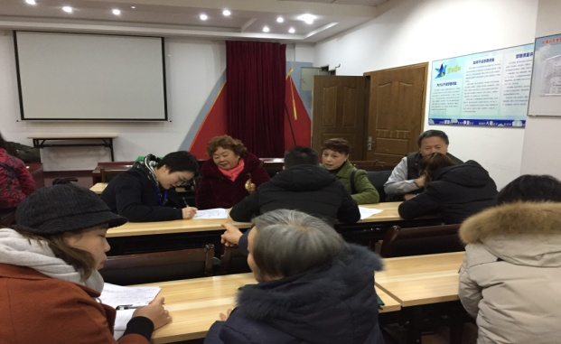  FGD in Houbao Community, Nanping Sub-district | 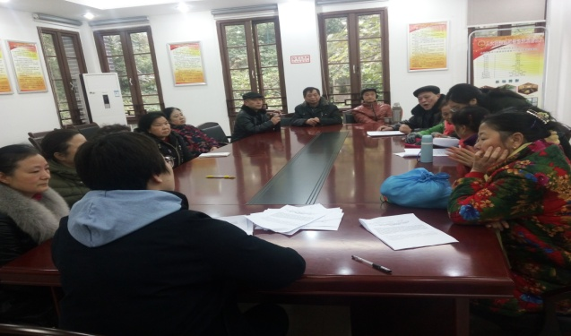  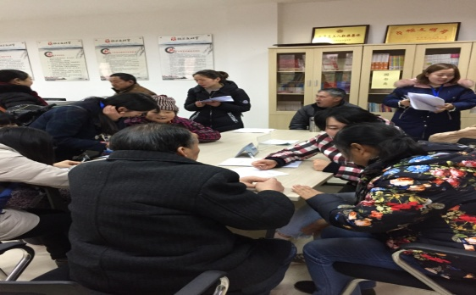  FGD in Huangjiaoya Community, Nanshan Sub-district
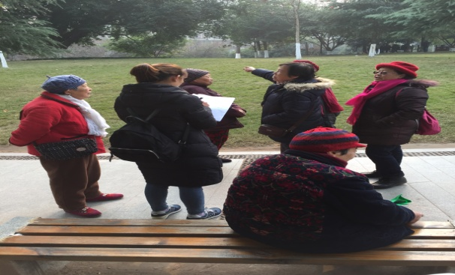  Random interview in Nanhu Park | Interview in Chongwen Road Community, Nanshan Sub-district
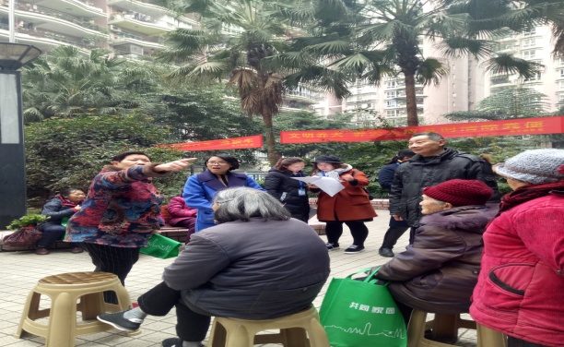  Women’s FGD in Xingyu Garden, Nanping Sub-district | 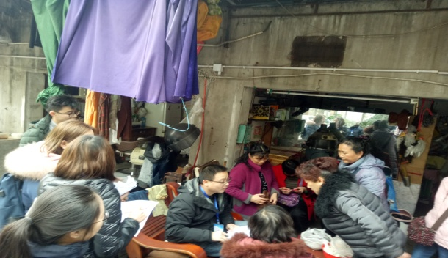  Women’s FGD in Dongxing Road Community, Nanping Sub-district
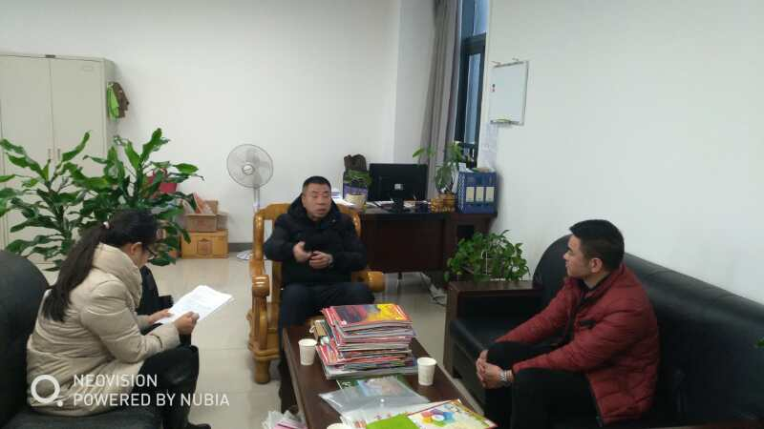  Interview at the Nan’an District Civil Affairs Bureau | 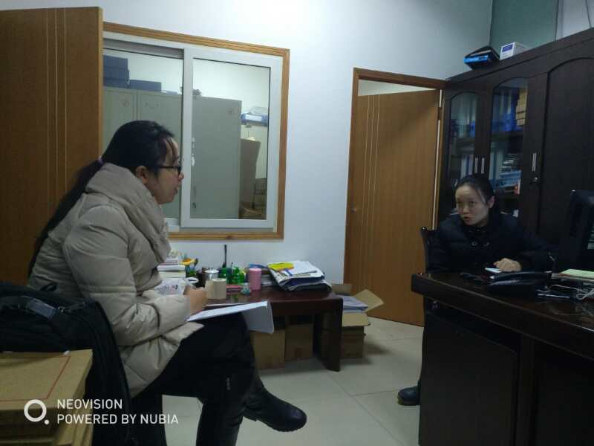  Interview at the Nan’an District Disabled People’s Federation
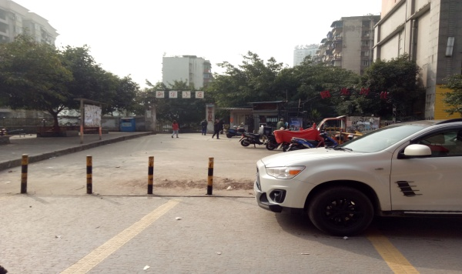  Unregulated Parking in Xinhua Community | 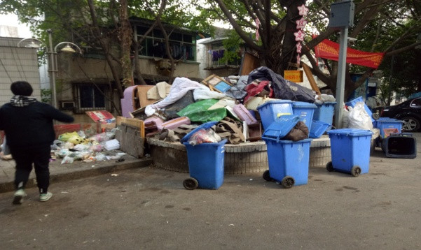  Unregulated waste dumping in Changhang Community
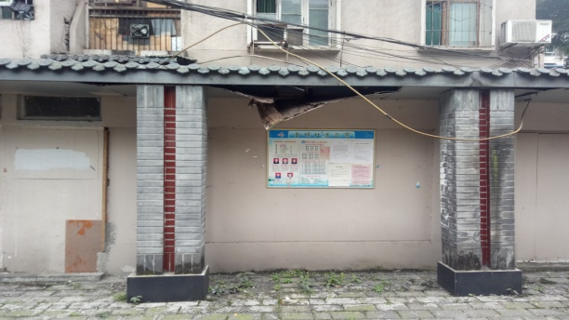  Damaged shed in Tuanyuanbao Community | 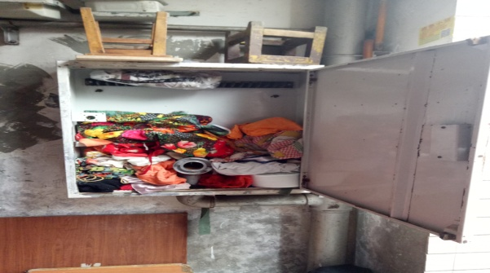  Damaged fire fighting facility in Xinjian Street Community
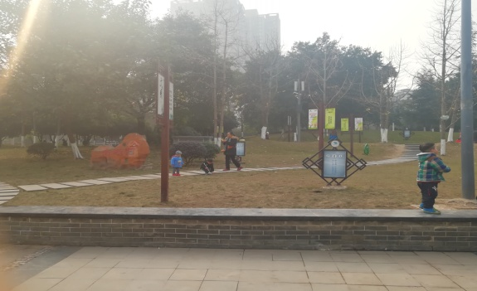  Nanhu Park | 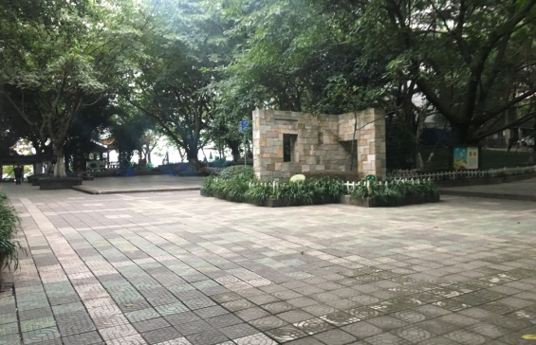  Houbao Park
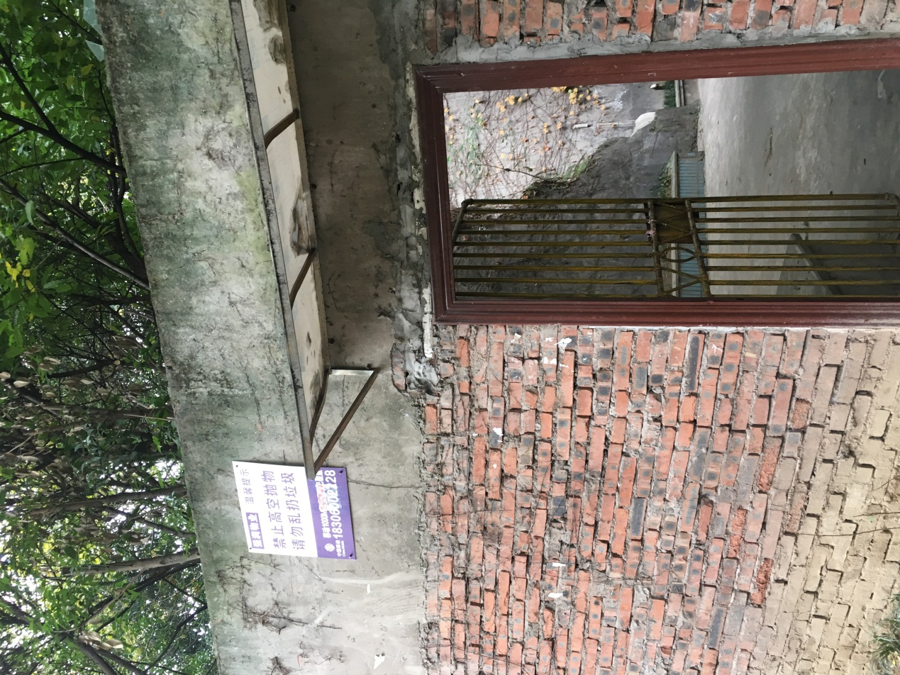  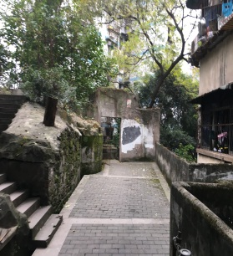  Road from community to Guohuishan Park | 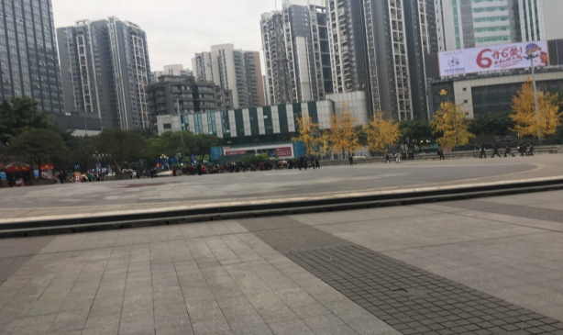  Hongsheng Square
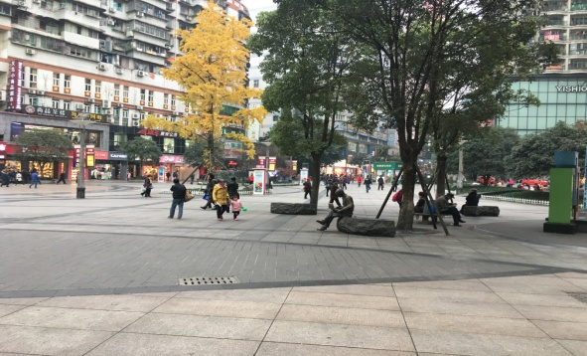  Huigong Road (Pedestrian Street) | 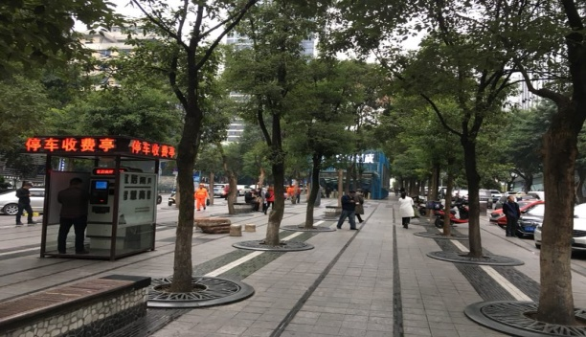  Nanping Wanda Square

In 1998, China’s housing system was reformed from welfare-oriented allocation to monetized allocation.

