Early Childhood Education Impact Evaluations for the Middle East and North Africa
Summary of workshop discussions for EGYPT
Prepared by: Juan Baron and Mohammed Audah

Participants
- Dr. Nawal xxxxxx, Director of ECE Department, Ministry of Education
- Dr. Mohamed xxxxxx, Educational Projects and Initiatives Coordinator, Ministry of Education
- Nelly Elzayat, Internal Audit Coordinator, Ministry of Education
- Mohamemed Audah, Economist, World Bank
- Juan Baron, Senior Economist, World Bank

Background

Although some enroll in Early Childhood Education (ECE) programs, most children in Egypt enter the school system at the primary level. Education in Egypt is free and public regardless of level and includes parallel academic and vocational tracks. Figure 1 shows the broad structure of the Egyptian education system, in which students spend 6 years in primary education before moving into three grades of preparatory education. The first 9 grades collectively represent compulsory education in Egypt; students transition from preparatory education into either vocational or technical secondary degrees. For the former group, this typically represents the end of education, as opposed to the latter group who typically either enroll in a post-secondary program or a standard four-year higher education institution. In addition, a small percentage of students do enter four-year institutes after secondary, but due to perceptions of labor market opportunities are seldom utilized. Enrollment in ECE programs currently averages 40 percent, predominantly propped by higher income groups in urban settings.

Figure 1: Egypt Education System Structure
Compulsory |  | Secondary | Higher Education
Primary | Preparatory | General/Vocational | Post-Secondary | University
Grades 1-6 | Grades 7-9 | Grades 10-12 | Two-year Program | Four-year Program
(Ages 6-11) | (Ages 12-14) | (Ages 15-17) | (Ages 18 and above)

Policy Problems

The Egypt delegates advocated the need to design an evaluation that capitalizes on the education reform agenda currently underway. The newly developed competency-based curriculum and the nascent scheme to train all 40,000 teachers prior to the new school year presents an underlying challenge. Gaining the buy-in of teachers is critical to developing traction on the new curriculum. The team specifically pinpointed two main problems: motivation of teachers to adopt the new curriculum and the efficacy of a later in-service teacher training program. Egypt’s predominant expenditures on education are on recurrent items, of which compensation of staff roughly accounts for 90 percent of the overall budget. Teachers in Egypt typically cite a professional learning environment and professional reputation as two key areas that diminish their motivation in the classroom; assessing the impact of an encouragement design in the initial training program and supplementary in-service training was thus deemed a policy priority for the Egypt delegates in understanding what corrective measures need to be taken.

Summary of evaluation design

The team highlighted that the new curriculum would be adopted at the start of the new school year and wanted to develop two types of in-service teacher during the year for evaluation in the subsequent year. These “packages” differ in their intensity, scope and duration. The overall timeline for the evaluation is summarized in figure 2, with the design of the evaluation summarized in figure 3. Under a complete package, randomly selected teachers would receive additional in-service instruction on teaching practices, which differs from a scaled package in the length and intensity of the training (in terms of learning materials, coverage of pedagogical practices and use of supplementary materials).

Using a sampling frame of schools with KG classrooms, the country will be stratified into four major zones and school clustering units will be randomly selected with teachers from those schools receiving in-service training. The team is interested in the impact of the training on teacher performance initially and the impact of the scheme on student learning outcomes as the endpoint outcome of interest. The team discussed several teacher and student characteristics that need to be measured at baseline; for teachers, total years of experience, teacher education level, socioeconomic status.

Figure 2: Timeline of Evaluation

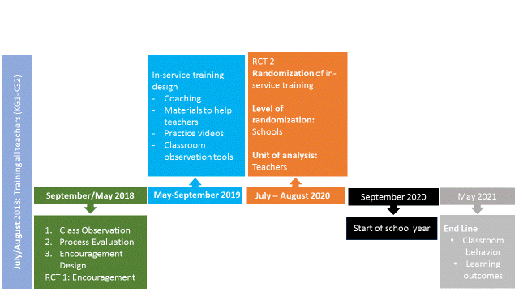

Figure 3: Evaluation Design

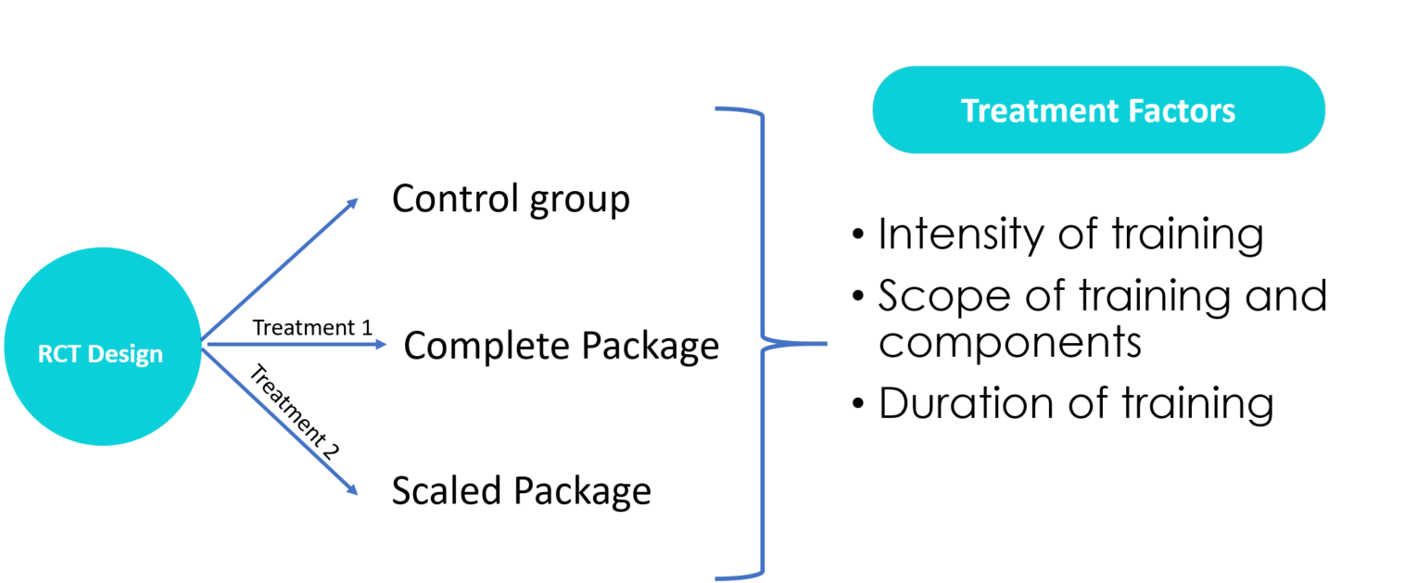

The team identified several areas that could impact the efficacy of the treatment on teacher performance and student outcomes. Primarily, the delegation was concerned that there would not be any serious uptake of the program, drawing on subdued incentives based on historical neglect of teachers in Egypt. Additionally, the team posited that many school directors could resist the disruption of additional training being set up, which could be seen as an implicit evaluation of the school itself. The team accordingly stressed the importance of designing an effective supplementary communication strategy for the schools that will be selected into the control group, to ensure that school leaders do not resist the adoption of the learning materials in the classroom.

Relevance to ongoing World Bank operations

The World Bank has an ongoing education operation in Egypt, which includes a component on ECE. The component is results-based and will disburse Bank financing against increases in KG enrollment rates and increased in KG education quality. The proposed impact evaluation will provide rigorous evidence of the effectiveness of in-service training against the priority of increasing quality of education in ECE programs.

Client interest

The delegates were extremely enthusiastic about the workshop, initially as a pedagogical practice, and laterally as an avenue to examine whether these reforms will be in effective in delivering on their promise of improved learning outcomes for preprimary children. It was a pleasure to work with them and highly encouraging of the potential experimental evidence in designing policies in the region.

Next steps

To get a serious start on this evaluation, it would be important to complete the following next steps within the next few months:

- Review of the initial rollout and adoption of the curriculum at the start of the school year
- Agreement and adapting a classroom observation tool to assess teacher practices in the classroom
- Design and implementation of an in-service teacher training program along with a researcher by clearly identifying the main areas requiring strengthening.

