ABBREVIATED RESETTLEMENT ACTION PLAN (RAP)
SFG1317 v2
in a frame of fourth Grant of Global Partnership for Education
(GPE-4)

Project: «Construction of educational building for 10 classes in secondary school # 56 of Constitutsiya village, dj. SariKishtiofRudaki»

1. Introduction

The Project Development Objective is to contribute to improving the learning conditions and quality in pre-school and general education
Grant is developed for assistance in filling gaps of implementation of the National Strategy of Education Development (NSED), in particular with regard to the objectives on improving of infrastructure, material and technical aspects of education system, on improvement of management and work of education system in providing of quality educational services; and for ensuring the quality of educational services.
Ministry of Education and Science (MoES) of the Republic of Tajikistan, with the support of local consultants, manages and implements Grant.

Components of project

GPE-4 will have four components, as described below.
Each component works towards the development of child-friendly schools to ensure that the children of Tajikistan, especially the most marginalised including girls, ethnic minorities, rural children, and children with disabilities, are afforded the opportunity to achieve their education goals for future development and success.
The child-friendly school is a conceptual framework by which various aspects of the education system are addressed to ensure that each child is afforded their basic right to education. Inclusive in this framework is provision of safe and adequate school structure; relevant curriculum and content; a child-centered pedagogical approach; and relevant resources.

Component | Title | Cost (million US dollars)
1 | Increasing Access to Quality Early Childhood Education Programmes | 2,55
2 | Enhancing Quality of Education | 3,25
3 | Improving child-friendly learning environments | 8,00
4 | Strengthening System Capacity | 2,40
 | Total: | 16,20

Component One: Increasing Access to Quality Early Childhood Education Programmes (US$ 2.55 million; 15.7% of total project cost)

The objective of this component is to increase access to affordable and quality early childhood education (ECE) programmes. As such this component will finance: i) an analysis of the pre-school sector; ii) the reinforcement of state kindergartens and early learning centers; and iii) where possible, expansion of the latter. The Department of Pre-School and General Secondary Education (DPGS) is responsible for the component implementation. DPGS will work in close collaboration with Academy of Education (AOE) and Republican Institute for In-service Teacher Training (RIITT). The Project will finance technical assistance to support the DPGS to implement activities.

Component Two: Enhancing Quality of Education (US$ 3.25 million; 20.1% of total project cost)
The objective of this component is to improve the quality of education in the general education programme. There are three sub-components which build upon FTI-3 components and are in line with NSED 2020 goals and objectives to improve the quality of education at the primary and secondary levels. The Department of Pre-School and General Secondary Education (DPGS) is responsible for the component’s implementation. The DPGS will work in close collaboration with AOE and RIITT. It is expected that in enhancing the quality of education, learning outcomes will be improved.
Sub-component 2.1: Upgrading Primary Education Curriculum and Pedagogy (US$ 2.15 million; 13.3% of the total project cost)

Sub-component 2.2: Upgrading Secondary Education Curriculum and Pedagogy (US$ 0.35 million; 2.2% of total project cost)
Sub-component 2.3: Promoting Inclusive Education (US$ 0.75 million; 4.6% of total project cost)
Component Three: Improving child-friendly learning environments (US$ 8.00 million; 49.4% of total project cost)

The objective of this component is to increase access to improved child-friendly learning environments in general secondary education through the provision of safe and secure schools. It is expected that this will contribute to an improvement in student completion, teacher motivation, and learning outcomes. As such, this component will finance improvement and expansion of child-friendly learning environments in approximately 30 schools to the benefit of approximately 7,900 students through construction or rehabilitation of premises and provision of furniture.

Sub-component 3.1: Increasing Access to Child-Friendly Schools (US$ 7.00 million; 43.2% of total project cost).
Sub-component 3.2: Provision of Supplies to Develop Child-Friendly Schools (US$ 1.00 million; 6.2% of total project cost).

Component Four: Strengthening System Capacity (US$2.4million; 14.8% of total project cost)

The objective of this component is to strengthen the capacities at the central and local levels to manage the education system.

Sub-component 4.1: Management Capacity Strengthening (US$ 0.12million; 0.7% of total project cost).
Sub-component 4.2: Directors’ Training (US$ 0.80 million; 4.9% of total project cost).
Sub-component 4.3: Per Capita Financing (US$ 0.19 million; 1.2% of total project cost).

Sub-component 4.4: Education Management Information System (US$ 0.09 million; 0.6% of total project cost).

Sub-component 4.5: Project Management, M&E (US$ 0.85 million; 7.4% of the total project cost).
2. Legal framework
The problem of compensation for damage specified in a frame of action plan is regulated with following laws and regulations:
- Constitution of the Republic of Tajikistan which establishes exclusive state property on land;
- Land Code of the Republic of Tajikistan - most systematic set of rules regulating complex of legal relationship that occur in the process of ownership, use and disposal of land;
- Civil Code of the Republic of Tajikistan, determining the legal status of participants of civil turnover, basis of emergence and procedure of implementation of the rights, contractual obligations, property and non-property relations;
- Law of the Republic of Tajikistan dated May 12, 2001 "On Land Assessment", which establishes the legal basis of assessment of land;
- Law of the Republic of Tajikistan dated May 14, 2004 “On local public authorities” establishing regulatory framework of allocation and redistribution of land;
- Law of the Republic of Tajikistan on January 5, 2008 "On land management," regulating relations associated with the legal bases of activity on Land Management;
- State Land Cadastre as a system of information and documents on the natural, economic and legal status of land, their categories, qualitative characteristics and economic value;
- Regulation on the procedure of compensation of damages on land users and losses of agricultural production, approved by the Government of the Republic of Tajikistan dated December 30, 2000 № 515, establishing procedure of compensation of losses to land users;
- Code of Civil Procedure of the Republic of Tajikistan, determines the procedure, rules and terms of judicial protection at occurrence of judicial disputes on involuntary resettlement.
- For realization of Programme of Resettlement Policy also is used Regulations of the World Bank Policy on Involuntary Resettlement.

3. Impact of resettlement from project activities and compensation
Concerning farmland
Secondary school № 56 is located in the Constitution village of Sarikishti Jamoat of Rudaki district. The old building is located directly on the territory of village. For construction of a new school is selected land plot in the western part of the village, outside of the territory of the village.
On the basis of written request of Ministry of Education 06.03.2014, on the allocation land plot for construction of additional educational building for 10 classes of secondary school №56 of Rudaki district by decision of the Chairman of the Rudaki district №511 from 01.08.2014, the allocated land plot 1.5 hectares from land farm "Vaysiddin", located on the western part of Constitution village of Sarikishti Jamoat.Also available agreement of the dekhkan farm on alienation of 1.5 hectares of land under construction of schools from the total land area 21 hectares, which is owned by dekhkan farm "Vaysiddin." Withdrawn land plot of dekhkan farm "Vaysidin" is agricultural land.

Affected individuals and Compensation
The list of affected persons in this ARAP includes 4 people. Members of dekhkan farm "Vaysiddin" (total 4 people) M.B. (Chairman of farm) T.K. B.S. and S.M. (members of farm) given land plot used exclusively for seeding of wheat.During the conversation with the members of the dekhkan farm "Vaysiddin" (5th of May 2015) revealed that all members of dekhkan farm have no other sources of income.
Despite the fact that Hukumat of Rudaki district as compensation d / f Vaysiddin allocated a new land plot and therefore not followed withdrawal of previous land plot. Instead of this farm was provided with all conditions for seeding of previous land plot with wheat (photo from 12.18.2014), which will be released for construction of school at the end of June, that is June 15of this year after the harvest.
Also, at the beginning of spring sowing according to the decision of Chairman of the Rudaki district №131 from 01.26.2015 farm is provided with land plot (allocated new land plot of 1.5 ha), which has similar features and sowing of harvest will occur in time therefore not followed impact on the assets.
All members of dekhkan farm "Vaysiddin" were acquainted with new land ploton10th of January, 2015, which is Hukumat provided as compensation. Allocated land plot of 1.5 hectares from agricultural land of the reserve fund of Rudaki district is located on the territory of the same Sarikishti Jamoat and on its characteristics identical to the previous land plot.
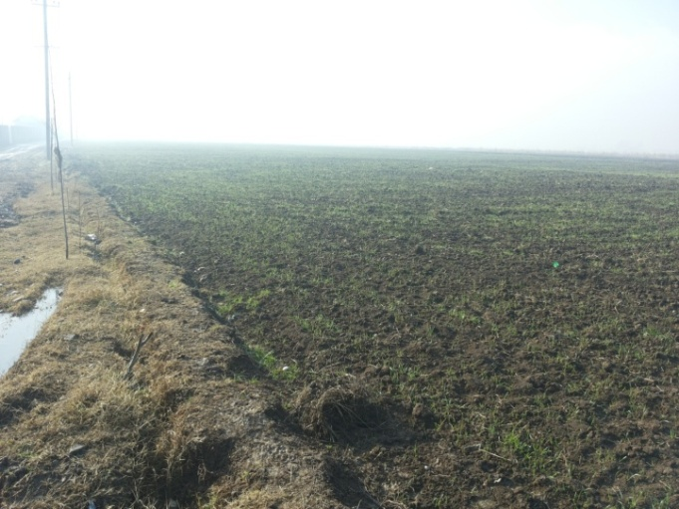
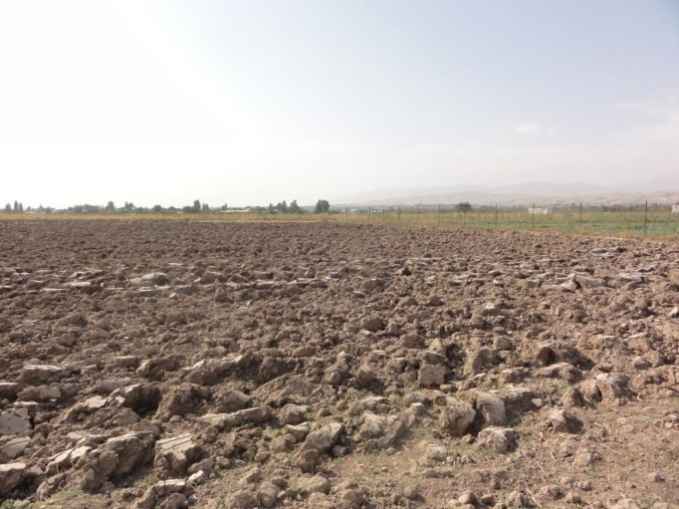

.
18.12.2014

Certificate for use of land will be issued by the Committee on Land Use and Geodesy on the basis of the aforementioned decision of Chairman of the Rudaki district within 6 months. All expenses related with re-issuance of land plot, including expenses for obtaining Certificate of land will be paid by the Hukumat of Rudaki district.
18.12.2014
23.09.2014
In a frame of this project does not provide physical and economical resettlement of any household.
The project also does not impact on living conditions of households that are far away from residential areas of these farms. All members of dehkan farm were informed and aware of the degree of exposure, scope of compensation as providing of new land plot which identical to the previous onebefore making decision the Chairman of Rudaki district on acquisition of land under construction of schools, ie up to 01.08.2014
At the last meeting, which took place on 26 May, Chairman of d / f "Vaysiddin" M.B. once again ensured that land plot for construction of the school will be released until June 15 of the current year after the harvest.

In December 2014, Mr. M.B. complained to the Ministry of Education that by decision of the Chairman of Hukumat of Rudaki district from 01.08.2014 confiscated land plot of 1.5 hectares from land plot of d / f Vaysiddin for the construction of schools, but up to December compensation by Hukumat the district had not provided promised new land plot.Concerning grievance of Chairman of d/f Vaysiddin MoES in its written request to the Hukumat of district asked to solve the problem with provision and registration of new land plot.

In response to the complaint and on the basis of written request of MoES (from 01.06.2015 and from 01.22.2015 ) Chairman of Hukumat of Rudaki district by its decision №131 from 1.26.2015 as compensation has allocated to d / v "Vaysiddin" earlier promised new land plot with area 1.5 hectares which identical to the previous land plot.

Chairman of dekhkan farm "Vaysiddin" Mr. B. M. considers compensation secured and effective in the form of replacement of land plot, evidence of this on behalf of members of farm was sent letter of thanks to the Minister of Ministry of Education of RT (attached).

During the conversation with Chairman of d/ f "Vaysiddin" by Mr. M.B. revealed that the average yieldof farm from the land plots of 1.5 ha (which falls under construction of the school) is:
- 7 tons of grain;
- 4 tons of hay to feed cattle.

The income from this yield was approximately:
- 7 tonnesof hay х 1200 somoni = 8400 somoni;
- 4 tonnesof hay х 200 somoni = 800 somoni.
Total: 9200 somoni.
№ п/п | Title of farm | Land plot area 1 (affected area, which is compensated) | Impact | Degree of impact (general partial, minimum)  Affected area does not exceed 10% of the total land area | Status of landholder² | Employment status of all adults | Compensation
1 | Dekhkan farm «Vaysiddin»:  Chairman -  B.Madjidov  Members -  TuychievK.,  Buhorieva S.,  Mirzoev S. | 1,5 hectares | Loss of land plot 1.5 hectares;  Corn - 1.5 tons;  Hay to feed cattle - 1.0 tons. | Minimum | Perpetual use on inheritance | Members of dekhkan farm | As compensation, d / v "Vaysidin" allocated land plot with area 1.5 hectares from arable land of reserve fund of Rudaki district on the territory of the same Sarikishti Jamoat and on its characteristics identical to the previous property.Crop losses would not be because provided all rights and conditions without losses to harvest grain.

1Land plot used exclusively for seeding of wheat
2Land is state property of the Republic of Tajikistan, which is inherited for use of dehkan farm

4. Theproposedassistance.
Physical movement of families from one place to another in this case is not expected.

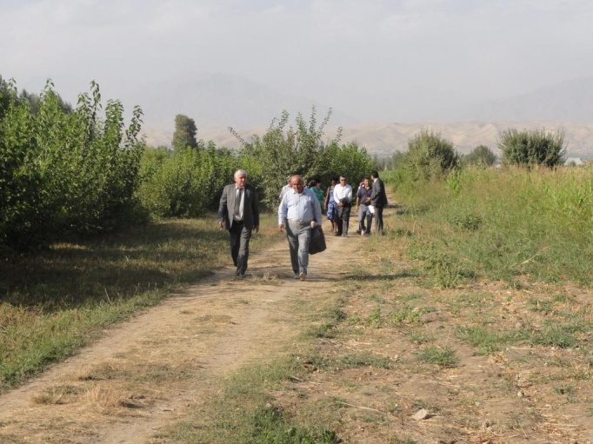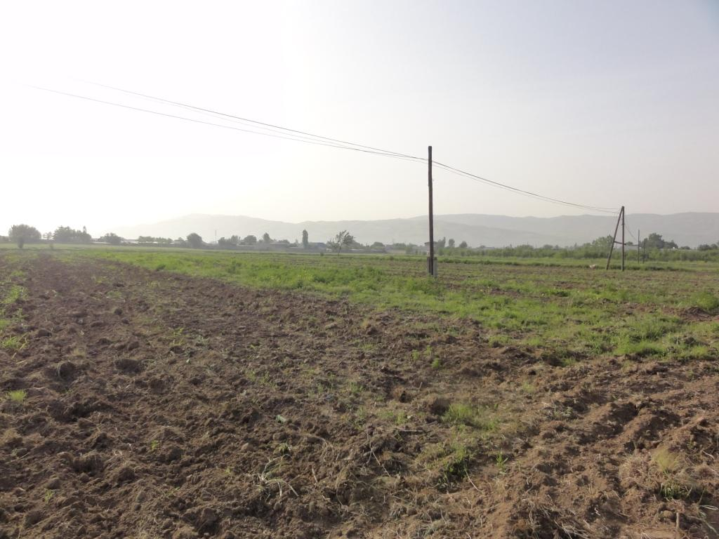
03.05.2015
23.09.2014

It should be noted that earlier Hukumat of district has been provided as compensation land plot of 1.5 hectares from reserve land of Rudaki district is located at a distance of 2.5 km. and in which many years grew up mulberry and was planted grass to feed cattle (photo from 23.09.2014.).
Uponcompletionon time HukumatofRudakiDistricthaschanged its decision and provide new land plot with 1, 5 hectares from agricultural land of reserve fund of Rudaki District on the territory of the same Sarikishti djamoat and on its characteristic is identical to previous land plot (photo from 03.05.2015).

5. Responsible Authority
MoES RT is controlling authority for implementation of ARAP. Hukumat of Rudaki district will be responsible for the timely payment of compensation in the form of equivalent allocation of land plot assistance in harvesting in the previous land plot and registration and preparation of a new land plot.

6. The source of budget and estimated cost
In this case, we evaluated material and social risks associated with loss of sources of income, creation of new infrastructure and physical relocation provided in such cases, OP 4.12.
At inspection of new site is established that allocation of land plot for dekhkan farm "Vaysidin" located on the territory of the same Sarikishti Jamoat, and its characteristics identical to the previous land (arable land).In this connection is no question on significant material and social losses - the loss of sources of income, creation of new infrastructure on use of compensated land plot and physical displacement (means transfer of the place of residence - home, infield, etc.). It is only on changing the place of cultivation on the territory of the same settlement, indicating the minimal impact of the project on the previous land users.

7.Schedule of resettlement.
Since selected as compensation land for dekhkan farm "Vaysidin" is located on the territory of the same Sarikishti Jamoat and on its characteristics identical to the previous land (arable land) occurred changing the place of cultivationon the territory of the same settlement.
There were no significant material and social losses in the form of loss of sources of income, creation of new infrastructure on use of compensated land plot and are not exist physical resettlement of members of dehkan farm that indicate minimal impact of project on the previous land users.
Prior to the start of construction work MoES will present work schedule. This schedule will indicate that Hukumat of district will be responsible for the provision of d/fwith all conditions for harvesting on the old land plot and preparation and sowing of crops on a new site to each person impacted by the Project in accordance with the agreed ARAP.
Construction work is planned to begin after harvesting at the end of May or beginning of June 2015 that up to this time d/f Vaysiddin can be able to collect all harvest of corn and release land plot for construction of school.
No construction works will occur until the affected farms have been allowed to harvest all their crops and have full access to the new replacement site.

п/н | Title of activities | Date of execution | Responsible
1 | Harvesting and release of land plot for school construction | 10-15 June 2015 | Dehkan farm «Vaysiddin»
2 | Beginning of construction | 30 June 2015 | MoES RT
3 | Receiving of Certificate of land | November-December 2015 | The Committee on land RT
4 | Completion of Construction | 30 June2016 | MoES RT

8. MonitoringandEvaluation/ Sequential implementation of activities
MoES and Hukumat of Rudaki district are the main agencies which are responsible for the implementation of this action plan and at the same time representatives of local khukumats and heads of dehkan farms will follow to this ARAP. Specialist on Monitoring of MoES and representative of the Hukumat of Rudaki district will verify that all work on the provision of compensation (in the form of new land plot) will be made up to permission for beginning of civil work.Specialist on Monitoring and independent consultant on monitoring will present report on the implementation of this action plan. Monitoring of the object will be made within 6 months and one year, when it will be possible to compare the incomes with the previous one and which received from the new land plot.
Twice yearly reports on the progress of resettlement of actions will be submitted to the World Bank as part of regular project reports. At the end of the project a final report will be submitted to the World Bank.
Monitoring of resettlement and keeping of records will be done by MoES. AlsoMoESwillhireindependentConsultantthat to provide independent assessment of resettlement program in consultation with all parties (ARAPs, project developers and civil society).
Monitoring and Evaluation will take place from the beginning of the project until the completion of all actions on resettlement. The form of report is discussed by MoES and consultant. At the end of the project independent consultant is submit detailed summary report on the whole scope of project, delivery of compensation and other rights as well as impact on existence of ARAP.
Expenses of consultant on monitoring and evaluation and observers of MoES will be financed by the project GPE-4:

п/н | Activity | Number of trip | Cost in somoni
1 | Consultant on Monitoring and Evaluation  Expenses for trip:  Salary: | 4 trips per 150 somoni  4 days per 200 somoni | 600 somoni  800 somoni
2 | Observers from the side of GPE-4 and MoES | 2 trips per 100 somoni | 200 somoni
 | Total: |  | 1600 somoni

Allocated land plot of 1.5 hectares under construction of the school is revealed from the harvest of grain.
15.06.2015

15.06.2015

The new land plot of 1.5 hectares is located in the territory of the same Sarikishti Jamoat and on its characteristics exceed previous land plot so that this land is irrigated (irrigated land) that by members of d / f land plot is processed and sown with maize.
In the new land plot do not requires cutting of trees and shrubs as land is irrigated and quality of soil is better than previous land.
New land plot subject to agro-technical requirements can be collected two or three harvests per year, which gives an advantage to members of d / f in addition, replenish its budget at the expense of planting of second and third harvest of vegetable crops.

In the previous land plot due to the lack of water was not possible more than once to harvest grain, and the land was idle for more than 6 months before planting of new crop for next year.

Copy of letter of Chairman of d\f Vaysiddin Mr.Madjidov B.
Hereby we inform that the whole grain yield in allocated land plot under construction of school №56 of Rudaki district was collected and revealed from crops culture up to 01.06.2015.

9. Grievance redress order
In the case of grievance or protest PAP (person affected by the project) can address to:
- Headofjamoat, localadministration/land surveyor or Hukumat of Rudaki District on address: 735100, Somonien settlement, 16 I.Somoni Street,Tel: 8(3137) 2-24-81, 442-21-04, 442-21-10(f).
- Legal Department and Secretariat of MoES (Dushanbe, Republic of Tajikistan, 13а Nisormuhammad Street, 221-46-05 fax: 221-70-41; www.edu-maorif.tj, E-mail: mort@maorif.tj).

In case if disputed issues cannot be resolved between the MoES, Sarikishti Jamoat and PAP (person affected by the project) then the last may apply to the judicial authorities or to the Chairman of Hukumat of Rudaki district and any disputed issues will be resolved in accordance

Communities and individuals who believe that they are adversely affected by a World Bank (WB) supported project may submit complaints to existing project-level grievance redress mechanisms or the WB’s Grievance Redress Service (GRS). The GRS ensures that complaints received are promptly reviewed in order to address project-related concerns. Project affected communities and individuals may submit their complaint to the WB’s independent Inspection Panel which determines whether harm occurred, or could occur, as a result of WB non-compliance with its policies and procedures. Complaints may be submitted at any time after concerns have been brought directly to the World Bank's attention, and Bank Management has been given an opportunity to respond. For information on how to submit complaints to the World Bank’s corporate Grievance Redress Service (GRS), please visit http://www.worldbank.org/GRS. For information on how to submit complaints to the World Bank Inspection Panel, please visit www.inspectionpanel.org.

10. Disclosureofinformation
This ARAP is a public document and will be available in English, Tajik and Russian in infoshops of World Bank, in World Bank office in Dushanbe, at the office Ministry of Education and Science of the Republic of Tajikistan (Dushanbe, RepublicofTajikistan, 13аNisormuhammadStreet, 221-46-05 fax: 221-70-41; www.edu-maorif.tj, E-mail: mort@maorif.tjandintheofficeofthelocalHukumatofdistrictonaddress:735100, Somoniensettlement, 16 I.SomoniStreet, Tel: 8(3137) 2-24-81, 442-21-04, 442-21-10(f). Affected people will also be given a copy of the ARAP in a language that they understand.

There is a large body of research documenting positive associations between the physical conditions of schools - including their quality and the availability of learning and other facilities and utilities – and student completion, teacher motivation and student learning.

