Rehabilitation of a fountain in Tskaltubo Park

Sub-Project Environmental and Social Screening and Environmental Management Plan

WORLD BANK FINANCED
SECOND REGIONAL DEVELOPMENT PROJECT (RDP 2)

Tbilisi, Georgia
August 2019
Environmental Screening
The sub-project (SP) for the rehabilitation of an existing fountain in Tskaltubo Park includes full restoration of the existing fountain located in the park of Tskaltubo town and installation of additional functions as well. The existing musical fountain in Tskaltubo Central Park, built in 80-ies of the previous century, consists of three round pools of various sizes connected to each other by a rectangular pond, with a small passage bridge arranged on it. All structural elements of the fountain were made of reinforced concrete. The fountain is in a poor condition. Most part of the existing granite tiles are cracked, while some part of the tiles are detached from the wall. Electricity network, water supply and discharge systems are out of control as well. The roof of the control building is damaged and leaks, resulting damages to the wooden structures of the roof and inner floor. Asbestos pipes, nowadays prohibited due to their unhealthy effects, are used for the façade revetment.
The existing fountain will be replaced by so called “dry interactive fountain” - a pedestrian platform will be arranged in the large round pool so that people can walk inside the fountain and interact and enjoy the direct contact with dancing water jets. Water will be erupted from 2 to 3 meters height simultaneously with synchronized lighting. The fountain will be controlled from the programmable management system. In the other two pools and connecting rectangular pools will be classical fountain schemes will be remained with different jets and lights; Sound system consisting of two wide range speakers will be installed on the existing posts around the fountain at 4 meters height, from where the sound wave will cover the whole plaza.
For the proper operation of the rehabilitated fountain the following works shall be carried out:
- Demolition of the existing pipeline in the fountain pools and covering stone tiles from the walls;
- Arrangement of 310 meters long water supply line and connecting to central network of the city;
- Arrangement of 400 meters long power cable from transformer building to the distribution board;
- Rehabilitation of the existing basalt stones and curbstones around the fountain;
- Rehabilitation of the existing benches around the fountain;
- Arrangement of the drainage channel along the stairs in front of the theater;
- Arrangement of water supply network for filter-pump chamber.

Furthermore, within the SP, appropriate public lavatory will be arranged meeting current standards to improve the sanitary conditions in the area. Nearby the fountain there are no lavatories, as the toilets built earlier in Tskaltubo Park are located at the other end of the park in about 2 km distance from the fountain. As mentioned above, the place has been a traditional gathering area for the locals and visitors. That’s why there is a need to arrange a new lavatory at the same place where the old one used to be. The old toilets were dismantled in 2012 and currently the area is cleaned from construction waste as well. The wastewater channel of the newly build toilet will be connected to the central wastewater network of the city. The newly built toilet will be adapted to the needs of people with disabilities.

(A) IMPACT IDENTIFICATION
Has sub-project a tangible impact on the environment? | The SP will not have any significant or irreversible negative impacts on the environment. No sensitive environmental receptors will be affected.
What are the significant beneficial and adverse environmental effects of sub-project? | The SP is expected to have positive long term social impact on as the rehabilitation of the fountain in the Park will increase visitation. Moreover, as the SP envisages removal of asbestos-containing pipes, the environment will become safer for the visitors of the park and this will be a positive impact on public health.  As a result of the SP, the existing fountain will be rehabilitated and renovated. This will be beneficial from the environmental point of view as the new system will support rational usage of the water resources.  Expected negative environmental and social impacts are likely to be short term and typical for small to medium scale rehabilitation works in urban landscape: noise, dust, vibration, and emissions from the operation of construction machinery; generation of construction waste; disruption of traffic and pedestrian access. Adverse effects are also related to the process of removing asbestos-containing materials.  All the mentioned impacts are expected to be temporary and insignificant.
May the sub-project have any significant impact on the local communities and other affected people? | No new land take and resettlement are expected during the SP implementation.  The fountain is located in Tskaltubo Park. The land is registered as the property of Tskaltubo municipality. Cadastral information is attached to this document.  Water and electricity supply for the local population will not be disrupted during the rehabilitation works. Only a short section of the water supply system will be locked for several hours while connecting the fountain water supply pipes to the municipal network. The population will be informed in advance.  The SP is expected to have positive long term social impact on the social environment as the rehabilitation of the fountain in the Park will increase visitors.  Consequently, negative impacts for local communities are short term and limited to the construction site. They are related to the possible disturbance described above.

(B) MITIGATION MEASURES

Were there any alternatives to the sub-project design considered? | The project has been initiated by Tskaltubo Municipality and as the SP envisages rehabilitation works of the existing fountain, there were no alternatives considered.
What types of mitigation measures are proposed? | The expected negative impacts of the construction phase can be easily mitigated by demarcation of the construction site, traffic management, good maintenance of the construction machinery, observance of the established working hours, and well-organized disposal of waste to the formally agreed sites.  The contractor will be responsible for the waste disposal at the permitted location; use the quarry materials from the licensed quarries only; prevention of water and soil pollution (fuel spills due to equipment failure, row asphalt/concrete spills, release of untreated pipe disinfection solvent to the natural environment, etc.); and avoiding disturbance of population (noise, dust, emissions) through proper work/supplies scheduling, traffic management, good maintenance of the construction machinery.  Asbestos-containing pipes will be removed and disposed in accordance with the Ordinance N145 of the Government of Georgia of 29/03/2016 on “Special Requirements for Hazardous waste collection and processing”.  Operations & Maintenance Training will be executed and operation manual will be supplied by works contractor to ensure safe functioning of the fountain.
What lessons from the previous similar projects have been incorporated into the sub-project design? | MDF have a wide experience in implementation of medium and large-scale water system rehabilitation projects financed by various donor organizations. Based on lessons learned from previous similar projects, it envisages not only rehabilitation of the existing fountain in the park, but also constructing toilets, in order to improve visitors’ comfort in the park from the social point of view. Furthermore, the newly built lavatory will be adapted to the needs of people with disabilities.
Have concerned communities been involved and have their interests and knowledge been adequately taken into consideration in sub-project preparation? | The SP has been developed by the MDF taking into consideration current needs and priorities of local population with consultation and collaboration of Municipality Assembly (Sakrebulo).  The site-specific EMP drafted for the SP was disclosed and discussed with local stakeholder on the public consultation meeting prior to tending of works, on June 8th, at Tskatubo City council. Minutes of the meeting are attached to the finalized EMP.

(C) RANKING

The subproject has been classified as environmental Category B according to the World Bank safeguards (OP 4.01) and requires Completion of the Environmental Management Checklist for Small Construction and Rehabilitation Activities.

Social Screening
Social safeguards screening information |  |  | Yes | No
1 |  | Is the information related to the affiliation, ownership and land use status of the sub-project site available and verifiable? (The screening cannot be completed until this is available) | √
2 |  | Will the sub-project reduce people’s access to their economic resources, such as land, pasture, water, public services, sites of common public use or other resources that they depend on? |  | √
3 |  | Will the sub-project result in resettlement of individuals or families or require the acquisition of land (public or private, temporarily or permanently) for its development? |  | √
4 |  | Will the sub-project result in the temporary or permanent loss of crops, fruit trees and household infrastructure (such as ancillary facilities, fence, canal, granaries, outside toilets and kitchens, etc.)? |  | √
If answer to any above question (except question 1) is “Yes”, then OP/BP 4.12 Involuntary Resettlement is applicable and mitigation measures should follow this OP/BP 4.12 and the Resettlement Policy Framework
Cultural resources safeguard screening information |  |  | Yes | No
5 | Will the sub-project require excavation near any historical, archaeological or cultural heritage site? |  |  | √

If answer to question 5 is “Yes”, then OP/BP 4.11Physical Cultural Resources is applicable and possible chance finds must be handled in accordance with OP/BP and relevant procedures provided in the Environmental Management Framework.

Environmental Management Plan
PART A: General Project and Site Information
INSTITUTIONAL & ADMINISTRATIVE
Country | Georgia
Project title | Regional Development Project 2
Sub Project title | Rehabilitation of fountain in Tskaltubo Park
Scope of site-specific activity | The sub-project (SP) for the rehabilitation of an existing fountain in Tskaltubo Park includes full restoration of the existing fountain located in the park of Tskaltubo town and installation of additional functions as well. The existing musical fountain in Tskaltubo Central Park, built in 80-ies of the previous century, consists of three round pools of various sizes connected to each other by a rectangular pond, with a small passage bridge arranged on it. All structural elements of the fountain were made of reinforced concrete. The fountain is in a poor condition. Most part of the existing granite tiles are cracked, while some part of the tiles are detached from the wall. Electricity network, water supply and discharge systems are out of control as well. The roof of the control building is damaged and leaks, resulting damages to the wooden structures of the roof and inner floor. Asbestos pipes, nowadays prohibited due to their unhealthy effects, are used for the façade revetment.  The existing fountain will be replaced by so called “dry interactive fountain” - a pedestrian platform will be arranged in the large round pool so that people can walk inside the fountain and interact and enjoy the direct contact with dancing water jets. Water will be erupted from 2 to 3 meters height simultaneously with synchronized lighting. The fountain will be controlled from the programmable management system. In the other two pools and connecting rectangular pools will be classical fountain schemes will be remained with different jets and lights; sound system consisting of two wide range speakers will be installed on the existing posts around the fountain at 4 meters height, from where the sound wave will cover the whole plaza.  For the proper operation of the rehabilitated fountain the following works shall be carried out:  - Demolition of the existing pipeline in the fountain pools and covering stone tiles from the walls;  - Arrangement of 310 meters long water supply line and connecting to central network of the city;  - Arrangement of 400 meters long power cable from transformer building to the distribution board;  - Rehabilitation of existing basalt stones and curbstones around the fountain;  - Rehabilitation of existing benches around the fountain;  - Arrangement of the drainage channel along the stairs in front of the theater;  - Arrangement of water supply network for filter-pump chamber.  Furthermore, within the SP, appropriate public lavatory will be arranged meeting current standards to improve the sanitary conditions in the area. Nearby the fountain there are no lavatories, as the toilets built earlier in Tskaltubo Park are located at the other end of the park in about 2 km distance from the fountain. As mentioned above, the place has been a traditional gathering area for the locals and visitors. That’s why there is a need to arrange a new lavatory at the same place where the old one used to be. The old toilets were dismantled in 2012 and currently the area is cleaned from construction waste as well. The wastewater channel of the newly build toilet will be connected to the central wastewater network of the city. The newly built toilet will be adapted to the needs of people with disabilities.
Institutional arrangements (WB) | Task Team Leader:  Vica Rosario Bogaerts |  | Safeguards Specialist:  Darejan Kapanadze – Environment  Sophia Georgieva - Social
Implementation arrangements (Borrower) | Implementing entity:  Municipal Development Fund of Georgia | Works supervisor:  Consulting company “Steget” |  | Works contractor:  “Java” Ltd
SITE DESCRIPTION
Name of institution whose premises are to be rehabilitated | Tskaltubo Municipality
Address and site location of institution whose premises are to be rehabilitated | 25 Rustaveli Street, Tskaltubo  E-mail: Tskaltubo1@gmail.com
Who owns the land?  Who uses the land (formal/informal)? | Fountain are located in Tskaltubo Park. The land is registered as the property of Tskaltubo municipality. Cadastral information is attached to this document.
Description of physical and natural environment around the site | Tskaltubo is situated in the central part of western Georgia at the foot of the South Caucasus, ten kilometers from the city Kutaisi, a hundred kilometers from the warm Black Sea and 230 kilometers from Tbilisi, the capital of Georgia.  Clinical data show the extraordinary wide range of curative properties of Tskaltubo as a health resort, but it became especially famous for its unique warm radioactive gaseous springs (baths) which has been well-known since the ancient times.  Tskaltubo mineral waters are of high medical properties, they can cure (treat) about sixty diseases. It magically helps the patients who have the joint disease, the disease of the peripheral nervous system, the cardiovascular system disease, skin disease, metabolic disorder, the disease of endocrine glands, gynecological disorders and many other diseases, but since the 1970s its repertoire has included "speleotherapy", in which the cool dust-free environment of local caves is said to benefit pulmonary diseases.  Tskaltubo is known not only as a Spa but as well as a popular tourist center. It is situated in a great hilly plain with its warm moderately humid climate. The peculiarities of the climate are formed by specially combined solar radiation, atmospheric circulation and complex topography. The solar radiation regime determines the subtropical climate of Western Georgia. Tskaltubo is famous for its mild winters (+3ºC) and not very hot summers (+33-35º C). So Tskaltubo can be considered to be a climate resort. Along with the treatment you can have a good rest here. There is a large beautiful park with about hundred different species of subtropical flora. There are also Historical and area Studies museums. From Tskaltubo holiday-makers can visit the second largest city Kutaisi, its museums, its Picture Gallery, ancient historical monuments, great Bagrati cathedral, Gelati Monastery and Academy, Motsameta, Geguti hunting house and fortress and other places of interests. It takes you about an hour and a half to reach the Black Sea shore or the Alpine snow-capped mountains of Svaneti. You can see the dinosaurs’ traces near the cave of Sataplia. The beauty of the karst cave takes your breath away. The territory of the Sataplia Protected Areas is interesting for its fauna and flora. The popular Prometheus cave is not far from Tskaltubo. It is fairly considered one of the best in Europe. Tourists can see and admire its wonderful transparent lakes, stalactite and stalagmite woods and fairy-tale halls. For those people who do not need any treatment there are recreation facilities at their disposal, they can see eastern Georgia’s sights, go to the seaside or to the mountains. So, they can both entertain and rest. From Tskaltubo to Tbilisi tourists can travel by cars and trains.  Moreover, throughout the RDP2 which aims to improve infrastructure services and institutional capacity to support increased contribution of tourism in the local economy of the Imereti region infrastructure, the following SPs were implemented in Tskaltubo Park: Rehabilitation of Water Supply and Sewerage System in central part of Tskaltubo Town; Construction of tourism-related small size facilities in Resort Management Office, Park and Lake "Tsivi" Territories in Tskaltubo Town; Restoration of Existing Buildings and Small Size Pedestrian Bridges in central part of Tskaltubo Town; Arrangement of Irrigation System and Landscaping of Central Park and Lake "Tsivi" Territory in Tskaltubo Town; Rehabilitation of Outdoor Lightings of the Circular Road, Central Park and Lake "Tsivi" Territory in Tskaltubo Town.
Locations and distance for material sourcing, especially aggregates, water, stones? | The fountain water supply system will be connected to the municipal network.  Municipal area of the licensed quarry is located in 15 km distance from the SP site, however, contractor does not extract natural construction material but rather purchase it from a supplier.  The nearest landfill from the SP site is 15 km away.
LEGISLATION
National & local legislation & permits that apply to project activity | The SP has been classified as low risk Category B according to the WB policies and the ESMF.  The SP proposal has been officially presented to the MDF by local municipality for financing and represents the need and priority of the Municipal Government according to common demands.  Georgian legislation does not require any type of environmental review, approval, or permitting for the SP. Though according to the national regulatory system:  - construction materials must be obtained from licensed providers,  - if contractor wishes to open quarries or extract material from river bed (rather than purchasing these materials from other providers), then the contractor must obtain licenses for extraction,  - if contractor wishes to operate own asphalt or concrete plant (rather than purchasing these materials from other providers), then the contractor must obtain an environmental permit with an established ceiling of pollutant concentrations in emissions and technical report on inventory of atmospheric air pollution stationary source agreed with Ministry of Environment Protection and Agriculture;  - Permanent placement of the cut ground generated in the course of earth works in a selected location must be approved by local (municipal) governing bodies in written;  - Construction waste must be disposed on the nearest municipal landfill in accordance with written agreement with the Solid Waste Management Company of Georgia Ltd.  - Copies of extraction licenses for inert materials and waste disposal permit will be provided.  - If over 200 tons of non-hazardous waste or over 1000 tons of inert materials or any volume of hazardous waste is generated annually (calculation apply to a calendar year) as a result of contractor’s general activities, they shall prepare and cause the Ministry of Environment Protection and Agriculture of Georgia to approve the inventory of Waste and Waste Management Plan for the Company, appoint an environmental manager, and submit an information on his/her identity to the Ministry of Environment Protection and Agriculture of Georgia in accordance with requirements of the Waste Code of Georgia.  - Asbestos-containing waste will be removed and disposed in accordance with the Ordinance N145 of the Government of Georgia of 29/03/2016 on Special Requirements for Hazardous Waste Collection and Processing”.  GOST and SNIP norms must be adhered.
PUBLIC CONSULTATION
When / where the public consultation process will take /took place | The site-specific EMP drafted for the SP was disclosed and discussed with local stakeholder on the public consultation meeting prior to tending of works, on June 8, 2018 at Tskatubo City council.
GRIEVANCE REDRESS MECHANISM
Appropriate grievance redress mechanism was established to solve grievances of Project-Affected People, as required. Tskaltubo Municipality has assigned a responsible person – Malkhaz Chkheidze, a head of infrastructural development and improvements of the City Hall of Tskaltubo Municipality to receive, review and react to the APs grievances (Tel: 595959601 email: malkhazchkheidze@gmail.com, 25 Shota Rustaveli str, Tskaltubo Municipality). A contact person from the MDF is Nutsa Gumberidze (Tel: +995 598 88 20 19, feedback@mdf.org.ge, 150 Davit Aghmashenebeli ave., 3rd floor, 0112 Tbilisi, Georgia.)

If the grievance will not be unsolved at the local level, it will be lodged to the MDF. As for grievance monitoring MDF registers all received compliances, comments and how the compliance was addressed. During public consultations, the local population will be informed about the grievance redress process and receive information about contact persons.
Attachment 1: Site plan / photos;
Attachment 2: Minutes of the public consultation meeting;
Attachment 3: Agreements, permits, contracts

PART B: safeguards information
ENVIRONMENTAL /SOCIAL SCREENING
Will the site activity include/involve any of the following? | Activity/Issue | Status | Triggered Actions
 | - Rehabilitation | [ ] Yes [ ] No | See Section A below
 | - New construction | [ ] Yes [ ] No | See Section A below
 | - Individual wastewater treatment system | [ ] Yes [ ] No | See Section B below
 | - Historic building(s) and districts | [ ] Yes [ ] No | See Section C below
 | - Acquisition of land | [ ] Yes [ ] No | See Section D below
 | - Hazardous or toxic materials | [ ] Yes [ ] No | See Section E below
 | - Impacts on forests and/or protected areas | [ ] Yes [ ] No | See Section F below
 | - Handling / management of medical waste | [ ] Yes [ ] No | See Section G below
 | - Traffic and Pedestrian Safety | [ ] Yes [ ]No | See Section H below
PART C: Mitigation measures
ACTIVITY | PARAMETER | MITIGATION MEASURES CHECKLIST
0. General Conditions | Notification and Worker Safety | - The local construction and environment inspectorates and communities have to be notified of upcoming activities  - The public has to be notified of the works through appropriate notification in the media and/or at publicly accessible sites (including the site of the works)  - All legally required permits have to be acquired for construction and/or rehabilitation  - The Contractor formally agrees that all work will be carried out in a safe and disciplined manner designed to minimize impacts on neighboring residents and environment.  - Workers’ PPE will comply with international good practice (always hardhats, as needed masks and safety glasses, harnesses and safety boots)  - Appropriate signposting of the sites will inform workers of key rules and regulations to follow.
A. General Rehabilitation and /or Construction Activities | Air Quality | - During pneumatic drilling/wall destruction dust shall be suppressed by ongoing water spraying and/or installing dust screen enclosures at site  - The surrounding environment (sidewalks, roads) shall be kept free of debris to minimize dust  - There will be no open burning of construction / waste material at the site  - There will be no excessive idling of construction vehicles at sites  - Truck loads should be confinement and protected with lining  - Vehicles/equipment discharging black smoke must be scheduled for maintenance immediately  - Limit vehicles speeds to 35-40 km on unpaved surfaces  - Watering of unpaved surfaces and roads
 | Noise | - Limit activities to daylight working hours;  - During operations the engine covers of generators, air compressors and other powered mechanical equipment shall be closed, and equipment placed as far away from residential areas as possible  - The machinery should move only along the preliminarily agreed route;  - The maximum allowed speed should be restricted;  - Proper technical control and maintenance practices of the machinery should be applied;  - No-load operations of the vehicles and heavy machinery is not allowed. Proper mufflers will be used on machinery.
 | Water Quality | - Contractor will be required to organize and cover material storage areas and to isolate wash down areas from watercourses by selecting areas that are not free draining into any watercourse. The material storage sites should be protected from washing out during heavy rain falls and flooding through covering by impermeable materials.  - Contractor will plan all excavations, topsoil and subsoil storage so as to reduce to a minimum any runoff.  - The site will establish appropriate erosion and sediment control measures such as e.g. hay bales and / or silt fences to prevent sediment from moving off site and causing excessive turbidity in nearby streams and rivers.  - Revision of vehicles will be required to ensure that there is no leakage of fuel and lubricating materials. All machinery will be maintained and operated such that all leaks and spills of materials will be minimized. Daily plant checks (Vehicle Maintenance Procedure) will be undertaken to ensure no leaks or other problems are apparent. Vehicle maintenance, cleaning, degreasing etc. will be undertaken in designated areas, of hard-standing, not over made ground. Maintenance points will not be located within 50m of any watercourse.  - Lubricants, fuel and solvents should be stored and used for servicing machinery exclusively in the designated sites, with adequate lining of the ground and confinement of possible operation and emergency spills. Spill containment materials (sorbents, sand, sawing, chips etc.) should be available on construction site.  - Wet cement and/or concrete will not be allowed to enter any watercourse, pond or ditch.  - Upon completion of washing and disinfection of water reservoir and water pipe the disinfection solution will be neutralized by the contractor prior to release to the environment – to avoid damage to terrestrial or aquatic organisms. In the case of disinfection via chlorination this is achieved by application of a reducing agent, such as sodium bisulfate to achieve de-chlorination. The reducing agent, in turn, must be applied by the contractor at the precise dosage to neutralize the disinfectant – but no more, since reducing agent residuals are also detrimental to aquatic ecosystems. Releasing of neutralized water to the environment by the contractor will be agreed with the local municipality.
 | Waste management | - Waste collection and disposal pathways and sites will be identified for all major waste types expected from demolition and construction activities.  - Mineral construction and demolition wastes will be separated from general refuse, organic, liquid and chemical wastes by on-site sorting and stored in appropriate containers.  - Construction waste will be collected and disposed properly on the agreed location.  - The records of waste disposal will be maintained as proof for proper management as designed.  - Burning of waste on the SP site is forbidden.  - Whenever feasible the contractor will reuse and recycle appropriate and viable materials (except asbestos)
 | Material supply | - Use existing plants, quarries or borrow pits that have appropriate official approval or valid operating license  - Obtain licenses for any new quarries and/or borrowing areas if their operation is required  - Reinstate used sections of quarries and/or borrowing areas as extraction proceeds on or properly close quarries if extraction completed and license expired  - Haul materials in of peak traffic hours  - Place speed regulating, diverting, and warning signs for traffic as appropriate
 | Soil contamination | a) Use existing plants, quarries or borrow pits that have appropriate official approval or valid operating license.  b) Obtain licenses for any new quarries and/or borrowing areas if their operation is required;  c) Reinstate used sections of quarries and/or borrowing areas as extraction proceeds on or properly close quarries if extraction completed and license expired;  d) Obtain wood materials only from licensed suppliers.  e) Contractor will be required to submit to the MDF copies of the licenses, permits, written agreements, certificates, etc. to prove that all materials are obtained from licensed providers.  f) Haul materials in of peak traffic hours;  g) Place speed regulating, diverting, and warning signs for traffic as appropriate.
B. Individual wastewater treatment system | Water Quality | - The approach to handling sanitary wastes and wastewater from building sites (installation or reconstruction) must be approved by the local authorities  - Before being discharged into receiving waters, effluents from individual wastewater systems must be treated in order to meet the minimal quality criteria set out by national guidelines on effluent quality and wastewater treatment  - Monitoring of new wastewater systems (before/after) will be carried out  Construction vehicles and machinery will be washed only in designated areas where runoff will not pollute natural surface water bodies.
E. Toxic Materials | Asbestos management | - If asbestos is located on the project site, it shall be marked clearly as hazardous material  - When possible, the asbestos will be appropriately contained and sealed to minimize exposure  - The asbestos prior to removal (if removal is necessary) will be treated with a wetting agent to minimize asbestos dust  - Asbestos will be handled and disposed by skilled & experienced professionals  - If asbestos material is stored temporarily, the wastes should be securely enclosed inside closed containments and marked appropriately. Security measures will be taken against unauthorized removal from the site.  The removed asbestos will not be reused
 | Toxic / hazardous waste management | - Temporarily storage on site of all hazardous or toxic substances will be in safe containers labeled with details of composition, properties and handling information  - The containers of hazardous substances shall be placed in an leak-proof container to prevent spillage and leaching  - The wastes shall be transported by specially licensed carriers and disposed in a licensed facility.  Paints with toxic ingredients or solvents or lead-based paints will not be used
H Traffic and Pedestrian Safety | Direct or indirect hazards to public traffic and pedestrians by construction  activities | (a) In compliance with national regulations the contractor will insure that the construction site is properly secured and construction related traffic regulated. This includes but is not limited to  - Signposting, warning signs, barriers and traffic diversions: site will be clearly visible and the public warned of all potential hazards  - Traffic management system and staff training, especially for site access and near-site heavy traffic. Provision of safe passages and crossings for pedestrians where construction traffic interferes.  - Adjustment of working hours to local traffic patterns, e.g. avoiding major transport activities during rush hours or times of livestock movement  - Active traffic management by trained and visible staff at the site, if required for safe and convenient passage for the public.  - Ensuring safe and continuous access to office facilities, shops and residences during renovation activities, if the buildings stay open for the public.

PART D: Monitoring Plan
Activity | What  (Is the parameter to be monitored?) | Where  (Is the parameter to be monitored?) | How  (Is the parameter to be monitored?) | When  (Define the frequency / or continuous?) | Why  (Is the parameter being monitored?) | Who  (Is responsible for monitoring?)
CONSTRUCTION PHASE
Supply with construction materials | Purchase of construction materials from the officially registered suppliers | In the supplier’s office or warehouse | Verification of documents | During conclusion of the supply contracts | To ensure technical reliability and safety of infrastructure | MDF,  Construction supervisor
Transportation of construction materials and waste;  Movement of construction machinery | Technical condition of vehicles and machinery;  Confinement and protection of truck loads with lining;  Respect of the established hours and routes of transportation | Construction site | Inspection | Unannounced inspections during work hours and beyond | To limit pollution of soil and air from emissions;  Limit nuisance to local communities from noise and vibration;  Minimize traffic disruption. | MDF,  Construction supervisor,  Traffic Police
Earth Works | Temporary storage of excavated material in the pre-defined and agreed upon locations;  Backfilling of the excavated material and/or its disposal to the formally designated locations;  In case of chance finds immediate suspension of works, notification of the Ministry of Culture and Monument Protection, and resumption of works exclusively upon formal consent of the Ministry. | Construction site | Inspection | In the course of earth works | Prevent pollution of the construction site and its surroundings with construction waste;  Prevent damage and loss of physical cultural resources | MDF,  Construction supervisor
Sourcing of inert material | Purchase of material from the existing suppliers if feasible;  Obtaining of extraction license by the works contract and strict compliance with the license conditions;  Terracing of the borrow area, backfilling to the exploited areas of the borrow site, and landscape harmonization;  Excavation of river gravel and sand from outside of the water stream, arrangement of protective barriers of gravel between excavation area and the water stream, and no entry of machinery into the water stream. | Borrowing areas | Inspection of documents  Inspection of works | In the course of material extraction | Limiting erosion of slopes and degradation of ecosystems and landscapes;  Limiting erosion of river banks, water pollution with suspended particles and disruption of aquatic life. | MDF,  Construction supervisor
Generation of construction waste | Temporary storage of construction waste in especially allocated areas;  Timely disposal of waste to the formally designated locations | Construction site;  Waste disposal site | Inspection | Periodically during construction and upon complaints | Prevent pollution of the construction site and nearby area with solid waste | MDF,  Construction supervisor
Generation of hazardous waste | Asbestos-containing roofing sheets are properly dismantled, packed, marked clearly as hazardous material and safely placed on temporary location;  prior to removal, asbestos containing materials are treated with a wetting agent to minimize asbestos dust;  Asbestos containing materials are handled and disposed by skilled & experienced professional  Hazardous waste is secured to avoid its unauthorized removal from the site.  The removed asbestos is not reused for other purposes  Asbestos containing materials are disposed on the permitted location | Construction site | Inspection | During dismantling of the sport complex roofing, before final disposal of the waste | To avoid pollution of the construction site and nearby area with hazardous materials | MDF,  Construction supervisor
Traffic disruption and limitation of pedestrian access | Installation of traffic limitation/diversion signage;  Storage of construction materials and temporary placement of construction waste in a way preventing congestion of access roads | At and around the construction site | Inspection | In the course of construction works | Prevent traffic accidents;  Limit nuisance to local residents | MDF,  Construction supervisor
Workers’ health and safety | Provision of uniforms and safety gear to workers;  Informing of workers and personnel on the personal safety rules and instructions for operating machinery/equipment, and strict compliance with these rules/instructions | Construction site | Inspection | Unannounced inspections in the course of work | Limit occurrence of on-the-job accidents and emergencies | MDF,  Construction supervisor
OPERATION PHASE
Maintenance of rehabilitated fountain | Proper functioning of the system | Rehabilitated fountain | Visual inspection | During maintenance works | Prevent accidents and disruption | Tskaltubo municipality

Attachment 1: Site Plan and pictures
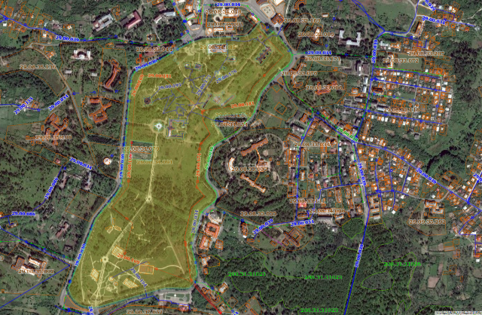

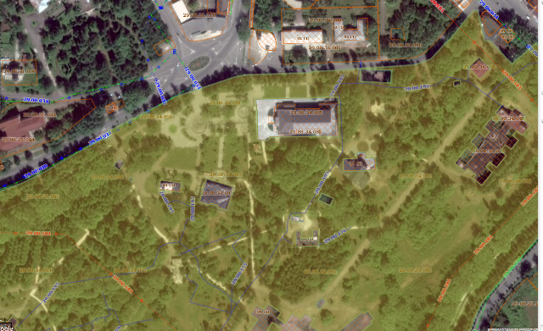

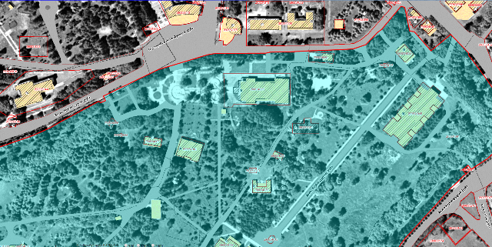

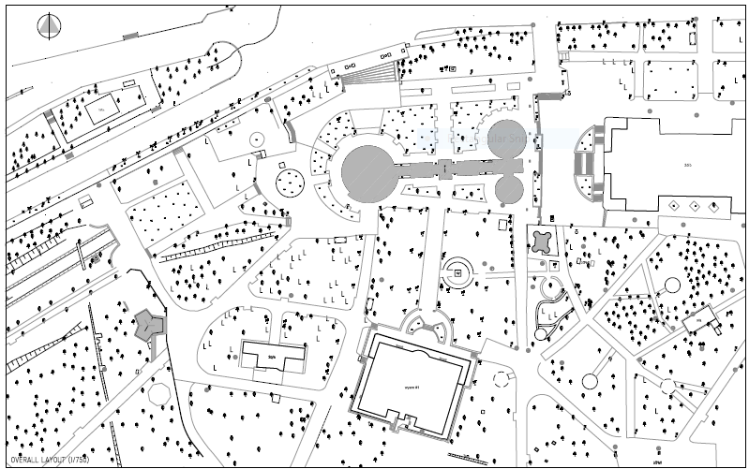
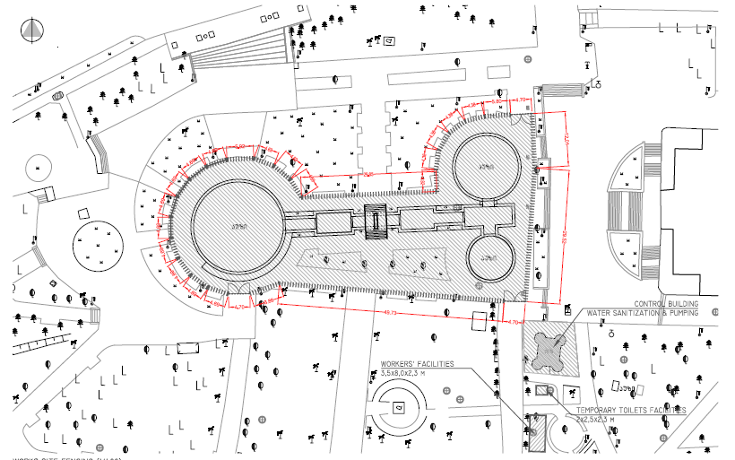
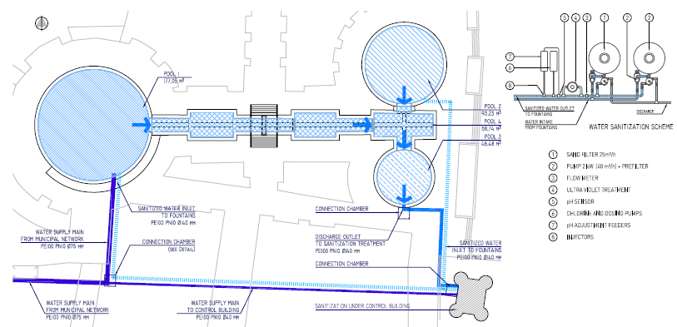

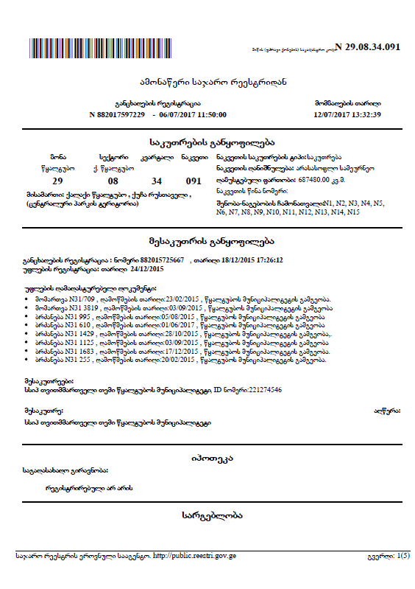 | 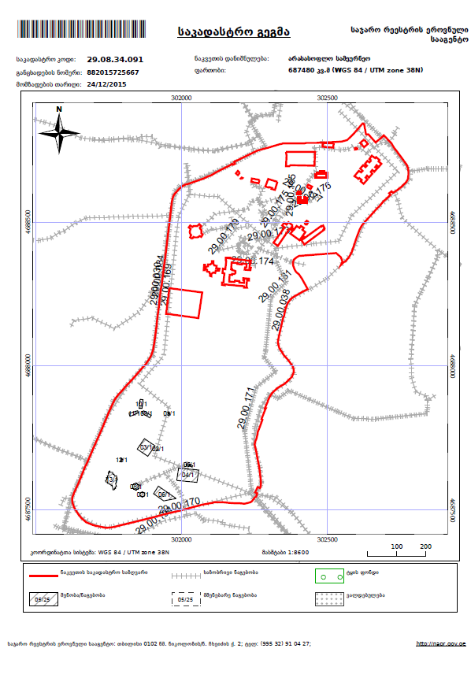

Attachment 2: Minutes of the Public Consultation Meeting
June 8, 2018
Tskaltubo Municipality, Georgia

Minutes of Public Consultation meeting

Second Regional Development Project (RDP 2)

Rehabilitation of a Fountain in Tskaltubo Park Sub-project

Environmental and Social Management Plan
On June 8, 2018 at 14:30, a public consultation meeting was held on Environmental and Social Management Plan of the subproject for rehabilitation of a fountain in Tskaltubo Park in Tskaltubo Municipality Governance (Sakrebulo). The SP is being implemented under the Second Regional Development Project (RDP 2).

The meeting aimed to inform local population regarding the works scheduled under the SP and anticipated negative/positive impacts on natural and social environment as well as ways and means for their prevention.
The Meeting was attended by:

Mayor of Tskaltubo Municipality – Grigol Ioseliani and First deputy of the Mayor Zurab Maisuradze.

The meeting was also attended by other citizens related to the project: Teona Qobuladze, Mamuka Vardanidze, Giorgi Iobidze, Murman Shalamburidze, Tengiz Nijaradze, Gia Bariladze, Zoia Baqradze, Marina Tkeshelashvili, Nino Nemsitsveradze, Vladimer Bazadze, Qristina Qaqutia, Badri Papava, Tamar Mamardashvili, Nika Apkhadze, Romeo Nijaradze, Davit Iobidze, Vaja Goduadze, Paata Buchuzishvili, Grigol Ioseliani, Malkhaz Chkheidze, Mamuka Gelenidze, koba Gogidze, Natia Chakvetadze, Aleksandre Dadunashvili, Teimuraz kachelia, Ani Gelenidze, Lili Gelenidze, Revaz Meskhi, Murtaz Kankadze, Gocha Jiqia.

Representatives from the Municipal Development Fund of Georgia:
Ketevan Papashvili - Environmental Safeguards Specialist;
George Mikeladze – Project Manager;
Melitta Tagauri – Intern.

The Meeting was opened by Mr. Giorgi Mikeladze, who provided meeting participants information on Municipal Development Fund and objectives of the meeting.
Ms. Papashvili talked in details concerning works scheduled under sub-project – „Rehabilitation of a fountain in Tskaltubo Park” along with respective environmental and social risks.
Ms. Papashvili reviewed also Environmental Management Plan elaborated for the sub-project. She familiarized meeting participants with the environmental requirements of the World Bank (WB) and reviewed the planned mitigation measures. Ms. Papashvili noted as well that pursuant to effective legislation of Georgia, works considered under above referenced sub-project do not require either Environmental Impact Permit or other kind of agreements with the Ministry of Environment Protection and Agriculture of Georgia, hence sub-projects will be executed in compliance with relevant Safeguards Policy of the WB and Operational Manual developed for the RDP 2.
Ms. Papashvili noted that the Environmental Management Plan represents an integral part of the Contract concluded with the construction contractor and contractor is obliged to provide execution of mitigation measures stipulated by the Plan. Ms. Papashvili spoke also about environmental monitoring of sub-project and respective reporting procedures.
Ms. Papashvili provided contact persons information to participants, who can be reached by population in case of any claims related to environment and social issues.
George Mikeladze provided participants with the detailed information about tendering procedures and terms, also about monitoring measures during the construction phase and information concerning supervising company.
After completion of the presentation, participants had opportunity to express their opinion and/or ask questions. Following questions were asked:
Questions / remarks | Answers and comments
When will the construction works begin? | As of today, the project is sent to the World Bank for approval. We suppose that by the end of June we will announce the tender. The implementation of the tender will take approximately one month and another month will be required for choosing the contractor and evaluating the project. After all that, the construction works will begin.
How much will the project cost? | The project will cost approximately 2.1 – 2.2 million GEL. Initially, the project cost was 1.5 million GEL but then additional features such as the pergola and the toilets were added, which obviously increased the budget.
Is it possible to involve local people in construction process? | According to the procurement rules, MDF cannot oblige the contractor to hire local people. However, in most cases, the local workers are hired by construction companies. Contractors mainly bring their people, employees, but often, it is advantageous to hire local residents.
Will there be any impact on the drinking fountain? | The drinking fountain is not considered by this project. However, the contractor might have some duties regarding it. It would be nice if the Municipality will also help us in this case.
Will the existing fountain change completely? | Yes, the existing fountain will be renovated and rehabilitated thoroughly. There are two options: using granite or marble. If the fountain will be built with marble, it will be more attractive and visually pleasing. However, the granite construction will be more stable and durable in the long-term.
It is very pleasing to hear that the toilets will be adapted for the disabled people. However, will the other facilities such as the drinking fountain and the pergola be accessible for them? | The disabled people can easily move around and access all facilities on the park except for the platform of the interactive fountain.
What contribution does the government have in this project? | The government finances 20% of the project.  Moreover, it is the duty of the government to initiate support the implementation of such projects to act with the interest of the country and provide better facilities for future generations. Furthermore, it is very important to avoid vandal acts as much as possible.  We hereby want to mention that when the construction phase is finalized, the operation of the fountain will become the duty of the Tskaltubo Municipality. It is considered under the project requirements that the contractor has to provide training for locals responsible for the maintenance of the fountain.  There is also a standard defect-elimination period which accounts for 1 year after the construction is finalized. Any defects that occur within this period are the responsibility of the contractor.
What will be the dimensions of the water network that will supply the fountain? | The diameter of the pipes will be 73 mm.
What will be the water cost of the operation of this fountain per year? | The fountain needs to be refilled only once per year. The fountain requires approximately 270 m³ of water to operate. But since the water will be circulated, the only additional water cost will be to compensate for the water evaporated. For complete functioning, the fountain needs water supply of 20 kilowatt energy.  Since the fountain is interactive and comes in direct contact with the audience, the water needs to be filtered.
How many toilet cabins will be constructed? | There will be 3 toilet cabins for men, 3 for women and one for the access of the disabled people.
What kind of roof will the pergola have? | The roofs will have the dimensions of 40x20, which is quite a significant area. The roof will be transparent, as visible on the slideshow provided.
How much time is it considered for the fountain rehabilitation? | The duration of this project is considered to be 8 months.
How will the pergola be maintained in case of snow? | The gradient of the roofs of the pergola is built in a way not to retain excessive snow, therefore the pergola will be able to function equally well in case of snow.
What warranty does the project have? | The warranty of the project is in accordance with Euro standards. I suppose it is 10 years or more.
I want to remark that this project has very good standards and it would be lovely if all projects met the same requirements. | This project is implemented under the requirements of both the World Bank and the law of Georgia. As mentioned in the presentation, The ESMP includes the requirement of Georgian legislation together with the requirement of the WB policy. The contractor more easily carries out the works in manner to minimize impacts on natural and social environment. Therefore, we not only assess its impact on the environment but important issues such as safety are also taken into consideration.  It is worth mentioning that from the month of October, the World Bank regulations will become even stricter.
The Tskaltubo park has a vast territory. It would be great if you could implement more projects like this. | The project, under which we’re rehabilitating this fountain, lasts till the year 2019. It also covers the improvement of Vani museum, which is a very important and valuable facility. Defect-elimination of previously implemented projects is also a part of this program.
- | As required by the World Bank, we notify you in advance that when the construction works of connecting fountain with the main water network take place, some households might be denied access to water supply for a couple of hours.
I want to give you one advice. I have direct contact with the disabled tourists in this park and it would be very pleasant to see facilities, other than toilets, being adapted to their needs. For instance, when constructing the pergola, please build one table shorter than the rest so that those in the wheelchair have easy access to it. | Thanks a lot for your insightful information. We will surely inform the contractor about this.
After discussing of Environmental Documents, meeting participants expressed their sympathy towards the scheduled project. There were no additional questions or comments.
Enclosure: Photo material and copy of list of attendees.
MoM is prepared by Melitta Tagauri - intern of Environment and resettlement unit at Municipal Development Fund of Georgia.
June 8, 2018

Registration Sheets for the meeting attendants:
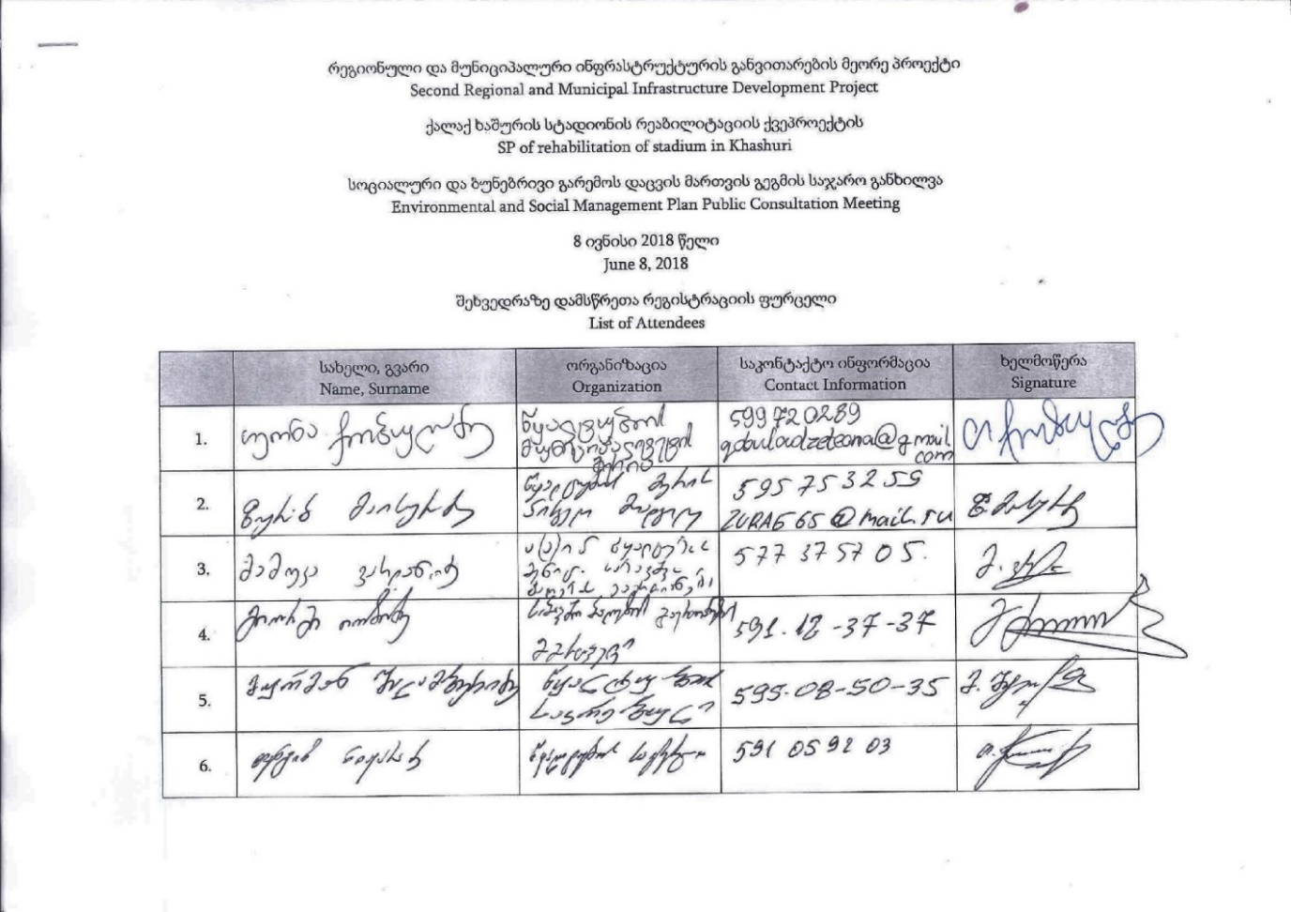
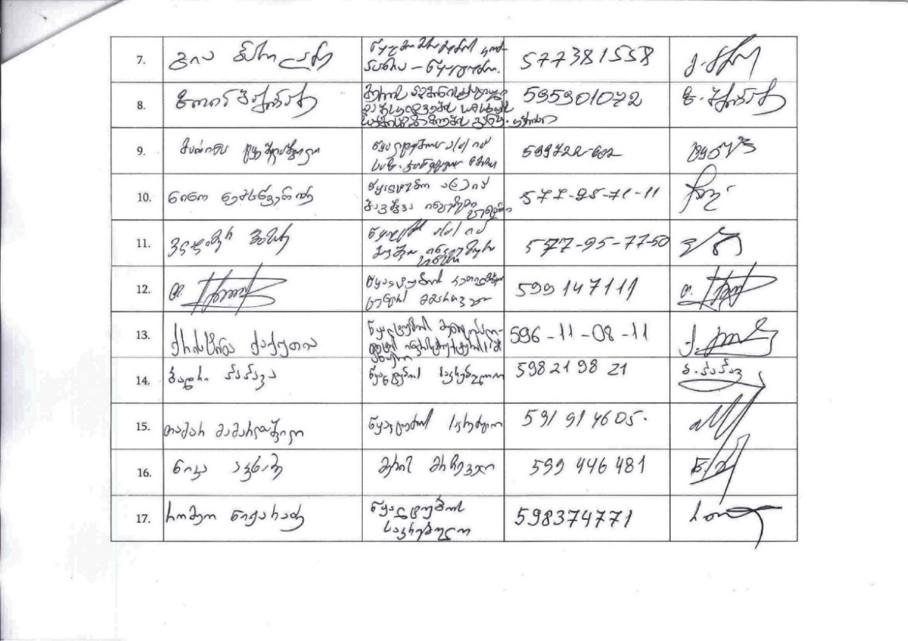
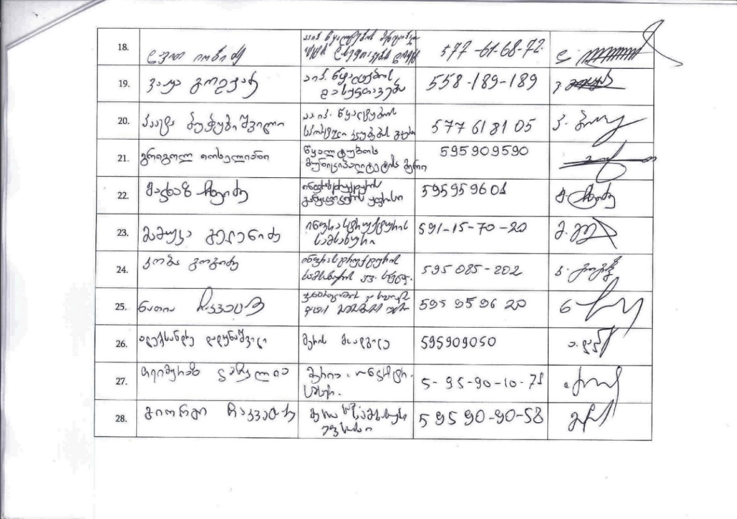
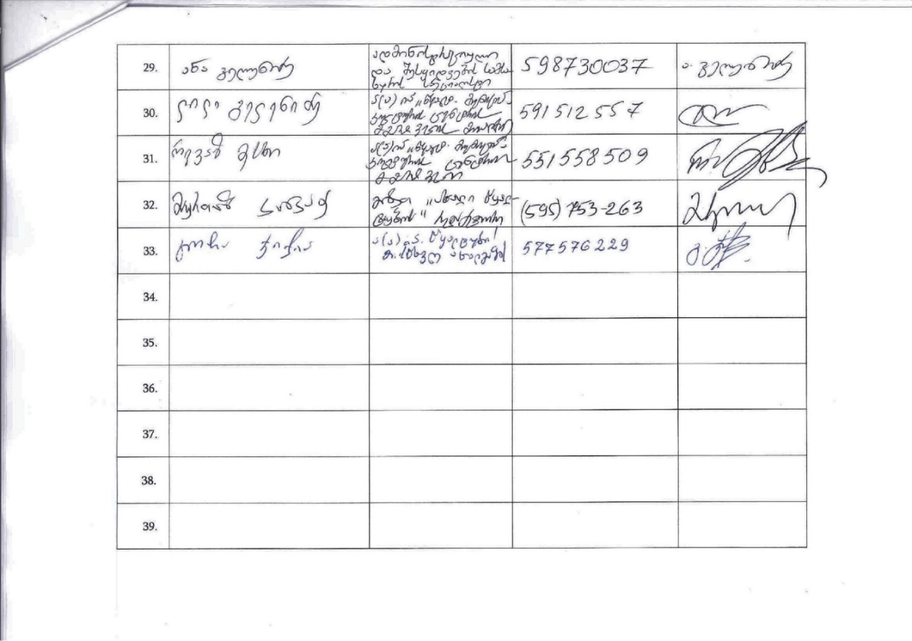

Photo Materials:
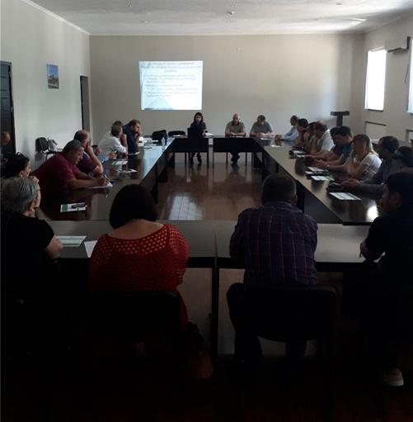 | 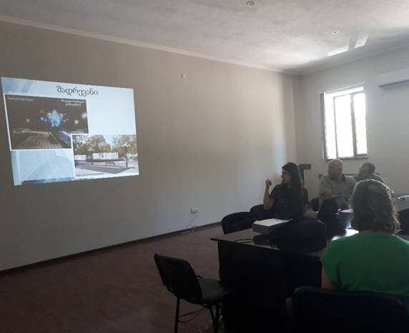
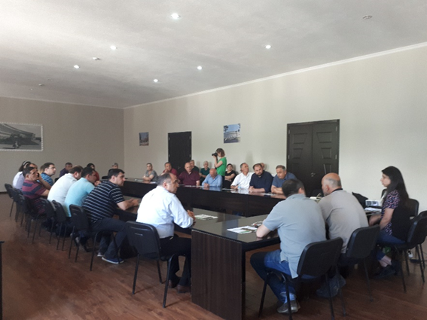 | 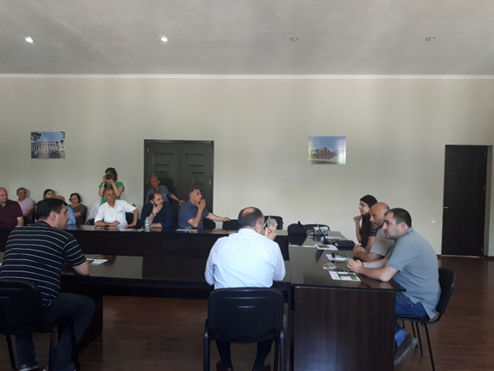

Attachment 3: Agreements for waste disposal
Agreement for disposal of asbestos containing material with Solid Waste Management Company of Georgia
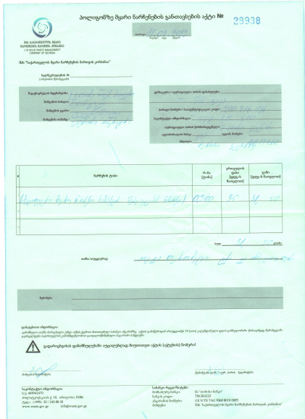

Letter from Tksaltubo Municipality on disposal of construction waste
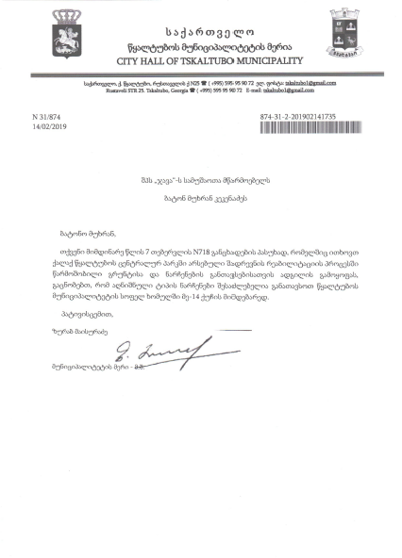

Land acquisitions includes displacement of people, change of livelihood encroachment on private property this is to land that is purchased/transferred and affects people who are living and/or squatters and/or operate a business (kiosks) on land that is being acquired.
Toxic / hazardous material includes but is not limited to asbestos, toxic paints, noxious solvents, removal of lead paint, etc.

