**GHANA ECONOMIC UPDATE**

91809

October 2014

|  |  |
| --- | --- |
|  | C:\Users\wb368095\Pictures\september 2014\NAGRAT-CCT-demo.jpg |
|  |



**AFTP3**

**Africa Region**

**The World Bank**

**Contents**

*Foreword* 1

*Summary* 2

Part I: Recent Economic Developments 3

*1.* *Balance of Payments* 3

*2.* *Fiscal Developments* 5

*3.* *Money and Prices* 8

*4.* *Economic Growth* 9

*5.* *Outlook* 9

Part II: Trends in Poverty, Inequality & Labor 10

*6.* *Introduction* 10

*7.* *Poverty and Inequality in Ghana* 11

*8.* *Employment trends in Ghana* 14

*Foreword*

*T*

*his report is the most recent in a series aimed at monitoring economic developments in Ghana and has two sections. The first section summarizes the recent macroeconomic developments in the country (written by Felix Oppong) while the second section presents the main findings on poverty and employment published recently by the Ghana Statistical Service (summarized by Dilek Aykut and Gregory Smith). It received inputs from Theo Braimah Awanzam. The entire report was reviewed by Santiago Herrera.*

*Comments on the content of this report are welcome.*

*Mark Thomas*

*Sector Manager*

*Poverty Reduction and Economic Management 3*

*Africa Region*

*Summary*

Ghana’s overall macroeconomic conditions have deteriorated further in 2014 with large twin-deficits lingering, fueling government debt and inflation, a sharp depreciation of its currency, and a weaker pace of economic growth.

The fiscal deficit remains the biggest source of vulnerability in the Ghanaian economy. Preliminary figures show the fiscal deficit was 9.2% of GDP in the first half of 2014, driven by the high wage bill and rising interest costs. The wage bill grew 25.7% (y-o-y) during the first half of 2014 despite promised measures to contain it, while interest payments reached 5% of GDP. Total domestic revenue collections were dragged down by a contraction in non-tax revenue while tax revenue only increased slightly to 15.6 % of GDP. With large expenditures planned for the second half of the year, the deficit is projected to be around 10% of GDP, above the government’s 8.8% target for 2014.

The government continued to add to its stock of public debt to finance the fiscal deficit. Public debt reached 58% of GDP in August 2014, excluding the stock of arrears and SOE’s debt. If the public debt figure is modified to include these two factors and the Eurobond issued in mid-September, the stock of public debt would exceed 70% of GDP.

Domestic financing of the fiscal deficit has been provided via the Bank of Ghana’s (BoG) expansion of net credit to the government and SOEs. In fact, the BoG financed the entire fiscal deficit during the first quarter of 2014. The monetary expansion was sterilized through open market operations and monetary tightening (300 bps in 2014). Interest rates on 91-day Treasury bills reached 25% in August.

Headline inflation was 15.9% in August 2014 up from 13.5% in December 2013 due to adjustments in prices of petroleum and utilities, plus rising prices of imported products following depreciation of the Ghanaian Cedi since January 2013. As a result, non-food inflation reached 24% and producer price inflation 48.3%; while food inflation remained subdued at 5.1%.

Ghana’s external imbalance persisted in 2014. While the current account deficit remained around 10% of GDP (first half of 2014) financing was particularly challenging. Despite the robust FDI inflows, the financial account significantly weakened following net outflows of portfolio investment and short-term capital. As a result, the Ghanaian cedi depreciated against the US dollar by 35% on the official interbank market, but by 43% on the forex bureau market by July. Net international reserves had declined to $601 million in June 2014, covering only 12 days of imports of goods and services. International reserves will get a boost from the Ghana Cocoa Board (Cocobod) loan of US$1.7billion and recently issued $1 billion Eurobond. Ghana issued its third 10-year Eurobond in mid-September with a yield of 8.25%. While the yield was slightly lower than 8.5% that Ghana paid last August, it was significantly higher than the 5.375% Ivory Coast paid for the 10-year $500 million Eurobond issued in July 2014. Spreads on Ghana’s existing sovereign bonds have narrowed slightly in September after the Ghanaian government officially requested assistance from the IMF.

Macroeconomic challenges continue to weigh on economic growth. In first quarter, growth was lower at 6.7% compared to 9% in the first quarter of 2013. GDP growth already slowed down to 7.1% in 2013 and is expected to remain subdued around 6.0 % for the full year 2014. Slower growth and higher inflation could easily erase recent gains in poverty reduction. Official data shows the poverty rate decreased to 24% in 2013 from 31% in 2006, making it very likely that Ghana meets the goal of halving poverty rates by 2015. However, there is a great disparity in poverty levels across the country. For instance, in rural areas, 38% of the population is poor, while in the urban areas only 11%. Geographically, the disparity is even larger with 55% of the Rural Savannah population living below the poverty line, compared to 3.5% of the population in Greater Accra Metropolitan area. Inequality, as measured by the Gini coefficient, increased from 41.9 in 2006 to 42.3 in 2013. Poverty reduction in Ghana is linked to developments in the labor market, where the participation rates increased substantially and the share of agriculture employment (with the lowest wages in the economy) decreased. The reported unemployment rate at 4.4% is extremely low, but the figure has to be interpreted with great caution due to the substantial size of the informal sector. In addition, underemployment reached 33 percent. A careful analysis of the determinants of poverty and inequality, and their interaction with labor market variables is just beginning, as the 2013 surveys were just released. However, these preliminary findings highlight how critical are Ghana’s policy decisions over the next 12 months to pursue more inclusive and stable growth. Urgent efforts are needed to build a more predictable policy environment that facilitates diversification from capital intensive activities in extractive industries towards more labor and land intensive activities in the agriculture and services sectors.

|  |
| --- |
| Part I: Recent Economic Developments |

# *****Balance of Payments*****

**Ghana’s external imbalance continued to deteriorate during the first half of 2014 with the lingering large current account deficit, reversal of short-term capital flows, declining international reserves and sharp currency depreciation.** Ghana’s current account deficit remained around 11 percent of GDP during the first half of the year (Table 1).The current account deficit narrowed by $233 million to $1.9 billion (10.9 percent of GDP) in the first semester of 2014, compared to $2.2 billion (9.9 percent of GDP) in the first half of 2013. The slight improvement in the current account balance was the net effect of the $1.1 billion narrowing of the trade deficit over $0.8 billion widening in the service and income deficit.

Table 1: Balance of Payments, 2012–14 as a percent of half year Gross Domestic Product



*Source: Bank of Ghana and World Bank staff calculations*

The merchandise trade deficit narrowed significantly as imports fell faster than exports. Compared to the first semester of last year, merchandise exports fell by $480 million to $6.9 billion in the first half of the year (figure 1.a), due mostly to the fall in gold; the exported value declined by $559 million (20 percent, y-o-y) to US$2.1 billion as both the price (15 percent) and volume (6 percent) fell. Cocoa export revenue increased slightly by $131 million to US$1.6 billion, as a result of 11 percent increase in volume offsetting the 2.5 percent fall in price. Oil exports remained almost the same at $2 billion as the slight price increase compensated for the decline in volume.

Ghana’s imports contracted by $1.6 billion from $8.8 billion (40 percent of GDP) to $7.2 billion in the first semester (figure 1.b). The sharp depreciation of the cedi and the slowing economy weighed down on import demand. The non-oil sector accounted for the larger portion of decline, with $1.3 billion. The adjustment was widespread among the types of goods but the largest drop was in capital goods with 33 percent, followed by the consumptions goods with 20 percent (figure 1.b).

During the first half of 2014, non-residents repatriated $1.1 billion of income generated in Ghana, almost doubling the $0.6billion repatriated during the first half of 2013. With the slight increase in net services imports, the net service and income deficit was an estimated 14.9 percent of GDP in the first half of 2014 compared with 8.4 of GDP during the same period in 2013.

**Financing of the current account deficit was challenging amid the significant reversal in short term capital inflows (including trade credit) and portfolio investment**. Despite the robust FDI inflows mainly to the oil sector during the first half, portfolio investment (debt and equities) marked net outflows and both private and official amortization increased. As a result, the capital and financial account, including net errors and omissions, totaled only $426 million (2.4 percent of GDP).

As a result of the external imbalance, the Cedi depreciated sharply. Actual depreciation figures differ, as Ghana has, in practice, a multiple exchange rate regime; official interbank and forex bureau, with the latter being more prevalent. The cedi depreciated against the US dollar by 35 percent in the official interbank market, but by 43 percent on the forex bureau market by July 2014 (figure 2).

The cumulative depreciation of official interbank rate over the last year was bigger than 30 percent depreciation that Ghana experienced after the global financial crisis in 2009. Ghana’s net international reserves stood at US$601million (12 days of imports of goods and services) as of end June, 2014.

For 2014, the current account deficit is projected to narrow slightly to 8.7 percent of GDP, on account of a lower trade deficit and decreased net services and income outflow during the second half of 2014.

Figure 2: Ghanaian Cedi against US$

(Official interbank)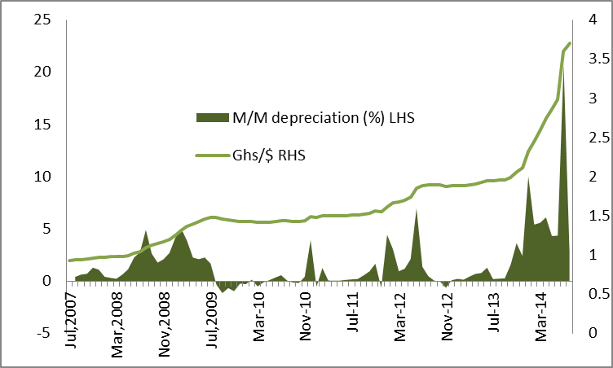

*Source: Bank of Ghana and World Bank staff calculations*

The capital and financial account (including errors and omissions) is projected to rebalance in the second half of the year, thanks to the effect of the Eurobond issued in mid-September (US$ 1 billion), Cocobod loan flows (US$1.7 billion), and slower short term capital outflow in response to the expectation of a positive outcome of the negotiation with the IMF. If the volatility persists or accentuates, and external financing does not materialize, then the reduction in the current account deficit required to close the financing gap would be larger, and force a stronger adjustment through relative prices of traded and non-traded goods.

# *****Fiscal Developments*****

**The fiscal deficit remains a major source of vulnerability for the Ghanaian economy.**  Preliminary figures show the fiscal deficit at 9.2 percent of GDP in the first half of 2014, higher than the 8.8 percent in the first half of 2013, due to the shortfall in revenue collection, and rising wage bill and interest costs (table 2).

Total revenue was dragged down by non-tax revenue, which fell to 18.1 percent of GDP by June 2014, compared to 19.5 percent of GDP during the same period in 2013. During the period, the government failed to implement planned revenue enhancing measures such as the change of petroleum excise taxes from specific to ad valorem and taxes on fee-based financial services.

Tax revenue remained at 15.6 percent of GDP, similar to the 15.5 percent recorded in first half of 2013 but stood below the half year budgeted target of 16.6 percent. The shortfall vis-à-vis the mid-year budget was mainly as a result of lower payments of corporate taxes and royalties payments by mining companies, a general slowdown of business activities, and the non-payment of withholding taxes by some government agencies such as the Ghana Education Trust Fund and some District Assemblies.

While revenue declined, total expenditure increased slightly to 22.7 percent of GDP, from 22.2 percent in June 2013. The increase was fueled by higher than budgeted wage bill, interest payment and foreign financed capital expenditure.

The wage bill grew 25.7 percent (y-o-y) during the first half of 2014, despite the government’s measures to contain it. The wage bill amounted to 8.8 percent of GDP in the half year of 2014. In addition, the government spent 0.7 percent of GDP (Ghs 379 million) on clearance of wage arrears. The wage to tax ratio was planned to reach 48.5 percent by the end of 2014 but reached 56.5 percent in June 2014, diminishing the likelihood of reaching the planned target by year end (figure 3).

Table 2: Central Government budgetary operations, 2012-14 (percent of GDP)



*Source: Ministry of Finance and Staff calculations*

Many factors account for the persistent rise of the wage bill in Ghana. These include the inability of government to implement the net freeze in employment and moratorium on public sector wage increase proposed in the 2014 national budget, persisting wage creeps within the public service wage administration, payment for backdated promotions and salary arrears, and higher than budgeted cost of migration onto the single spine payroll.

Figure 3: Wage to Tax Revenue (Percent)



*Source: MoF and Staff calculations*

As a short term measure to curtail the wage menace, the government agreed with the labor unions to pay a cost of living allowance (Cola) of 10 percent, effective May 2014 instead of a general salary increase. The Cola freezes the cost of pension in 2014 for employees on government payroll. Other measures being pursued include special audit of payroll, electronic salary payment vouchers and an upgrade of the payroll management system. Government is yet to record gains from these measures.

Interest payments constitute the other large and increasing expenditure item in the budget. (figure 4). The interest expenditure accounted for 40 percent of the revenue for the first half of the year while it reached 6.2 percent of GDP compared to 5.0 percent in June 2013. The increase has been driven by rising domestic borrowing at high interest rates. Domestic interest payments accounted for 5.3 percent of GDP, up from 4.4 percent last year, while external interest payment inched up to 0.9 percent of GDP from 0.7 percent in 2013.

Figure 4: Interest Payments as a percent of GDP and revenue (2004-2014h)



*Source: MoF and Staff calculations*

Capital expenditure rose slightly to 4.6 percent of GDP in 2014, up from 4.2 percent in June 2013. The increase came in form of foreign capital expenditure while domestic financing remained small (table 2).

The large fiscal deficit continued to be financed mostly with domestic credit during the first half of the year. In fact, Bank of Ghana (BoG) financed the entire budget deficit during the first quarter and 70 percent of the total deficit during the first half of the year. The rest was financed by foreign flows (22 percent of the total) and by domestic banking and non-bank institutions.

In order to finance the budget deficit, the Government kept on adding on to its stock of public debt, which reached 58 percent of GDP by the end of August 2014, excluding the stock of arrears estimated at 4.8 percent of GDP and SOEs debt of 6.3 percent. By June 2014, domestic public debt reached Ghs 28 billion (25.3 percent of GDP).

Most of domestic debt issuance over the last twelve months has been of short-term maturity—maturity with less than one year. The share of short-term instruments in total domestic public debt increased to 36.2 percent in July 2014 from 27.5 percent in July 2013 while the medium term instruments still account for the largest share (table 3).

The domestic financing of the deficit is possible due to the Bank of Ghana’s (BoG) accommodative credit policy as it has expanded net credit to the government and to public enterprises.

Table 3: Domestic debt stock composition by maturity, (percent of total)



*Source: Bank of Ghana*

Table 4: Domestic debt composition by holders,

(Percent of total)



*Source: Bank of Ghana*

Nevertheless, majority of the debt stock as of July 2014 is still with medium-term maturity together with the Eurobond; 91-day treasury bills (22.8 percent), followed by 3-Year Fixed Treasury note (17.3 percent), Long Term Government Stocks (17.2 percent) and the rest (42.7 percent) spread on other instruments.

The banking sector held 52.2 percent of the government domestic debt of which the central bank held 24.1 percent of the total domestic debt issued by July 2014. (Table 3)

Figure 5: 91-day and 182 day Treasury Bills (2014)

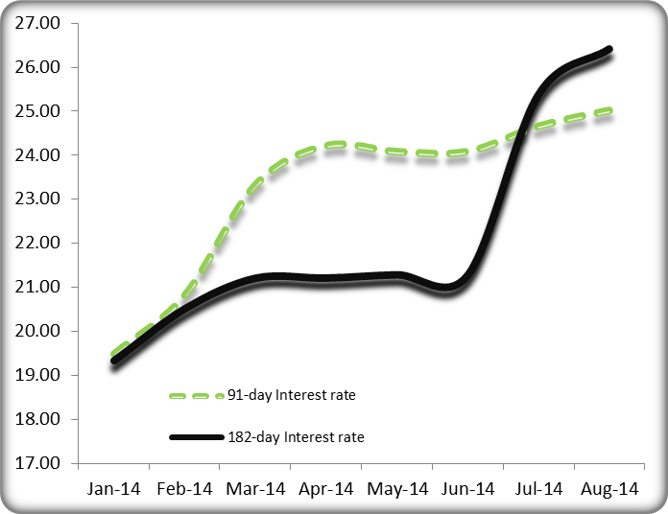

*Source: Bank of Ghana*

Domestic treasury issues increased to Ghs25.5 billion in September2014 from Ghs19.3billion during the same period last year. Government increased its issues this year in accordance with rising fiscal commitments. (Figure 6)

Figure 6: Government of Ghana Domestic Treasury Issues, 2012-14 (Million Ghana Cedis per week)

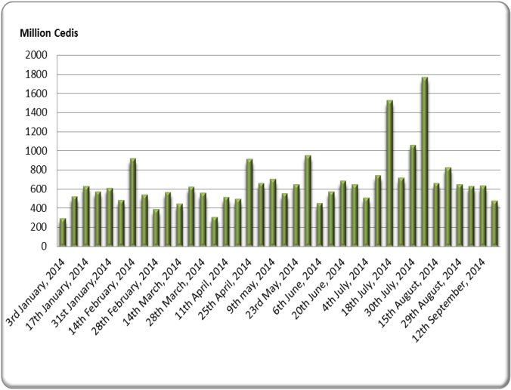

*Source: Bank of Ghana*

On the international front, Ghana issued its third Eurobond in September 2014 valued at $1 billion maturing in 2024. The yield was 8.25 percent slightly lower than 8.5 percent that Ghana paid last August and Zambia paid in April 2014 for a similar bond mainly due to the fall in US 10-year Treasury bond yield. That said the yield was much higher than the 5.375 percent for the 10-year Eurobond for $500 million that Ivory Coast issued in July even after it missed a coupon payment in December 2010.

The spread on Ghana’s Eurobond maturing in 2017 has narrowed since the announcement of possible IMF program in early September. Nevertheless Ghana still has to pay a premium over the sovereign bonds of Kenya, Zambia and Tanzania in the order of 100-150 basis points (figure 7).

Figure 7: Difference between bond-spreads of Ghana, Kenya, Tanzania and Zambia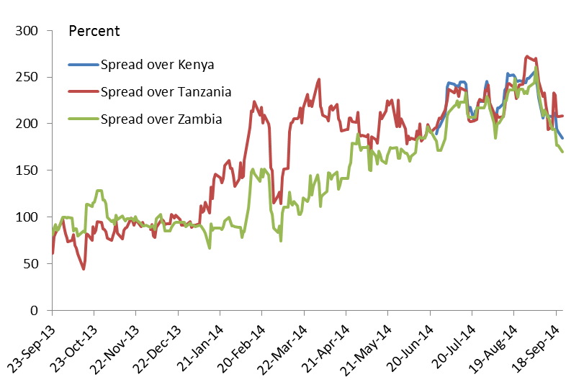

*Source: J.P. Morgan*

# *****Money and Prices*****

The Bank of Ghana continued to accumulate domestic assets while the net foreign assets decreased in first half of the year. Domestic assets increased by Ghs3.5billion (y-o-y), as a result of a Ghs4.0billion claims on the government and compensated by a Ghs530 million contraction from the rest of the economy. On the other hand, the net foreign assets declined by Ghs793million (a 15.8 percent fall from Ghs5.0billion in June, 2013 to Ghs4.2billion in June 2014).

BoG sterilized its monetary expansion by increasing open market operations, and raising its policy rate by 200 bps in February 2014 and another 100 bps in July to 19 percent to control inflation and arrest the depreciation of cedi. BoG also increased the reserve requirement of deposit money banks from 9 percent in the beginning of the year to 11 percent to tighten liquidity in the economy.

For the half-year, domestic credit from deposit money banks to the government increased by 29.2percent (y-o-y) to Ghs 5.8 billion while credit to private sector increased by 45.8 percent (y-o-y) to Ghs19.6billion. A non-trivial portion of the credit of commercial banks to the private sector originates in the financing of oil imports of the bulk oil distributors that have not been paid by the government.

Total liquidity in the banking sector (M2+) increased by almost 32 percent to Ghs30.7 billion by June 2014.

Figure 8: Consumer Price Index Inflation (January 2013 to August 2014)

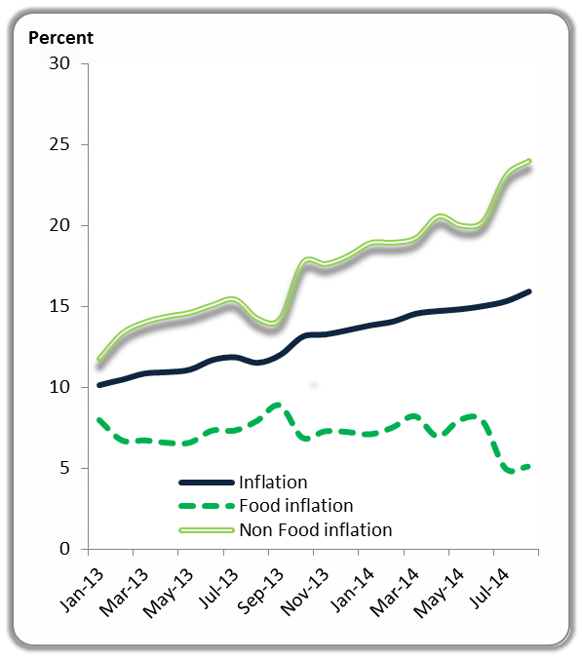

*Source: Ghana Statistical Service*

Inflation is increasing, and there is a wide divergence between consumer and producer prices indices. Consumer price inflation reached 15.9 percent in August, up from 13.5 percent in December 2013 (figure 8). Inflation was driven by the non-food inflation (24 percent) while food inflation remained subdued at 5.1 percent. Adjustments in prices of petroleum and utilities, and rising prices of imported products due to the depreciation of the Ghanaian cedi pushed the non-food inflation up to 24 percent in August. (Figure 8)

Similarly, producer price inflation also followed a rising trend to reach 48.3 percent in August 2014, up from 4.7 percent a year ago (figure 9).

Figure 8: Producer Price Index (Percent)

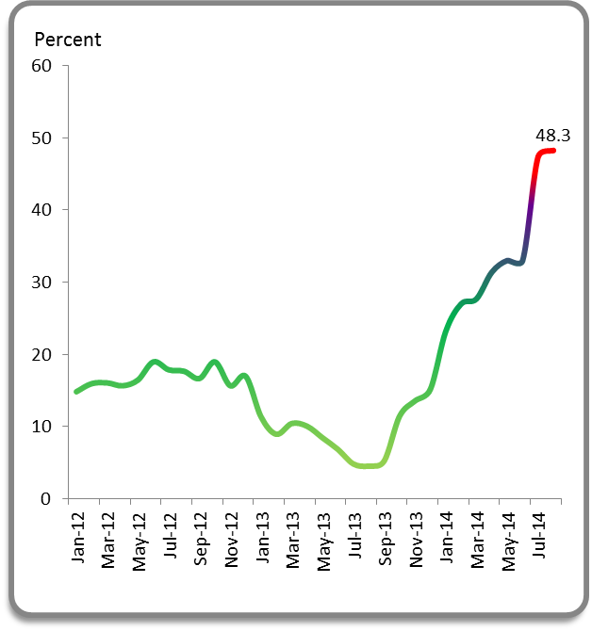

*Source: Ghana Statistical Service*

# *****Economic Growth*****

**Amid the macroeconomic challenges, economic growth slowed down in the first quarter in 2014 as the manufacturing sector contracted sharply.** GDP growth rate in the first quarter was 6.7 percent (y-o-y), though very likely it will be revised downward by the GSS. The slowdown was mainly driven by the 21.2 percent contraction in the manufacturing sector which reversed the growth in the entire industry sector and other sectors.

The contribution of the service sector reduced to 4.9 percent in Q1 2014 from 5.1 percent, while industry growth collapsed to 3.0 percent , from 0.7 percent in 2013. However, the production of oil increased by 16.3 percent in real terms leading to higher contribution of 2.3 percent to growth in Q1, 2014.

The contribution of the agriculture sector to growth increased 2.4 percent in Q1 2014 influenced by higher real production in all sub-sectors except the livestock sector. (Figure 15)

Figure 9: First quarter growth and sector contribution to growth

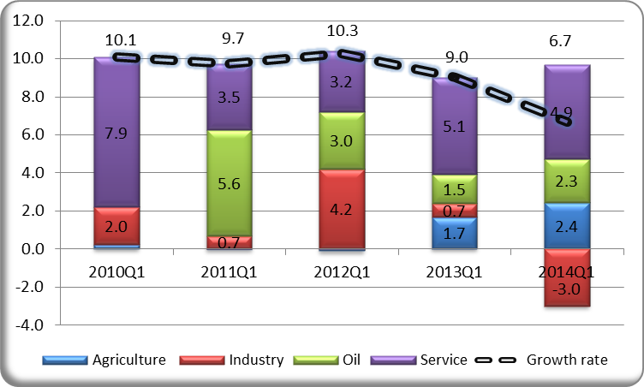

**Source: Ghana Statistical Service and World Bank staff calculations**

# *****Outlook*****

Growth in 2014 is expected to remain modest at around 6 percent. Despite the downside risks in the short-term, Ghana’s growth prospects are positive in the long-term, at around 4-6 percent per capita. But the economy has to be stabilized for the positive projections to materialize.

Inflationary pressure will continue mounting, due to adjustments in petroleum product prices and utilities. As a result, inflation is not likely to return to the target band of 13±2 percent before the end of the year. The producer price inflation is projected to reach 50 percent by the end of the year due in parts to the impact of the exchange rate depreciation on the manufacturing sector (which has a significant weight in the producer price basket).

Other inherent risks in the economy include the rising wage bill, high and rising interest rates, and the loss of net international reserves. Some medium term risks include the persisting energy sector constraints, rising public debt and debt service ratios, cyclical electoral over expenditure, the impact of volatility of international commodity prices on the external sector.

|  |
| --- |
| Part II: Trends in Poverty, Inequality & Labor |

# *****Introduction*****

One of the major challenges facing many developing countries, including Ghana, has been the need for a more comprehensive, reliable and up-to-date statistics and indicators to monitor and evaluate the impact of development policies and programs on the living conditions of their citizens. The Ghana Living Standards Survey was an initiative aimed at addressing this need.

The Ghana Living Standards Survey (GLSS) has emerged as one of the important tools in the welfare monitoring system as it collects information from a nationally representative sample of households for the measurement of the living conditions and well-being of the population. GLSS was conducted in 1987, 1988, 1991/92, 1998/99, 2005/06 and in 2012/13. Three new modules have been introduced in last round: Labor Force Module focusing on employment and time use, a module on Household Access to Financial Services and a module on Governance, Peace and Security.

This chapter summarizes the results of two reports: ***Poverty Profile in Ghana*** and ***Ghana Labor Force Report***, both were published by Ghana Statistical Service (GSS) in August 2014. These reports are based on the sixth round of the GLSS (GLSS 6) conducted by GSS over the period from 18th October 2012 to 17th October 2013. Additional reports based on the data are being prepared by the World Bank and will be available in coming months.

The reports by the GSS focus on GLSS6 data. While the reports do not seek to compare the results with the previous reports due to recent methodological changes, they provide comparable estimates for the 2005/06 survey, when possible, to reflect upon the changes. In addition, several social intervention programs including the Livelihood Empowerment against Poverty (LEAP), Capitation Grant and School

Feeding Program have been implemented with the aim of alleviating poverty among the vulnerable population.

**Main findings:**

• About a quarter of Ghanaians are poor whilst those considered as extreme poor are a little less than a tenth of the population. Poverty in Ghana remains a rural phenomenon as more than a quarter of people living in the rural savannah are extremely poor.

• Farmers are not just the poorest in Ghana, but they contribute the most to Ghana’s poverty levels. On the other hand, poverty incidence is the lowest among public employees.

• Lack of education is still a hindrance to poverty reduction. Aside the fact that households with uneducated household heads are the poorest in Ghana, they contribute the most to Ghana poverty incidence.

• Income inequality—measured by the Gini coefficient—has increased slightly from 41.9 in 2005/06 to 42.3 in 2012/13. The increase, even if it is small, implies that a lot more Ghanaians did not benefit from the robust growth rates since 2005.

• The unemployment rate is stated as 4 percent for 2012/13. While this rate is quite low in any international standards, the numbers should be evaluated against the size of informal sector as well under-employment in Ghana. On average 33 percent of employed people’s time is deemed to be inactive; i.e. there is underemployment.

# *****Poverty and Inequality in Ghana*****

The Poverty Profile in Ghana report examines the poverty levels and patterns in Ghana among geographical and administrative regions as well as among the various socioeconomic groups to better understand the improvements in poverty levels in Ghana as well as remaining vulnerabilities. The analysis is based mostly on two indicators: the poverty incidence (P0) which measures the proportion of the population that is poor, and the poverty gap index (P1) which measures intensity of poverty in a country. The gap index is the average ratio of the gap to which individuals fall below the poverty line (for non-poor the gap is counted as zero) as the proportion of the poverty line. The measure does not reflect changes in inequality among the poor, but it adds up the extent to which individuals on average fall below the poverty line, and expresses it as a percentage of the poverty line.

The report findings are based on the revised poverty lines for Ghana. As the consumption patterns changed, GSS was deemed necessary to update the composition of minimum consumption basket to attain an acceptable living standard.

Based on the revised consumption basket, the *extreme poverty* line for Ghana is Ghs 792.05 per adult per year. This is the cost of the consumption basket needed to meet the nutritional requirements of household members. Individuals whose total expenditure falls below this line are considered to be in extreme poverty. The *absolute poverty* line is Ghs 1,314.00 per adult per year. This incorporates both essential food and non-food consumption.

**According to the GLSS6 results, 24.2 percent of Ghanaians were poor, whilst those considered as extreme poor were 8.4 percent of the population.** About 5.9 million people in Ghana lived on less than Ghs 1,314.00 in 2013. More than two million Ghanaians are extremely poor and cannot afford to feed themselves in order to consume 2,900 calories per adult equivalent of food per day, even if they were to spend all their income on food (table 2.1, figure 2.1).

**This represents a significant reduction in poverty rates since 2006.** Since the consumption basket was recalculated in GLSS 6, some adjustments are required to make the results of the previous survey comparable. After such adjustments, the comparison shows that Ghana experienced a 7.7 percentage point reduction in overall poverty and 8.1 percentage point in extreme poverty since 2005/06. Poverty rates in both urban and rural areas were reduced albeit from smaller levels in urban areas. The significant reduction strengthens Ghana’s position to achieve the first Millennium Development Goal, which seeks to halve the poverty rates by 2015 from the rate in 1991/92



(51.7percent) at a minimum basket (poverty line) of Ghs 3,708 in 1991/92.

**The poverty decline in Ghana has not been evenly distributed geographically, however.** The poverty rates declined significantly in Accra, urban and rural Savannah and rural coastal, while it increased in urban and rural forest and urban coastal (figure 2.2).

**Poverty continues to be a disproportionately rural phenomenon.** According to 2012/13 survey, 50 percent of the Ghanaians living in the rural communities contributed as much as 78 percent to the national poverty incidence levels, whilst the remaining half living in urban communities contribute just 22 percent. Among rural localities, the poverty incidence is much higher among

those living in Rural Savannah localities (55 percent). The report indicates that in 2012/13 contribution to poverty incidence in Rural Savannah localities is higher than Rural Coastal and Rural Forest localities combined. Notably, Rural Savannah contributes 41 per cent to the overall poverty in Ghana.

Similarly, although extreme poverty is relatively low in Ghana with less than ten percent of the population, it is quite concentrated in Rural Savannah areas, with more than a quarter of people living in the rural savannah areas of Ghana considered to be extremely poor (figure 2.1).

Ghana’s rural areas are also where the poverty gap—average fall below the poverty line—is the largest (table 2.1). While on average the poor population in Ghana lived 32 percent below the poverty line of GH¢1,314, the rural population contributes more than 80 percent of the poverty gap, which needs to be closed to reduce poverty.



**Accra recorded the lowest poverty incidence among all the geographical areas.** This low rate of 3.5 percent may be due to the fact that Accra, being the capital of Ghana witnessed the highest rural-urban migration, with many people who come to seek for job been engaged as self-employed within the services sector where most of the youth are engaged in petty trading. This sector, according to the numerous reports on the performance of the economy published between 2007 and 2013 by the Ghana Statistical Service shows that the sector has been the main driver of Ghana’s GDP. A large proportion of individuals engaging in these economic activities lived above the poverty line.

**The types of economic activity and education level of the head of the household seem to matter considerably.** The poverty incidence among households engaged in self-employment in agricultural sector is highest whilst households whose head are paid employees, self-employed in non-agricultural sector or retired are less likely to be poor (figure 2.3).

Despite the slight improvement since 2005/06, farmers are still the poorest in Ghana. The GSS report shows how households in the Savannah are poorer compared to other areas while agriculture is their main economic activity.

Among employed population, public employees are the group with the least incidence of poverty.

The GSS report also shows that poverty incidence among households headed by a person with secondary education or higher is lower than the national average (figure 2.3). The contribution to national poverty incidence by households headed by an uneducated person is about twice their population share, whilst the contribution of households headed by highly educated persons are almost nonexistence.

**Despite the reduction in poverty rates, inequality increased and remains prevalent.** Nationally, the Gini coefficient increased slightly from 41.9 in 2005/06 to 42.3 in 2012/13. The increase, even though small, implies that Ghanaians did not benefit equally from the robust growth rates since 2005 (figure 2.4).

Among regions, urban regions seem to have experienced a more equitable growth. While Accra’s Gini coefficient fell from 41.5 to 36, the Rural Coastal region Gini increased from 34 to 43. On the other hand, all the rural areas experienced a worsening inequality between the two periods, with the rural coastal been the worst affected. The worsening inequality in the rural coastal localities is largely due to worsening levels of inequality in the Volta region of Ghana, where households in the rural localities are predominantly engaged in fishing.

A more detailed analysis of the povery trends and determinants needs to be undertaken in order to understand how to reduce the inequlity in Ghana.

# *****Employment trends in Ghana*****

Jobs are a critical concern in Ghana, for government, the business community, and all Ghanaians. Employment opportunities are

instrumental to achieving economic and social development and as a principal source of household income. As discussed in the previous section, certain types of jobs can be instrumental in reducing poverty.

This section summarizes recent data from the ‘Ghana Labor Force Report’ published in August 2014 by the Ghana Statistical Service which presents information on the trends, types and changes in the Ghanaian labor force. Comparisons are made with an earlier version of the survey conducted in 2005/06.

**The Ghanaian Statistical Service reports a national rate of unemployment of 4.1 percent—those over 15 years without jobs and potentially available for jobs— in 2012/13.** There is variation between genders (the male rate is reported as 3.9 percent and female rate at 4.3 percent) and whether job seeking citizens are living in rural or urban areas (the rural rate is 3.3 percent and the urban rate is 4.9 percent); see Table 2.2.

**These unemployment numbers are very small when compared globally, but care must be taken in interpreting these numbers; as is the case in any economy with a large informal sector[1].** In such cases, standard indicators of unemployment offer only a partial and not very useful description of the labor market. Many people can be labeled ‘employed’ in this manner whilst being engaged in activities with limited productivity, underemployment and very low associated incomes.

**The unemployment numbers exclude those reported to be ‘economically not active’, i.e. not seeking work.** This group categorizes 20 percent of the population (15 years and over) and includes those: studying; performing household duties; retired; disabled and persons unable to work on account of their age. This group has decreased considerably from about 30 percent of the population reported in an earlier round of the survey (GLSS5) conducted during 2005/06.

**There is also some variance in the activity rates across age groups.** Almost 90 percent of adults aged 25 to 64 years are reported as economically active compared to 57 percent of those aged 65 or more, 52 percent of those between 15 and 24 years and 28 percent of those between 5 and 14 years (Figure 2.5). When everyone above 7 years of age is considered, 60 percent of the population is reported as economically active compared to the 54.1 percent reported in the previous survey (for those over 7 years). Interestingly the most significant change between the surveys there has been an increase of those aged 15-24, from 39 percent deemed economically active to 52 percent.

**Figure 2.5: Proportion of people economically active by the age group**

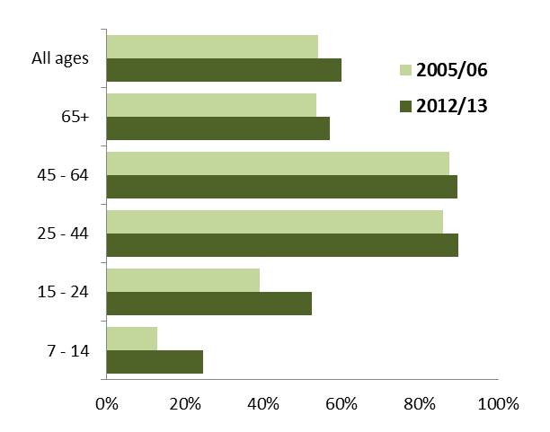

*Source: GLSS5 and GLSS6, Ghana Statistical Service.*

**Even when people are deemed economically active and employed, there are reported levels of under-employment.** Time-related underemployment exists when the hours of work of an employed person are insufficient in relation to an alternative employment situation in which the person is willing and available to engage.  On average 33 percent of employed people’s time is deemed to be inactive; i.e. there is underemployment (Figure 2.6). The extent is higher in rural areas (41 percent) and relative to urban areas (26 percent) and for females (37 percent) relative to males (30 percent).

**Most employed people in Ghana are engaged in agri-business (48 percent), and a further 36 percent are employed in the informal private sector (Figure 2.7).** Only 8.2 percent are working in the formal private sector and 7.6 percent across the public sector. This is further reflected in reported number of self-employed workers (52 percent) and that only are 20 percent are wage earners (Figure 2.6).

**Figure 2.6: Proportion of time underemployed**

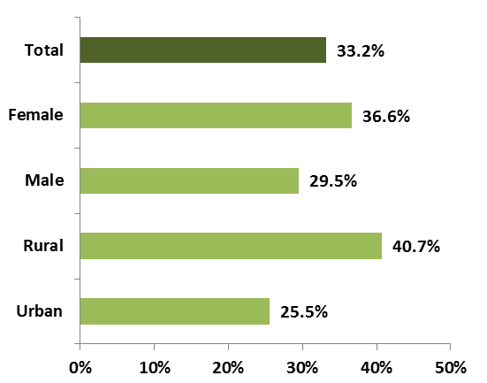

*Source: GLSS6, Ghana Statistical Service, August 2014.*

**The combined share of workers that are engaged in the informal or agri-business sectors is 84 percent.** This suggests that the formal sector (both public and private) cannot generate jobs in sufficient numbers and people are pushed into the informal sector.

These sectors are made up predominantly of small- and medium-size businesses which consist of producers, wholesalers, retailers, and service providers. These businesses are staffed and run by family workers, casual wage workers, and home-based work. Activities include: farming; street vending; artisans and craft-work; trading; and food processing, among others.

**When economic sectors are considered, the largest share (45 percent) of those employed, are active in the agriculture, forestry, and fisheries sector.** This is followed by the wholesale and retail sector (20 percent) and manufacturing (9 percent) (Figure 2.8).

**The average hourly earnings of Ghanaian workers is reported as Ghs1.82 (US$0.49 in September 2014), but there is considerable range across occupations (Figure 2.9).** The lowest earnings are in agriculture, (where a significant portion of workers are engaged) and the highest in public administration and defense; education; and electricity, gas and air conditioning supply. This reflects considerable inequality.

**Figure 2.7: Categories of Employment**

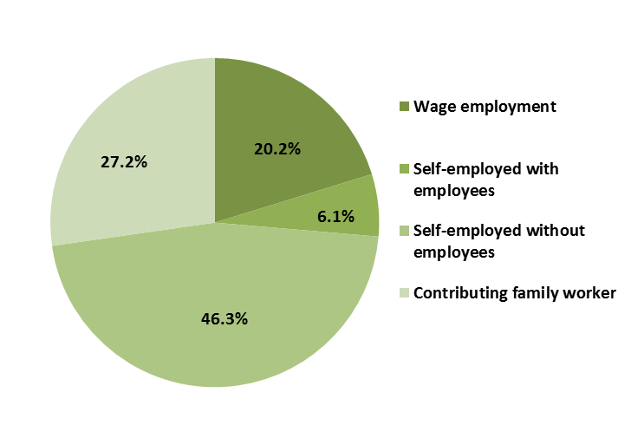

*Source GLSS6, Ghana Statistical Service, August 2014.*

**Figure 2.8: Employment by economic sector**

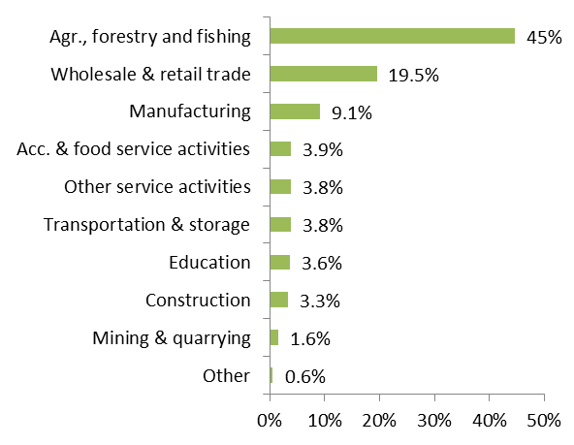

*Source GLSS6, Ghana Statistical Service, August 2014.*

**There has been considerable nominal growth in basic wages since 2007-08 (Figure 2.10).** This is expected given the rates of inflation recorded, but there is a considerable range in the magnitude of the changes. For example nominal wages in agriculture, forestry and fishing—where the majority of workers are engaged—have only increased by 102 percent, whilst wages in the public sector and defense have increased by 495 percent.

**Figure 2.9: Average basic hourly earnings (GH₵), selected industries** 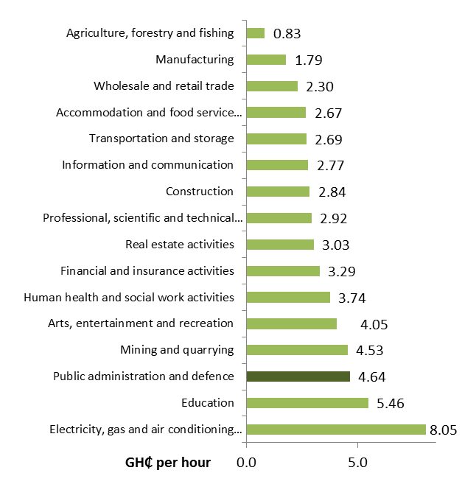

*Source: GLSS6, Ghana Statistical Service, August 2014.*

**Figure 2.10: Nominal growth in average basic hourly earnings (GHs); 2007-2012, selected industries**

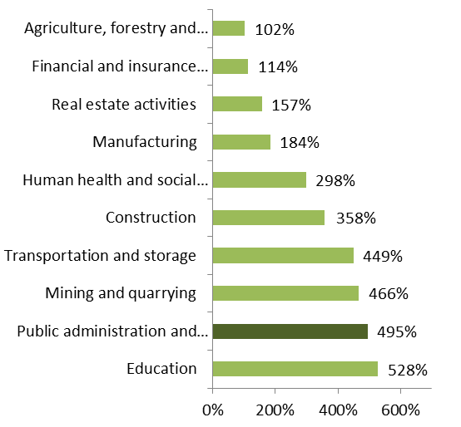

*Source: GLSS6, Ghana Statistical Service, August 2014*

Appendix Table 1: Ghana - Economic Indicators, 2000–13

|  | **2000** | **2001** | **2002** | **2003** | **2004** | **2005** | **2006** | **2007** | **2008** | **2009** | **2010** | **2011** | **Avg. '00–'11** | **2012 est.** | **2013 estimate** | **2014**  **forecast** |
| --- | --- | --- | --- | --- | --- | --- | --- | --- | --- | --- | --- | --- | --- | --- | --- | --- |
| **Income and Economic Growth** |  |  |  |  |  |  |  |  |  |  |  |  |  |  |  |  |
| GDP growth (annual percent) | 4.2 | 4.5 | 4.8 | 5.2 | 5.4 | 6.2 | 4.6 | 6.5 | 8.4 | 4.0 | 8.0 | 15.0 | 6.4 | 7.9 | 5.4 | 6.0 |
| GDP per capita growth (annual percent) | 1.6 | 1.9 | 2.2 | 2.6 | 2.7 | 3.5 | 1.9 | 3.9 | 5.8 | 1.4 | 5.4 | 11.8 | 3.7 | 5.3 | 2.8 | 3.4 |
| GDP per capita (US$) | 393 | 387 | 482 | 556 | 706 | 824 | 953 | 1,127 | 1,266 | 1,124 | 1,358 | 1,580 | 896 | 1,622 | 1,730 | 1,319 |
| GDP per capita, PPP (current international US$) |  |  |  |  |  |  |  |  |  |  |  |  |  |  |  |  |
| Private Consumption growth (annual percent) | -2.4 | 31.8 | 41.5 | 23.7 | 42.3 | 23.2 | 19.3 | 22.6 | 35.8 | 10.2 | 26.5 | 2.5 | 23.1 | 21.2 | 29.7 | 21.5 |
| Gross Fixed Investment ( percent of GDP) | 21.4 | 23.3 | 17.8 | 20.4 | 23.1 | 24.1 | 21.6 | 22.9 | 23.0 | 23.8 | 23.0 | 18.6 | 21.9 | 33.2 | 31.0 | 32.2 |
| Gross Fixed Investment - Public ( percent of GDP) | 6.3 | 9.3 | 4.0 | 6.2 | 7.5 | 7.4 | 7.7 | 8.7 | 9.1 | 7.1 | 7.6 | 6.2 | 7.3 | 6.6 | 6.0 | 8.2 |
| Gross Fixed Investment - Private ( percent of GDP) | 15.0 | 14.0 | 13.8 | 14.2 | 15.6 | 16.7 | 13.9 | 14.2 | 13.8 | 16.7 | 15.4 | 12.3 | 14.6 | 26.6 | 25.0 | 24.0 |
| **Money and Prices** |  |  |  |  |  |  |  |  |  |  |  |  |  |  |  |  |
| Inflation, consumer prices (annual percent, end of year) | 40.5 | 21.3 | 15.2 | 23.6 | 11.8 | 14.8 | 10.9 | 12.7 | 18.1 | 16.0 | 8.6 | 8.6 | 16.8 | 8.8 | 13.5 | 14.0 |
| Inflation, consumer prices (annual percent, period average) | 25.2 | 32.9 | 14.8 | 26.7 | 12.6 | 15.1 | 10.2 | 10.7 | 16.5 | 19.3 | 10.7 | 8.7 | 16.9 | 9.2 | 11.3 | 13.9 |
| Treasury Bill Rate ( percent) | 39.1 | 40.9 | 25.1 | 28.6 | 17.3 | 15.4 | 10.2 | 9.9 | 17.8 | 25.4 | 14.1 | 10.7 | 21.2 | 18.7 | 18.8 | 19.5 |
| Nominal Exchange Rate (End of period) | 0.7 | 0.7 | 0.8 | 0.9 | 0.9 | 0.9 | 0.9 | 1.0 | 1.2 | 1.4 | 1.5 | 1.6 | 1.1 | 1.8 | 2.20 | 3.20 |
| Real Exchange Rate Index (2005=100) | 92.0 | 93.0 | 92.6 | 92.8 | 91.5 | 100.0 | 105.3 | 104.5 | 99.5 | 91.6 | 97.6 | 92.7 | 96.1 | 93.7 | 91.2 | 101.3 |
| **Fiscal** |  |  |  |  |  |  |  |  |  |  |  |  |  |  |  |  |
| Revenues ( percent of GDP) | 13.4 | 11.4 | 12.7 | 17.0 | 17.5 | 16.7 | 17.1 | 17.5 | 16.0 | 16.5 | 16.8 | 19.3 | 16.0 | 18.8 | 16.9 | 17.2 |
| Expenditures ( percent of GDP) | 18.8 | 15.3 | 15.9 | 19.6 | 20.3 | 18.7 | 21.4 | 22.7 | 24.0 | 20.5 | 22.7 | 20.7 | 20.1 | 27.0 | 25.6 | 24.9 |
| Current ( percent of GDP) | 12.5 | 10.5 | 11.9 | 13.5 | 12.7 | 11.3 | 13.7 | 13.9 | 14.8 | 13.4 | 15.1 | 14.5 | 13.2 | 20.4 | 19.6 | 17.5 |
| Capital ( percent of GDP) | 6.2 | 4.9 | 4.0 | 6.1 | 7.6 | 7.4 | 7.7 | 8.7 | 9.1 | 7.1 | 7.6 | 6.2 | 6.9 | 6.6 | 6.0 | 7.4 |
| Overall Fiscal Balance before grants( percent of GDP) | -6.8 | -5.2 | -5.7 | -6.6 | -6.9 | -6.1 | -8.1 | -9.3 | -11.2 | -8.8 | -9.6 | -6.0 | -7.5 | -13.2 | -10.6 | -12.1 |
| Overall Fiscal Balance after grants( percent of GDP) | -5.3 | -4.0 | -4.4 | -3.3 | -3.0 | -2.8 | -4.7 | -5.6 | -8.5 | -5.8 | -7.2 | -4.0 | -4.9 | -11.7 | -10.1 | -11.3 |
| Primary Fiscal Balance ( percent of GDP) after grants | 0.2 | -2.0 | -0.2 | 0.9 | -0.4 | -0.6 | -2.6 | -3.7 | -6.2 | -3.0 | -4.1 | -1.4 | -1.9 | -7.5 | -5.4 | -3.5 |
| Non-oil Primary Fiscal Balance as percent of GDP | 0.2 | -2.0 | -0.2 | 0.9 | -0.4 | -0.6 | -2.6 | -3.7 | -6.2 | -3.0 | -4.1 | -2.5 | -2.0 | -8.8 | -7.2 | -5.2 |
| Total Public Debt ( percent of GDP) | 108.2 | 105.0 | 86.4 | 85.6 | 60.4 | 50.6 | 26.9 | 30.5 | 31.5 | 36.1 | 45.7 | 41.1 | 59.0 | 51.7 | 55.6 | 66.9 |
| External Public Debt ( percent of GDP) | 88.2 | 83.2 | 69.0 | 69.3 | 44.8 | 37.0 | 10.7 | 15.0 | 16.2 | 19.5 | 20.0 | 21.0 | 41.2 | 22.1 | 23.8 | 28.9 |
| **External Accounts** |  |  |  |  |  |  |  |  |  |  |  |  |  |  |  |  |
| Export real growth ( percent, yoy) | -3.5 | -3.6 | 10.2 | 24.6 | 5.5 | 3.6 | 27.1 | 17.1 | 26.3 | 10.8 | 36.3 | 60.6 | 17.9 | 5.9 | 1.5 | -0.1 |
| Import real growth ( percent, yoy) | -0.8 | 2.6 | -4.0 | 20.1 | 31.7 | 24.4 | 26.3 | 19.4 | 27.3 | -21.6 | 35.7 | 45.1 | 17.2 | 12.2 | -0.9 | -16.3 |
| Merchandise exports (current US$ millions) | 1936 | 1867 | 2057 | 2562 | 2704 | 2803 | 3563 | 4172 | 5270 | 5840 | 7960 | 12785 | 4,460 | 13543 | 13752 | 13735 |
| of which: main export (i.e. oil) | 705 | 618 | 689 | 830 | 840 | 946 | 1277 | 1734 | 2246 | 2551 | 3804 | 4920 | 1,763 | -17763 | -17600 | -14736 |
| Merchandise imports (current US$ millions) | -2758 | -2831 | -2717 | -3263 | -4297 | -5347 | -6754 | -8066 | -10268 | -8046 | -10922 | -15843 | -6,759 | -17763 | -17600 | -14736 |
| Services, net (current US$ million) | -198 | -169 | -180 | -451 | -554 | -354 | -277 | -307 | -613 | -1267 | -2060 | -3090 | -793 | -3108 | -3797 | -3102 |
| Workers' remittances, net (BoP, current US$ millions) | 496 | 600 | 680 | 1009 | 1278 | 1539 | 1645 | 1834 | 1970 | 1788 | 2123 | 2369 | 1,444 | 2148 | 1859 | 2135 |
| Current account balance before grants (BoP, current US$ millions) | -525 | -532 | -160 | -142 | -868 | -1359 | -1823 | -2367 | -3642 | -1685 | -2969 | -3770 | -1,654 | -5,181 | -5,784 | -3,372 |
| as percent of GDP | -7.1 | -7.2 | -1.7 | -1.3 | -6.0 | -7.8 | -8.9 | -9.6 | -12.8 | -6.5 | -9.2 | -9.7 | -7.3 | -12.9 | -12.1 | -9.8 |
| Current account balance after grants (BoP, current US$ millions) | -371 | -270 | -1 | 240 | -324 | -783 | -1452 | -2158 | -3400 | -1395 | -2699 | -3549 | -1,347 | -4924 | -5704 | -3278 |
| as percent of GDP | -5.0 | -3.6 | 0.0 | 2.1 | -2.2 | -4.5 | -7.1 | -8.7 | -11.9 | -5.4 | -8.4 | -9.2 | -5.3 | -12.3 | -12.0 | -9.5 |
| Foreign Direct Investment (current US$ millions) | 59 | 56 | 50 | 50 | 139 | 145 | 636 | 855 | 1806 | 2897 | 2527 | 3222 | 1,037 | 3293 | 3226 | 2409 |
| External debt outstanding, total (current US$ million) | 6021 | 6026 | 6131 | 7549 | 6448 | 6348 | 2177 | 3586 | 4035 | 5008 | 6255 | 8135 | 5,643 | 9154 | 11342 | 12556 |
| External debt outstanding, total ( percent of GDP) | 81.8 | 81.0 | 64.7 | 67.5 | 44.3 | 36.5 | 10.7 | 14.5 | 14.1 | 19.4 | 19.4 | 21.0 | 39.6 | 22.9 | 23.8 | 36.3 |
| Multilateral debt ( percent of total external debt) | 70.5 | 69.8 | 71.6 | 72.6 | 88.9 | 94.2 | 68.3 | 47.7 | 50.3 | 49.2 | 49.0 | 51.4 | 65.3 | 55.1 | 39.6 | 37.9 |
| Debt service ratio ( percent of goods and nfs) | 22.9 | 19.1 | 16.7 | 13.1 | 15.4 | 11.2 | 12.2 | 3.3 | 3.6 | 3.1 | 2.8 | 2.4 | 10.5 | 2.4 | 3.4 | 4.5 |
| **Population, Employment, and Poverty** |  |  |  |  |  |  |  |  |  |  |  |  |  |  |  |  |
| Population, total (millions) | 18.4 | 18.9 | 19.4 | 19.9 | 20.4 | 20.9 | 21.4 | 22.0 | 22.5 | 23.1 | 23.7 | 24.3 | 21.2 | 24.9 | 25.6 | 26.2 |
| Unemployment Rate | Na | Na | Na | Na | Na | Na | Na | Na | Na | Na | Na | Na | Na | Na | Na | Na |
| Poverty headcount ratio at national poverty line ( percent of population) | 39.5 |  |  |  |  |  | 28.5 |  |  |  |  |  | 34.0 | Na | Na | Na |
| Poverty headcount ratio at US$ 1.25 a day (PPP) ( percent of population) | Na | Na | Na | Na | Na | Na | Na | Na | Na | Na | Na | Na | Na | Na | Na | Na |
| Poverty headcount ratio at US$ 2 a day (PPP) ( percent of population) | Na | Na | Na | Na | Na | Na | Na | Na | Na | Na | Na | Na | Na | Na | Na | Na |
| Inequality - Income Gini |  |  |  |  |  |  | 42.8 percent |  |  |  |  | Na |  | Na | Na | Na |
| Population Growth (annual percent) | 2.6 | 2.6 | 2.6 | 2.6 | 2.6 | 2.6 | 2.6 | 2.6 | 2.6 | 2.6 | 2.6 | 2.6 | 2.6 | 2.6 | 2.6 | 2.6 |
| Life Expectancy | 57.9 | 57.6 | 57.2 | 56.9 | 56.7 | 56.5 | 56.5 | 56.5 | 56.6 | 56.8 | 60.6 | 64.2 | 57.8 | 64.6 | Na | Na |
| **Other Indicators** |  |  |  |  |  |  |  |  |  |  |  |  |  |  |  |  |
| GDP (current LCU, billions) | 4.0 | 5.3 | 7.5 | 9.7 | 13.1 | 15.8 | 18.7 | 23.2 | 30.2 | 36.6 | 46.0 | 59.8 | 22.5 | 75.0 | 93.5 | 114.8 |
| GDP (current US$, billions) | 7.4 | 7.4 | 9.5 | 11.2 | 14.6 | 17.4 | 20.4 | 24.8 | 28.5 | 25.8 | 32.2 | 38.8 | 19.8 | 40.0 | 47.7 | 34.6 |
| Doing Business Rank 2/ | Na | Na | Na | Na | Na | 102.0 | 94.0 | 82 | 87 | 97 | 77 | 67.0 | Na | Na | Na | Na |
| HDI (Human Development Index) ranking 3/ | 0.43 |  |  |  |  | 0.44 | 0.45 | 0.46 | 0.46 | 0.46 | 0.47 | 0.54 | 0.46 | 0.56 | 0.56 | Na |
| CPIA (overall rating) | Na | Na | Na | Na | Na | 3.90 | 3.93 | 4.00 | 3.90 | 3.80 | 3.90 | 3.90 | 3.9 | 3.8 | 3.7 | Na |
| Economic Management | Na | Na | Na | Na | Na | 4.2 | 4.2 | 4.0 | 3.7 | 3.7 | 3.7 | 3.8 | 3.9 | 3.5 | 3.0 | Na |
| Structural Policies | Na | Na | Na | Na | Na | 3.8 | 3.8 | 4.0 | 4.0 | 4.0 | 4.2 | 4.2 | 4.0 | 4.0 | 4.0 | Na |
| Policies for Social Inclusion and Equity | Na | Na | Na | Na | Na | 3.7 | 3.8 | 3.9 | 4.0 | 3.9 | 4.0 | 3.9 | 3.9 | 4.0 | 4.0 | Na |
| Public Sector Management and Institutions | Na | Na | Na | Na | Na | 3.7 | 3.9 | 3.9 | 3.9 | 3.8 | 3.7 | 3.7 | 3.8 | 3.7 | 3.7 | Na |

*Source:* Government authorities; IMF macroeconomic framework; World Bank World Development Indicators and staff estimates.

*Note:*

**Inequality - Income Gini:** A summary measure of the extent to which the actual distribution of income, consumption expenditure, or a related variable differs from a hypothetical distribution in which each person receives an identical share. *The coefficient is a measure of the inequality of a distribution*: a percentage of 0 expresses total equality and a percentage of 100 expresses maximal inequality.

**Life expectancy (yrs): Life expectancy** at a specific age is the average number of additional years that a person of that age could expect to live if current mortality levels observed for ages above that age were to continue for the rest of that person’s life. In particular, life expectancy at birth is the average number of years a newborn would live if current age-specific mortality rates were to continue.

**Human Development Index (HDI):** Summary measure for assessing long-term progress in basic dimensions of human development. In 2010 HDI was calculated for 169 countries.

**Doing Business Indicators:** Provide objective measures of business regulations for local firms in 183 countries.

**World Bank Country Policy and Institutional Assessment (CPIA): R**ates the policy and institutional performance of approximately 135 IBRD and IDA recipient countries. Ratings range from 1 (unsatisfactory for an extended period) to 6 (good for an extended period)

1. Interestingly the term informality regarding sector of the economy was first coined in a paper about Ghana.