Europe and Central Asia Region
88948

Procurement Post Review
Supervision Mission
Report

Post Review Conducted
By
Kashmira Daruwalla
Sr. Proc. Specialist

June 2, 2014

Procurement Post Review Supervision Mission Report

Country: |  | Kosovo
Loan/Credit/TF No.: |  | IDA-5005-0XK
Project Name*: |  | Agriculture and Rural Development (KARP)
Project ID: |  | P112526
Name of Implementing Agency: |  | Ministry of Agriculture Forestry and Rural Development (MAFRD)
TTL: |  | Meeta Sehgal
PS/PAS: |  | Kashmira Daruwalla
Post Review Conducted by*: |  | Kashmira Daruwalla
Date*: | June 2, 2014 |  | Date of Last Post Review: | April 2, 2013
Number of Contracts Issued  since Last Post-Review*: |  |  | 4
Number of Contracts Reviewed*: |  |  | 4
Total Value of Contracts Reviewed: |  |  | Euro 68,896.00

(*… Information required together with Annex 1 when filing the PPR report in Operations Portal)

1. Executive Summary
As part of the fiduciary responsibility of the World Bank, post-review was conducted in June 2014. The project became effective on May 3, 2012. The overall project risk for procurement was rated “high”. According to the PAD at least 20 percent of contracts are to be post-reviewed. Since project effectiveness, forty four contracts subject to post review have been signed. During this review period all 4 contracts signed were reviewed.
The objective of the review was to verify the procurement and contracting procedures and processes followed by the project, and identify noncompliance with the agreed provisions of the legal agreement and applicable Guidelines, as well as to identify mitigating measures or remedies to correct procurement deficiencies and recommend them to the Borrower and its executing agency.
The contracts under the post-review were found in full compliance with the procedures agreed with the Bank. The following positive observations were made: (i) filing well done and include all the documents duly signed; (ii) adequate competition ensured for the applicable procurement/selection method; (iii) most of the payments are made in a timely manner.

2. Discussion on the Selection of the Contract Samples to be Reviewed and
List of Contracts Reviewed
The following 4 contracts were reviewed:
Shopping (Goods) – 2 contracts (Euro 3,705.00 and Euro 39,611.00)
Individual Consultant – 1 contract (Euro 5,600)
Firm (CQS) – 1contract (Euro 19,980.00)

3. Findings on the Review of Procurement Processes
The contracts were found in full compliance with the procedures agreed with the Bank: (i) contracts were awarded to the lowest evaluated substantially responsive bidders; (ii) sufficient competition was ensured; (iii) all companies which submitted bids were informed about the outcome of the evaluation process. However, evaluation report for contract KARP-CS-14.1 was not in file only Minutes of negotiations was prepared.

4. Findings on the Review of Contract Administration
Generally the payments are made timely, but some delays occur at MAFRD Finance Office who takes a while to process, especially for contract KARP-G-6.1. No delays in contract implementation have been registered.

5. Indication of Possible Governance Issues
No fraud and corruption issues were identified.

6. Progress of Implementation of Recommendations in the Last Post Review
The Bank noted an improvement in timely payments to the suppliers. The estimated costs were realistic and the contract amounts were close to the estimates. Adequate storage space was in place and contracts were signed by both parties before work was started.

7. Compliance& Performance Risk Rating and Recommendations (Required for online filing, risk rating of compliance & performance, and recommendations in the Post Review system in Operations Portal)
Definitions of Post Review Compliance/Performance Risk Ratings:
Low Compliance/ Performance Risk | Borrower procurement processes, and/or contract administration are of highest quality, reliability, timeliness, and transparency, and required little or no corrective action needed by the Bank
Moderate Compliance/ Performance Risk | Borrower procurement processes, and/or contract administration are of generally good quality, reliability, timeliness, and transparency with minor corrective actions needed by the Bank
Substantial Compliance/ Performance Risk | Moderate shortcomings in Borrower procurement processes, and/or contract administration have limited or jeopardized the timely or efficient achievement of one or more major outputs, but resolution(s) is/are likely
High Compliance/ Performance Risk | Significant shortcomings in Borrower procurement processes, and/or contract administration have limited or jeopardized the timely or efficient achievement of one or more major outputs, and resolution is uncertain or unlikely

ComplianceRisk Rating of Procurement Processes: | • Low Moderate Substantial High  (Indicators to consider:  - Procurement Planning: Assessment of quality of, and adherence to, the procurement plan, including changes/updates if applicable  - Publications: Assessment of quality of, and adherence to, advertising and contract award publication requirements for applicable contracts  - Bidding: Assessment of quality of, and adherence to, requirements for bidding documents, including RFP's, LOI's, short lists, terms of reference, and other applicable documents  - Evaluation: Assessment of quality of, and adherence to, bid evaluation requirements/criteria, including draft contracts, technical and financial evaluation reports, and bid amendments, if applicable  - Awards: Assessment of quality of, and adherence to, contract award requirements, including amendments, variation orders, and extensions)
Recommendations: | Complete Bid Evaluation Reports even when hiring Individual Consultants must be prepared and available in the procurement folders for each contract.

PerformanceRisk Rating of Contract Administration: | Low Moderate Substantial High  (Indicators to consider:  - Implementation: Assessment of quality of, and adherence to, contract implementation criteria, including results of physical inspections  - Payments: Assessment of adherence to contract payment schedules, including timeliness of payments to contractors  - Compliance: Assessment of adherence to all contractual compliance with agreed provisions; adherence to all related anti-corruption practices)  - Record-keeping: Availability, quality, security and completeness of contract records and files
Recommendations: | PIU to inform MAFRD finance department to process the invoices in a timely manner.

Annex B: Profile of Procurement Items

Category | Prior Review Thresholds in US$ | Proposed Revised Prior Review Thresholds  (to be completed by PS/PAS if so required and updated in the Procurement Plan)
Works  ICB  NCB | ˃US$ 1,000,000 (All Contracts)  ≤US$1,000,000 (First two contracts) | -
Goods  ICB  NCB | ˃US$ 200,000 (All Contracts)  ≤US$200,000 (First two contracts) | -
Consulting firms (QCBS) | ˃US$ 100,000 (All)
Consulting firms (CQ) | <US$ 200,000 (First contracts) | -
Individual consultants | ˃US$ 50,000 (All) | -
 |  | -

Procurement method thresholds (USD) | Civil works | Goods
ICB | ˃US$ 1,000,000 | ˃US$ 200,000
NCB | ≤US$ 1,000,000 | ≤US$ 100,000
Shopping | ≤US$ 100,000 | ≤US$ 100,000

Shortlist comprising entirely national consultants (USD) | ≤US$ 100,000

Category | No. of Contracts Awarded in Review Period  Review Period is (April 3, 2013 to May 31, 2014)
 | ICB | NCB | Shopping | DC/SS | Others  (Competitive Selection of Consultants) | Total
Works
Goods |  |  | 2 |  |  | 2
Services
Consulting firms |  |  |  |  | 1 | 1
Individual consultants |  |  |  |  | 1 | 1
Total |  |  | 2 |  | 2 | 4

Category | No. of Procurements Reviewed
 | ICB | NCB | Shopping | DC/SS | Others | Total
Works
Goods |  |  | 2 |  |  | 2
Services
Consulting firms |  |  |  |  | 1 | 1
Individual consultants |  |  |  |  | 1 | 1
Total |  |  | 2 |  | 2 | 4

Annex C1: Worksheet for Post Review of Procurement Processes and Contract Administration for Goods/Works/Service Contracts awarded under the Shopping Procedure
Date of Review: 02 June 2014 | Name of Reviewer: Kashmira Daruwalla
Contract No. KARP/SH/001/2013/ KARP-G-6.1  Date: 8 May, 2013  Title: Office Furniture - Bookshelves for Paying Department |  | Contract Amount: EUR 3,705.00
Contractor’s Name and Address:
Gold Invest, Prizren, Kosovo

Aspects | Comments and Findings
Procurement Documentation (Filing) | Good - All documents in the file
Reference in Procurement Plan | KARP-G-6.1 (estimated amount EURO 3,705.00)
Solicitation Letter issued to firms and the number of firms to whom sent | ITQ dated: 2 May, 2013  Issued to Gold Invest only; No Objection received to go through Direct Contracting method on 30 April 2014
Time allowed for submission of quotations | Deadline: 07 May, 2013 – 5 days
Verification (not evaluation) of existence of the quotations; Names of suppliers who gave quotations | Gold Invest EUR 3,705.00  Quotation in file
Quotation evaluation report and date; comments, if any | Contract awarded to “Gold Invest”
Signed Contract / Purchase Order document | May 10, 2013  Warranty 12 months
Delivery date | 10 days from the date of contract signing – May 10, 2013
“Delivery Receipt” or “Store Receipt” or like instrument | Report of Acceptance signed dated 21 May 2013 and Invoice dated 03 June 2013
Complaints or related matters | None
Timeliness of Payments | Payment delay paid on July 30, 2013. PIU sent the file to MAFRD Finance Office on June 17. The Finance office processed the invoice on July 30, 2013.
Indication of possible fraud or corruption | None
Other matters | None

Date of Review: 02 June 2014 | Name of Reviewer: Kashmira Daruwalla
Contract No. KARP/SH/002/2013/ KARP-G-9  Date: 4 December, 2013  Title: IT Equipment for AES and additional equipment for Paying Department (Notebook, Printer, Projector, Flipchart and Camera) |  | Contract Amount: EUR 39,611.00
Contractor’s Name and Address:
Comtrade Computers, Pristina, Kosovo

Aspects | Comments and Findings
Procurement Documentation (Filing) | Good - All documents in the file
Reference in Procurement Plan | KARP-G-9 (estimated amount EURO 40,000.00)
Solicitation Letter issued to firms and the number of firms to whom sent | ITQ dated: 19 November, 2013  Issued to six companies:  - Ilir Kosova  - Comtrade Computers  - Artech Kosovo  - Botek  - Komtel  - Asseco
Time allowed for submission of quotations | Deadline: 27 November 2013 – 8 days
Verification (not evaluation) of existence of the quotations; Names of suppliers who gave quotations | The following three companies submitted quotations:  - Ilir Kosova - 38,941.20 EUR  - Artech - 38,996.20 EUR  - Comtrade Computers - 39,611.00 EUR  All quotations are in file
Quotation evaluation report and date; comments, if any | 27 November 2013, EC duly signed evaluation sheets are in file.  -Ilir Kosova did not meet the delivery period required, they have offered 30 days instead of 20. The reason why we have requested the delivery period of 20 days is that we could have perform the payments in this budgetary year (2013) as already committed for this financial year.  -Artech did not meet the technical specification for the Laptop processor, offered with the lowest performance. It was requested i3-3120M and offered i3-2328. As per CPU Benchmark, average CPU Mark requested is 3295 and it was offered CPU 2516. Committee considered not technically responsive offer.
Signed Contract / Purchase Order document | 4 December 2013
Delivery date | 20 days from the date of contract signing – December 24, 2013.
“Delivery Receipt” or “Store Receipt” or like instrument | Delivery Receipt dated December 24, 2013.
Complaints or related matters | None
Timeliness of Payments | Invoice dated December 24, 2013 and Payment executed on December 24, 2013 – on time.
Indication of possible fraud or corruption | None
Other matters | None
Annex C2: Worksheet for Post Review of Procurement Processes and Contract Administration of Consultants Contracts

PROCUREMENT METHOD: QCBS QBS Fixed Budget

CQ Least Cost Single Source

Others, Specify: Individual Consultants (IC)

CATEGORY: Firm x Individual

Date of Review: 02June 2014 | Name of Reviewer: Kashmira Daruwalla
Contract No., KARP-CS-14.1  Date: 04 December 2013  Title: Communication and Public Relation Consultant for MA |  | Contract Amount:  EUR 5,600 (for the duration of assignment – five months)
Contractor’s Name and Address:
Birol Urcan, Peja, Kosovo

Aspects | Comments and Findings
Procurement Documentation (Filing) | Good – All documents in the file
Reference in Procurement Plan | KARP-CS-14.1
Solicitation Letter issued to firms and the number of firms to whom sent | CV collected from candidates with relevant experience, qualification
Time allowed for submission of quotations | n/a
Verification (not evaluation) of existence of the quotations; Names of suppliers who gave quotations | 5 (five) CV were received, Short list of 3 candidates invited for interview in person only 2 responded.  - Birol Urcan  - Veton Kasapolli  - Shkumbin Brestovci  - Besa Dida  - Rudina Efendia  Mr. Brestovci was not available for the entire period of the assignment. Candidates Dida and Efendia were not qualified for the assignment.  2 Candidates Interviewed – 26 November 2013  - Birol Urcan  - Veton Kasapolli
Quotation evaluation report and date; comments, if any | Minutes of negotiation done on December 02, 2013. No evaluation report in file.
Signed Contract / Purchase Order document | Contract signed on December 4, 2013
Delivery date | Contract from 04 December 2013 through 30 April 2014
“Delivery Receipt” or “Store Receipt” or like instrument | Time sheet and report every month
Complaints or related matters | None
Timeliness of Payments | Invoice, timesheet and report submitted every month. First payment 14 February 2014  Second payment 04 March 2014  Third payment 21 March 2014  Fourth payment 23 April 2014  Fifth payment sent to MAFRD finance on 26 May 2014
Indication of possible fraud or corruption | None
Other matters | None
Annex C2: Worksheet for Post Review of Procurement Processes and Contract Administration of Consultants Contracts

Procurement Method: QCBS QBS Fixed Budget

x CQ Least Cost Single Source

Others, Specify: ________________

CATEGORY: x Firm Individual

Date of Review: 02June 2014 | Name of Reviewer:  Kashmira Daruwalla
Contract No. KARP-CS.17, Date: December 4, 2013  Title: Public Awareness Campaign |  | Contract Amount:  EUR 19,980 (for the duration of assignment (Two Years)
Contractor’s Name and Address:
PR Solution, Str. UCK, No. 2; 10000 Pristina, Kosovo

Aspects | Comments and Findings
Procurement Documentation (Filing) | Good - All documents in file
Reference in Procurement Plan | KARP-CS-17
Solicitation Letter issued to firms and the number of firms to whom sent | Expression of Interest published 08 October 2013 (local newspaper Koha Ditore and MAFRD and UNDB on-line)
Time allowed for submission of quotations | Deadline for submission of EOI 22 October 2013 – two (2) weeks Deadline for submission of RFP 02 December 2013-two (2) weeks
Verification (not evaluation) of existence of the quotations; Names of suppliers who gave quotations | 10 Expression of Interest received:  - PR Solution, (Kosovo)  - Joint Venture Entermedia and Frakton (Kosovo)  - Koperativa, (Kosovo)  - MDA (Kosovo)  - INIT (Kosovo)  - Pixels Production (Kosovo) and sub consultant Kutia (Kosovo)  - D-Line (Kosovo)  - New Moments New Ideas (Kosovo)  - Republica (Kosovo)  - Rrota, (Kosovo)  Shortlist of Candidates that were scored the highest:  - PR Solution, (Kosovo)  - Koperativa, (Kosovo)  - D-Line (Kosovo)  - Rrota, (Kosovo)  Only PR Solution has been asked to submit the technical and financial proposal.
Quotation evaluation report and date; comments, if any | EOI Evaluation dates 24 October 2013; 25 October 2013 and 28 October 2013;  Negotiation and recommendation dated 03 December 2013
Signed Contract / Purchase Order document | 04 December 2014
Delivery date | Contract from 09 December 2013 through 09 December 2015
“Delivery Receipt” or “Store Receipt” or like instrument | Report of acceptance  First - January 23, 2014  Second - March 4, 2014
Complaints or related matters | none
Timeliness of Payments | Two invoices submitted and processed for payment  Invoice 1 submitted on 22 January 2014 paid on 14 February 2014  Invoice 2 submitted on 03 March 2014 paid on 21 March 2014
Indication of possible fraud or corruption | none
Other matters | none
Report on Physical Inspection

Location | MAFRD Paying Agency Office
Date of Visit | June 2, 2014
Quantity awarded/quantity received | Office Furniture, Bookshelves for PD  (pieces of Furniture)  Contract No. KARP/SH/001/2013/ KARP-G-6.1
Arrival date at port | N/A
Arrival date at project site/warehouse | 21 May, 2013
Time overruns | No
Cost overruns | No
Deficiencies/defects observed | No
Comments and recommendations | N/A

PICTURES

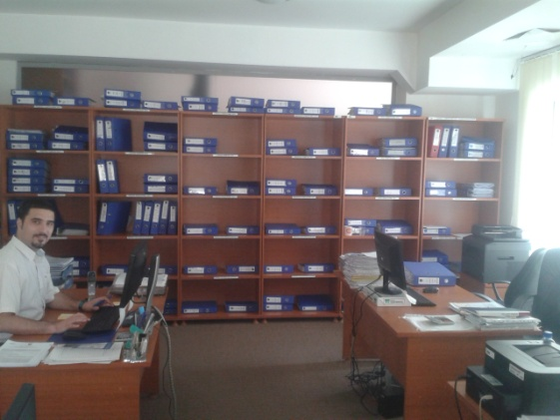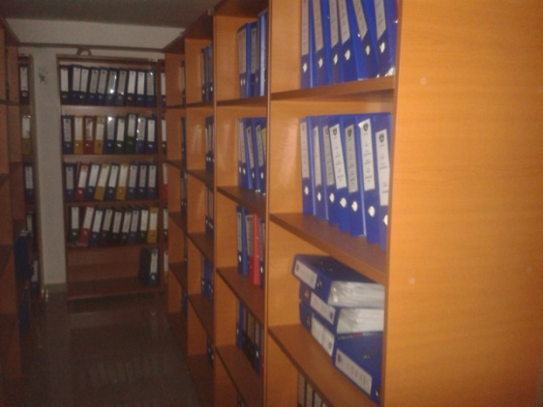

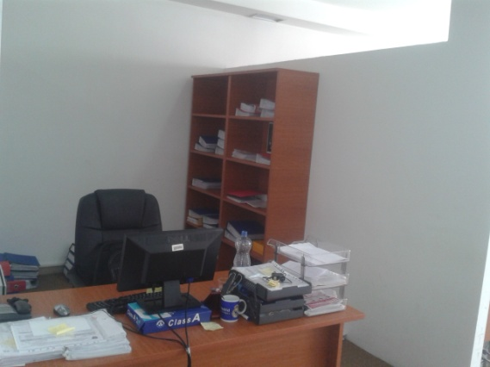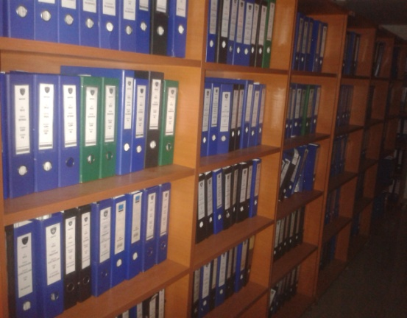
Report on Physical Inspection

Location | MAFRD AES Office in Junik, Vitia, shtime and Gjakove
Date of Visit | 30 May, 2014
Quantity awarded/quantity received | IT Equipment for AES and additional equipment for Paying Department (Notebook, Printer, Projector, Flipchart and Camera)  Contract No. KARP/SH/002/2013/ KARP-G-9  34 Sets. Delivered in 34 regions
Arrival date at port | N/A
Arrival date at project site/warehouse | 24 December, 2013
Time overruns | No
Cost overruns | No
Deficiencies/defects observed | No
Comments and recommendations | Warranty 12 months – Items functioning well.

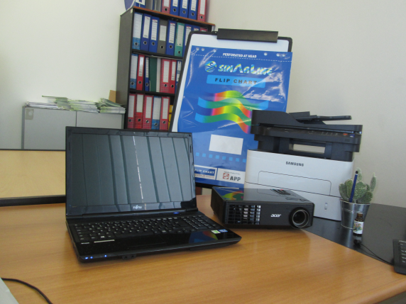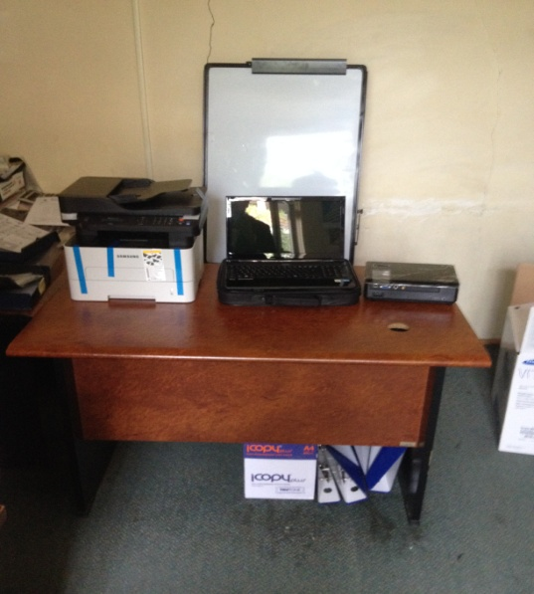

Shtime Region Vitia Region

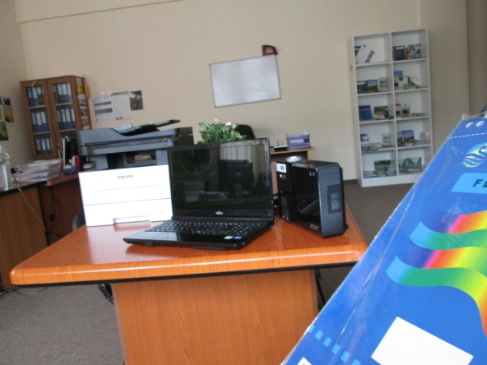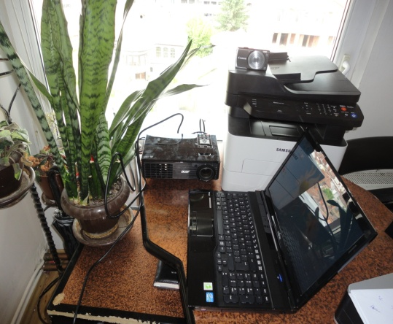

Junik Region Gakova Region

Compliance in accordance with the Legal Agreement, Procurement Guidelines and other agreed provisions
Performance of executing agency in implementing the contract

