SUMMARY

Russian Federation: Doing Extra-Curricular Education: Blending traditional and digital activities for equitable learning

Summary

Extra-curricular activities (ECA) are instrumental in the acquisition of 21st-century skills, which include both intra-and inter-personal skills. Now that basic skills of reading and writing in early grades are taken for granted in many parts of the world, 21st-century skills are becoming more important. With robots and artificial intelligence taking on ever greater presence in society, education has to go much beyond the provision of knowledge and basic skills. Especially in western countries where ECA was not high on the policy agenda, there is a growing realization that ECA can be the “disruptive innovation” that will shake up the status quo of traditional education. The policy attention to coding and robotics through government investments in Russia is a positive step, but more is needed. 21st-century learning will need to involve more participative activities in all spheres of learning, greater collaboration and group project work with children taking the “driver’s seat” in their own learning. ECA has long embodied these practices; activities such as art, theatre and sport involve a strong aspect of play, and ECA that stresses concentration, focus and disciplined practice strengthens intra-personal abilities like grit or perseverance in the face of adversities. Extra-curricular activities could be an engine to drive the Russian Federation to be a top performer in education, and consequently support innovation, growth and prosperity in the long run. The May decree calls for Russia to be a top performing country for education – Russia is already at the top with regard to basic skills in the early grades (PIRLS), but is around the OECD mean for Grade 9 children (PISA) and below average with regard to Collaborative Problem Solving Skills (CLPS).

The World Bank Doing Extra-Curricular Education report explores the comparative international situation regarding ECA and studies the empirical data regarding the benefits of ECA for the Russian Federation. The report presents theoretical and empirical arguments to support the claim that ECA can help drive overall Russian education performance. First, the heritage of providing extra-curricular education during the Soviet era has been strengthened by concerted policy action to maintain the endowments. The policy attention including consistent budget allocations to ECA have been instrumental in the provision of inputs – infrastructure, equipment, and the most important – human resources. Second, the long history of engagement in ECA has generated a depth of professional knowledge amongst teachers and administrators and the academicians who help them. Professional development networks provide space for deliberation and discussion. This endowment is not easily replicable, which creates a competitive advantage. Third, there is a new understanding about the importance and role of ECA for learning. ECA provides a venue for the development of multiple intelligences – especially creativity, team-work and self-responsibility that are going to be increasingly important in the emerging robotic age. Education systems around the world are seeking ways to incorporate these 21st century skills, and educators the world over can learn from the ECA practices in the Russian Federation.

The report is motivated by three guiding questions regarding quality, efficiency and equity. The first guiding question asks about the evidence to back up the claim that Extra-Curricular Activities (ECA) can be the means for Russia to become a top performing education nation, as directed by the May decree of 2018. The second guiding question relates the efficiency of those investments – considering a range of inputs and outputs can provide a window for efficiency improvements across and within regions. A third guiding question deals with the issue of equity – the empirical data utilized for this report shows a welcome convergence between regions with regard to coverage of ECA just in the past four or five years. Regions which had low coverage of ECA appear to be catching up with regions with higher coverage, though further convergence is likely to take place. Equity from the perspective of the family is also discussed in the report.

ECA in the International Context
The extent of ECA provision varies across countries and the data indicates a positive relationship between ECA participation and academic achievement. Figure A shows the positive correlation between ECA and PISA mathematics performance in a 2012 comparison between Russia and the United States. Whereas ECA has not been a policy priority in the U.S. until very recently, ECA has been supported for long in Russia, and the Soviet Union. In the 2012 sample, only 7% of students participated in mathematics related ECA in the U.S. as compared to 31% in Russia.

Figure A: PISA 2012 Relationship between PISA Math Score and Math Extra-Curriculars
Level 5 or above  No EC 2.08%  Yes EC 3.58% | United States of America  Russian Federation | Level 5 or above  No EC 6.54%  Yes EC 10.4%
Source: PISA 2012 data regarding Mathematics performance linked to student participation in Math extra-curricular activities

There is a strong correlation between those who are at the top of the PISA score distribution and their ECA participation. In Russia, amongst those who are ECA participants, 10.4% are in the % are in the top 2 of 6 levels or excellent in the PISA range, compared to 6.5% at that level from those who do not take part in ECA. The relationship becomes clearer when comparing top performing and bottom performing PISA countries(Figure B). In the top 10 countries, 45% of the ECA participants are in performance level 5 or above, compared to 27% for those who do not take part in ECA. In the bottom 10 countries, there are not many students in level 5 or above, but there is no positive effect of ECA.

Figure B: PISA 2012 Relationship between PISA Math Score and Math Extra-Curriculars
Level 5 or above  No EC 0.45%  Yes EC 0.53% |  | Level 5 or above  No EC 26.7%  Yes EC 44.5%
ource: PISA 2012 data regarding Mathematics performance linked to student participation in Math extra-curricular activities

Literature from many countries documents the benefits of ECA, including recent research focused on rigorous impact evaluation studies, which are very useful for policy makers. A growing body of studies has estimated the benefits of ECA participation on behavioral parameters as well as academic performance. The literature indicates support for traditional activities like sports, chess and ballet, as well as bright prospects for newer activities like the Центр молодежного инновационного творчества (Creativity Centers for Innovative Youth), known internationally as Fab Labs or Maker Spaces. ECA is characterized by self-directed student projects, typically conducted in a setting of fun or play, with a high degree of agency for the student. ECA enhances disciplined individual performance in some cases, and promotes competencies of collaboration and team work in other cases. Throughout the world, policy makers seeking to modernize education systems want to move away from a system of teacher directed knowledge provision. The focus on students building competencies with the support of teachers and other adults has always been the focus of ECA. As pressure grows on regular education systems to reform from the factory model of education towards group work, play and socio-emotional skills, ECA will become more and more important, and traditional education will start looking more and more like ECA. To answer whether such a turn of events is desirable, we turn next to the empirical evidence.

ECA in Russia: Empirical Evidence
Participation in ECA leads to an improvement in academic achievement of children in Russia. ECA are instrumental in the development of multiple intelligences of which cognitive achievement (as measured by standardized testing) is only a partial measure. However, given the lack of data or even a consensus amongst researchers about how the other skills can be measured, the report provides an analysis of the effect on a metric familiar to all Russian children and their caregivers – the grades obtained at school, ranging from “unsatisfactory” ratings (A1) to highly satisfactory (A5). As seen in Figure C, and using data from the MEMO survey, there is a causal impact of ECA on the students’ grades.

Figure C: Correlation between ECA participation and academic achievement at school
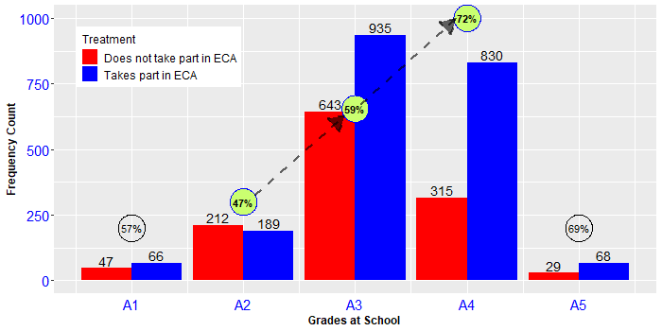
Source: MEMO Survey 2016

The magnitude of improvement in achievement due to ECA, converted into PISA terms, is equivalent to two-thirds of one year, and the improvement is highly cost-efficient when considering public expenditures. The analysis carried for the report determined that the average magnitude of ECA effect on school grades was equivalent to about 20 PISA points, or 2/3^{rds} of one year of general education. The average annual cost per ECA student served in ECA organizations was 14,445 rubles (US$602/student using PPP exchange rate of 24 rubles/USD) in 2017. Taking this cost as a benchmark, the cost of 2/3^{rds} year of academic achievement would be 9,630 rubles/student (US$401/student). The general education expenditure per student in Russia in 2017 was approximately 25,322 rubles (US$1,055). The cost efficiency of ECA using these metrics can thus be considered to be high.

Digital transparency and participation: Improved quality and equity
Government initiatives for citizen feedback can be exploited to generate feedback about performance that in turn can serve as a knowledge source and as stimulus for competition and better performance. Using data from the treasury managed website bus.gov.ru combined with data from other sources, one arrives at measures of efficiency for regional governments. While there is variation in spending per student across regions, there is even greater variation in the results obtained from that spending. Figure D shows one of the extracts of the efficiency measurements and rankings. Data collected by the government can be analyzed to obtain the benefits of information sharing and healthy competition between jurisdictions and regions and how league tables of efficiency could set in place a process of continuous quality improvement. The Russian Federation has made big strides with regard to transparency and citizen engagement in the provision of services. One of the many interventions in this regard is the bus.gov.ru website that provides a mechanism for parents and other stakeholders to obtain information regarding service provision. The final mile of service delivery is the one that counts the most.

Figure D: Correlation between ECA participation and academic achievement at school
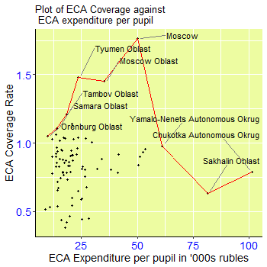 | Top 10 Efficiency level  Moscow Oblast 0.9306  Tyumen Oblast 0.9187  Kurgan Oblast 0.9167  Samara Oblast 0.9119  Chuvash Republic 0.8897  Moscow City 0.8876  Tambov Oblast 0.8701  Stavropol Krai 0.8617  Tuva Republic 0.8554  Pskov Oblast 0.8520
Source: Combination of various sources listed in the main report

Regional data analyzed for the report show a convergence of differences between regions, with lagging regions catching up in coverage with leading regions. As seen in Figure E, the coverage of ECA services has been consistently improving between 2015 and 2018, likely to the commitment of the government in providing resources to improve quantity and quality. It is clear that in just for years, there are more and more regions with increased coverage. Inter-regional equity is one of the two dimensions concerning equity.

Figure E: Coverage of the Population Aged 0-17 Years Old by ECA
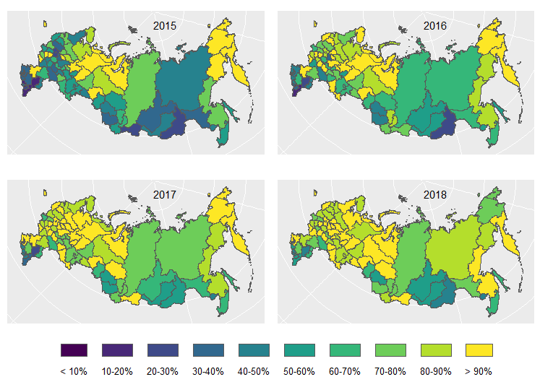
Source: Russian Federal State Statistics Service.

The principal economic rationale for government investment in ECA provision is to provide opportunities for access to children from lower income families similar to those enjoyed by wealthier families from private ECA providers. Private provision of regular education is limited in Russia – unlike in many other countries, rich and poor families alike mostly attend public schools for general education. Parents of children in general education were asked in the MEMO survey about ECA participation of children within the general school where they were enrolled in, as well as ECA in other organizations. Amongst those who reported attending ECA in other organizations, 13% reported doing so in private, commercial organizations. From a policy perspective, the objective is ECA participation, whether in a private or public organization. The results presented in the main report examine the possible determinants of ECA participation, including the reported family income level. Quite interestingly, the parental income does not appear to be different between ECA participants and non-participants. Rather, the consistently important variable is parental participation and parental activism in the child’s education.

Policy Recommendations
Role of Extra-Curricular Education in Education Policy: There are theoretical and empirical reasons to believe that Extra-Curricular Education, or Extra-Curricular Activities (ECA), possess crucial elements that makes ECA a high value tool to provide a 21st-century education to Russia’s children and youth. The elements include content (what is taught); structure (in what setting it is taught and by whom); and process (the pedagogical principles such as active and participative learning). ECA has a beneficial impact on learning in the Russia. ECA will help provide holistic human learning in the age of robots. The federal and regional governments need to pay close policy attention towards ECA provision as they have done in the past for schools, colleges and universities. However, supporting ECA is difficult to do in practice because of the diversity of institutional arrangements – through regular schools as well as specialized institutions that belong to different government agencies. With its high level of diversity of services and organizational arrangements , it is by no means clear that there should even exist standards for extra-curricular education. Yet, there needs to be quality assurance and methods to ensure that there is greater efficiency and efficacy of public expenditures, as well as collaboration with the private sector, and the pathways are not easy.

Russia’s Advantage: Russia has a special advantage because of the long history of ECA provision. While some of the Soviet era youth palaces and art centers are a bit run-down, our report provides evidence that the situation is improving. The heritage going back several generations has a number of positive consequences – there is a cultural endowment with families in terms of high valuation of classical arts, music and ballet, to give some examples. Heated swimming pools in winter, even in small towns in the most frigid of regions, accessible to the common citizen, have a value that is not easy to count in dollar terms. Tradition going back for generations of teachers, supplemented by serious pedagogical scholarship, has resulted in a knowhow that is not easy to replicate. Whatever may have been the original motivation of Soviet era policy makers to promote ECA, there is a new realization of the value of the benefits of ECA that are hard to bring about through formal classroom-based learning. The key point is that ECA has positive benefits towards both cognitive and non-cognitive skills – data analysis shown in the report leads to the conclusion that ECA can be an engine to power Russia to the top of the list of countries. To be a top performer in collaborative problem solving skills has an implication not just for education or the well-being of the student, but also for the future innovation and improvement in productivity and living standards. There are actions that both the federal and regional governments can take that will enhance the likelihood of success.

Scope to leverage transparency and participation: If indeed ECA is a remarkable good thing as it appears to be, and truly Russia’s rich heritage provides a boost for using ECA as a means for national competitive leadership, these two conclusions would hardly be useful without the third conclusion from the study – how to make it happen. For this aspect we turn to developments in another branch of government – the support for digitization and the avenues created for citizen feedback and engagement through portals such as bus.gov.ru. The presence of such portals provides the opportunity to create a system where the feedback from citizens is used to generate efficiency measures and performance indicators and used for policy analysis and eventual improvement in service delivery. Our report has provided a small step in a suggested long journey where real time data analysis and feedback, reputation ranking algorithms and other iterative feedback techniques can be put to work to improve ECA quality. Efficiency improvements can lead to savings which can be ploughed back to improve access or deepen the quality of services.

This report seeks to raise awareness amongst policy makers at the federal level in Russia that ECA can help raise the country’s education performance to the top ranks in the world. Russia’s experience in ECA is also a topic which other countries can learn from Russia. But national performance is only the aggregation of regional performance, and the report concludes that healthy competition to build on the digital transparency initiatives like bus.gov.ru is likely to yield rich dividends. The report shows variation in quality of performance between ECA providing educational institutions of different types – similar analysis can be carried out by geographical location and other parameters. For example, the report shows a mapping of the highest performing ECA institutions in a region, based on analysis of data provided by users. Popularization of such feedback loops would enhance the prestige of high performing organizations, and provide parents with substantiated knowledge about the quality of ECA services. Regional authorities can analyze these findings to improve the overall performance of the regional ECA system.

