Enhancing Cooperation between Auditors and Supervisors: A building Block Approach

Building trust takes time, whether it is between individuals, stakeholders’ groups, or institutions, the road to cooperation is long and requires important investments. The objective of this policy note is to provide in a succinct document, some of the key aspects for building that trust to foster cooperation, using the experience of several supervisors.

The 2008 financial crisis highlighted weaknesses in the risk management, control and governance processes of banks as well as in their statutory audit and financial supervision. This led to increased scrutiny of the respective roles and interactions of banking supervisors and external auditors who are key contributors to market discipline. Auditors ensure that financial information is transparent and reliable while supervisors provide confidence in the financial systems. Both supervisors and auditors allow market players to make informed decisions and contribute to financial stability.
In many countries, if not most, supervisors are not fully aware of where the responsibilities of external auditors start and where they end. This confusion among supervisors creates many direct and indirect issues which prevent effective communication and fruitful cooperation and collaboration between supervisors and external auditors. In some cases, it generates suspicion and a lack of trust between all parties.
Supervisors and auditors possess complementary skills and knowledge. External auditors may participate in the supervisory process by performing additional work at the request of the supervisors, providing reasonable or limited assurance on a range of areas, such as: internal controls, IT systems, risk management, or prudential returns. For instance, supervisors have greater confidence in prudential returns when they are reconciled with audited financial statements. By reporting to supervisors, external auditors contribute to strengthening the supervisory process. Audit information is, however, not always reviewed during the regular inspection of banks and supervisors do not always have a good understanding of what an external audit comprises and how they can rely on auditors’ work. Practices vary across ECA in terms of the scope of auditors’ work, the extent of auditors’ contributions to the supervisory process, and the type of assurance they provide.

Box 1: What is an external audit?
An external audit is a process by which an independent external auditor will obtain sufficient appropriate audit evidence to give reasonable assurance about whether the financial statements as a whole are free from material misstatement, whether due to fraud or error, thereby enabling the auditor to express an opinion on whether the financial statements are prepared, in all material respects, in accordance with an applicable financial reporting framework, and to report on the financial statements in accordance with the auditor’s findings. Reasonable assurance is a high, but not absolute level of assurance. The independent opinion enhances the degree of confidence of intended users in the financial statements.

Three steps to building for building an effective relationship between auditors and supervisors:
A first step: find topics of mutual interest
Sharing information on a range of important accounting and auditing themes due to their complexity, materiality and/or judgment involved is crucial. At a crossroads between accounting and finance, topics covered under accounting standards for financial instruments, such as loan valuation and provisioning as well as the bank’s asset valuation, are key for both external auditors and supervisors. Compliance with prudential regulations and the consistency of disclosures in financial statements with published prudential information are also important. Finally, the effectiveness of banks’ internal control, risk management and IT systems are essential inputs for assessing the bank’s risk profile and going concern assumption. External auditors may identify additional areas of interest to supervisors during the course of the audit.

Box 2: Possible discussion topics according to the French Banking regulators
  - Accounting: significant aspects of accounting practices and changes, implementation of new accounting standards, valuation process and model used, adequacy of disclosures.
  - Accounting estimates: Review of significant accounting estimates, including those lacking objective data and involving a judgment; Assessment of the factors likely to influence and/or guide the judgment of management and their choice between several options in the valuation process; and
  - Assessment of the analysis made by the management and the external auditors with regards to the banks’ ability to continue as a going concern.

  - External audit: Significant difficulties encountered during the audit; circumstances that led to a change in the audit mission plan; Work carried out due to significant non-recurring and complex transactions requiring an expert opinion; Compliance and reliability of financial information with regard to reporting requirements, risks, and exercised judgments discussed at prior meetings.

Significant topics that were the subject of considerable discussions with the management;
Summary of audit adjustments used and not disclosed and an estimation of their materiality;
Documentation of internal control weaknesses identified during the financial reporting process; and
Likelihood of the issuance of a qualified opinion.

Communication with those in charge of Governance: Auditors and the audit committee
- Key points communicated to the audit committee;
- Involvement of the audit committee in overseeing the preparation of the financial statement and its appendix, including the quality of the relationship with the external auditors; and

- Evidence of a failure of the control environment or flaws in the internal control process; Evidence of a failure in internal audit, risk management and compliance.

A second step: protecting the communications of external auditors
It is essential to have a proper cooperation with auditors that they can be safe in sharing their concern with supervision. External auditors do not always have the statutory duty to disclose significant findings and fraud encountered during the course of their audit (statutory duty to report), nor all jurisdictions provide safe haven rules for auditors when reporting matters to supervisors that do not give rise to a statutory duty to report but may, nevertheless, be relevant to the supervisor’s exercise of his/her functions (right to report).
Updating regulations to include examples of instances and events when external auditors must report bank-specific information directly to supervisors (statutory duty to report). Examples may include when external auditors detect significant findings, fraud or going concern issues during the course of the audit or when management uses significant accounting judgment which materially affects the bank’s results and position.
Creating safe haven rules to allow auditors to share bank-specific information with the supervisors on matters that fall outside the scope of the duty to report if communicated in good faith, and if reasonably believed to be relevant to the supervisor in order to conduct his/her functions (right to report); For matters that give rise to the right to report, it is normally appropriate for the auditor to request in writing that those charged with governance in the bank bring these matters to the attention of the supervisor. If those charged with governance fail to inform the supervisor of the matters in a timely manner, the auditor shall report them directly to the supervisor.
The signing of the Memorandum of Understanding between the audit profession, and the supervisor, and in addition between the audit supervisor and the prudential supervisors will facilitate the effectiveness of the cooperation.

The third step: meeting and exchanging information for the benefit of both external auditors and supervisors
Regular exchanges of information between external auditors and banking supervisors enable both parties to perform their duties effectively. A strong and fruitful two-way relationship depends on the quality of interaction between auditors and supervisors. The objective is to have “the right discussions at the right level and at the right time”, using the most appropriate channels of communication so that supervisors can engage more effectively with external auditors.
The cooperation cannot be equal for all supervised entities. In a proportionate risk-based approach towards the relationship between supervisors and external auditors, a greater supervisory effort is directed to banks that are classified as Systemically Important Banks (SIBs). For example, the Basel Committee on Banking Supervision (BCBS) specifies that the implementation of their principles, including those concerning the relationship between supervisors and external auditors, should be “proportionate to the size, complexity, structure, economic significance and risk profile of the bank and the group (if any) to which it belongs” and “should be applied in accordance with the national legislation and corporate governance structures applicable in each country”.

Dialogue between external auditors and supervisors can be established through both formal (e.g. official written communication, official meetings, etc.) and informal (e.g. telephone conversations, informal meetings, emails, etc.) channels of communication. Supervisors and external auditors should generally use the most appropriate communication channel applicable to the circumstances and sensitivity of the issues discussed There are many reasons for promoting discussions as early as possible in the planning stage of the audit.
The timing of the communication is also important. Sharing information with external auditors at the planning stage because it affects the audit’s planning and, in some cases, the scope of the external audit of a bank. Holding discussions about risks at an early stage of the audit process may improve the supervisor own risk assessment of the supervised entity and contributes to closer cooperation between external auditors and supervisors. Scheduling discussions just before the audit opinion is issued also has advantages; it allows both supervisors and auditors to share findings and evaluate their impacts. Conclusions on areas that require substantial accounting judgment have already been reached when the external audit process is almost complete; it is then too late to start discussing or challenging auditors’ key accounting treatments, assumptions and methodologies.

Conclusion
The Bank of the Netherlands describes the benefit from a long-lasting investment in the relation between supervisors and auditors. Without this investment both parties suffer from mistrust and miscommunication resulting in formal approaches or even defensive or non-collaborative approaches. They started to engage with auditors with topics of common interest. Investing helps to get into a phase in which roles and responsibilities are defined protocols are set up for proper communications. After several years, the next phase of ‘trust’ and ‘mutual understanding’ starts to grow, where it is possible to be critical to each other without affecting the relationship.

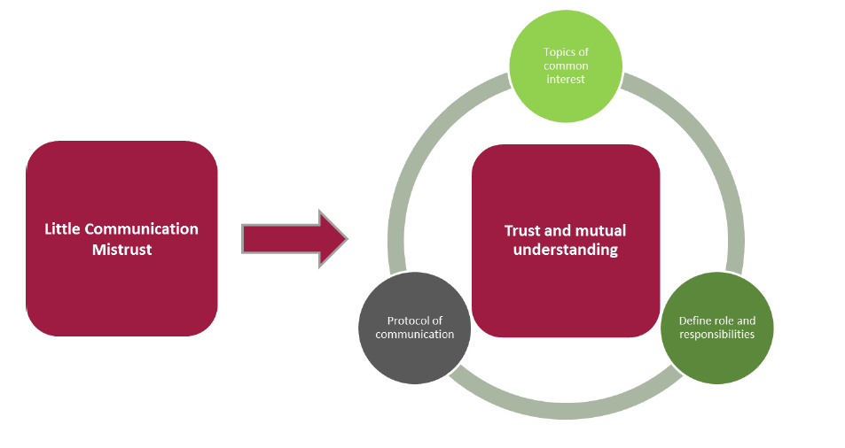
National Bank of the Netherlands: We have invested heavily in this communication structure for over 10 years, and we are sure that we have to keep investing

